UNITED STATES

SECURITIES AND EXCHANGE COMMISSION
Washington, D.C. 20549

SCHEDULE 14A INFORMATION

PROXY STATEMENT PURSUANT TO SECTION 14(a) OF THE

SECURITIES EXCHANGE ACT OF 1934

Filed by the Registrant ☐ Filed by a Party other than the Registrant ☒

Check the appropriate box:

- Preliminary Proxy Statement

- Confidential, for Use of the Commission Only (as permitted by Rule 14a-6(e)(2))

- Definitive Proxy Statement

- Definitive Additional Materials

- Soliciting Material Pursuant to §240.14a-12

TICC CAPITAL CORP.

(Name of Registrant as Specified In Its Charter)

TPG Specialty Lending, Inc.

(Name of Person(s) Filing Proxy Statement, if other than the Registrant)

Payment of Filing Fee (Check the appropriate box):

- Fee not required.

- Fee computed on table below per Exchange Act Rules 14a-6(i)(1) and 0-11.

  - Title of each class of securities to which transaction applies:

  - Aggregate number of securities to which transaction applies:

  - Per unit price or other underlying value of transaction computed pursuant to Exchange Act Rule 0-11 (set forth the amount on which the filing fee is calculated and state how it was determined):

  - Proposed maximum aggregate value of transaction:

  - Total fee paid:

- Fee paid previously with preliminary materials.

- Check box if any part of the fee is offset as provided by Exchange Act Rule 0-11(a)(2) and identify the filing for which the offsetting fee was paid previously. Identify the previous filing by registration statement number, or the Form or Schedule and the date of its filing.

  - Amount Previously Paid:

  - Form, Schedule or Registration Statement No.:

  - Filing Party:

- Date Filed:

On October 13, 2015, TPG Specialty Lending, Inc. issued the following press release:

TPG Specialty Lending, Inc. Highlights Four Key Facts for TICC Stockholders to Consider about Their Dividend

NEW YORK—(BUSINESS WIRE)—TPG Specialty Lending, Inc. (“TSLX”; NYSE:TSLX), a specialty finance company focused on lending to middle-market companies, today issued the following statement in response to a misleading press release issued by TICC Capital Corp. (“TICC”; Nasdaq: TICC) regarding its stockholder distribution.

FACT 1: TICC’s net asset value has consistently declined over the last few years which is in part a direct reflection of TICC’s policy to distribute investor capital as part of its dividend policy. The simple fact of paying a dividend consisting of investor capital is unsustainable, this is true regardless of TICC’s supposed interpretation of accounting rules.
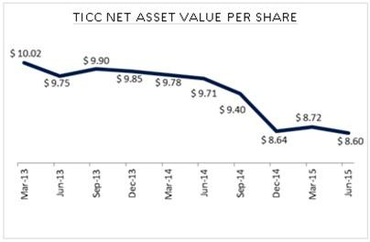

TICC Net Asset Value Per Share (Graphic: Business Wire)1

FACT 2: Five respected, independent equity analysts believe that TICC’s dividend is unsustainable. TICC does not address the concerns raised by these independent voices.

FACT 3: TICC re-issued a stockholder letter updating how it refers to its dividend to directly state the dividend is in part a return of investor capital. TICC decided to bury this statement in a footnote. Stockholders should be mindful of these disclosures and how they contradict TICC’s own narrative.

FACT 4: TSLX has been clear about its approach to its dividend policy and the long-term sustainability of such policy. TSLX has been clear that with TICC it believes it can grow the TSLX dividend. TICC has made no such similar statements about BSP’s ability to grow the TICC dividend over time.

- Net Asset Value Per Share includes effect of realized and unrealized gains Source: Public Filings

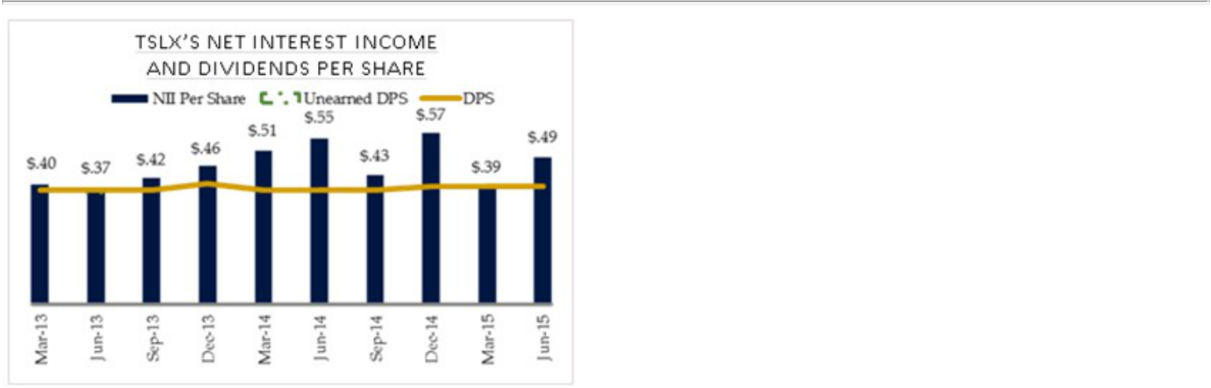

TSLX’s Net Interest Income and Dividends Per Share (Graphic: Business Wire)2

Josh Easterly, Chairman and Co-Chief Executive Officer of TSLX, commented: “TSLX has delivered a strong, clear and bona fide offer to give TICC’s stockholders, the true owners of the company, an upfront premium and an opportunity to enjoy the value-creation of a superior platform. We believe the facts are simple and stockholders will not be misled by complex and flawed arguments about CLO accounting and quarterly distributions. TICC’s past failed performance speaks for itself and we look forward to solidifying our support of TICC stockholders over the coming weeks.”

TSLX also reminds stockholders that TICC has still not directly answered four simple questions. Those questions are repeated below with a continued request for direct answers from TICC.

- Are management or interested board members of TICC receiving compensation, remuneration, or other payments related to the proposed change of control of the TICC external manager?

- As compared to other business development companies and asset classes, what results has management’s leadership produced for TICC stockholders in the past three years? What about since TICC’s initial public offering under this management team and board supervision?

- Why should the TICC external manager that oversaw massive underperformance now be paid a premium to leave? Why can’t the board simply replace the manager in a way that pays TICC stockholders instead? Who is the TICC board looking out for here?

- Is TICC’s dividend sustainable? Is TICC currently earning enough to deliver its dividend? Does TICC disagree with five respected independent analysts who believe the TICC dividend will be cut? While TICC has addressed the accounting of its dividend, it has explicitly avoided any comment about the sustainability of said policy.

About TPG Specialty Lending

TPG Specialty Lending, Inc. (“TSLX”, or the “Company”) is a specialty finance company focused on lending to middle-market companies. The Company seeks to generate current income primarily in U.S.-domiciled middle-market companies through direct originations of senior secured loans and, to a lesser extent, originations of mezzanine loans and investments in corporate bonds and equity securities. The Company has elected to be regulated as a business development company, or a BDC, under the Investment Company Act of 1940 and the rules and regulations promulgated thereunder. TSLX is externally managed by TSL Advisers, LLC, a Securities and Exchange Commission (“SEC”) registered investment adviser. TSLX leverages the deep investment, sector, and operating resources of TPG Special Situations Partners, the dedicated special situations and credit platform of TPG, with over $12 billion of assets under management, and the broader TPG platform, a global private investment firm with over $74 billion of assets under management. For more information, visit the Company’s website at www.tpgspecialtylending.com.

- TSLX Presentation; Source: Public Findings

Forward-Looking Statements

Information set forth herein includes forward-looking statements. These forward-looking statements include, but are not limited to, statements regarding TSLX proposed business combination transaction with TICC Capital Corp. (“TICC”) (including any financing required in connection with the proposed transaction and the benefits, results, effects and timing of a transaction), all statements regarding TPG Specialty Lending, Inc.’s (“TSLX”, or the “Company”) (and TSLX and TICC’s combined) expected future financial position, results of operations, cash flows, dividends, financing plans, business strategy, budgets, capital expenditures, competitive positions, growth opportunities, plans and objectives of management, and statements containing the words such as “anticipate,” “approximate,” “believe,” “plan,” “estimate,” “expect,” “project,” “could,” “would,” “should,” “will,” “intend,” “may,” “potential,” “upside,” and other similar expressions. Statements set forth herein concerning the business outlook or future economic performance, anticipated profitability, revenues, expenses, dividends or other financial items, and product or services line growth of TSLX (and the combined businesses of TSLX and TICC), together with other statements that are not historical facts, are forward-looking statements that are estimates reflecting the best judgment of TSLX based upon currently available information.

Such forward-looking statements are inherently uncertain, and stockholders and other potential investors must recognize that actual results may differ materially from TSLX’s expectations as a result of a variety of factors, including, without limitation, those discussed below. Such forward-looking statements are based upon management’s current expectations and include known and unknown risks, uncertainties and other factors, many of which TSLX is unable to predict or control, that may cause TSLX’s plans with respect to TICC, actual results or performance to differ materially from any plans, future results or performance expressed or implied by such forward-looking statements. These statements involve risks, uncertainties and other factors discussed below and detailed from time to time in TSLX’s filings with the Securities and Exchange Commission (“SEC”).

Risks and uncertainties related to the proposed transaction include, among others, uncertainty as to whether TSLX will further pursue, enter into or consummate the transaction on the terms set forth in the proposal or on other terms, potential adverse reactions or changes to business relationships resulting from the announcement or completion of the transaction, uncertainties as to the timing of the transaction, adverse effects on TSLX’s stock price resulting from the announcement or consummation of the transaction or any failure to complete the transaction, competitive responses to the announcement or consummation of the transaction, the risk that regulatory or other approvals and any financing required in connection with the consummation of the transaction are not obtained or are obtained subject to terms and conditions that are not anticipated, costs and difficulties related to the integration of TICC’s businesses and operations with TSLX’s businesses and operations, the inability to obtain, or delays in obtaining, cost savings and synergies from the transaction, unexpected costs, liabilities, charges or expenses resulting from the transaction, litigation relating to the transaction, the inability to retain key personnel, and any changes in general economic and/or industry specific conditions.

In addition to these factors, other factors that may affect TSLX’s plans, results or stock price are set forth in TSLX’s Annual Report on Form 10-K and in its reports on Forms 10-Q and 8-K.

Many of these factors are beyond TSLX’s control. TSLX cautions investors that any forward-looking statements made by TSLX are not guarantees of future performance. TSLX disclaims any obligation to update any such factors or to announce publicly the results of any revisions to any of the forward-looking statements to reflect future events or developments.

Third Party-Sourced Statements and Information

Certain statements and information included herein have been sourced from third parties. TSLX does not make any representations regarding the accuracy, completeness or timeliness of such third party statements or information. Except as expressly set forth herein, permission to cite such statements or information has neither been sought nor obtained from such third parties. Any such statements or information should not be viewed as an indication of support from such third parties for the views expressed herein. All information in this communication regarding TICC, including its businesses, operations and financial results, was obtained from public sources. While TSLX has no knowledge that any such information is inaccurate or incomplete, TSLX has not verified any of that information. TSLX reserves the right to change any of its opinions expressed herein at any time as it deems appropriate. TSLX disclaims any obligation to update the data, information or opinions contained herein.

Proxy Solicitation Information

The information set forth herein is provided for informational purposes only and does not constitute an offer to purchase or the solicitation of an offer to sell any securities. TSLX has filed with the SEC and mailed to TICC stockholders a definitive proxy statement and accompanying GOLD proxy card to be used to solicit votes at a special meeting of stockholders of TICC scheduled to be held on October 27, 2015 against (a) approval of the new advisory agreement between TICC and TICC Management, LLC (the “Adviser”), to take effect upon a change of control of the Adviser in connection with the entrance of the Adviser into a purchase agreement with an affiliate of Benefit Street Partners L.L.C. (“BSP”), pursuant to which BSP will acquire control of the Adviser,

- the election of six directors nominated by TICC’s board of directors, and (c) the proposal to adjourn the meeting if necessary or appropriate to solicit additional votes.

TSLX STRONGLY ADVISES ALL STOCKHOLDERS OF TICC TO READ THE TSLX PROXY STATEMENT AND ITS OTHER PROXY MATERIALS AS THEY BECOME AVAILABLE BECAUSE THEY CONTAIN IMPORTANT INFORMATION. SUCH TSLX PROXY MATERIALS ARE AND WILL BECOME AVAILABLE AT NO CHARGE ON THE SEC’S WEB SITE AT HTTP://WWW.SEC.GOV AND AT TSLX’S WEBSITE
AT HTTP://WWW.TPGSPECIALTYLENDING.COM. IN ADDITION, TSLX WILL PROVIDE COPIES OF THE PROXY STATEMENT WITHOUT CHARGE UPON REQUEST. REQUESTS FOR COPIES SHOULD BE DIRECTED TO TSLX’S PROXY SOLICITOR AT TPG@MACKENZIEPARTNERS.COM.

The participant in the solicitation is TSLX and certain of its directors and executive officers may also be deemed to be participants in the solicitation. As of the date hereof, TSLX directly beneficially owned 1,633,660 shares of common stock of TICC.

Security holders may obtain information regarding the names, affiliations and interests of TSLX’s directors and executive officers in TSLX’s Annual Report on Form 10-K for the year ended December 31, 2014, which was filed with the SEC on February 24, 2015, its proxy statement for the 2015 Annual Meeting, which was filed with the SEC on April 10, 2015, and certain of its Current Reports on Form 8-K. These documents can be obtained free of charge from the sources indicated above. Additional information regarding the interests of these participants in the proxy solicitation and a description of their direct and indirect interests, by security holdings or otherwise, will also be included in any proxy statement and other relevant materials to be filed with the SEC when they become available.

Contacts

Investors

TPG Specialty Lending

Robert Ollwerther, 212-430-4119

bollwerther@tpg.com

or

TPG Specialty Lending

Lucy Lu, 212-601-4753

llu@tpg.com

or

MacKenzie Partners, Inc.

Charlie Koons, 800-322-2885

tpg@mackenziepartners.com

or

TPG Specialty Lending

Media

Luke Barrett, 212-601-4752

lbarrett@tpg.com

or

Abernathy MacGregor

Tom Johnson or Pat Tucker

212-371-5999

tbj@abmac.com /pct@abmac.com

