UNITED STATES

SECURITIES AND EXCHANGE COMMISSION
Washington, D.C. 20549

FORM 8-K

CURRENT REPORT

Pursuant to Section 13 or 15(d)
of the Securities Exchange Act of 1934

Date of Report (Date of earliest event reported): March 26, 2020

TPG Specialty Lending, Inc.

(Exact name of registrant as specified in charter)

Delaware | 001-36364 | 27-3380000
(State or Other Jurisdiction | (Commission | (I.R.S. Employer
of Incorporation) | File Number) | Identification No.)
2100 McKinney Avenue, Suite 1500
Dallas, TX |  | 75201
(Address of Principal Executive Offices) |  | (zip code)

Registrant’s telephone number, including area code: (469) 621-3001

Check the appropriate box below if the Form 8-K filing is intended to simultaneously satisfy the filing obligation of the registrant under any of the following provisions:

- Written communications pursuant to Rule 425 under the Securities Act (17 CFR 230.425)

- Soliciting material pursuant to Rule 14a-12 under the Exchange Act (17 CFR 240.14a-12)

- Pre-commencement communications pursuant to Rule 14d-2(b) under the Exchange Act (17 CFR 240.14d-2(b))

- Pre-commencement communications pursuant to Rule 13e-4(c) under the Exchange Act (17 CFR 240.13e-4(c))

Securities registered pursuant to Section 12(b) of the Act:

Title of each class | Trading Symbol(s) | Name of each exchange on which registered
Common Stock, par value $0.01 per share | TSLX | The New York Stock Exchange

Indicate by check mark whether the registrant is an emerging growth company as defined in Rule 405 of the Securities Act of 1933 (§230.405 of this chapter) or Rule 12b-2 of the Securities Exchange Act of 1934 (§240.12b-2 of this chapter).

Emerging growth company ☐

If an emerging growth company, indicate by check mark if the registrant has elected not to use the extended transition period for complying with any new or revised financial accounting standards provided pursuant to Section 13(a) of the Exchange Act. ☐

Item 7.01 – Regulation FD Disclosure

On March 26, 2020, the registrant issued a press release, included herewith as Exhibit 99.1, and by this reference incorporated herein.

The information disclosed under this Item 7.01, including Exhibit 99.1 hereto, is being furnished and shall not be deemed “filed” for purposes of Section 18 of the Securities Exchange Act of 1934, and shall not be deemed incorporated by reference into any filing made under the Securities Act of 1933, except as expressly set forth by specific reference in such filing.

Item 9.01 – Financial Statements and Exhibits

- Exhibits:

Exhibit
Number |  |  | Description
99.1 | Press release, dated March 26, 2020

SIGNATURES

Pursuant to the requirements of the Securities Exchange Act of 1934, as amended, the Registrant has duly caused this report to be signed on its behalf by the undersigned hereunto duly authorized.

TPG SPECIALTY LENDING, INC.

(Registrant)

Date: March 26, 2020 By: /s/ Ian Simmonds

Ian Simmonds

Chief Financial Officer

Exhibit 99.1


TPG Specialty Lending, Inc. Provides an Update on its Funding Model, Rollforward of Key Balance Sheet Items, Valuation Framework and Liquidity

NEW YORK—(BUSINESS WIRE)—March 26, 2020— TPG Specialty Lending, Inc. (NYSE: TSLX, or the “Company”) today sent the following letter to its stakeholders to provide an update on its funding model, rollforward of key balance sheet items, valuation framework and liquidity.

March 26, 2020

Dear Stakeholder,

As uncertainty persists given the COVID-19 pandemic, we believe that we have a heightened responsibility to provide ongoing communication to the stakeholders of TSLX (which is externally managed by TSL Advisers, LLC, an affiliate of Sixth Street Partners). There are many “unknowns” around the impact of COVID-19, including the extent of permanent damage to the real economy, the full impact to our underlying portfolio companies (although we believe our portfolio has been positioned defensively leading up to current events), the direction of interest rates given significant fiscal stimulus and central bank intervention, and central to all these “unknowns”, how long the global economy will be in hibernation. It is with this context in mind that we wanted to provide an update on the following topics:

  - Our funding model (which we believe is clearly differentiated from other non-bank “finance companies”);

  - A summary roll-forward of our key balance sheet items;
  - The underlying valuation framework of our portfolio; and most importantly,
  - Our liquidity

- Funding Model

We believe it is important to emphasize the nature of our funding model and differentiate the right hand-side of our balance sheet from those of other vehicles in the non-bank lending sector, such as commercial and residential mortgage REITs. Important characteristics of our funding model to highlight include the following:

- Significantly Less Leverage – Our reported leverage (debt-to-equity) at December 31, 2019 was 1.0x, and our current estimated leverage is 0.89x (based on portfolio activity to-date and prior to the impact of valuation marks on our investments since 12/31/2019; our general valuation framework is discussed later on in this letter). As a point of comparison, reported leverage for residential mortgage REITs and commercial mortgage REITs were approximately 8.5x and 3.3x, respectively as of December 31, 2019.1
- Financial Flexibility – Approximately 67% of our current outstanding debt is unsecured in nature, which we believe provides significant financial flexibility during times of market volatility. This compares favorably to the investment grade-rated BDC space of approximately 45% as of December 31, 2019.2

- No Near-Term Maturities – We have no near-term debt maturities. Our earliest maturity is over 2.25 years away (August 2022). It should also be noted that this maturity obligation is

- Source: Capital IQ & S&P Global Market Intelligence.

2 Source: SNL.

relatively small at $172.5 million compared to our current liquidity position of approximately $1.0 billion (discussed later in this letter).

- No Use of “Repo” Like Financing – All of our financing is “term in nature”. As of December 31, 2019, the weighted average remaining life of our debt outstanding was approximately 4.6 years, which was approximately double the weighted average remaining life of our portfolio investments that are funded with this debt, which was approximately 2.4 years.3
- Significant Liquidity – The current balance drawn on our revolving credit facility is approximately $330 million, relative to our total facility size of $1.315 billion. In addition, as of February 29, 2020, the borrowing base based on stated advance rates against our portfolio was approximately $1.5 billion. Our current liquidity is therefore approximately $980 million on a total investment portfolio of $2.1 billion (prior to the impact of valuation marks on our investments since 12/31/2019). Our liquidity is specifically discussed later on in this letter.

Given these characteristics, we believe we have a highly durable funding model that is designed to support our business and protect our stakeholders across various market and economic environments.

2. Summary Rollforward of Key Balance Sheet Items (Estimated)

We wanted to provide a summary of our balance sheet adjusted for activity post quarter-end. Accordingly, below is our summary of certain balance sheet items as of December 31, 2019 adjusted through March 25, 2020 for quarter-to-date activity and prior to the impact of valuation marks on our investments since 12/31/2019. On the portfolio activity side, since December 31, 2019, we fully realized our $77.4 million par value first lien term loan for Curriculum Associates at a price of 103, our $75.8 million par value ABL FILO term loan for Sears at a blended price of 101.3, and our $15.9 million par value first lien term loan for AppStar Financial at par.
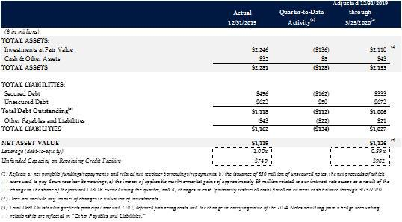

- Weighted by amortized cost of debt investments. This analysis assumes longer-dated investments are currently funded by permanent equity capital (46% of investments) and the remaining (shorter-dated) investments (54% of investments) are currently funded by debt financing. Investments for purposes of this analysis include unfunded commitments, and permanent equity capital is defined as 12/31/19 net assets.

2


3. Valuation Framework of Underlying Portfolio Investments

As we have discussed over the years, we believe that an intellectually honest framework for portfolio valuations is the bedrock to effective risk management. We believe it is important to listen to what the market is saying and incorporate those inputs into a rigorous decision-making framework. As an investor, you may take a contrarian view to the market view; however, we believe ignoring market inputs regarding risk, opportunities, and alternative uses of your capital can lead to poor decision making.

As we approach quarter-end valuations, we wanted to provide a detailed framework of our approach (which is consistent with our approach since inception).

- Market Spreads – We incorporate movements in market spreads each quarter into the discount rates applied in valuing our underlying investment, adjusting for individual sectors and industries. For example, 68% of our portfolio at fair value as of December 31, 2019 were software/software-related—a sector which has had significantly less spread widening in 2020 vs. other sectors. Further, LCD credit spreads for single B software loans have widened approximately 450 basis points since year-end 2019, while single B spreads in more cyclical industries, such as hospitality and leisure have widened approximately 850 basis points during this period.4

- Adjusting Market Spreads for Existence of LIBOR Floors – We make a further adjustment to market spreads (as discussed above) to reflect the impact of the LIBOR floors across our debt portfolio, which is meaningfully higher than the LIBOR floors in the broadly syndicated loan markets. The average LIBOR floor across our debt portfolio is currently 1.1%, compared to a LIBOR floor of approximately 0.35% for the broadly syndicated loan markets.5 As such, our portfolio will not require the same magnitude of the market spread adjustment compared to the broadly syndicated market, as these floors allow us to mitigate (to a degree) the impact of such spread widening on the valuation of our investments.
- Weighted Average Life – Generally speaking, the weighted average life of our portfolio is much shorter than the broadly syndicated loan market. This is a function of the following characteristics: (1) our portfolio’s shorter weighted average remaining contractual life of 3.2 years as of today, compared to 4.9 years for the broadly syndicated market as of February 29, 2020 according to LCD; (2) the existence of approximately two financial covenants (or borrowing base constraints for asset-based loans) per loan agreement across our portfolio at December 31, 2019, compared to the prevalence of “covenant-lite” loans in the broadly syndicated market, which comprises over 80% of loans in the broadly syndicated market6; and (3) limited ability of our portfolio companies to incur additional debt and make restricted payments (i.e. limited flexibility for issuers to engage in “liability management transactions,” which keeps our debt outstanding without significant modifications), and other idiosyncratic events specific to the issuer what would change our view of the effective life of the investment.

To provide a hypothetical example of the application of our valuation framework described above, let us compare two issuers with the same credit profile (i.e. identical assessment of credit risk and same stated credit spread) in an environment where market spreads for the issuers’ sector have widened 500 basis points and LIBOR is 50 basis points and flat along the curve across the expected maturity for both issuers:

- Source: LCD LII Discounted Spreads, as of March 25, 2020.

5 Source: LCD, data as of February 28, 2020.

6 Source: LCD S&P/LSTA Leveraged Loan Index, as of February 28, 2020.

3

- Issuer A has one year until its expected debt maturity (either contractually or effectively through other circumstances), with a LIBOR floor of 1.5%; and

- Issuer B has seven years until its expected maturity (and significant contractual flexibility to conduct liability management trades), with a LIBOR floor of zero and limited to no real financial covenants (i.e. a “covenant lite” borrower).

Based on these terms, assuming a flat credit curve and no deterioration in issuers’ ability to repay their principal, the trading price of Issuer A and Issuer B’s debt securities would differ meaningfully. Issuer A would trade in the context of approximately 96.5, reflecting a spread widening of 350 basis points after adjusting for the benefit of its 1.5% LIBOR floor over a 1-year life. Issuer B would trade in the context of approximately 65.0, reflecting the spread widening of 500 basis points across its 7-year expected life to maturity.

In summary, we incorporate “market spreads” into the quarterly valuation of our investments, adjusting for the existence of LIBOR floors, expected weighted average life, and other idiosyncratic factors specific to each investment (including issuer-specific credit marks related to idiosyncratic issues, such as outperformance / underperformance). We believe it is fundamental to our risk management framework to “mark” our book as discussed above. The ultimate question that needs to be answered is: what value would you be able to realize in the sale of that security in today’s market? In any event, as we have seen through the historical price-to-book trends in our sector, if a market participant doesn’t mark their book, the “market” itself will do so.

With this valuation framework in mind, we have provided below a sensitivity table illustrating the estimated impact of different spread widening and duration assumptions our portfolio valuations and therefore, our balance sheet leverage. This analysis is based on the rollforward of certain balance sheet items for quarter-to-date activity described in the table above. Based on this analysis, we believe we are well positioned with a significant buffer against our regulatory leverage limit (2.0x debt-to-equity) taking into account anticipated potential valuation marks.
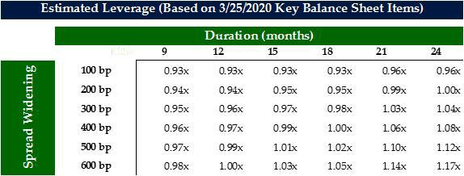

4

4. Liquidity

The following table presents a summary of our current liquidity at December 31, 2019, adjusted through March 25, 2020 for quarter-to-date activity, including changes to unfunded commitments as described below.
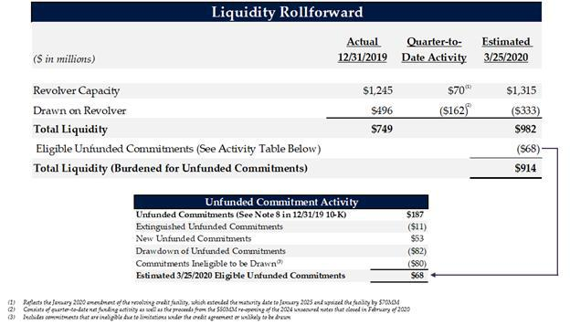

As previously discussed, our earliest debt maturity is over 2.25 years from today, with our next scheduled maturity date not until August 2022.
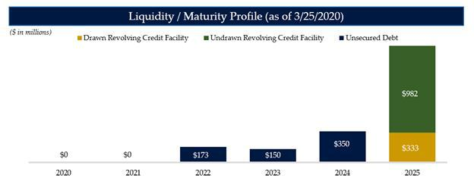

From a liquidity perspective, we currently have in excess of $980 million of undrawn capacity on our revolving credit facility (and we expect that to grow to approximately $1 billion in the near-term based on

5

current expectations for upcoming net investment activity) against only $68 million of estimated unfunded commitments currently available to be drawn based on contractual requirements in the underlying loan agreements. We currently have meaningful cushions to all applicable financial covenant thresholds under our revolving credit facility (including our 150% asset coverage ratio), and as a result, expect to continue to be able to access our available revolver capacity.

Some Final Thoughts

We understand that these are exceptionally challenging times for you and your families, and our thoughts are with you and our communities.

At Sixth Street Partners, our guiding principle continues to be our people and our shareholders/clients first. We are relentlessly focused on protecting both groups, and we will continue to dedicate our collective human and intellectual capital to serve these two masters.

As we have shared in this letter, we have a clear understanding of our current balance sheet, capital and liquidity positions – all of which we roll forward on a daily basis as part of our overall risk management discipline. In addition to being well capitalized and with significant liquidity, we believe we have the right framework to measure and deploy our capital and liquidity to best serve our shareholders’ capital at the appropriate time.

Sincerely,


Joshua Easterly

Chief Executive Officer and Chairman of the Board, TSLX
Partner, Sixth Street Partners

6

About TPG Specialty Lending

TSLX is a specialty finance company focused on lending to middle-market companies. The Company seeks to generate current income primarily in U.S.-domiciled middle-market companies through direct originations of senior secured loans and, to a lesser extent, originations of mezzanine loans and investments in corporate bonds and equity securities. The Company has elected to be regulated as a business development company, or a BDC, under the Investment Company Act of 1940 and the rules and regulations promulgated thereunder. TSLX is externally managed by TSL Advisers, LLC, an affiliate of Sixth Street Partners and a Securities and Exchange Commission (“SEC”) registered investment adviser. TSLX leverages the deep investment, sector, and operating resources of Sixth Street Partners, a global finance and investment firm with over $34 billion of assets under management as of December 31, 2019. For more information, visit the Company’s website at www.tpgspecialtylending.com.

About Sixth Street Partners

Sixth Street Partners is a global multi-asset class investment business with over $34 billion in assets under management as of December 31, 2019. Sixth Street operates eight diversified, collaborative investment platforms across our growth investing, direct lending, par liquid credit, fundamental public strategies, infrastructure, agriculture, special situations and adjacencies businesses. Our long-term oriented, highly flexible capital base and “One Team” cultural philosophy allows us to invest thematically across sectors, geographies and asset classes. Founded in 2009, Sixth Street has more than 275 team members including over 140 investment professionals operating from nine locations around the world. For more information, visit www.tssp.com.

Forward-Looking Statements

Statements included herein may constitute “forward-looking statements,” which relate to future events or the Company’s future performance or financial condition, including our future operating results and liquidity position, the impact of COVID-19 and related changes in base interest rates and market volatility on our business, our portfolio companies, our industry and the global economy. These statements are not guarantees of future performance, conditions or results and involve a number of risks and uncertainties. Actual results may differ materially from those in the forward-looking statements as a result of a number of factors, including those described from time to time in the Company’s filings with the Securities and Exchange Commission. The Company assumes no obligation to update any such forward-looking statements.

Investors:

Lucy Lu, 212–601-4753

IRTSL@tpg.com

Media:

Patrick Clifford, 617-793-2004

PClifford@tssp.com

7

