UNITED STATES

SECURITIES AND EXCHANGE COMMISSION
Washington, D.C. 20549

FORM 8-K

CURRENT REPORT

Pursuant to Section 13 or 15(d)
of the Securities Exchange Act of 1934

Date of Report (Date of earliest event reported): August 2, 2022

Sixth Street Specialty Lending, Inc.

(Exact name of registrant as specified in charter)

Delaware | 001-36364 | 27-3380000
(State or Other Jurisdiction | (Commission | (I.R.S. Employer
of Incorporation) | File Number) | Identification No.)
2100 McKinney Avenue, Suite 1500
Dallas, TX |  | 75201
(Address of Principal Executive Offices) |  | (zip code)

Registrant’s telephone number, including area code: (469) 621-3001

Check the appropriate box below if the Form 8-K filing is intended to simultaneously satisfy the filing obligation of the registrant under any of the following provisions:

- Written communications pursuant to Rule 425 under the Securities Act (17 CFR 230.425)

- Soliciting material pursuant to Rule 14a-12 under the Exchange Act (17 CFR 240.14a-12)

- Pre-commencement communications pursuant to Rule 14d-2(b) under the Exchange Act (17 CFR 240.14d-2(b))

- Pre-commencement communications pursuant to Rule 13e-4(c) under the Exchange Act (17 CFR 240.13e-4(c))

Securities registered pursuant to Section 12(b) of the Act:

Title of each class |  | Trading |  | Name of each exchange
 |  | Symbol(s) |  | on which registered
Common Stock, par value $0.01 per share |  | TSLX |  | The New York Stock Exchange

Indicate by check mark whether the registrant is an emerging growth company as defined in Rule 405 of the Securities Act of 1933 (§230.405 of this chapter) or Rule 12b-2 of the Securities Exchange Act of 1934 (§240.12b-2 of this chapter).

Emerging growth company ☐

If an emerging growth company, indicate by check mark if the registrant has elected not to use the extended transition period for complying with any new or revised financial accounting standards provided pursuant to Section 13(a) of the Exchange Act. ☐

Item 7.01 – Regulation FD Disclosure

On August 2, 2022, the registrant issued a press release, included herewith as Exhibit 99.1, and by this reference incorporated herein.

The information disclosed under this Item 7.01, including Exhibit 99.1 hereto, is being furnished and shall not be deemed “filed” for purposes of Section 18 of the Securities Exchange Act of 1934, and shall not be deemed incorporated by reference into any filing made under the Securities Act of 1933, except as expressly set forth by specific reference in such filing.

Item 9.01 – Financial Statements and Exhibits

- Exhibits

Exhibit

Number Description

99.1 Press release, dated August 2, 2022

SIGNATURES

Pursuant to the requirements of the Securities Exchange Act of 1934, the registrant has duly caused this report to be signed on its behalf by the undersigned hereunto duly authorized.

SIXTH STREET SPECIALTY LENDING, INC.

(Registrant)

Date: August 2, 2022 By: /s/ Ian Simmonds

Ian Simmonds

Chief Financial Officer

Exhibit 99.1


August 2, 2022

Dear Stakeholder,

As part of our commitment to providing relevant and timely information on our business and financial results, and in conjunction with the earnings release for the quarter ended June 30, 2022, published today, we wanted to share our observations relating to the investment environment, the private credit asset class, and how we have positioned Sixth Street Specialty Lending, Inc. (“TSLX”).

For long time followers of TSLX, you will be familiar with our approach to sharing information and our perspectives. Our proactive communication during the heightened uncertainty of the COVID-19 pandemic period reinforced our belief that transparency is critical and serves as the foundation for our relationship with our stakeholders and strengthens our ability to best serve all our clients, including issuers and financial sponsors.

Today’s Investment Environment and Yesterday’s Underwriting Standards

The “macro” currently feels like even more of a factor in today’s investment decisions than usual and appears to swamp the idiosyncratic. Estimates of forward inflation and the terminal federal funds rate have been evolving and changing rapidly, making even idiosyncratic investment decisions more complicated across asset classes (especially asset classes with long dated or back-end weighted cash flows).

With the benefit of hindsight, the monetary and fiscal stimulus response to COVID stoked an asset bubble driven by ‘free money’. Without casting aspersions on policymakers, to paraphrase a good friend of the firm, Goldman Sachs’ Chief Economist Jan Hatzius, policymakers often fight the last war (Jan was referring to the policy response to the Global Financial Crisis).

It is clear to us that negative real rates have distorted the investment environment and investor behavior. This has been particularly true for long-duration assets such as equities and long-dated securities, as noted above. For example, year-to-date total returns¹ for bio-tech companies², the technology sector³ and 30-year treasuries⁴ are down 27.5%, 16.7% and 21.2%, respectively. If you believe every asset class should reflect a premium to the risk-free rate, a long period of zero real rates compressed risk premia to the point that pricing was highly sensitive to a both a change in the risk premia and the outlook for the risk-free rate. The higher inflation rate experienced in 2022 has provided the catalyst to unravel much of this bubble in prices.

- Year-to-date total returns through July 29, 2022.
- Source: Bloomberg, SPDR S&P Biotech ETF.
- Source: Bloomberg, Technology Select Sector SPDR Fund.

- Source: Bloomberg, S&P U.S. Treasury Bond Current 30-Year Total Return Index. 1

On the surface, private credit should be relatively insulated given its floating rate nature and the relatively short duration inherent in typical contracts and borrower behavior. Private credit has typically framed underwriting decisions in the context of Loan-to-Value (“LTV”). The “Value” in LTV, or more specifically enterprise value, has been artificially high given the low rate-induced asset bubble. In short-hand corporate finance terms, Value (i.e., enterprise value) in this context we believe is a function of three factors:

- Discount rate applied to cash flows;

- Growth in cash flows; and

- Durability of said cash flows

We believe that two, and possibly all three, of these factors have some connection to interest rates, which are determined in large part by inflation. The most obvious connection to interest rates is the discount rate, because of the direct and strong correlation between the two. The correlation is not one-to-one, however, as the risk premium plays a role and is not static. Growth in cash flows also has a connection to the prevailing interest rate environment. When discount rates (the combination of the risk-free rate and a risk premium) are low, investment decisions (e.g., in sales and marketing to capture new customers, or growth capital expenditure) that are fundamental in driving growth in revenue and cash flows, are set at a relatively low bar. The opposite is true when discount rates are higher, as investment decisions become harder as the economic hurdles get higher.

Given the free money environment of yesterday, it seems likely, if not a foregone conclusion, that there were many investment decisions and businesses (that we believe we have successfully stayed away from investing in and financing) that were allocating capital in unproductive ways. Some of this has already come to light and we expect more in the future.

The final determining factor in value is cash flow durability, which may have a lower correlation to the then-prevailing rate environment. However, we do not think this correlation is zero. As the economy evolves and risk is re-priced, we expect an issuer’s customers will make different decisions that will indeed feed through how durable those cash flows remain (e.g., churn may increase, or customers may purchase less of a product or service).

2

Environments like the one we are in today are stark reminders that “value” behaves in the same fashion as leverage; small changes in assumptions across several vectors have large impacts.

We have worked diligently to keep our underwriting standards consistent through the cycle while focusing on what downside cases might look

like. Although, at this moment, we feel pretty good about the impact this approach has generated, time will tell if we were successful. We have focused on framing our notion of Value based on a normalized rate environment. In addition, our underwriting model centered around our assumed more normalized growth case that we believe mitigated the effects of the ‘free money’ environment. We also focused on issuers with defensive business models, namely those with recurring revenue, variable cost structures, high switching costs and products or services that were mission critical.

One last thought on the current investment environment. There is NO broad-based free lunch for the BDC sector’s returns on equity based simply on higher rates. A possible recession and a continued inflationary environment will be very difficult for many (but not all) issuers to manage. Simply put, less demand for products or services, higher non-interest costs plus higher interest costs will, in our view, likely lead to additional credit costs for the sector. As a reminder, at the end of the day, investors in the sector can only “eat” net investment income less realized credit costs, regardless of the dividend payout, as underwriting quality will eventually show itself in net asset value (although this might not necessarily be reflected today, as we will discuss below).

So as an investor in the space, “what really matters?” In short, although we started with the notion that, for the moment, “the macro swamps the idiosyncratic”, we believe the “idiosyncratic” will ultimately be the determining factor for success, with success defined as durable return on equity for our shareholders. We believe investors should focus on a few specific vectors in this vein: 1) Current Portfolio Positioning (also known as Underwriting Standards), 2) Balance Sheet Flexibility (i.e., Capital and Liquidity), 3) Capital Allocation (remember, it is your capital); and 4) Team and Platform (“ability to execute”). We will briefly discuss each vector below, but before we do that, we will hit “valuation” as it seems to us this is key to so much, especially capital allocation. In short, we think this environment is uniquely tricky, but also provides an incredible opportunity for those in the sector who are positioned thoughtfully.

It All Starts with Valuation

Valuation is a “must have” competency of any investing business. It is key to any underwriting decision (specifically as it relates to private credit, it allows one to understand “LTV” and creating “par” securities), asset management, risk management, and capital allocation.

3

As we have stated before, we believe it is important to listen to what the market is saying and incorporate those inputs into a rigorous decision-making framework. What is the market telling us? During the quarter ended June 30, 2022, high yield loans, leveraged loans and the S&P 500 generated total returns of negative 9.8%, 4.5% and 16.1%⁵, respectively, reflecting downward pressure on a broad range of asset classes. With the broad-based widening of “risk premiums”, it is the clear the market is signaling trouble ahead, including among other things, the probability of increased losses from defaults. To be even more specific, the S&P BDC index generated a total return of negative 14% for the quarter ending June 30, 2022. Although our portfolio companies still have strong performance (measured by earnings, cash flow, revenue growth, etc.), credit spread widening (and increased cost of equity for the sector) is clearly signaling the price for credit should increase.

Before diving into the specifics of our valuation process, let us take a second and expand on why “marking your book” is a cornerstone for shareholder value creation (and is accordingly required by GAAP and law). A number of examples are below:

- How would you otherwise know the appropriate return required to extend new credit (and therefore create a new “par security” and efficiently use your shareholders’ capital)?

- How can you otherwise have a thoughtful capital allocation framework, e.g.,

  - Investing in a new loan vs. buying back stock. The lack of marking one’s book along with managers’ economic incentives may be why the sector rarely buys back stock.

  - What security to buy or create. As an example, top of mind for us this quarter, we were able to buy BBB and BB CLO securities that have significant loss-taking ability through subordination at much wider spreads. This is an unusual circumstance, as private loans typically provide a 400+ basis point and 200+ basis point premium to such securities, respectively, while this quarter the spread premium was flat to negative 300 basis points, respectively.

- Market Credibility – simply put, if you don’t correctly mark your book, we believe the market is highly efficient at doing so. And the market’s voice is loud! With the BDC sector having returned negative 14% for the quarter, the market has already spoken and priced in declines in net asset value.

- Source: Bloomberg US Corporate High Yield Total Return Index, S&P/LSTA Leverage Loans Index, S&P 500 Total Return Index. 4

Forgive us, we are going to get further into the weeds for a moment. Ultimately, the goal of our valuation process is to use tools that allow us to determine “the price that would be received to sell an asset or paid to transfer a liability in an orderly transaction between market participants at the measurement date.”⁶ The starting point within our quarterly valuation framework focuses on incorporating market credit spread movements for the period into the determination of discount rates applied to projected cash flows. As previously stated, the movement in LCD 1st lien and 2nd lien spreads during Q2 2022, which widened by 123 basis points and 206 basis points, respectively, is therefore incorporated into the valuation assessment of our debt investments. Additional inputs are also considered including sector adjustments and other borrower-specific factors such as over- or underperformance.

On average, this resulted in a spread movement of approximately 115 basis points being applied to our debt investments at quarter end June 30, 2022. The shorter weighted average life in our investments relative to that of the broadly syndicated loan market composition further impacts how this spread movement impacted fair value. These components of our valuation framework resulted in approximately $0.66 per share of unrealized losses when applied to our portfolio during Q2 2022, with $0.40 per share from the impact of market spread movement in isolation, and a further $0.26 per share primarily from the movement in equity valuations on our equity positions. On a dollar price basis, this resulted in quarter-on-quarter movement in the price of our portfolio declining from 99.5% at the end of Q1 2022, to 97.9% at the end of Q2 2022. We have followed this framework for valuation since inception and believe it allows us to make sound investment and risk management decisions based on the market signals and information available to us. We are happy to talk about this topic at length.

We have presented the movement in our net asset value per share for Q2 2022 below to highlight the impact from valuation under our framework.
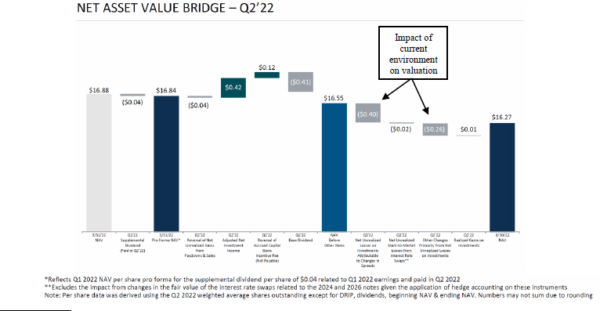

- Accounting Standards Codification (ASC) Topic 820 definition of “fair value”. 5

We expect that if our underwriting was sound, this quarter’s unrealized losses related to credit spread widening for the most part should unwind as the underlying credits mature. As it relates to our marks on our equity positions, they should also unwind (to an extent less known and more difficult to quantify), as today’s marks reflect an investor’s expectation to earn a return on a go-forward basis.

What really matters? (A Framework for Durable Return on Equity/Shareholder Value Creation)

As we discussed in our July 23, 2020, stakeholder letter, pure credit assets are by nature fragile. While there are a number of reasons for this, it is primarily a function of two factors: (i) pure credit (i.e., loans) assets are callable (the “gardening the weeds paradox,” where one’s good investments are called away, and you are left with your bad investments, the weeds), and (ii) they are short volatility and uncertainty (i.e., during periods of uncertainty, credit spreads tend to widen and lower the value of these assets and the prospect for losses on capital increases). For my partners and me, who are all long-term stakeholders and managers in TSLX, this fragility seems outright undesirable. Complicating this further is the typical BDC model where managers have to be long-only investors and fully invested to meet a dividend that the market expects. This is even further complicated by the promises and perils of financial leverage, a mark-to-market valuation framework, and regulatory requirements (which include the inability to retain meaningful capital and limitations on the incurrence of debt), to name a few.

Our stated goal is not to survive volatility and uncertainty, but to grow and create value (this concept is best described as anti-fragility by Nassim Nicholas Taleb⁷). We think we accomplished this during the “COVID years (2020-2021)” where we generated a total cumulative shareholder return of approximately 36%⁸ vs. our BDC peers cumulative total shareholder return of approximately 20%⁹ over that same period, an outperformance of 80%.

Current Portfolio Positioning

Thoughtful portfolio positioning serves two masters: 1) it allows you to avoid losses (efficiently use your shareholders’ capital) and 2) it allows you to dedicate your resources, both human and capital, to invest in moments of uncertainty to support your issuers and sponsor clients and to drive returns. We have long operated with a late-cycle mindset. Specifically, we have been primarily focused on investing at the top of the capital structure in businesses with limited commodity and cyclical exposure. Since our IPO in Q1 2014 to June 30, 2022, we have increased the first lien composition of our

- “Antifragility is beyond resilience or robustness. The resilient resists shocks and stays the same; the antifragile gets better.” Antifragile: Things

- Represents calendar year 2020 and 2021 return on equity (based on adjusted net income, excluding accrued capital gains incentive fees).
- BDC peers consist of 19 externally managed BDCs in the S&P BDC Index with total assets greater than $750 million measured as of 6/30/21.

6

portfolio from 82.8% to 91.5% of the portfolio on a cost basis. We think it is prudent to think about the world on a cost basis, as our only choice is how we proactively allocate your capital (exits are often not in our control). Over this period, we also decreased the cyclical exposure in our portfolio from 19.0% to 2.9% of the portfolio on a cost basis.¹⁰ There is a positive selection bias when you look at our portfolio on a fair value basis, as our equity investments have made money (and by their nature can have significant value above their cost basis).¹¹
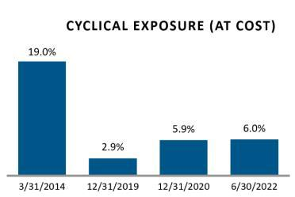

As of June 30, 2022, the overall performance of our portfolio continues to be solid, with approximately 98.2% of our portfolio rated 1 or 2 on a performance rating scale of 1 to 5, with 1 being the strongest. We continue to have minimal names on non-accrual, less than 0.01%, or 10 basis points, of the portfolio at fair value, which represents no change from the prior quarter. In short, we have yet to see any material changes in the underlying fundamentals of our portfolio. Again, time will tell, but we believe the portfolio is well-positioned given (a) our long-term focus on a defensive portfolio construction (including sector, business model and management team selection), with limited exposure of our portfolio on a fair value basis to cyclical industries at only 6.0%, and (b) our positioning primarily at the top of the capital structure as a way to provide downside protection to our committed capital.

- Cyclical exposure includes certain portfolio companies in the following industries: automotive; beverage, food and tobacco, capital equipment, construction and building; containers and packaging; hotel, gaming and leisure; manufacturing; metals and mining, which TSLX believes are subject to business cycle volatility. Excludes energy-related portfolio companies and asset-backed loan portfolio companies.

- As of June 30, 2022, TSLX equity positions as measured by fair value, divided by cost represented a multiple of money of 1.21x.

7

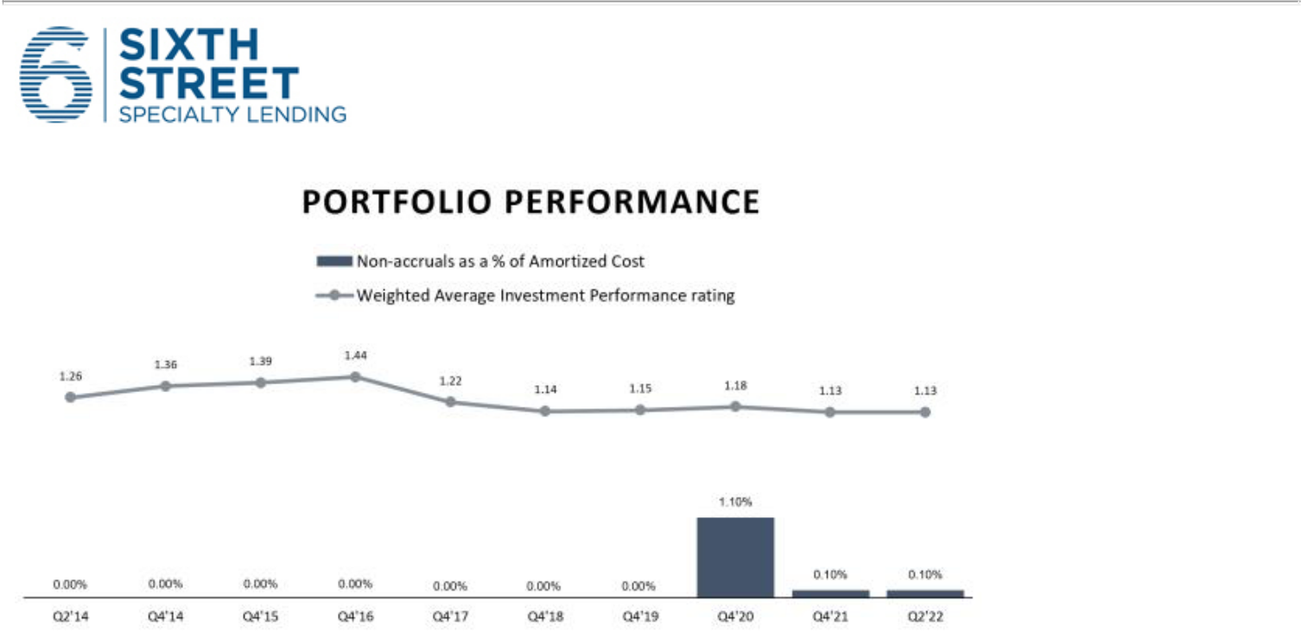

Balance Sheet Flexibility (Capital and Liquidity)

Distinct from liquidity, below is our framework on how we think about your capital. As industry observers know, the regulatory rules provide for a minimum capital requirement (expressed as 150% asset coverage or maximum 2:1 debt-to-equity). The consequences of breaching these rules are severe. In addition to the regulatory constraints, there are other considerations including rating agency criteria and contractual obligations under one’s financing agreements. We operate, and think it is prudent to do so, with more capital than the minimum required by regulations, rating agencies’ investment grade ratings criteria, and the BDC space in general. For example, we held approximately 52% capital to total assets vs. the sector at 45% (using data as of March 31, 2022)¹².

How much capital do we think is required for our business? We think about the amount of capital required through three different lenses. First, “Loss Absorption”, the ability to withstand both realized and as important, unrealized losses. Secondly, capital to support “unfunded commitments” including undrawn revolvers and delayed draw term loans. And lastly, we believe it is prudent to hold capital for “new investment opportunities”. The challenge with our business model, just as it is for our clients (i.e., financial sponsors) is that the best time to invest your capital—and when our management teams and financial sponsor clients are most appreciative of our support—is highly correlated to the moment of time when capital is scarce (i.e., the sector is trading below book value, the fundraising environment is more difficult, etc.). This is exactly what we did during COVID, providing much needed capital to our clients when they needed it the most!

- Source: Company filings: Data as of June 30, 2022, is not yet available across the sector. 8

On August 1, 2022, the remaining principal amount of our 2022 Unsecured Convertible Notes matured and those that converted were settled through a combination of newly issued common stock and cash in accordance with the settlement method that we elected earlier this year. This resulted in the issuance of 4.36 million shares resulting in estimated accretion to our net asset value of approximately $0.08 per share, which will be reflected in our Q3 financial results.

As a result of this conversion, our capital position has been enhanced post-quarter end through a de-leveraging of our balance sheet, creating additional capacity for our investing activities in support of our clients. Pro forma for the settlement of these convertible notes, and inclusive of the impact of net fundings and the tightening of market credit spreads experienced quarter to date, we estimate our current leverage ratio is 1.04x. On a relative basis, we think we are positioned uniquely with more capital to support our clients, grow our balance sheet and enhance our return on equity.
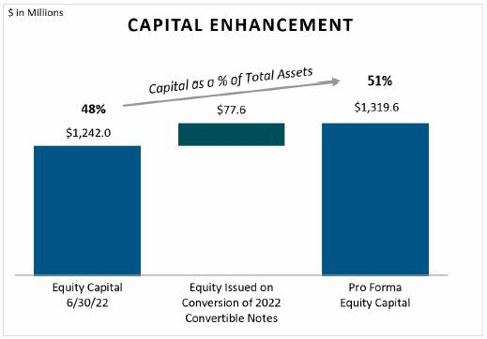

Liquidity and capital should not be conflated. Liquidity is a distinct need; we reserve liquidity and capital in reference to our “unfunded commitments” (which we fully reserve) and “new investment opportunities”. In addition to the above needs, we also reserve liquidity to support our dividend (as we believe it is a liability to the business) and any future near-term maturity of the business (for example, given the uncertainty we had reserved liquidity to settle our 2022 convertible notes). Cash flow from operations should generally support the dividend, but there may be slight timing differences that require external financing. This perspective has informed our policy of extending the maturity of our revolving credit facility on an annual basis, and funding ourselves in the unsecured market (vs. other markets such as via collateralized loan obligations where an issuer can risk losing access to the net interest spread in the portfolio as source of cash/liquidity when markets are highly stressed or correlated, i.e., “cash trapping”). Lastly, we reserve liquidity (and “capital” if it is a repurchase of our own stock) to make investments in our own capital structure.

9

Liquidity As of June 30, 2022

Revolving Credit Facility |  |  |  |  | Unfunded Commitment Activity
Revolver Capacity |  | $ 1,585 |  |  | Unfunded Commitments (See Note 8 in 3/31/22 10-Q) |  |  | $ | 314
Drawn on Revolver |  | ($ | 422) |  | Extinguished Unfunded Commitments |  |  | ($ | 25)
Unrestricted Cash Balance |  | $ | 6 |  | New Unfunded Commitments |  |  | $ | 82
Total Liquidity (Pre-Unfunded Commitments) |  | $ 1,169 |  |  | Net Drawdown of Unfunded Commitments |  |  | ($ | 50)
Available Unfunded Commitments¹ |  | ($ | 155) |  | Total Unfunded Commitments |  |  | $ | 321
Total Liquidity (Burdened for Unfunded |  |  |  |  | Unavailable Unfunded Commitments¹ |  |  | ($ | 166)
Commitments) |  | $ 1,014 |  |  | Available Unfunded Commitments¹ |  |  | $ | 155

- Commitments may be subject to limitations on borrowings set forth in the agreements between the Company and the applicable portfolio company. As a result, portfolio companies may not be eligible to borrow the full commitment amount on such date.
Note: May not sum due to rounding.

Since before the pandemic, we have intentionally held capital and liquidity that is at the top end of our peer set.¹³ We include this “insurance” when we think about our cost of capital and required returns on the asset side of our balance sheet. We believe a significant amount of TSLX’s historical outperformance of the sector is directly attributable to our capital and liquidity positions (and our willingness to “pay for insurance”).

Capital Allocation

We believe the first building block of a capital allocation model must be a sound and thoughtful valuation framework and policy (and most importantly execution of said framework and policy). For brevity’s sake (as you can tell that is not our strong suit), we will ignore capital allocation regarding investment decisions on the asset side of the balance sheet. To be clear, those investment decisions are extremely meaningful to shareholder experience (i.e., the presence or absence of credit losses has an outsized impact on returns for companies in the sector). We will focus our attention to other capital allocation decisions, with a particular focus on repurchasing our stock or other securities in our capital structure. We also have published extensive materials related to stock issuances that can be found on the Investor Resources section of our website¹⁴.

TSLX has had a stock repurchase program at below NAV per share or better (currently at below 1.05x of NAV per share, or $17.08) since our IPO in

March of 2014. Our capital allocation philosophy has benefited our shareholders to date by:

- Signaling to our fellow shareholders that we believe our current “marks” present a good investment opportunity (the devil, your existing assets that you have lived with, you know, and if marked appropriately, are more attractive than the devil you don’t); and

- Source: Company filings.

- See “Expanding Tools for Value Creation and Financial Flexibility”, May 3, 2022; Q1 2022 Equity Investor Presentation (page 14).

10

- Share repurchases are accretive (1) to Net Asset Value (and total returns to shareholders as measured by dividends plus or minus change in NAV per share) and (2) on a return on equity basis (as your denominator is reduced over the same earning asset base).

We intend to continue to manage your capital in a manner that is in your best interests by making what we believe are appropriate capital allocation decisions. We have often pondered why the space has not repurchased more stock given its historical discount to net asset value (including at this moment). We have only come up with two possible reasons: 1) management teams do not believe their own net asset value numbers or the 2) the economic incentives of the industry provide strong reasons not to reduce the balance sheet by reducing capital (and therefore, management fees).

It’s simple for us. We believe that if we mark our book to fair value and allocate capital in the best interest of our shareholders, the market will provide us capital to support additional investments (this goes both from providers of equity and debt capital).

Team, Platform and Culture

Principles and frameworks are one thing, but without the team and culture to execute, they are simply words on paper. We believe we have demonstrated, based on any measure of performance (e.g., credit losses, NAV stability/growth, Return on Equity), that we have delivered. As you know, Sixth Street has more than $60 billion under management with dedicated resources across sectors and solutions. Sixth Street is built for cross-platform collaboration at scale and this collaboration is reinforced by our culture. One of our biggest advantages in the direct lending business is our ability to marshal resources (including sourcing and sector expertise) from across our firm together with consistent investment acumen. This allows us to effectively partner with financial sponsors and issuers, large and small, in any sector. We believe we have shown the power of our platform to shareholders historically and will be able to provide significant benefits during these uncertain times that are sure to bring opportunity.

11

Concluding Thoughts

Although the macro environment and uncertainty can seem possibly overwhelming, we believe at the end of day it’s all about the idiosyncratic:

- current portfolio positioning, (2) balance sheet flexibility, (3) capital allocation and (4) team, platform and culture. We believe we continue to have substantial investment capacity and flexibility, which will allow us to create value for our stakeholders and serve our portfolio companies, management teams and financial sponsor partners with creative financing solutions.

On behalf of the TSLX and Sixth Street teams,

Sincerely,

Joshua Easterly

Chief Executive Officer and Chairman of the Board, Sixth Street Specialty Lending, Inc.

Partner, Co-Founder and Co-President, Sixth Street

12

About Sixth Street Specialty Lending

Sixth Street Specialty Lending is a specialty finance company focused on lending to middle-market companies. TSLX seeks to generate current income primarily in U.S.-domiciled middle-market companies through direct originations of senior secured loans and, to a lesser extent, originations of mezzanine loans and investments in corporate bonds and equity securities. TSLX has elected to be regulated as a business development company, or a BDC, under the Investment Company Act of 1940 and the rules and regulations promulgated thereunder. TSLX is externally managed by Sixth Street Specialty Lending Advisers, LLC, an affiliate of Sixth Street and a Securities and Exchange Commission (“SEC”) registered investment adviser. TSLX leverages the deep investment, sector, and operating resources of Sixth Street, a global investment firm with over $60 billion in assets under management and committed capital. For more information, visit TSLX’s website at https://sixthstreetspecialtylending.com.

About Sixth Street

Sixth Street is a global investment firm with over $60 billion in assets under management and committed capital. The firm uses its long-term flexible capital, data-enabled capabilities, and One Team culture to develop themes and offer solutions to companies across all stages of growth. Founded in 2009, Sixth Street has more than 400 team members including over 180 investment professionals around the world. For more information, visit https://sixthstreet.com or follow Sixth Street on LinkedIn.

Forward-Looking Statements

Statements included herein may constitute “forward-looking statements” about TSLX that involve substantial risks and uncertainties. These forward-looking statements may relate to future events or TSLX’s future performance or financial condition, including TSLX’s future operating results and liquidity position, TSLX’s valuation and the valuation of its assets including its portfolio companies, expectations with respect to future dividends, the impact of COVID-19, and changes in base interest rates and market volatility on TSLX’s business, TSLX’s portfolio companies, TSLX’s industry and the global economy. These forward-looking statements are not historical facts, but rather are based on current expectations, estimates and projections about us, our current and prospective portfolio investments, our investment returns, our future performance and financial condition including our future operating results, our industry, our beliefs, and our assumptions. Words such as “anticipates,” “expects,” “intends,” “plans,” “believes,” “seeks,” “estimates,” “would,” “should,” “targets,” “projects,” and variations of these words and similar expressions are intended to identify forward-looking statements. These statements are not guarantees of future performance and are subject to risks, uncertainties, and other factors, some of which are beyond our control and difficult to predict, that could cause actual results to differ materially from those expressed or forecasted in the forward-looking statements. Such statements are also subject to a number of uncertainties and factors outside TSLX’s control. Such factors include, but are

13

not limited to the risks, uncertainties and other factors we identify in the section entitled “Risk Factors” in filings we make with the SEC, including in our Annual Report on Form 10-K for the year ended December 31, 2021, filed with the SEC on February 17, 2022, in our Quarterly Report on Form 10-Q for the quarter ending June 30, 2022, filed with the SEC on August 2, 2022 and elsewhere in our filings with the SEC. Opinions expressed are current opinions as of the date hereof. Should TSLX’s estimates, projections and assumptions or these other uncertainties and factors materialize in ways that TSLX did not expect, actual results could differ materially from the forward-looking statements herein, including the possibility that investors may lose a material portion of the amounts invested. No representation or warranty, express or implied, is made as to the accuracy or completeness of the information contained in this Presentation, and nothing shall be relied upon as a promise or representation as to the performance of any investment. Investors are cautioned not to place undue reliance on such forward-looking statements and should rely on their own assessment of an investment. TSLX assumes no obligation to update any such forward-looking statements.

Investors:

Cami VanHorn, 469-621-2033

Sixth Street Specialty Lending

IRTSLX@sixthstreet.com

Media:

Patrick Clifford, 617-793-2004

Sixth Street

PClifford@sixthstreet.com

14

