UNITED STATES

SECURITIES AND EXCHANGE COMMISSION
Washington, D.C. 20549

SCHEDULE 14A INFORMATION

PROXY STATEMENT PURSUANT TO SECTION 14(a) OF THE

SECURITIES EXCHANGE ACT OF 1934

Filed by the Registrant ☐ Filed by a Party other than the Registrant ☒

Check the appropriate box:

- Preliminary Proxy Statement

- Confidential, for Use of the Commission Only (as permitted by Rule 14a-6(e)(2))

- Definitive Proxy Statement

- Definitive Additional Materials

- Soliciting Material Pursuant to §240.14a-12

TICC CAPITAL CORP.

(Name of Registrant as Specified In Its Charter)

TPG Specialty Lending, Inc.

(Name of Person(s) Filing Proxy Statement, if other than the Registrant)

Payment of Filing Fee (Check the appropriate box):

- Fee not required.

- Fee computed on table below per Exchange Act Rules 14a-6(i)(1) and 0-11.

  - Title of each class of securities to which transaction applies:

  - Aggregate number of securities to which transaction applies:

  - Per unit price or other underlying value of transaction computed pursuant to Exchange Act Rule 0-11 (set forth the amount on which the filing fee is calculated and state how it was determined):

  - Proposed maximum aggregate value of transaction:

  - Total fee paid:

- Fee paid previously with preliminary materials.

- Check box if any part of the fee is offset as provided by Exchange Act Rule 0-11(a)(2) and identify the filing for which the offsetting fee was paid previously. Identify the previous filing by registration statement number, or the Form or Schedule and the date of its filing.

  - Amount Previously Paid:

  - Form, Schedule or Registration Statement No.:

  - Filing Party:

  - Date Filed:

TPG Specialty Lending, Inc. (“TSLX”) has filed a definitive proxy statement with the Securities and Exchange Commission and an accompanying GOLD proxy card to be used to solicit votes against TICC Capital Corp.’s (the “Company”) proposal to approve a new advisory agreement between the Company and TICC Management, LLC, to take effect upon a change of control of TICC Management, LLC, and certain related proposals, at a special meeting of stockholders of the Company scheduled to be held on October 27, 2015.

On October 7, 2015, representatives of TSLX gave a presentation to representatives of Institutional Shareholder Services Inc. (“ISS”) regarding the Company (the “ISS Presentation”). A revised version of the ISS Presentation was submitted to ISS on October 13, 2015, along with additional materials. A copy of the new materials and the revised ISS

Presentation are attached hereto.



TPG Specialty Lending Proposal

The Right and Value Maximizing Choice for TICC Stockholders

October 2015

http://www.tpgspecialtylending.com/


Forward-Looking Statement

Forward-Looking Statements

Information set forth herein includes forward-looking statements. These forward-looking statements include, but are not limited to, statements regarding TSLX proposed business combination transaction with TICC Capital Corp. (“TICC”) (including any financing required in connection with the proposed transaction and the benefits, results, effects and timing of a transaction), all statements regarding TPG Specialty Lending, Inc.’s (“TSLX”, or the “Company”) (and TSLX and TICC’s combined) expected future financial position, results of operations, cash flows, dividends, financing plans, business

strategy, budgets, capital expenditures, competitive positions, growth opportunities, plans and objectives of management, and statements containing the words such as “anticipate,” “approximate,” “believe,” “plan,” “estimate,” “expect,” “project,” “could,” “would,” “should,” “will,” “intend,” “may,”

“potential,” “upside,” and other similar expressions. Statements set forth herein concerning the business outlook or future economic performance, anticipated profitability, revenues, expenses, dividends or other financial items, and product or services line growth of TSLX (and the combined businesses of TSLX and TICC), together with other statements that are not historical facts, are forward-looking statements that are estimates reflecting the best judgment of TSLX based upon currently available information.

Such forward-looking statements are inherently uncertain, and stockholders and other potential investors must recognize that actual results may differ materially from TSLX’s expectations as a result of a variety of factors, including, without limitation, those discussed below. Such forward-looking statements are based upon management’s current expectations and include known and unknown risks, uncertainties and other factors, many of which TSLX is unable to predict or control, that may cause TSLX’s plans with respect to TICC, actual results or performance to differ materially from any plans, future results or performance expressed or implied by such forward-looking statements. These statements involve risks, uncertainties and other factors discussed below and detailed from time to time in TSLX’s filings with the Securities and Exchange Commission (“SEC”).

Risks and uncertainties related to the proposed transaction include, among others, uncertainty as to whether TSLX will further pursue, enter into or

consummate the transaction on the terms set forth in the proposal or on other terms, potential adverse reactions or changes to business relationships

resulting from the announcement or completion of the transaction, uncertainties as to the timing of the transaction, adverse effects on TSLX’s stock price

resulting from the announcement or consummation of the transaction or any failure to complete the transaction, competitive responses to the

announcement or consummation of the transaction, the risk that regulatory or other approvals and any financing required in connection with the

consummation of the transaction are not obtained or are obtained subject to terms and conditions that are not anticipated, costs and difficulties related to

the integration of TICC’s businesses and operations with TSLX’s businesses and operations, the inability to obtain, or delays in obtaining, cost savings

and synergies from the transaction, unexpected costs, liabilities, charges or expenses resulting from the transaction, litigation relating to the transaction, the inability to retain key personnel, and any changes in general economic and/or industry specific conditions.

In addition to these factors, other factors that may affect TSLX’s plans, results or stock price are set forth in TSLX’s Annual Report on Form 10-K and in its reports on Forms 10-Q and 8-K.

Many of these factors are beyond TSLX’s control. TSLX cautions investors that any forward-looking statements made by TSLX are not guarantees of future performance. TSLX disclaims any obligation to update any such factors or to announce publicly the results of any revisions to any of the forward-looking statements to reflect future events or developments.

TSLX (NYSE) | 1


Third Party-Sourced Statements and Information | Proxy Solicitation Information

Third Party-Sourced Statements and Information

Certain statements and information herein have been sourced from third parties. TSLX does not make any representations regarding the accuracy, completeness or timeliness of such third party statements or information. Except as expressly set forth herein, permission to cite such statements or information has neither been sought nor obtained from such third parties. Any such statements or information should not be viewed as an indication of
support | from | such third parties for the |  |  | views | expressed | herein. All information |  |  |  |  | in this | communication |  | regarding |  | TICC, including |  |  | its businesses,
operations and financial results, was obtained from public sources. While TSLX has no knowledge that any such information is inaccurate or incomplete,
TSLX has not |  | verified any of that information. |  |  |  | TSLX reserves |  | the right |  | to change |  | any of its opinions expressed |  |  |  | herein |  | at any time as it deems appropriate.
TSLX disclaims any obligation to update the data, information or opinions contained herein.
Proxy Solicitation Information
The information |  |  | set forth herein is provided |  |  | for informational |  | purposes |  | only and does |  |  | not constitute |  | an offer | to purchase or the solicitation of an offer to
sell any securities. TSLX has filed with the SEC and mailed to TICC stockholders a definitive proxy statement and accompanying GOLD proxy card to be
used to solicit |  | votes at a special meeting |  |  | of stockholders |  | of TICC scheduled |  |  |  | to be held on October 27, 2015 against |  |  |  |  |  | (a) approval |  | of the new advisory
agreement between TICC and TICC Management, LLC (the “Adviser”), to take effect upon a change of control of the Adviser in connection with the
entrance | of the |  | Adviser | into a purchase | agreement with |  | an affiliate |  | of Benefit Street Partners |  |  |  |  | L.L.C. (“BSP”), pursuant |  |  |  | to which | BSP will acquire control
of the Adviser, |  |  | (b) the | election of six directors |  | nominated | by TICC’s |  | board |  | of directors, |  | and | (c) the proposal to adjourn |  |  |  | the meeting |  | if necessary or
appropriate to solicit additional votes.

TSLX STRONGLY ADVISES ALL STOCKHOLDERS OF TICC TO READ THE TSLX PROXY STATEMENT AND ITS OTHER PROXY MATERIALS AS THEY BECOME AVAILABLE BECAUSE THEY CONTAIN IMPORTANT INFORMATION. SUCH TSLX PROXY MATERIALS ARE AND WILL BECOME AVAILABLE AT NO CHARGE ON THE SEC’S WEB SITE AT HTTP://WWW.SEC.GOV AND AT TSLX’S WEBSITE AT

HTTP://WWW.TPGSPECIALTYLENDING.COM. IN ADDITION, TSLX WILL PROVIDE COPIES OF THE PROXY STATEMENT WITHOUT CHARGE UPON REQUEST. REQUESTS FOR COPIES SHOULD BE DIRECTED TO TSLX’S PROXY SOLICITOR AT TPG@MACKENZIEPARTNERS.COM.

The participant in the solicitation is TSLX and certain of its directors and executive officers may also be deemed to be participants in the solicitation. As of the date hereof, TSLX directly beneficially owned 1,633,660 shares of common stock of TICC.

Security holders may obtain information regarding the names, affiliations and interests of TSLX’s directors and executive officers in TSLX’s Annual

Report on Form 10-K for the year ended December 31, 2014, which was filed with the SEC on February 24, 2015, its proxy statement for the 2015 Annual Meeting, which was filed with the SEC on April 10, 2015, and certain of its Current Reports on Form 8-K. These documents can be obtained free of

charge from the sources indicated above. Additional information regarding the interests of these participants in the proxy solicitation and a description of their direct and indirect interests, by security holdings or otherwise, will also be included in any proxy statement and other relevant materials to be filed with the SEC when they become available.

TSLX (NYSE) | 2

Response to NexPoint Analysis


($ in millions)

Fees and expenses are best benchmarked against returns generated, not based on assets under management

— Investors would be inclined to pay higher fees if they generated a better total return on their investment net of those fees

TICC Capital Corp (“TICC”) stockholders would have incurred 31%(1) in total shareholder costs as a percentage of economic profit assuming NexPoint Advisors, L.P. (“NexPoint”) fee structure had been in place since inception

— This is marginally lower than the historical rate paid by TPG Specialty Lending (“TSLX”) stockholders of 34%⁽¹⁾

This modestly higher fee ratio is more than justified when looking at the historical performance of the manager and taking into account TSLX’s active management approach

— Since commencement of investment activities in July 2011, TSLX has generated a total return of 62.4%

— Under the direction of members of the NexPoint management team, Highland Distressed Opportunities, a BDC, generated market price returns of NEGATIVE 57%⁽²⁾ before it was absorbed into Highland Credit Strategies

Investors would need to consider the fees paid to the manager in conjunction with the confidence they have in the manager’s ability to generate returns

— NexPoint’s analysis assumes that they are able to generate the same return for TICC stockholders as TSLX could, but given their respective historical performance, investors should be understandably skeptical

- See page titled “Fees as a Portion of Total Economics” for supporting calculation
- Supplement Dated April 22, 2009 to the Proxy Statement/Prospectus Dated March 5, 2009 of Highland Distressed Opportunities
Source: Company Filings. Financial data as of Q2 2015

TSLX (NYSE) | 3

Fees as a Portion of Total Economics
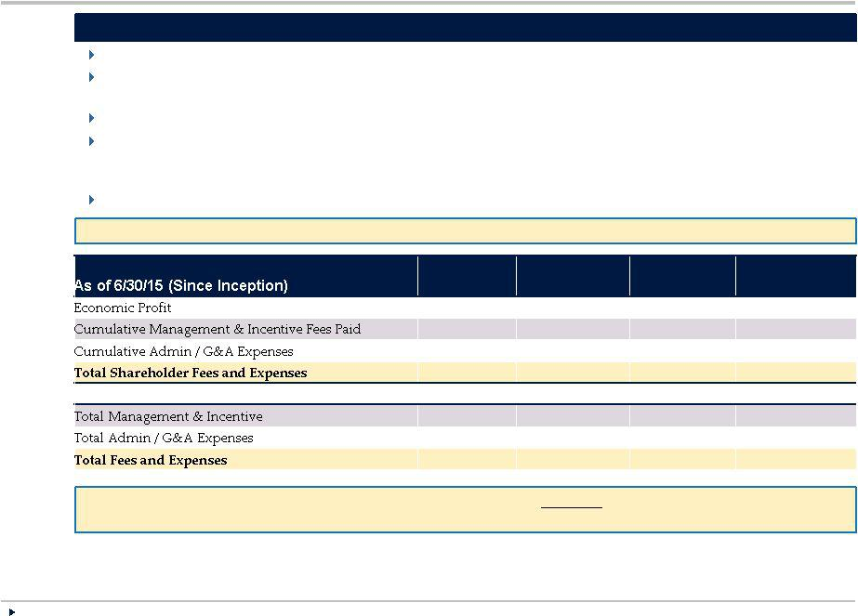

($ in millions)
Economic Profit versus BDC Manager Compensation

For stockholders, it is important to look at fees relative to the returns received by the stockholders

Investors are generally less concerned with high fees as a percentage of assets if attractive returns are passed to the stockholder

TICC has consistently delivered lackluster returns, leading to comparatively outsized fees for themselves

The table below analyzes economic profit versus manager compensation for TSLX, TICC, TICC pro forma as if it had been subject to the fee structure under the BSP proposal, and TICC pro forma as if it had been subject to the fee structure under the NexPoint proposal

Economic profit defined as Cumulative Net Income + Total Shareholder Fees and Expenses (1)

“Overall, the market does not look at expenses in a vacuum and neither should the TICC board.” – Wells Fargo Sept. 22

 | TSLX | TICC | TICC under | TICC under
 | TSLX | TICC | BSP Fees⁽²⁾ | NexPoint Fees⁽³⁾
 | $ 380 | $ 415 | $ 415 | $ 415
 | 102 | 128 | 101 | 88
 | 27 | 38 | 38 | 38
 | $129 | $166 | $140 | $127
Memo – (as % Economic Profit)
Fees | 27% | 31% | 24% | 21%
 | 7 | 9 | 9 | 9
 | 34% | 40% | 34% | 31%
Members of the NexPoint team oversaw Highland Distressed Opportunities which had a NEGATIVE |  |  | market return of 57% before it was acquired by
Highland Credit Strategies. Investors should consider management’s track record of total returns in connection with evaluating fees.

- See pages titled “Reconciliation of Certain Non-GAAP Financial Measures” for a reconciliation to the most recent comparable financial measures calculated and presented in accordance with GAAP.

- Assumes 25% reduction of Cumulative Investment Advisory Fees Paid (illustrating management fee reduction from 2.0% to 1.5% of AUM), holding economic profit constant

- Assumes 38% reduction of Cumulative Investment Advisory Fees Paid (illustrating management fee reduction from 2.0% to 1.25% of AUM), holding economic profit constant

Source: Wells Fargo Research Report, Company Filings. Financial data as of Q2 2015

TSLX (NYSE) | 4

Reconciliation of Certain Non-GAAP Financial Measures (1/2)

- Total economics of your investment, as set forth in this presentation, may be considered a non-GAAP financial measure. TSLX provides this

information to stockholders because TSLX believes it enhances stockholders’ understanding of the relative costs stockholder bear in relation to the assets generated by operations of TSLX, TICC, TICC pro forma as if it had been subject to the fee structure in the BSP proposal, and TICC pro forma
as if it had been subject to the fee structure in the NexPoint proposal, respectively. Non-GAAP financial measures should not be considered in isolation from, or as a substitute for, financial information presented in compliance with GAAP, and non-GAAP financial measures as used by TSLX may not be comparable to similarly titled amounts used by other companies.

- Economic Profit = Increase in Net Assets Resulting from Operations + Total Shareholder Fees and Expenses

- The table below illustrates a reconciliation of the increase in net assets resulting from operations over the years TSLX and TICC (on the next page) had operations to the ratio of shareholder fees and expenses to economic profit, with the table on the following page presenting the same
information for TICC on a pro forma |  |  | basis as if it had | been | subject to the fee structure under |  |  | the BSP proposal | and pro forma | as if it had | been
subject to the fee structure | under the |  | NexPoint proposal:
TSLX |  |  |  |  |  |  |  |  | 2015
TSLX |  |  |  |  |  |  |  |  | (through
(In thousands) |  |  | 2011 |  | 2012 | 2013 |  | 2014 | June 30) | Cumulative
Increase in Net Assets Resulting from
Operations (GAAP)
 |  |  | 813 | $ | 39,595 | 66,983 | $ | 85,050 | 58,573 | $ | 251,014
Shareholder Fees & Expenses:
Management fees (GAAP) |  | (1)
 |  |  | 1,593 | $ | 8,892 | 13,376 | $ | 18,296 | 10,247 | $ | 52,404
Incentive fees (GAAP) |  |  | 347 |  | 6,996 | 11,790 |  | 17,839 | 12,137 |  | 49,109
Professional fees (GAAP) |  |  | 1,563 |  | 2,881 | 3,691 |  | 4,752 | 2,490 |  | 15,377
Directors’ fees (GAAP)
 |  |  | 245 |  | 287 | 285 |  | 342 | 187 |  | 1,346
Other general and administrative
(GAAP) |  |  | 773 |  | 1,564 | 2,434 |  | 3,858 | 2,427 |  | 11,056
Compensation expense (GAAP)
 |  |  | — |  | — | — |  | — | — |  | —
Total Shareholder Fees & | Expenses |  | 4,521 |  | 20,620 | 31,576 |  | 45,087 | 27,488 |  | 129,292
Economic Profit |  |  |  |  |  |  |  |  |  | $ | 380,306
Ratio of Total Shareholder Fees &
Expenses to Economic Profit |  |  |  |  |  |  |  |  |  |  | 34

(1) Includes management fees waived by TSLX’s investment advisor prior to TSLX’s IPO in 2014, which totaled $7 in 2011, $3,704 in 2012, $7,135 in 2013 and $2,464 in 2014.

5

Reconciliation of Certain Non-GAAP Financial Measures (2/2)
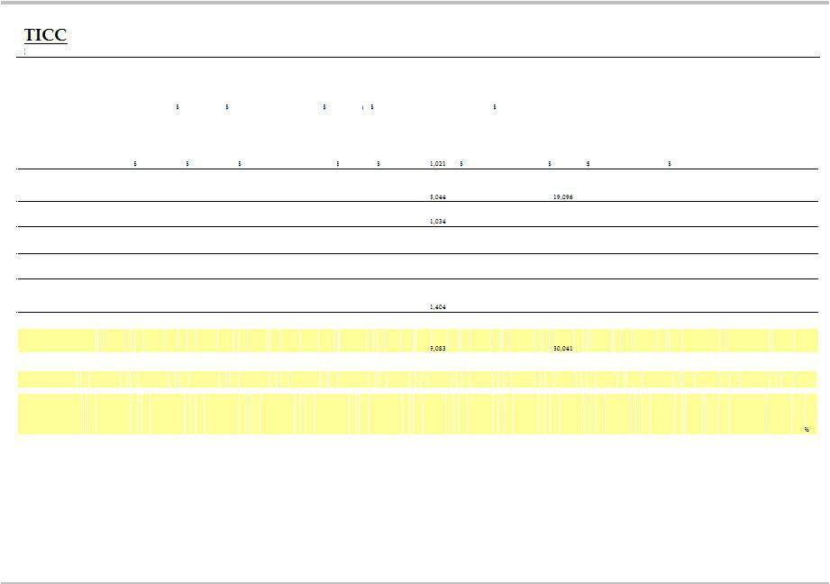

 |  |  |  |  |  |  |  |  |  |  |  |  |  |  |  |  |  |  |  |  | 2015 |  |  |  | Cumulative | Cumulative TICC
 |  |  |  |  |  |  |  |  |  |  |  |  |  |  |  |  |  |  |  |  | (through |  | Cumulative |  | TICC under | under NexPoint
In thousands) |  | 2003 |  |  | 2004 | 2005 | 2006 |  | 2007 | 2008 | 2009 | 2010 | 2011 |  | 2012 |  | 2013 |  | 2014 |  | June 30) |  | TICC |  | BSP Fees ⁽⁴⁾ |  | Fees⁽⁵⁾
Increase
(Decrease) in
Net Assets
Resulting from
Operations
(GAAP) | $ |  | (578) | $ | 3,364 | 16,304 | 26,331 | $ | (11,649) | (53,266 | 35,182 | $ 63,947 | $ 14,209 | 68,323 |  | $ | 58,945 | $ | (3,348) | $ | 30,856 | $ | 248,620 | $ | 275,195 | $ | 288,483
Shareholder Fees &
Expenses: | (2)
Compensation
expense (GAAP) |  | $ | 27 |  | 208 | 725 | 712 | $ | 898 | 906 | 971 | $ | 1,091 | $ | 1,183 |  | 1,648 |  | 1,861 | $ | 876 |  | 12,127 |  | 12,127 |  | 12,127
Investment
advisory fees
(GAAP) |  |  | 259 |  | 2,774 | 4,346 | 6,240 |  | 7,462 | 7,001 | 4,070 |  | 7,317 |  | 11,223 |  |  |  | 21,150 |  | 10,319 |  | 106,301 |  | 79,726 |  | 66,438
Professional fees
(GAAP) |  |  | 30 |  | 587 | 1,102 | 1,060 |  | 1,010 | 1,626 | 1,306 |  | 1,191 |  | 1,874 |  | 1,996 |  | 2,150 |  | 1,512 |  | 16,478 |  | 16,478 |  | 16,478
General and
administrative
(GAAP) (3) |  |  | 9 |  | 145 | 368 | 221 |  | 310 | 401 | 250 | 401 | 587 |  | 1,028 |  | 1,590 |  | 1,398 |  | 1,184 |  | 7,892 |  | 7,892 |  | 7,892
Directors’ Fees
(GAAP) |  |  | — |  | 141 | 135 | 169 |  | 165 | 185 | 193 | 179 | 223 |  | 261 |  | 323 |  | 317 |  | — |  | 2,291 |  | 2,291 |  | 2,291
Total incentive
fees (GAAP)
 |  |  | — |  | — | — | — |  | — | — | 52 |  | 3,350 |  | 10,969 |  | 5,388 |  | 1,731 |  | (1,505) |  | 21,389 |  | 21,389 |  | 21,389
Total Shareholder Fees &
Expenses |  |  | 325 |  | 3,855 | 6,676 | 8,402 |  | 9,845 | 10,119 | 6,842 |  | 13,759 |  | 26,538 |  |  |  | 28,607 |  | 12,386 |  | 166,478 |  | 139,903 |  | 126,615
Economic Profit |  |  |  |  |  |  |  |  |  |  |  |  |  |  |  |  |  |  |  |  |  | $ | 415,098 | $ | 415,098 | $ | 415,098
Ratio of Total
Shareholder Fees
& Expenses to
Economic Profit |  |  |  |  |  |  |  |  |  |  |  |  |  |  |  |  |  |  |  |  |  |  | 40% |  | 34% |  | 31

- TICC has recategorized and renamed certain line items in its statement of operations since it began reporting in 2003. From 2003 to 2008, incentive fees were included in “Investment advisory fees.” For years after 2008, incentive fees have been reported separately. For the six months ended June 30, 2015, directors’ fees, which previously had been separately reported, were included in “General and administrative.” Prior to 2006, TICC reported the line “Compensation expense” as “Salaries and benefits.”
- Does not include “Insurance” or “ Transfer agent and custodian fees” for periods prior to 2015. Prior to 2015, these expenses were included as separate line items on TICC’s statement of operations. For the six months ended June 30, 2015, these expenses were included in “General and administrative.”
- Assumes 25% reduction of Cumulative Investment Advisory Fees Paid (illustrating management fee reduction from 2.0% to 1.5% of AUM), holding economic profit constant

- Assumes 38% reduction of Cumulative Investment Advisory Fees Paid (illustrating management fee reduction from 2.0% to 1.25% of AUM), holding economic profit constant

6

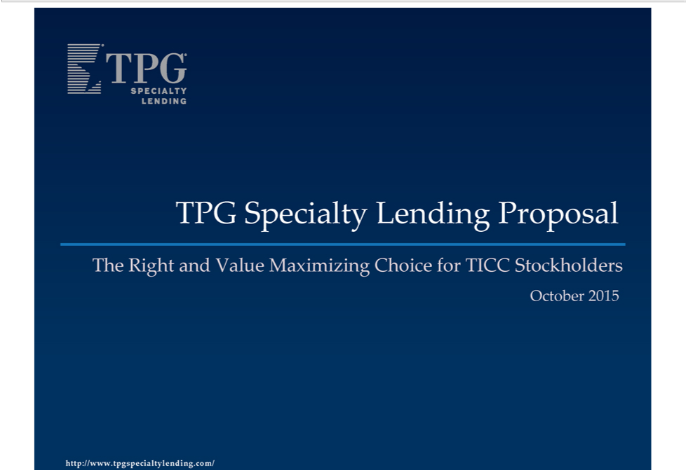

^{The}PG Specialty Lending Proposal
OctoberRight2015and Value Maximizing Choice for TICC Stockholders
http://www.tpgspecialtylending.com/

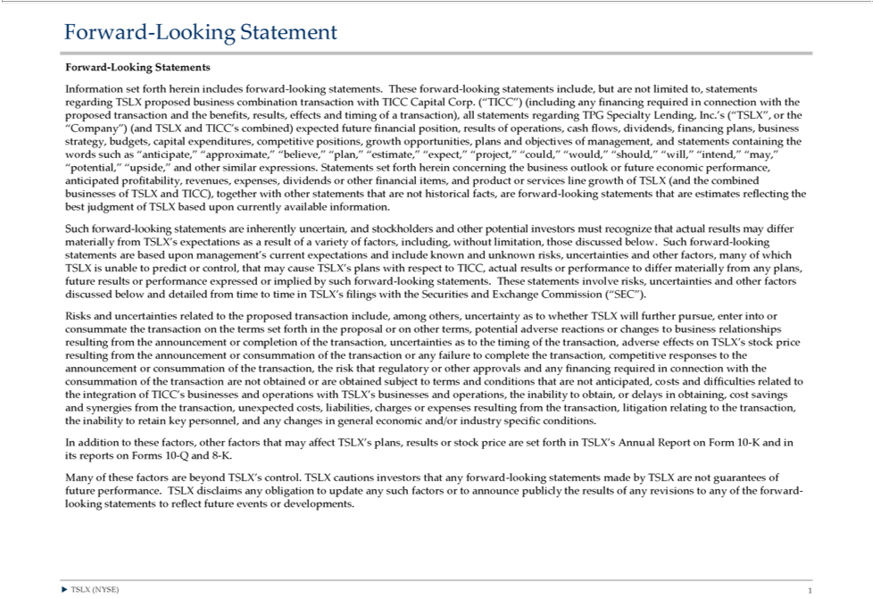

Forward-Looking Stateme ts | forward-looking statements. These forward-looking statements include, but are not limited to, statements regarding TSLX proposed business combination |  |  |  |  | with TICC Capital Corp. (“TICC”)
Information set forth herein |  |  |  |  |  | with TICC Capital Corp. (“TICC”)
(including any financing requiredincludes connection with the proposed |  | nsaction and the benefits, results, effects and timing of |  |  | all statements regarding TPG Specialty Lending, Inc.’transaction(“TSLX”, the “Company”) (and TSLX and
TICC’s combined) expected future financial position, results of operations, cash flows, dividends, financing plans, business strategytransaction),budgets, capital expenditures, competitive positions, growth opportunities, plans and objectives of
management, and statements containing the words such as “anticipate,” “approximate,” “believe,” “plan,” “estimate,” “expect,” |  |  |  |  | “could,” “would,” “should,” “will,” “intend,” “may,” “potential,” “upside,” and other similar
expressions. Statements set forth herein concerning the business outlook or future economic performance, anticipated profitability“project,”revenues, expenses, dividends or other financial items, and product or services line growth of TSLX (and the
combined businesses of TSLX and TICC), together with other statements that are not historical facts, are forward-looking statements that are estimates reflecting the best judgment of TSLX |  |  |  |  |  | upon currently available information.
Such forward-looking statements are inherently uncertain, and stockholders and other potential |  |  |  | must recognize that actual results may differ materially from TSLX’s expectations asbasedresult of a variety of factors, including, without
limitation, those discussed below. Such forward-looking statements are |  |  | upon management’investorscurrent expectations and include known and unknown risks, uncertainties and other factors, many of which TSLX is unable to predict or
control, that may cause TSLX’ | plans with respect to TICC, actual resulbasedorperformance to differ materially from any plans, future results or performance expressed or implied by such forward-looking statements. These statements involve
risks, uncertainties and other | discussed below and detailed from time to time TSLX’ |  |  | filings with the Securities and Exchange Commission (“SEC”).
Risks and uncertainties relatedfactorsthe proposed transaction include, among others, uncertainty as to whether TSLX will further pursue, enter into or consummate the transaction on the terms set forth in the proposal or on other terms, potential
adverse reactions or changes to business relationships resulting from the announcement or completion of the transaction, uncertainties as to the timing of the transaction, adverse effects on TSLX’ |  |  |  |  |  | stock price resulting from the announcement
or consummation of the transaction or any failure to complete the transaction, competitive responses to the announcement or consummation of the transaction, the risk that regulatory or other approvals and any financing required connection
with the consummation of the transaction are not obtained or are obtained subject to terms and conditions that are not anticipated, costs and difficulties related to the integration of TICC’s businesses and operations with TSLX’s businesses and
operations, the inability to obtain, or delays in obtaining, cost savings and synergies from the transaction, unexpected costs, liabilities, charges or expenses resulting from the transaction, litigation relating to the transaction, the inability to retain
key pers nel, and any changes in general economic and/or |  | specific conditions.
In addition to these factors, other factors that may affect TSLX’industryplans, results or stock price are set forth in TSLX’s Annual Report on Form 10-K and in its reports on Forms 10-Q and 8-K.
Many of these factors are beyond TSLX’_{revisions}control. TSLX cautions investors th_{statements}anyforward-looking statements made by TSLX are not guarantees of future performance. TSLX disclaims any obligation to update any such factors or to
TSLXannounce(NYSE)publicly1 the results of any to any of the forward-looking to reflect future events or developments.

Third Party-Sourced Statements and Information | Proxy Solicitation Information
Certain statements and information herein have been sourced from third parties. TSLX does not make any representations regarding the accuracy, completeness or timeliness of such third party statements information. Except as expressly set
forth herein, permission to c te such statements or information has neither been sought nor obtained from such third parties. Any such statements or information should not be viewed as an indication of support from such third parties for the
views expressed herein. All information in this communication regarding TICC, including its businesses, operations and financial results, was obtained from public sources. While TSLX has no knowledge that any such information is
accurate or incomplete, TSLX has not verified any of that information. TSLX reserves the right to change any of its opinions expressed herein at any time as it deems appropriate. TSLX disclaims any obligation to update the data,
information or opinions contained herein.
Proxy Solicitation Information
The information set forth herein is provided for informational purpos s only and does not constitute an offer to purchase or the solicitation of an offer to sell any securities. TSLX has filed with the SEC and mailed to TICC stockholders a
definitive proxy statement d accompanying GOLD proxy card to be used to solicit votes at a special |  |  | of stockholders of TICC scheduled to be held on October 27, 2015 against (a) approval of the new advisory agreement between
TICC and TICC Management, | LLC (the “Adviser”), to take effect upon a change of control of the Advisermeetingconnection with the entrance of the Adviser into purchase agreement with an affiliate of Benefit Street Partners L.L.C. (“BSP”),
pursuant to which BSP will acquire control of the Adviser, (b) the election of six directors nominated by TICC’s board of directors, and (c) the proposal to adjourn the meeting if necessary or appropriate to solicit additional votes.
TSLX STRONGLY ADVISES ALL STOCKHOLDERS OF TICC TO READ THE TSLX PROXY STATEMENT AND ITS OTHER PROXY MATERIALS AS THEY BECOME AVAILABLE BECAUSE THEY CONTAIN IMPORTANT
INFORMATION. SUCH | PROXY MATERIALS ARE AND WILL
BECOME AVAILABLE TSLXNO CHARGE ON THE SEC’S WEB SITE AT HTTP://WWW.SEC.GOV AND AT TSLX’S WEBSITE AT
HTTP://WWW.TPGSPECIALTYLENDING.COM. IN ADDITION, TSLX WILL PROVIDE COPIES OF THE PROXY ST TEMENT WITHOUT CHARGE
UPON REQUEST. REQUESTS FOR COPIES SHOULD BE DIRECTED TO TSLX’S PROXY SOLICITOR AT TPG@MACKENZIEPARTNERS.COM.
The participant in the solicitation is TSLX and certain of its directors and executive officers may also be deemed to be participants in the solicitation. As of the date hereof, TSLX directly beneficially owned 1,633,660 shares of common stock
of TICC.
Security holders may obtain information regarding the names, affiliations and interests of TSLX’s directors and executive officers in TSLX’s Annual
on Form 10-K for the year ended |  | 31, 2014, which was filed with the SEC on February 24, 2015, its proxy statement for the 2015 Annual Meeting, which was filed with the SEC on April 10, 2015, and certain of its Current
Reports on Form 8-K. These documents canDecemberobtained free of charge from the sources indicated above. Additional information regarding the interests of these participants in the proxy solicitation and a description of their direct and indirect interests, by security holdings or otherwise, will also be included in any proxy statement and other relevant materials to be filed with the SEC when they become available.
TSLX (NYSE) 2

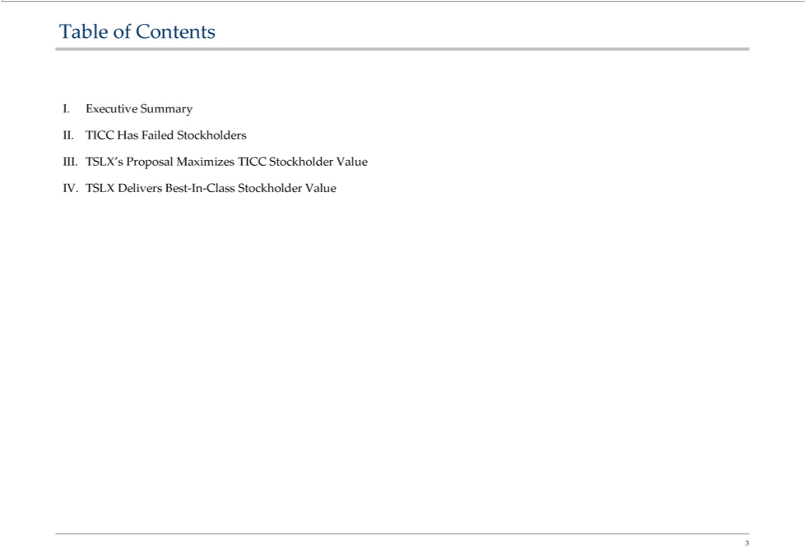

Table of Contents
. Executive Summary
^{II}. TICC ^{Has} Failed Stockholders
^{IV}
₃ .. TSLXTSLX’DeliversProposalBestMaximizes-In-Class TICCStockholderStockholderValue Value

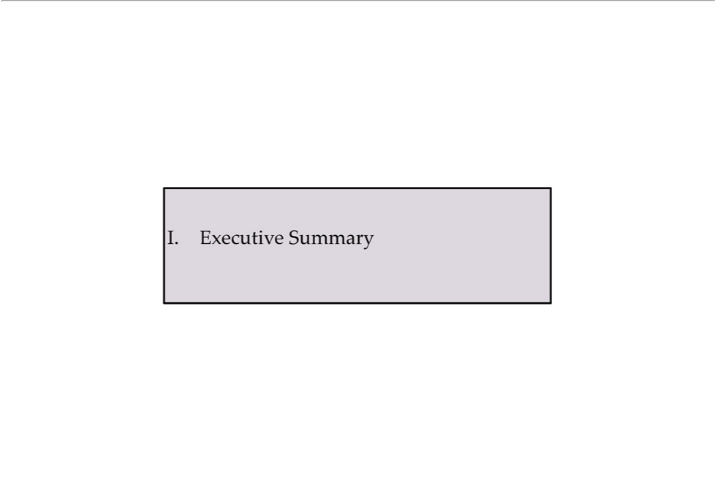

I. Executive Summary

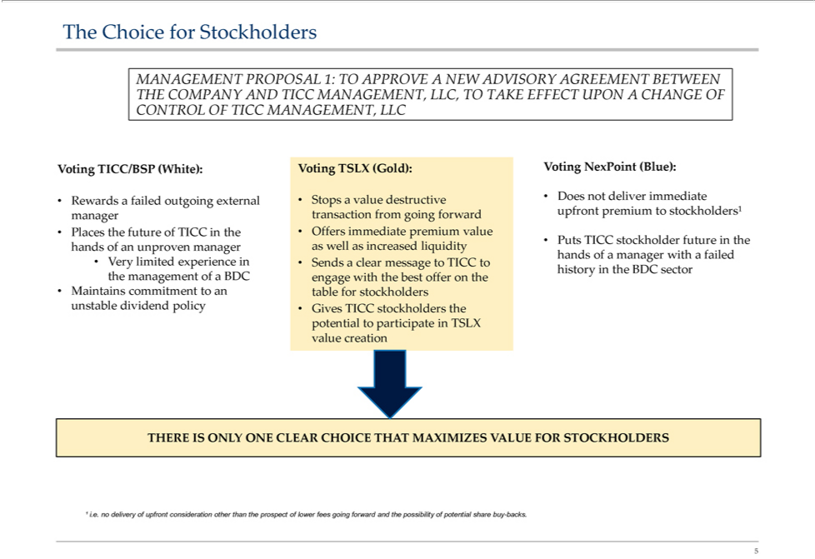

MANAGEMENTTheChoiceforStockholdersPROPOSAL 1: TO APPROVE A NEW ADVISORY AGREEMENT BETWEEN THE COMPANY AND TICC MANAGEMENT, LLC, TO TAKE EFFECT UPON A CHANGE OF CONTROL OF TICC , LLC

StopsVoting TICC/BSPdestructive(White):DoesVotingnot TSLXdeliver(Gold):immediateVoting NexPoint (Blue):
Rewardsvalue
Putslaces the futurefailed ofoutgoingTICCinexternaltheOfferstransactionimmediatefrompremiumgoingforwardvalue upfront premium to stockholders¹ manager

TICC stockholder future in the hands of an unproven
THERE IS ONLY ONE CLEAR CHOICE THAT MAXIMIZES VALUE FOR STOCKHOLDERS
5¹ i.e. no delivery of upfront consideration other than the prospect of lower fees going forward and the possibility of potential share buy-backs.

Why Stockholders Should Support TSLX’s Proposal
—UnlikeThe TSLX,proposalTICCrecommendedhasconsistentlybytheprioritizedTICCSpecialthe externalCommitteemanagerincludes an estimated $60 million payout to the outgoing TICC management team (through the purchase of
TICC’s existing adviser, as distinguished from normal advisory fees that would be payable to any external manager, such as TICC’s adviser or TSLX’s adviser, in the form of base management fees and incentive fees) that has overseen the
—dramaticTICC underperformancehasunilaterallydeniedsincestockholdersIPO,which thethe opportunitySpecialCommitteetovoicehastheirnotopinionrefutedon the merits of the TSLX proposal and rejected TSLX’s non-binding offer without engaging in substantive dialogue or negotiations or conducting proper due
diligence
The—TSLXTSLXhasproposalbestin wouldclassfeedemonstratedstopstructurepaymentandtoa commitmenttheunderperformingtorepurchaseTICC stockexternal manager that has destroyed the value of the TICC stockholders’ investment
TheUnlikeTSLXTICC,offer,TSLXifacceptedhas proposed,capacitywouldenablepayingTICCa stockholderssustainabledividendtoparticipate in leading platform that has consistently outperformed the sector
— TSLX would rotate TICC’as portfolio into higher performing assets and thus provide greater opportunity for stockholder return Leading _{Research}indpendent investment professionals agree that TSLX offers TICC stockholders superior value
6Source: analysts reports.

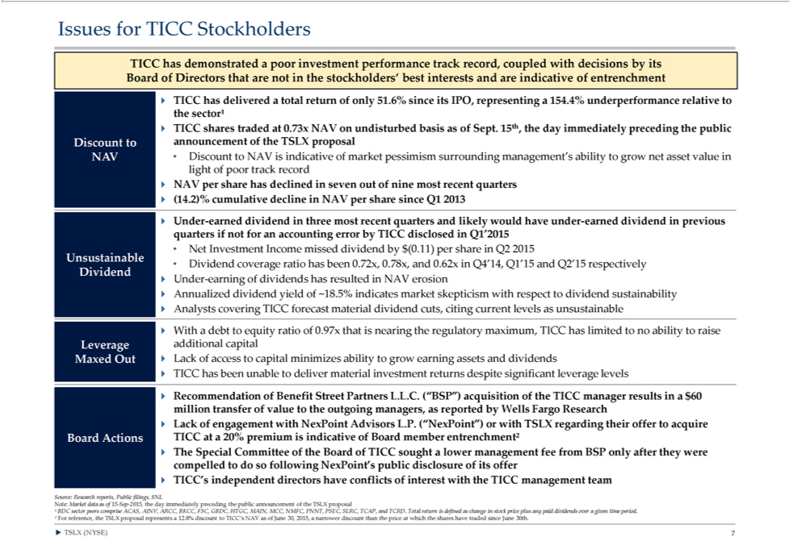

Issues for TICC Stockholders |  |  |  |  |  | that are not in the stockholders’ best interests and are indicative of entrenchment
TICC has | poor investment performance track record, coupled with decisions by its Board of
? TICC hasdemonstratedtotaldelivered |  |  | return of only 51.6% since its IPO, representing a 154.4% underperformance relativeDirectorsthe sector¹ ? TICC shares traded at 0.73x NAV on undisturbed basis as of Sept. 15th, the day immediately preceding the
public Discount to announcement of the TSLX proposal
NAV • Discount to NAV is |  |  | of market pessimism surrounding management’s ability to grow net asset value in light of poor track record
NAV per share has |  | indicativeseven out of nine most recent quarters ? (14.2)% cumulative decline in NAV per share since Q1 2013
? Under-earned dividenddeclinedthree most recent quarters and likely would have under-earned dividend in previous quarters if not for an accounting error by TICC disclosed in Q1’2015
Net Investment Income missed dividend by $(0.11) per share in Q2 2015
Unsustainable
Dividend • Dividend coverage ratio has been 0.72x, 0.78x, and 0.62x in Q4’14, Q1’15 and Q2’15 respectively
U der-earning of dividends has resulted |  |  |  | NAV erosion
dividend yield of ~18.5% indicates market skepticism with respect to dividend sustainability ? Analysts covering TICC forecast material dividend cuts, citing current levels as unsustainable
? AnnualizedWithdebt to equity ratio of 0.97x that is nearing the regulatory maximum, TICC has limited to no ability to raise Leverage additional capital Maxed Out ? Lack of access to capital minimizes ability to grow earning assets and dividends ?
TICC has been unable to d liver material investment returns despite significant leverage levels
Recommendation of Benefit Street Partners L.L.C. (“BS |  |  |  |  | acquisition of the TICC manager results in $60 million transfer of value to the outgoing managers, as reported by Wells Fargo Research
? Lack of engagement with NexPoint |  |  |  | L.P. (“NexPoint”) or with TSLX regarding their offer to acquire
Board Actions TICC at a 20% premiumAdvisorsindicative of Board member entrenchment²
? The Special Committee of the Board of TICC sought a lower management fee from BSP only after they were compelled to do so following NexPoint’s public disclosure of its offer ? TICC’s independent directors have conflicts of interest with the TICC management team
Source: Research reports, Public filings, SNL
Note: Market data as of 15-Sep-2015, the day immediately preceding the public announcement of the TSLX proposal
¹ BDC sector peers comprise ACAS, AINV, ARCC, BKCC, FSC, GBDC, HTGC, MAIN, MCC, NMFC, PNNT, PSEC, SLRC, TCAP, and TCRD. Total return is defined as change in stock price plus any paid dividends over a given time period.

?² ForTSLXreference,(NYSE)the7 TSLX proposal represents a 12.8% discount to TICC’s NAV as of June 30, 2015, a narrower discount than the price at which the shares have traded since June 30th.

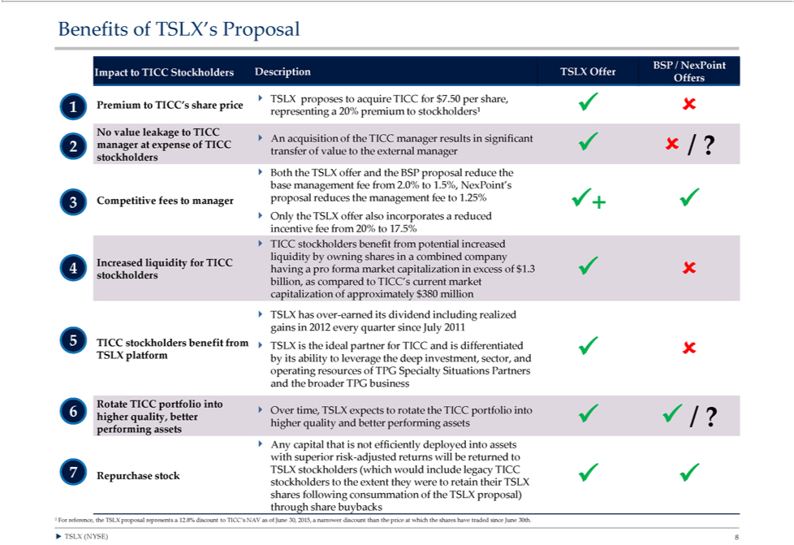

enefits of TSLX’s Proposal
BSP / NexPoint Impact to TICC Stockholders Description TSLX Offer Offers
? TSLX proposes to acquire TICC for $7.50 per
1 Premium to TICC’s share price ?? representingshare,20% premium to stockholders¹
No value leakage to TICC
? An acquisition of the TICC manager sults in significant
2 manager at expense of TICC ?? transfer of value to the external manager / ? stockholders
? Both the TSLX offer and the BSP proposal reduce the base management fee from 2.0% to 1.5%, NexPoint’
3 Competitive fees to manager proposal reduces the management fee to 1.25% ?+ ? ? Only the TSLX offer also incorporates a reduced incentive fee from 20% to 17.5% ? TICC stockholders benefit from potential increased liquidity by owning
shares in a combined company
Increased liquidity for TICC
4 having | pro forma market capitalization excess of $1.3 ?? stockholders billion, as compared to TICC’s current market capitalization of approximately $380 million
? TSLX has over-earned its dividend including realized gains in 2012 every quarter since July 2011
5 TICC stockholders benefit from ? TSLX is the ideal partner for TICC and is differentiated ?? TSLX platform by its ability to leverage the deep investment, sector, and operating resources of TPG Specialty Situations Partners and the broader
TPG business
Rotate TICC portfolio into
6 ? Over time, TSLX expects to rotate the TICC portfolio into higher quality, better ?? higher quality and better performing assets / ? performing assets
? Any capital that is not efficiently deployed into assets with superior risk-adjusted returns will be returned to
7 TSLX | (which would include legacy TICC | of the TSLX proposal) through share buybacks
Repurchasestockholders??stockholders to the extent they were to retain their TSLX shares following |  | of the TSLX proposal) through share buybacks
consummation
?¹ ForTSLXreference,(NYSE)the8 TSLX proposal represents a 12.8% discount to TICC’s NAV as of June 30, 2015, narrower discount than the price at which the shares have traded since June 30th.

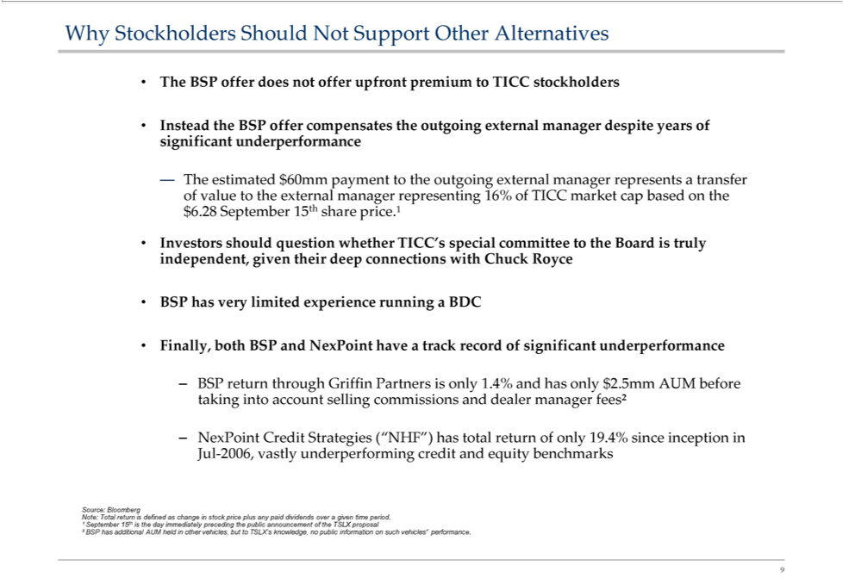

WhyTheBSPStockholdersofferdoesShouldnotofferNotupfrontSupportpremiumOtherAlternativestoTICCstockholders
—InsteadThe estimatedtheBSPoffer$60mmcompensatespayment tothetheoutgoingoutgoingexternalexternalmanagermanagerdespiterepresentsyears aoftransfersignificantofvalueunderperformancetotheexternal manager representing 16% of TICC market cap based on the $6.28 September 15th share price.¹ Investors should question whether TICC’s special committee to the Board is truly independent, given their deep connections with Chuck Royce
BSP has very limited experience running BDC
–Finally,BSPreturnboth BSPthroughand GriffinNexPointPartnershave aistrackonly record1.4%andofsignificanthasonly$2.5mmunderperformanceAUMbefore taking into account selling commissions and dealer manager fees²
JulNexPoint-2006,vastlyCredit Strat gies (“NHF”)credithasandtotalequityreturnbenchmarksofonly19.4% since inception in
Source: Bloomberunderperforming
¹Note:SeptemberTotalreturn15thisisthedefineddayimmediatelyaschangeinprecedingstockpricethepluspublicany announcementpaiddividends ofovertheaTSLXgiven proposaltimeperiod.
9² BSP has additional AUM held in other vehicles, but to TSLX’s knowledge, no public information on such vehicles’’ performance.

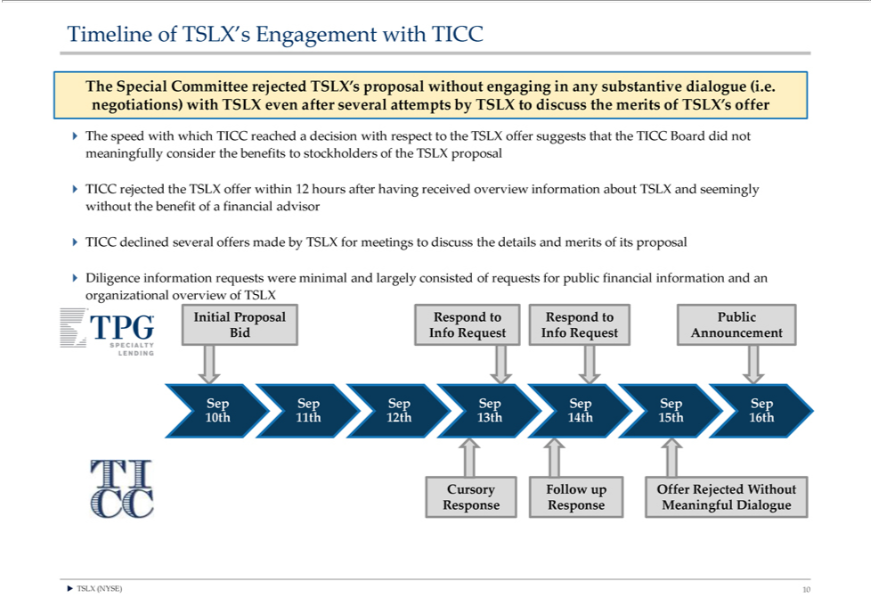

^{The}imeline of TSLX’s Engagement with TICC
Special Committee rejected TSLX’s proposal without engaging in any substantive dialogue (i.e. negotiations) with TSLX even after several attempts by _{stockholders}TSLXdiscuss the merits of TSLX’s offer
he speed with which TICC reached a decision with respect to the TSLX offer suggests that the TICC Board did not meaningfully consider the benefits to of the TSLX proposal ^{TICC} rejected the TSLX offer within 12 hours after having received overview information about TSLX and seemingly without the benefit of a financial advisor
? declined several offers made by TSLX for meetings to discuss the details and merits of its proposal
Diligence information requests were minimal and largely consisted of requests for public financial information and an organizational overview of TSLX Initial Proposal Respond to Respond to Public Bid Info Request Info Request Announcement
Sep Sep Sep Sep Sep Sep Sep 10th 11th 12th 13th 14th 15th 16th
?CursoryTSLX (NYSE)Followup10Offer Rejected Without Response Response Meaningful Dialogue

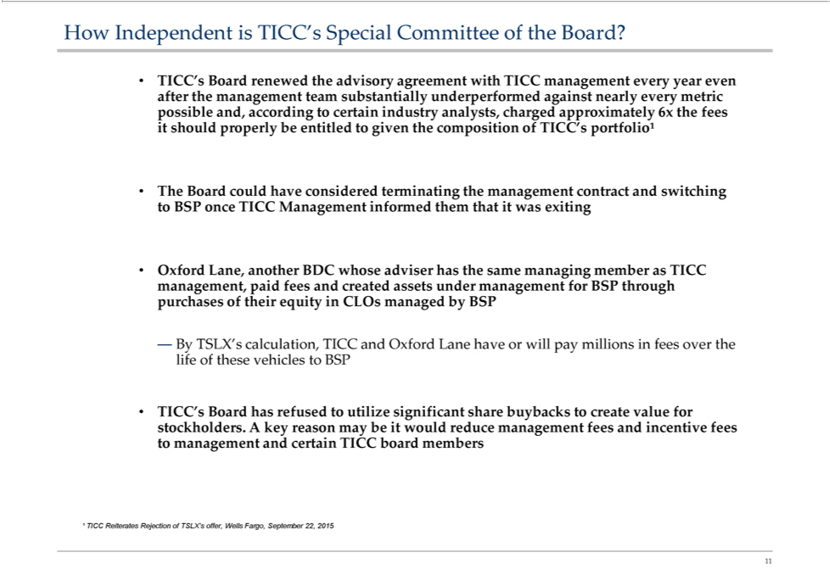

HowTICC’sIndependentBoardrenewedisTICC’stheadvisorySpecial CommitteeagreementwientitledofhtheTICCBoard?management every year even after the management team substantially underperformed against nearly every metric possible and, according to certain industry analysts, charged
approximately 6x the fees it should properly be to given the composition of TICC’s portfolio¹
OxfordTheBoardLane,couldanotherhave BDCconsideredwhoseterminatingadviserhas thethe managementsamemanagingcontractmemberandasswitchingTICCmanagement,toBSPoncepaidTICCfeesManagementandcreated informedassetsunderthemmanagementthatitwas exitingforBSP through purchases of their equity in CLOs managed by BSP
TICC’s—ByTSLX’sBoard hascalculation,refusedtoTICCutilizeand Oxford Lanesharehavebuybacksorwilltopaycreatemillionsvalueinforfeesstockholders.overthelifeAofkeythesereasonvehiclesmay tobeBSPitwould reduce management fees and incentive fees to management and certain TICC board members
significant
11¹TICC Reiterates Rejection of TSLX’ offer, Wells Fargo, September 22, 2015

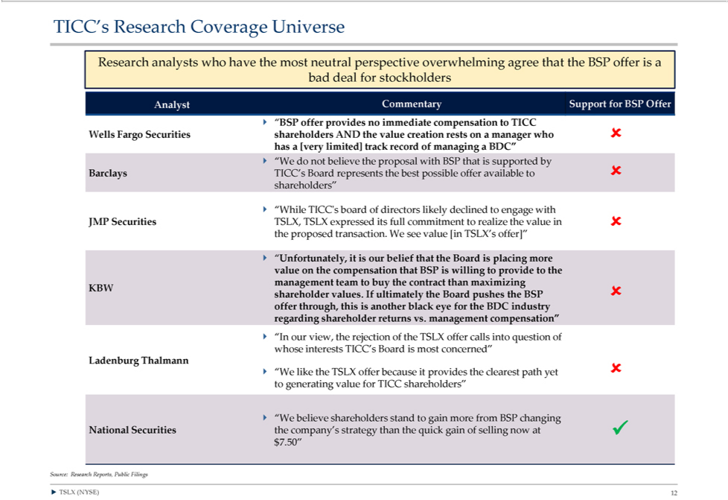

TICC’ Research Coverage Universe
Research analysts who have the most neutral perspective overwhelming agree that the BSP offer is a bad deal for stockholders
Analyst Commentary Support for BSP Offer ? “BSP offer provides no immediate |  |  | to TICC
Wells Fargo Securities shareholders AND the value creation rests on a manager whocompensation?has[very limited] track record of managing a BDC”
? “We do not believe the proposal with BSP that is supported by
Barclays TICC’s Board represents the best possible offer available to? shareholders”
? “While TICC’s board of directors likely declined to engage with
JMP Securities | TSLX expressed its full commitment to realize the value in ? the proposed transaction. We see value [in TSLX’s offer]”
? “UnfortunatelyTSLX,itisour belief that the Board is placing more value on the compensation that BSP is willing to provide to the management team to buy the contract than maximizing KBW shareholder values. If ultimately the Board pushes the
BSP ? offer | this is | black eye for the BDC industry regarding shareholder | vs. management compensation”
through, another returns
Ladenburg?“InourviewThalmanntherejection of TSLX offer calls into question of whose interests TICC’ Board is most concerned”
^{? “We}
believelikethe shareholdersTSLXofferbecausestandtoitgainprovidesmore thefromclearestBSPchangingpathyet? to generating value for TICC shareholders”
National Securities the company’s strategy than the quick gain of selling now at ? $7.50”
Source: Research Reports, Public Filings
? TSLX (NYSE) 12

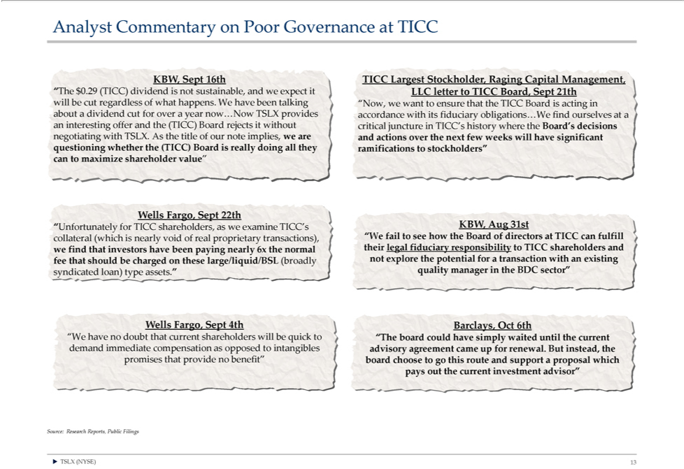

AnalystKBW,SeptCommentary16thTICConLargestPoorGovernanceStockholdersustainable,atRagingTICC Capital Management,
for“Theover$0.29year(TICC)now…NowdividendTSLXisnotprovides accordanceandwe expectwithitsitfiduciaryLLCletterobligations…WetoTICCBoard,findSeptourselves21thwillatbe ancutinterestingregardless offerofwhatandhappens.the(TICC)We Boardhavebeenrejectstalkingitwithout“Now,criticalwewantjuncturetoensureinTICC’thatthe TICC whereBoard theisactingBoard’sin aboutdecisionsadividend cut
negotiating with TSLX. As the title of our note implies, we are and actions over the next few weeks will have significant questioning whether the (TICC) Board is really doing all they ramificationshistorystockholders” can to maximize shareholder value”
“Unfortunately for TICC shareholders, as we examine_{responsibility}TICC’ KBW, Aug 31st collateral (which is nearly void of real proprietary transactions), “We fail to see how the Board of directors at TICC can fulfill we find that investors have been
paying nearly 6x the normal their legal fiduciary to TICC shareholders and fee that should be charged on these large/liquid/BSL (broadly not explore the potential for a transaction with an existing syndicated loan) type assets.” quality manager in the BDC sector”
_{“Wells} Fargo, Sept 4th Barclays, Oct 6th
have no doubt that current shareholders will be quick to “The board could have simply waited until the current demand immediate compensation as opposed to intangibles advisory agreement came up for renewal. But instead, the promises that provide no benefit” board choose to go this route and support a proposal which pays out the current investment advisor”

?Source:TSLX Research(NYSE)13Reports, Public Filings

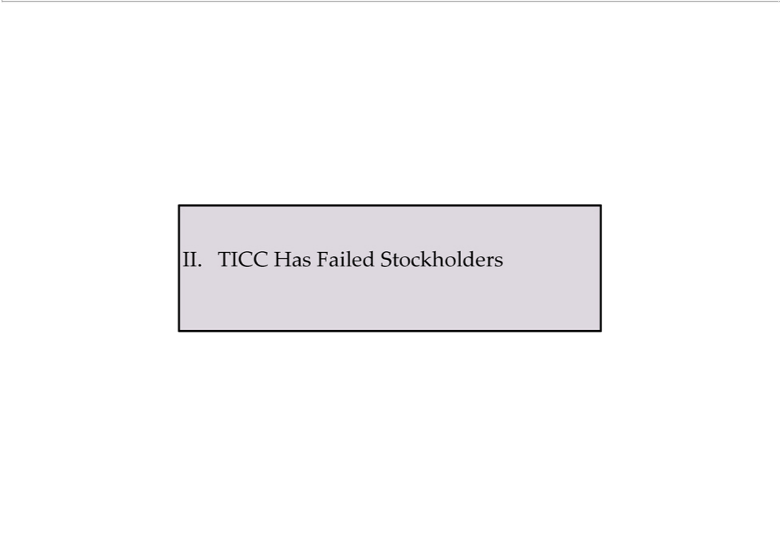

II. TICC Has Failed Stockholders

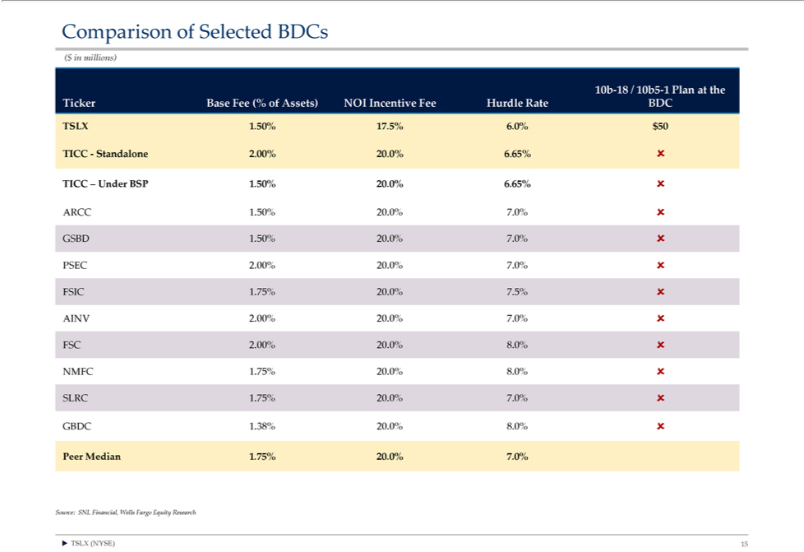

Comparison of Selected BDCs
10b($in-18millions)/10b517- Plan at the Ticker Base Fee (% of Assets) NOI Incentive Fee Hurdle Rate BDC
SLX—Standalone1.50%.5%2.600%. $20.0%50 6.65% ?
TICC – Under BSP 1.50% 20.0% 6.65% ?
ARCC 1.50% 20.0% 7.0% ? GSBD 1.50% 20.0% 7.0% ? PSEC 2.00% 20.0% 7.0% ? FSIC 1.75% 20.0% 7.5% ? AINV 2.00% 20.0% 7.0% ? FSC 2.00% 20.0% 8.0% ? NMFC 1.75% 20.0% 8.0% ? SLRC 1.75% 20.0% 7.0% ? GBDC 1.38% 20.0% 8.0% ?

?Source:TSLX SNL(NYSE)Financial,15 Wells Fargo Equity Research

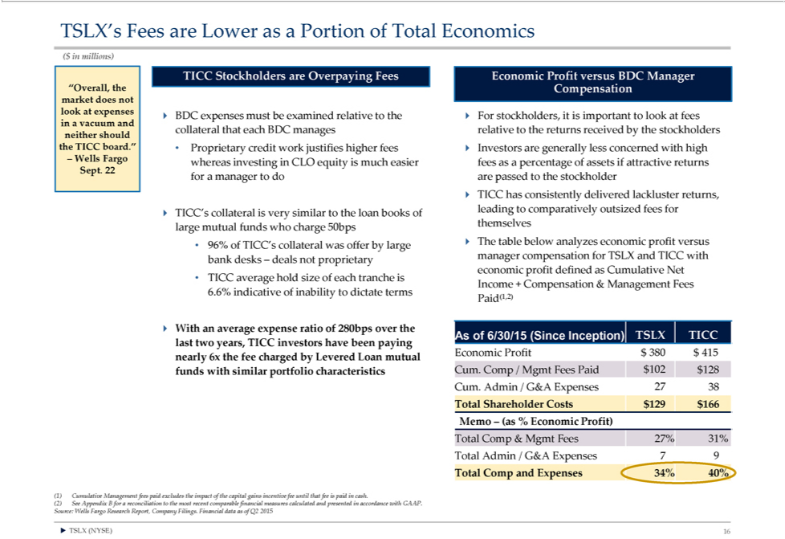

TSLX’ Fees are Lower as a Portion of Total Economics
($ in millions)
TICC Stockholders are Overpaying Fees Economic Profit v rsus BDC Manager
“Overall, the Compensation market does not look at expenses in |  | vacuum and ? BDC expenses must be examined relative to the ? For stockholders, is important to look at fees collateral that each BDC manages relative to the returns
received by the stockholders neither should the TICC board.”• |  | credit work | higher fees ? Investors are generally less concerned with high
– Wells Fargo whereas investing in CLO equity is much easier Proprietaryfeesaspercentage of assetsjustifies attractive returns
Sept. 22 for a manager to do are passed to the stockholder
? TICC’hascollateral | delivered lackluster returns, leading to comparatively outsized fees for
? TICC’hascollateral | very similar to the loan books of themselves large mutual funds who charge 50bps
96% of TICC’consistentlycollateral was offer by large ? The table below analyzes economic profit versus bank desks – deals not proprietary manager compensation for TSLX and TICC with economic profit defined as Cumulative Net
TICC average hold size of each tranche is
6.6% indicative of inability to dictate terms Income + Compensation & Management Fees
Paid(1,2)
? With an average expense ratio of 280bps over the
As of 6/30/15 (Since Inceptio ) TSLX TICC last two years, TICC investors have been paying |  |  |  | $128
Economic Profit $ 380 $ 415 nearly 6x the fee charged by Levered Loan mutual funds with similar portfolio characteristics Cum. Comp / Mgmt Fees Paid $102 |  |  |  | $128
Cum. Admin / G&A Expenses 27 38
Shareholder Costs $129 $166 Memo – (as % Economic Profit)
& Mgmt Fees 27% 31% Total Admin / G&A Expenses 7 9
Total Comp and Expenses 34% 40%
1) Cumulative | fees paid excludes the impact of the capital gains incentive fee until that fee is paid in cash.
(2) See AppendixManagementBforreconciliation to the most recent comparable financial measures calculated and presented in accordance with GAAP. Source: Wells Fargo Research Report, Company Filings. Financial data as of Q2 2015 ? TSLX (NYSE) 16

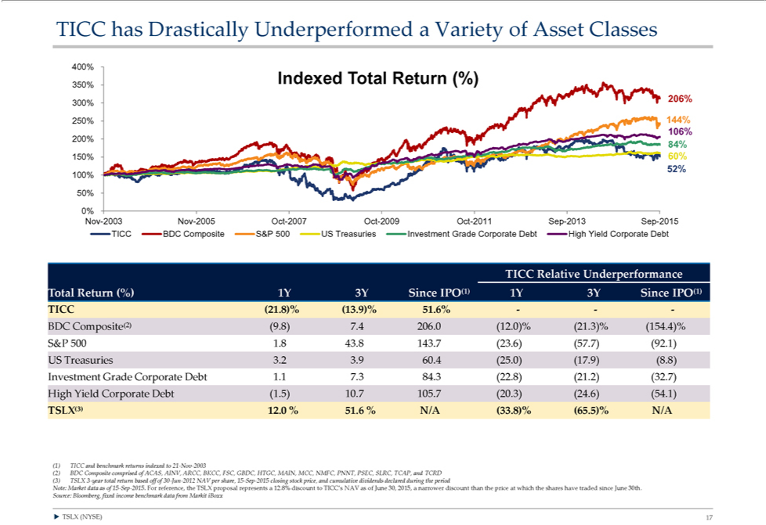

TICC has Drastically Underperformed a Variety of Asset Classes
⁴⁰350%
^{2 6%} Indexed Total Return (%)
30
250% 144% 200% 106%
84%
150% 60%
52%
¹50%^{0%}
Nov-2003 Nov-2005 Oct-2007 Oct-2009 Oct-2011 Sep-2013 Sep-2015 TICC BDC Composite S&P 500 US Treasuries Investment Grade Corporate Debt High Yield Corporate Debt ^{TICC} Relative Underperformance Total Return (%) 1Y 3Y Since IPO(1) 1Y 3Y Since IPO(1)
(21.8)% (13.9)% 51.6% — — —
BDC Composite(2) (9.8) 7.4 206.0 (12.0)% (21.3)% (154.4)% S&P 500 1.8 43.8 143.7 (23.6) (57.7) (92.1) US Treasuries 3.2 3.9 60.4 (25.0) (17.9) (8.8) Investment Grade Corporate Debt 1.1 7.3 84.3 (22.8) (21.2) (32.7) High Yield Corporate Debt (1.5) 10.7 105.7 (20.3) (24.6) (54.1)
TSLX(3) 12.0 % 51.6 % N/A (33.8)% (65.5)% N/A
⁽²⁾1) TICC and benchmark returns indexed to 21-Nov-2003
BDC Composite comprised of ACAS, AINV, ARCC, BKCC, FSC, GBDC, HTGC, MAIN, MCC, NMFC, PNNT, PSEC, SLRC, TCAP, and TCRD (3) TSLX 3-year total return based off of 30-Jun-2012 NAV per share, 15-Sep-2015 cl^{Note:}sing stock price, and cumulative dividends declared during the period
Market data as of 15-Sep-2015. For reference, the TSLX proposal represents a 12.8% discount to TICC’s NAV as of June 30, 2015, a narrower discount than the price at which the shares have traded since June 30th. Source: Bloomberg, fixed income benchmark data from Markit iBoxx
? TSLX (NYSE) 17

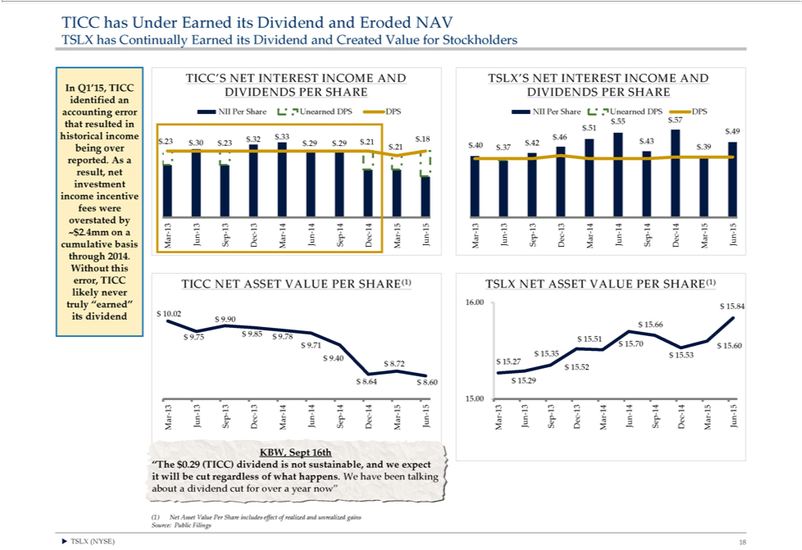

_{TICC’SSLX}has Under Earned its Dividend and Eroded NAV
has Continually Earned its Dividend and Created Value for Stockholders
NET INTEREST INCOME AND TSLX’S NET INTEREST INCOME AND
In Q1’15, TICC DIVIDENDS PER SHARE DIVIDENDS PER SHARE identified an _{accounting} error NII Per Share Unearned DPS DPS NII Per Share Unearned DPS DPS $.55 $.57 that resulted in $.51 $.49 historical income $.32 $.33 $.18 ~.46^{$2} $.23 $.30 $.23 $.29 $.29 $.21 $.42 $.43 being over $.21 $.40 $.37 $.39 reported. As result, net investment income incentive fees were overstated by 13 13 13 13 14 14 14 14 15 15 13 13 13 13 14 14 14 14 15 15
.4mm on a — Jun Sep — — Jun—Sep ——Jun — Jun—Sep ——Jun—Sep ——Jun cumulative basis Mar Dec Mar Dec Mar Mar Dec Mar Dec Mar through 2014.
Without this error, TICC TICC NET ASSET VALUE PER SHARE(1) TSLX NET ASSET VALUE PER SHARE(1) likely never truly “earned” 16.00 $ 15.84 its dividend $ 10.02 $ 9.90 $ 15.66 $ 9.85 $ 9.78 $ 9.75 $ 15.51 $ 9.71 $ 15.70 $ ^{5.}60⁰⁰ $ 15.35 $ 15.53 $ 9.40 $ 8.72 $ 15.27 $ 15.52 $ 8.64 $ 8.60 $ 15.29
13—13 — 13 13—14 — 14 14—14—15—15 — 13—13—13—13—14 14—14—14—15—15 -Mar Jun Sep Dec Mar Jun Sep Dec Mar Jun Mar Jun Sep Dec Mar Jun Sep Dec Mar Jun KBW, Sept 16th
“The $0.29 (TICC) dividend is not sustainable, and we expect it will be cut regardless of what happens. We have been talking about a dividend cut for over a year now”
?(1)TSLXNetAsset(NYSE)Value18 Per Share includes effect of realized and unrealized gains Source: Public Filings

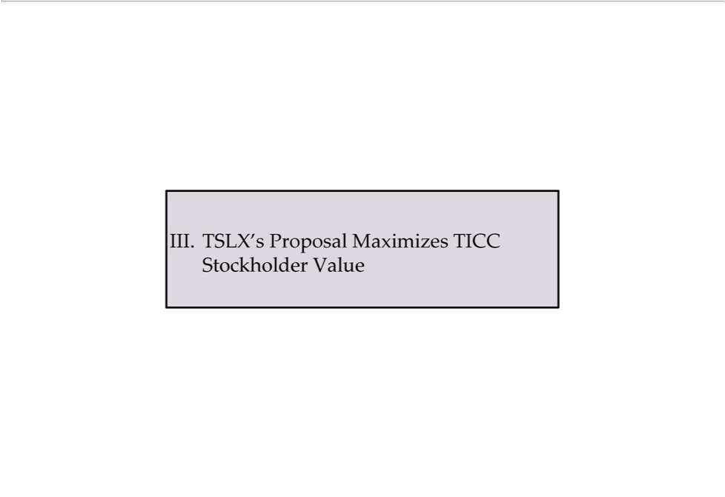

- TSLX’s Proposal Maximizes TICC Stockholder Value

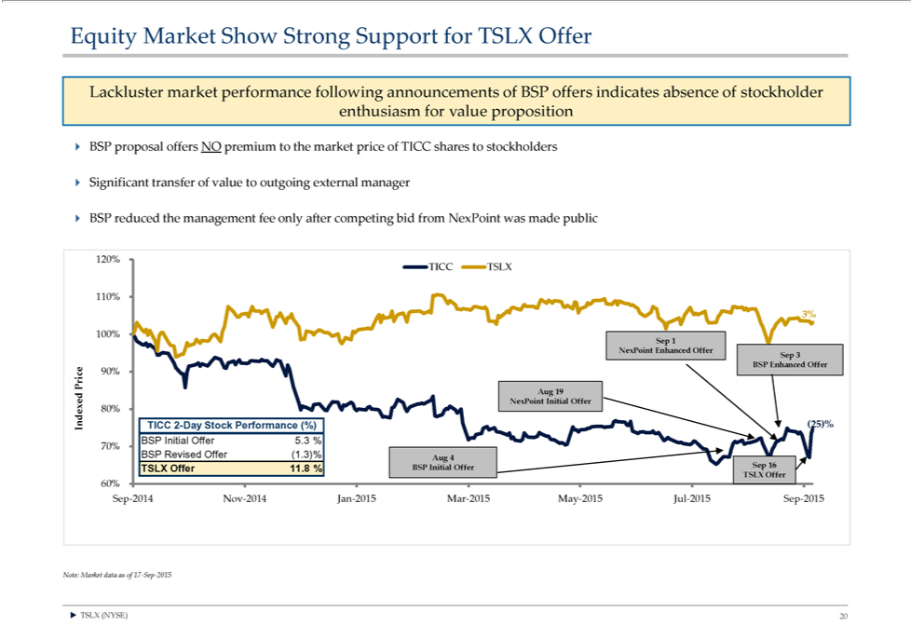

Equity Market Show Strong Support for TSLX Offer
Lackluster market performance following announcements of BSP offers indicates absence of stockholder enthusiasm for value proposition BSP proposal offers NO premium to the market price of TICC shares to stockholders
? Significant transfer of value to outgoing external manager
BSP reduced the management fee only after competing bid from NexPoint was made public
¹20% TICC TSLX
10%
3%
100% Sep 1
SepNexPoint3 Enhanced Offer
PriceBSPEnhanced90% Offer
Aug 19
80%NexPoint Initial Offer
Indexed TICC 2-Day Stock Performance (%) (25)%
BSP Initial Offer 5.3 % 70% BSP Revised Offer (1.3)%
Aug 4
60%TSLX Offer 11.8 % BSP Initial Offer Sep 16 TSLX Offer
Note:Sep-2014MarketNovdata-2014as Janof17-2015-SepMar-2015-2015 May-2015 Jul-2015 Sep-2015
? TSLX (NYSE) 20

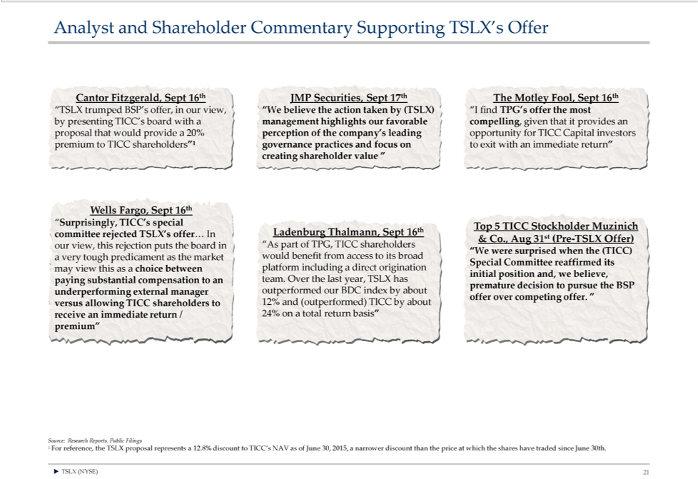

Analyst and Shareholder Commentary Supporting TSLX’s Offer
“TSLXCantor Fitzgerald,trumpedBSP’sSept offer,16thJMPinourSecurities,view“WSeptbelieve17th theTheactionMotleytakenFool,bySept(TSLX)16th“I find TPG’s offer the most by presenting TICC’s board with a management highlights our favorable compelling, given that it provides an proposal that would provideFar 20% perception of the company’ leading opportunity for TICC Capital investors premium to TICC shareholders”¹ governance practices and focus on to exit with an immediate return” creating shareholder value “
“Surprisingly,Wellsgo,SeptTICC’s16thspecial Top 5 TICC Stockholder Muzinich Ladenburg Thalmann, Sept 16th committee rejected TSLX’s offer… In st & Co., Aug 31 (Pre-TSLX Offer) our view, this rejection puts the board in “As part of TPG, TICC shareholders
“WSpecialwereCommitteesurprised reaffirmedwhenthe(TICC)itsmayaviewvery thistoughas predicamentchoicebetweenastheplatformmarket wouldincludingbenefitdirectfrom riginationaccessto itsinitialbroadposition and, we believe, paying substantial compensation to an team. Over the last year, TSLX has premature decision to
pursue the BSP underperforming external manager outperformed our BDC index by about offer over competing offer. “ versus allowing TICC shareholders to 12% and (outperformed) TICC by about receive an immediate return / 24% on a total return basis” premium”

?¹ ForTSLXreference,(NYSE)the21TSLX proposal represents a 12.8% discount to TICC’s NAV as of June 30, 2015, a narrower discount than the price at which the shares have traded since June 30th.

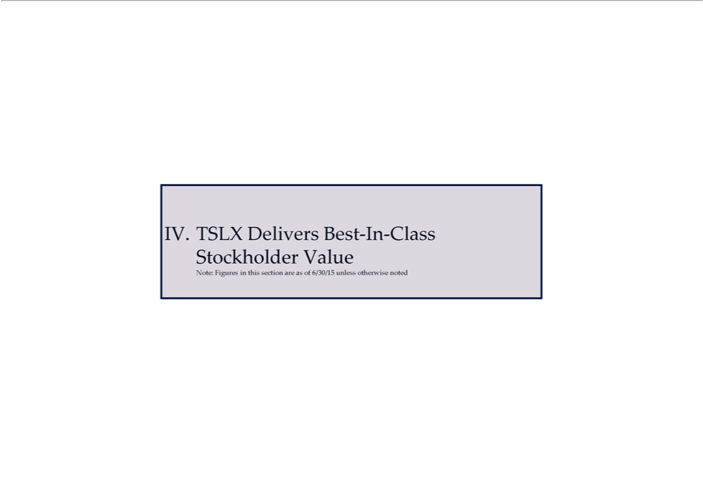

IV. TSLX Delivers Best-In-Class Stockholder Value
Note: Figures in this section are as of 6/30/15 unless otherwise noted

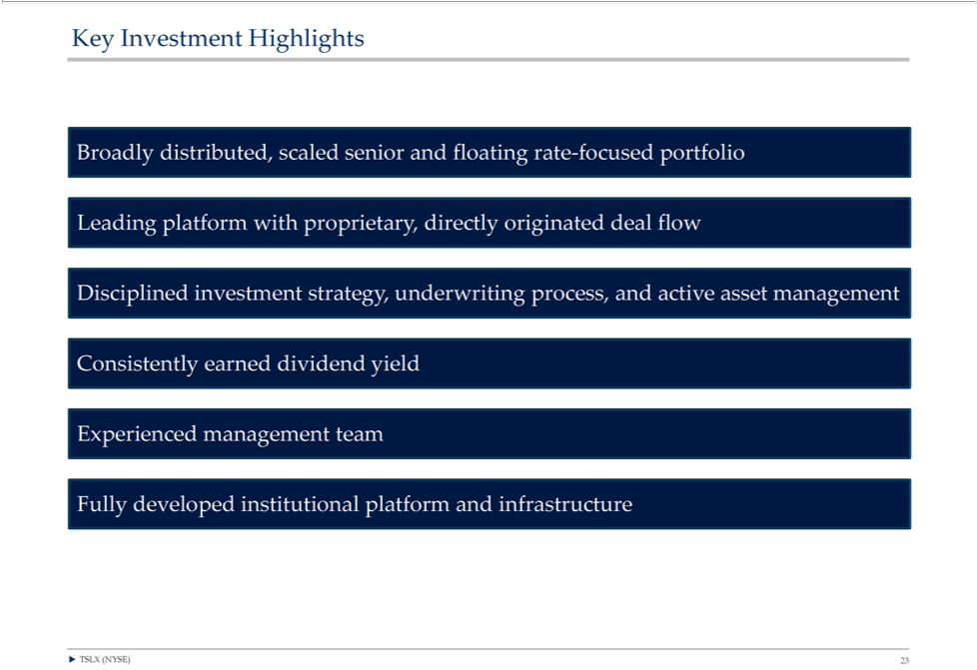

Key Investment Highlights
LeadingBroadly distributed,platformwithscaledproprietary,senioranddirectlyfloatingoriginatedrate?focuseddealflowportfolio
Disciplined investment strategy, underwriting process, and active asset management Consistently earned dividend yield Experienced management team Fully developed institutional platform and infrastructure ? TSLX (NYSE) 23

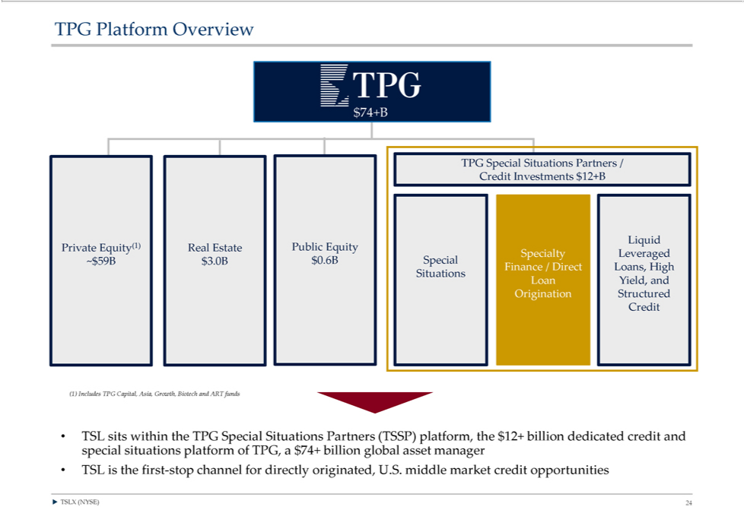

$TPG74+BPlatform Overview
LiquidTPGSpecial Situations Partners / Credit Investments $12+B
SpecialtyPrivateEquity(1)LeveragedReal Estate Public Equity
~$59B $3.0B $0.6B Special
LoanFinanceYield,/Directand Loans, High Situations
Origination Structured Credit
(1) Includes TPG Capital, Asia, Growth, Biotech and_{(TSSP)}ARfunds
^{TSL} sits within the TPG Special Situations Partners platform, the $12+ billion dedicated credit and special situations platform of TPG, a $74+ billion global asset manager is the first-stop channel for directly originated, U. . middle market credit opportunities
? TSLX (NYSE) 24

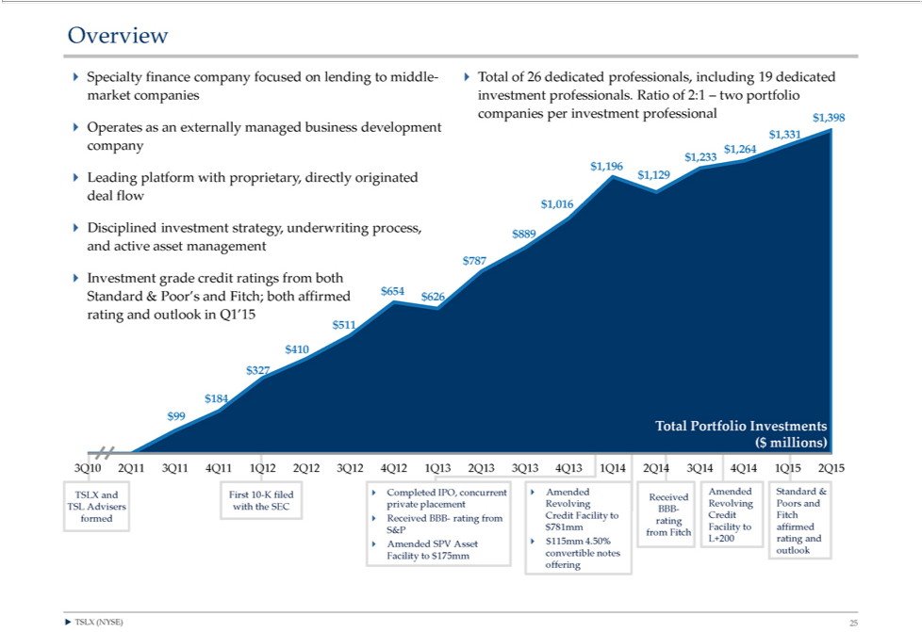

Overview | company focused on lending to middle-? Total of 26 dedicated professionals, including 19 dedicated market companies investment professionals. Ratio of 2:1 – two portfolio companies per investment professional $1,398 ?
? Specialty
Operates as financeexternally managed 6% business development
$1,331
company
$1,233 $1,264 $1,196 $1,129
Leading platform with proprietary, directly originated deal flow $1,016
? Disciplined investment strategy, underwriting process,
$889
and active asset management
$787
? Investment grade credit ratings from both
$654
Standard & Poor’s and Fitch; both affirmed $626 rating and outlook in Q1’15
51 $410 $327
184
$0 $0 $99 Total Portfolio Investments ($ millions)
3Q10 2Q11 3Q1 | 4Q11 1Q12 2Q12 3Q12 4Q12 1Q13 2Q13 3Q13 4Q13 1Q14 2Q14 3Q14 4Q14 1Q15 2Q15
TSLX and First 10-K filed ? Completed IPO, concurrent ? Amended Amended Standard & Received TSL Advisers with the SEC private placement Revolving Revolving Poors and BBB- formed ? Received BBB- rating from Credit Facility to Credit Fitch rating S&P $781mm Facility to affirmed from Fitch ? $115mm 4.50% L+200 rating and ? Amended SPV Asset convertible notes outlook Facility to $175mm offering
? TSLX (NYSE) 25

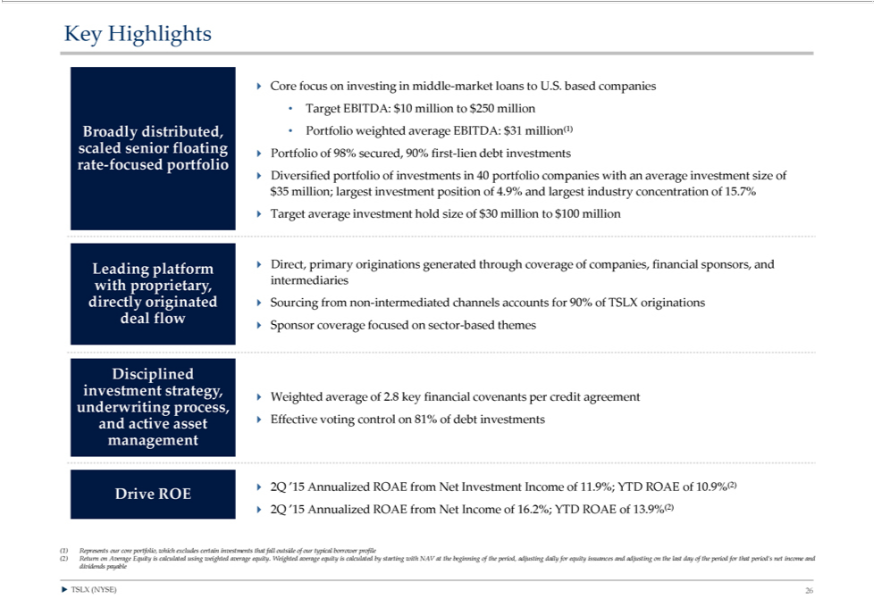

Key Highlights
? Core focus on investing in middle-market loans to U.S. based companies
Target EBITDA: $10 million to $250 million Broadly distributed, Portfolio weighted average EBITDA: $31 million(1) scaled senior floating ? Portfolio of 98% secured, 90% first-lien debt investments rate-focused portfolio
? Diversified portfolio of investments in 40 portfolio companies with an average investment size of $35 million; largest investment position of 4.9% and largest industry concentration of 15.7% Target average investment hold size of $30 million to $100 million
withLeadingproprietary,platformintermediaries?Direct,primary originations generated through coverage of companies, financial sponsors, and
^{deal}
irectlyfloworiginated ? Sourcing from non-intermediated channels accounts for 90% of TSLX originations
Disciplined?Sponsorcoverageinvestmentfocusedstrategy,onsector-based themes
underwriting process, ? Weighted average of 2.8 key financial covenants per credit agreement? Effective voting control on 81% of debt investments and active asset management
Drive ROE ? 2Q ’15 Annualized ROAE from Net Investment Income of 11.9%; YTD ROAE of 10.9%(2) ? 2Q ’15 Annualized ROAE from Net Income of 16.2%; YTD ROAE of 13.9%(2)
⁽²⁾1) ^{Return}presents our core portfolio, which excludes certain investments that fall outside of our typical borrower profile
on Average Equity is calculated using weighted average equity. Weighted average equity is calculated by starting with NAV at the beginning of the period, adjusting daily for equity issuances and adjusting on the last day of the period for that period’s net income and dividends payable
? TSLX (NYSE) 26

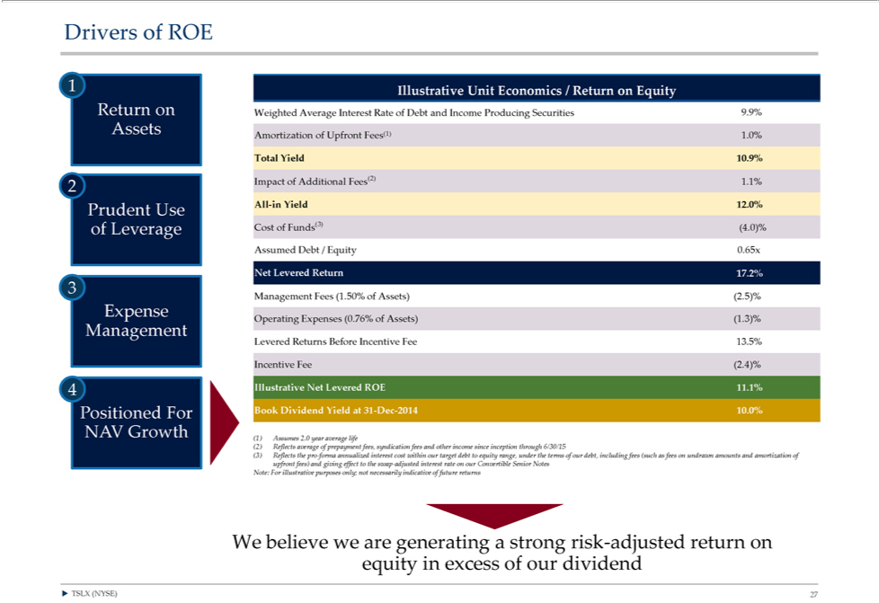

Drivers of ROE
1 Illustrative Unit Economics / Return on Equity
Return | Weighted Average Interest Rate of Debt and Income Producing Securities 9.9%
ssets (1)
Amortization of Upfront Fees 1.0%
Total Yield 10.9%
Impact of Additional Fees(2) 1.1%
2
Prudent Use All-in Yield 12.0% of Leverage Cost of Funds(3) (4.0)% Assumed Debt / Equity 0.65x
Net Levered Return 17.2%
3
Management Fees (1.50% of Assets) (2.5)%
Expense
Operating Expenses (0.76% of Assets) (1.3)%
Management
Levered Returns Before Incentive Fee 13.5%
Incentive Fee (2.4)%
4 Illustrative Net Levered ROE 11.1% Positioned For Book Dividend Yield at 31-Dec-2014 10.0%
NAV Growth
1) Assumes 2.0 year average life
2) | average of prepayment fees, syndication fees and other income since inception through 6/30/15
(3) Reflects the pro-forma annualized interest cost within our target debt to equity range, under the terms of our debt, including fees (such as fees on undrawn amounts and amortization of upfront fees) and giving effect to the swap-adjusted _{interest} rate on our Convertible Senior Notes Note: For illustrative purposes only; not necessarily indicative of future returns
?WTSLXbelieve(NYSE)weare27generating a strong risk-adjusted return on equity in excess of our dividend

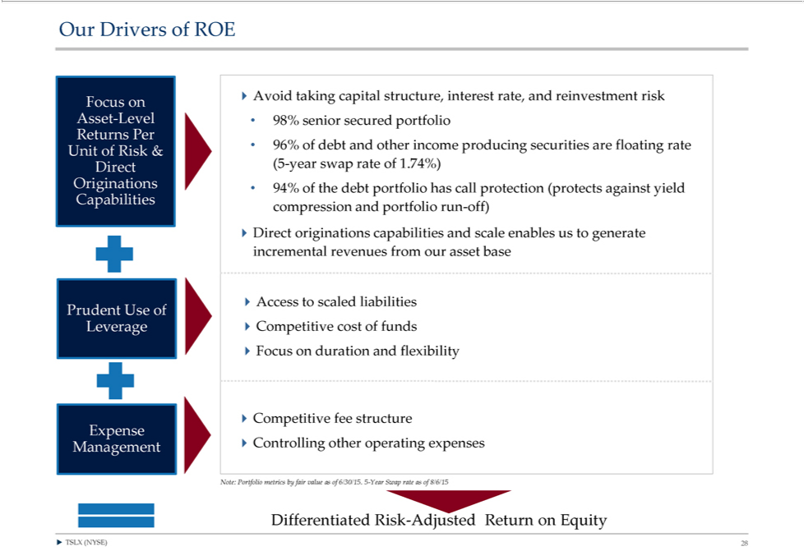

Our Drivers of ROE
Focus?Avoidontaking capital structure, interest rate, and reinvestment risk
ReturnsAsset-LevelPer • 98% senior secured portfolio
Unit96% ofof Riskdebt and& other income producing securities are floating rate
Direct (5-year swap rate of 1.74%)
CapabilitiesOriginations compression•94%ofthe anddebtportfolioportfoliorunhas-off)call protection (protects against yield
_{?Access}Directoriginationstoscaledliabilitiescapabilities and scale enables us to generate incremental revenues from our asset base
Prudent Use of
?CompetitiveLeverage?Competitivefeestructurecost of funds ?Focus on duration and flexibility
Expense
Management ?Controlling other^{value}oprating expenses
DifferentiatedNote:PortfolioRiskmetrics-AdjustedbyfairReturn ason ofEquity6/30/15. 5-Year Swap rate as of 8/6/15
? TSLX (NYSE) 28

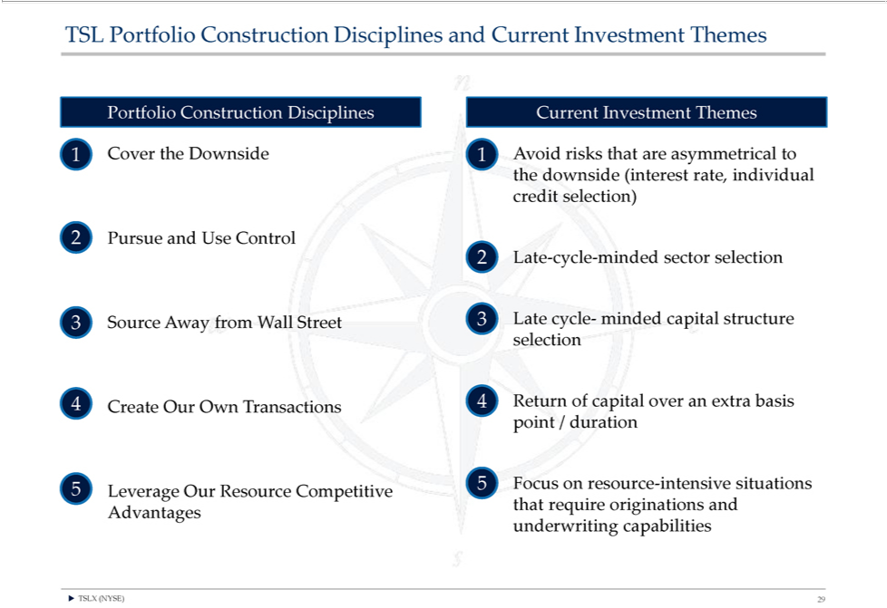

PortfolioTSLPortfolioConstructionConstructionDisciplinesDisciplinesCurrentandInvestmentCurrentInvestmentThemes Themes
1 Cover the Downside 1 Avoid risks that are asymmetrical to the downside (interest rate, individual credit selection)
²
LatePursue-cycleand-mindedUseControlsector selection
3 Source Away from Wall Street 3 Late cycle- minded capital structure selection
4 Create Our Own Transactions 4 Return of capital over an extra basis point / duration
5 5 Focus on resource-intensive situations Leverage Our Resource Competitive that require originations and Advantages underwriting capabilities ? TSLX (NYSE) 29

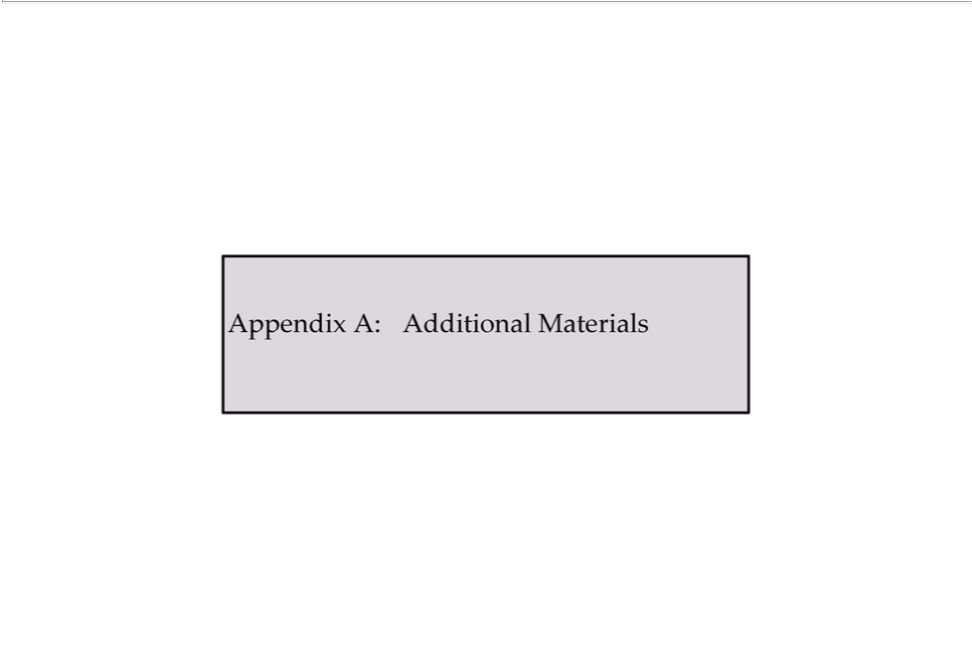

Appendix A: Additional Materials

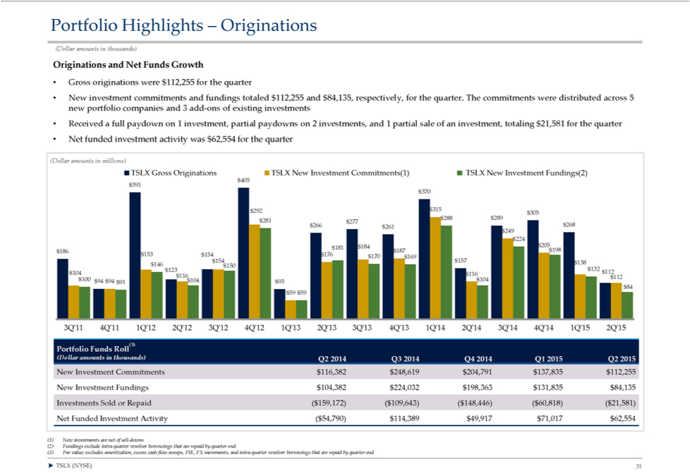

Portfolio Highlights – Originations
(Dollar amounts in thousands)
O iginations and Net Funds Growth
Gross originations were $112,255 for the quarter
New investment commitments and fundings totaled $112,255 and $84,135, respectively, for the quarter. The commitments were distributed across 5 new portfolio companies and 3 add-ons of existing investments
Received a full paydown on 1 investment, partial paydowns on 2 investments, and 1 partial sale of an investment, totaling $21,581 for the quarter
Net funded |  |  |  |  | activity was $62,554 for the quarter
(Dollar amountsinvestmentmillions)
TSLX Gross Originations TSLX New Investment Commitments(1) TSLX New Investment Fundings(2)
3 |  | 1 | 405 |  | 70 | $224 $184 $205 $181 $186 $153 $176 $187 $198 $154 | $170 $169 $154 $157 $138 $146 $150 $132 $123 $112 $104 $116 $116 $112 $100 $94 $94 $104 | $104
292 |  |  | $ 15 | $305 $288 $289 $281 $266 $277 $268 $261 $249 |  | $224 $184 $205 $181 $186 $153 $176 $187 $198 $154 |  | $104
91 |  |  | 93 $84
$59 |  | $59
3Q’11 4Q’11 1Q’12 2Q’12 3Q’12 4Q’12 1Q’13 2Q’13 3Q’13 4Q’13 1Q’14 2Q’14 3Q’14 4Q’14 1Q’15 2Q’15
(3)
Portfolio Funds Roll
(Dollar amounts in thousands) Q2 2014 Q3 2014 Q4 2014 Q1 2015 Q2 2015 |  |  |  |  |  |  | $224,032 $198,363 $131,835 $84,135 Investments Sold or Repaid ($159,172) ($109,643) ($148,446) ($60,818) ($21,581)
 | w Investment Commitments $116,382 $248,619 $204,791 |  |  |  |  | $137,835 $112,255 New Investment Fundings $104,382
Net |  | Funded Investment Activity ($54,790) $114,389 $49,917 |  |  |  | $71,017 $62,554
1) New investments are net of sell-downs
2) | Fundings exclude intra-quarter revolver borrowings that are repaid by quarter-end
(3) | Par value; excludes amortization, excess cash flow sweeps, PIK, FX movements, and intra-quarter revolver borrowings that are repaid by quarter-end
? TSLX (NYSE) 31

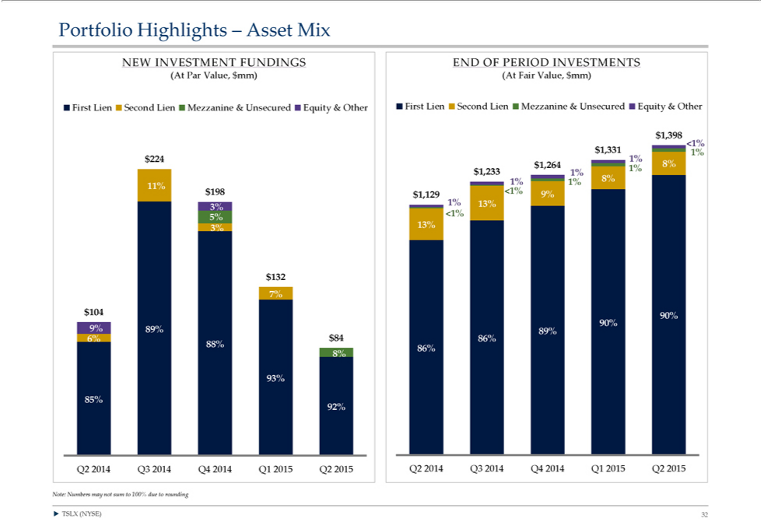

Portfolio Highlights – Asset Mix
NEW |  | FUNDINGS END OF PERIOD INVESTMENTS
(At ParINVESTMENTalue,$mm)(At Fair Value, $mm)
First Lien Second Lien Mezzanine & Unsecured Equity & Other First Lien Second Lien Mezzanine & Unsecured Equity & Other
$1,398 |  | $1,331 <1% $224 1% 1% $1,264 8% $1,233 1% 1%
0% |  | 1% 8% 0% 11% $198 <1% 9% $1,129
1% | 13%
3% | <1% 5%
3% | 13%
$132 0% 7% 0% $104 90% 90%
9% | 89% 89%
6% | $84 86% 88%
0% | 0% 86% 8%
0% | 93%
92%^{85%}

? TSLX (NYSE) 32

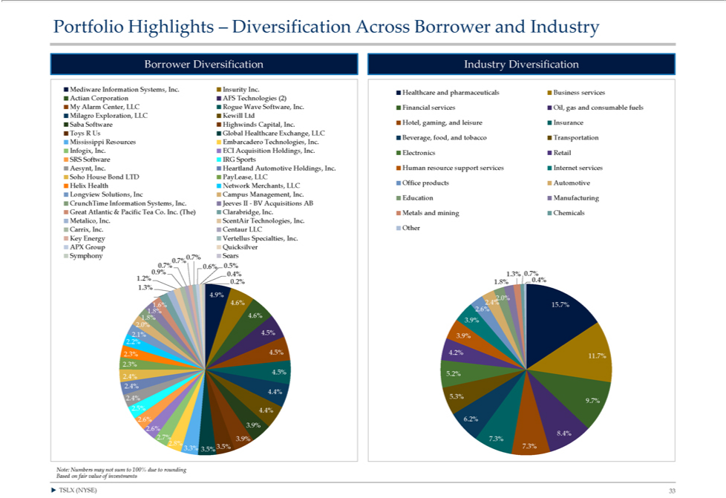

Portfolio Highlights – Diversification Across Borrower and Industry
Borrower Diversification Industry Diversification
Mediware Information Systems, Inc. Insurity Inc.
Healthcare and pharmaceuticals Business services Actian Corporation AFS Technologies (2)
My Alarm Center LLC Rogue Wave Software, Inc. Financial services Oil, gas and consumable fuels Milagro Exploration, LLC Kewill Ltd Saba Software Highwinds Capital, Inc. Hotel, gaming, and leisure Insurance Toys R Us Global
Healthcare |  |  |  | Exchange, LLC
Beverage, food, and tobacco Transportation Mississippi Resources Embarcadero Technologies, Inc.
Infogix, Inc. ECI Acquisition Holdings, Inc. Electronics Retail SRS Software IRG Sports
Aesynt, Inc. Heartland Automotive Holdings, Inc. Human resource support services Internet services Soho House Bond LTD PayLease, LLC
Office products Automotive Helix Health Network Merchants, LLC
Longview Solutions, Inc Campus Management, Inc.
 | runchTime Information Systems, Inc. Jeeves II—BV Acquisitions AB Education Manufacturing Great Atlantic & Pacific Tea Co. Inc. (The) Clarabridge, Inc. Metals and mining Chemicals Metalico, Inc. ScentAir Technologies, Inc.
Carrix, |  |  | Inc. Centaur LLC Other Key Energy Vertellus Specialties, Inc.
APX Group Quicksilver Symphony 0.7%0. 7% Sears
 | 7% |  | 6% | 0 5%
0 9% |  | 0 4% |  | 1.3% 0.7%
1 | 2%
0 | 2% | 1.8%
 | 3% | 4.9%
1 6%
2 | 0% | 2.4% |  | 15.7%
4 | 6% |  |  | 15.7%
 | 6% | 2 | 6%
1 8% |  | 4 | 6%
 | 0% | 3 | 9%
2 1% |  | 4.5%
3 | 9%
 | 2% | 4.5% |  | 4.2%
2.3% |  |  |  | 4.2%
11.7%
2 3% |  | 5.2%
4 | 5%
2 |  | 5.3%
4 | 4%
2 | 4%
9 | 7% | 4 4%
 | 5%
2 6% |  | 6.2%
3 | 9% | 8 4%
 | 6% |  |  | 7.3%
 | 7% | 3.9% |  | 7.3%
2 8% |  | 3.5% |  | 7.3%
 | 3% |  |  | 7.3%
3.5%
?Note:TSLXNumbers(NYSE)may33 not sum to 100% due to rounding Based on fair value of investments

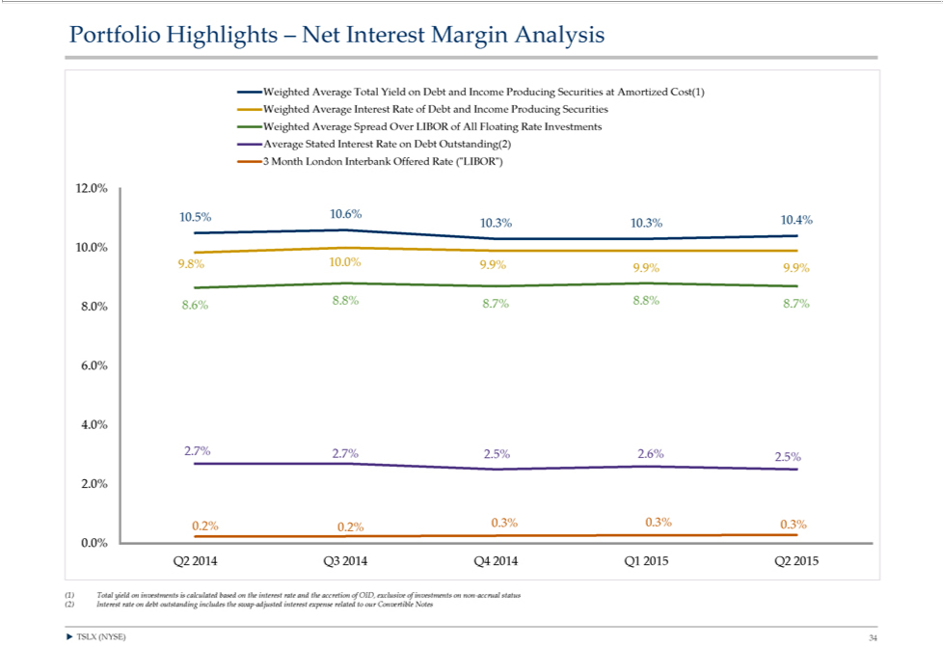

Portfolio Highlights – Net Interest Margin Analysis
Weighted Average Total Yield on Debt |  |  |  |  | Income Producing Securities at Amortized Cost(1) Weighted Average Interest Rate of Debt and Income Producing Securities Weighted Average Spread Over LIBOR of All Floating Rate Investments
Average Stated Interest Rate on Debt Outstanding(2)
3 | Month London Interbank Offered Rate (“LIBOR”)
 | 2 0% |  | 6%
 | 5%
 | 3% 10.3% 10.4%
^{10.0%}10.0% 9.9%
9 | 9% | 9 9% |  | 8.8% 8.7%
8 | 8% |  | 7% | 8.8% 8.7%
8 |  | 8.6%
6 | 0%
4 | 0% | 2.7% |  | 2.5% 2.6%
 | 7% |  |  | 2.5% 2.6%
2 | 5%
2 | 0% | 0.3% |  | 0.3% 0.3%
 | 2% |  |  | 0.3% 0.3%
0.0%
Q2 2014 Q3 2014 Q4 2014 Q1 2015 Q2 2015
(1) Total yield on investments is calculated based on the interest rate and the accretion of OID, exclusive of investments on non-accrual status (2) Interest rate on debt outstanding includes the swap-adjusted interest expense related to our Convertible Notes
? TSLX (NYSE) 34

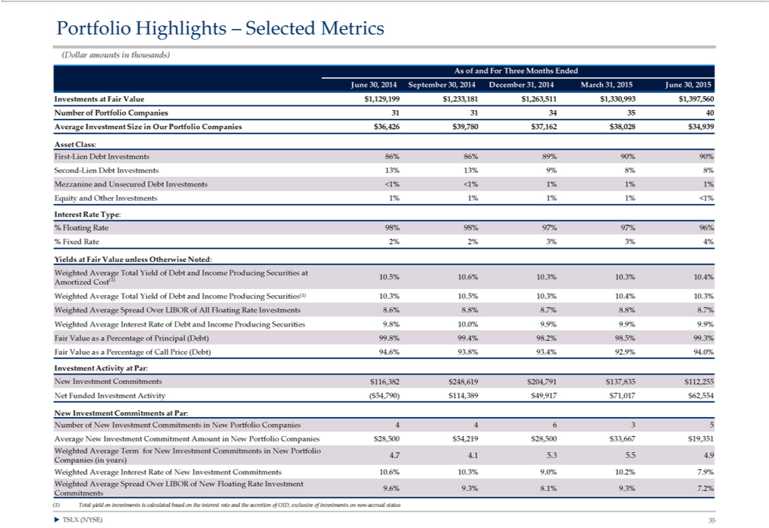

(DollarPortfolioamountsHighlightsinthousands)–Selected Metrics
As of and For Three Months Ended
June 30, 2014 September 30, 2014 December 31, 2014 March 31, 2015 June 30, 2015
NumberInvestmentsofPortfolioatFairValueCompanies$1,129,1993131$341,233,1813540 $1,263,511 $1,330,993 $1,397,560
^{Asset}
verageClass:Investment Size in Our Portfolio Companies $36,426 $39,780 $37,162 $38,028 $34,939
InterestFirst-LienRateDebtType:Investments 86% 86% 89% 90% 90% Second-Lien Debt Investments 13% 13% 9% 8% 8% Mezzanine and Unsecured Debt Investments <1% <1% 1% 1% 1% Equity and Other Investments 1% 1% 1% 1% <1%
_{% Fixed}loating Rate 98% 98% 97% 97% 96%
Rate 2% 2% 3% 3% 4%
Yields at Fair Value unless Otherwise Noted:
Weighted Average Total Yield of Debt and Income Producing Securities at
(1) 10.5% 10.6% 10.3% 10.3% 10.4% Amortized Cost
Weighted Average Total Yield of Debt and Income Producing Securities(1) 10.3% 10.5% 10.3% 10.4% 10.3% Weighted Average Spread Over LIBOR of All Floating Rate Investments 8.6% 8.8% 8.7% 8.8% 8.7% Weighted Average Interest Rate of Debt and Income Producing Securities 9.8% 10.0% 9.9% 9.9% 9.9% Fair Value as a Percentage of Principal (Debt) 99.8% 99.4% 98.2% 98.5% 99.3% Fair Value as a Percentage of Call Price (Debt) 94.6% 93.8% 93.4% 92.9% 94.0% Investment Activity at Par:
^{ewt}
FundedInvestmentInvestmentCommitmentsActivity$(116,382$54,790)$248,619$114,389$204,791$49,917 $$137,83571,017$$62,554112,255
_{Number}Investment Commitments at Par:
of New Investment Commitments in New Portfolio Companies 4 4 6 $3^{28,500}
Average New Investment Commitment Amount in New Portfolio Companies $54,219 $28,500 $33,667 $19,351 Weighted Average Term for New Investment Commitments in New Portfolio 4.7 4.1 5.3 5.5 4.9
Companies (in years)
Weighted Average Interest Rate of New Investment Commitments 10.6% 10.3% 9.0% 10.2% 7.9% Weighted Average Spread Over LIBOR of New Floating Rate Investment 9.6% 9.3% 8.1% 9.3% 7.2% Commitments
(1)^{TSLX}otal yield on investments is calculated based on the interest rate and the accretion of OID, exclusive of investments on non-accrual status
? (NYSE) 35

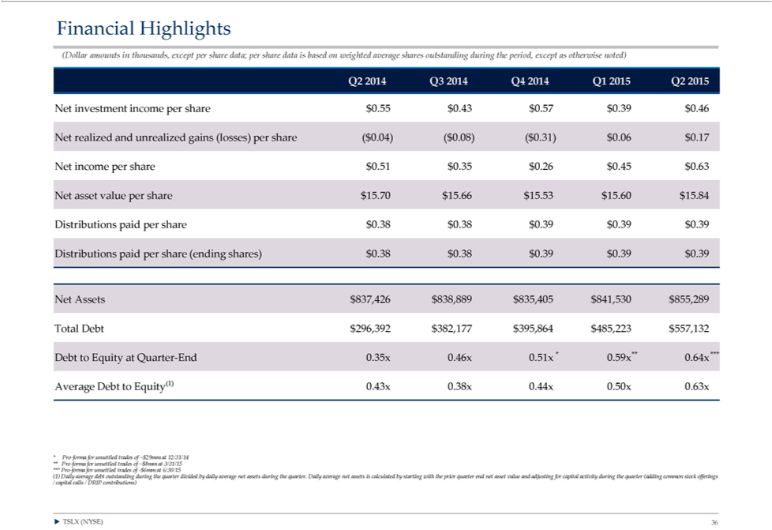

Financial Highlights
(Dollar amounts in thousands, except per share data; per share data is based on weighted average shares outstanding during the period, except as otherwise noted)
Q2 2014 Q3 2014 Q4 2014 Q1 2015 Q2 2015 |  |  |  |  |  | $0.06 | $0.17 Net income per share $0.51 | $0.35 | $0.26 | $0.45 | $0.63 Net asset value per share $15.70
Net investment income per share $0.55 $0.43 $0.57 $0.39 $0.46 Net realized and unrealized gains (losses) per share ($0.04) ($0.08) ($0.31)
$15.66 $15.53 $15.60 $15.84 Distributions paid per share $0.38 $0.38 |  |  |  |  | $0.39 $0.39 $0.39 Distributions paid per share (ending shares) $0.38 | $0.38 | $0.39 $0.39 $0.39
Net Assets $837,426 | $838,889 | $835,405 | $841,530 | $855,289
Total Debt $296,392 | $382,177 | $395,864 | $485,223 | $557,132
Debt to Equity at Quarter-End 0.35x 0.46x 0.51x * 0.59x** 0.64x ***
Average Debt to Equity(1) 0.43x 0.38x 0.44x 0.50x 0.63x
Pro-forma for unsettled trades of ~$29 |  |  | 12/31/14
** Pro-forma for unsettled_{outstanding}radesof ~$8mm at 3/31/15 *** Pro-forma for unsettled trades of -$6mm at 6/30/15
(1) Daily average debt during the quarter divided by daily average net assets during the quarter. Daily average net assets is calculated by starting with the prior quarter end net asset value and adjusting for capital activity during the quarter (adding common stock offerings / capital calls / DRIP contributions)
? TSLX (NYSE) 36

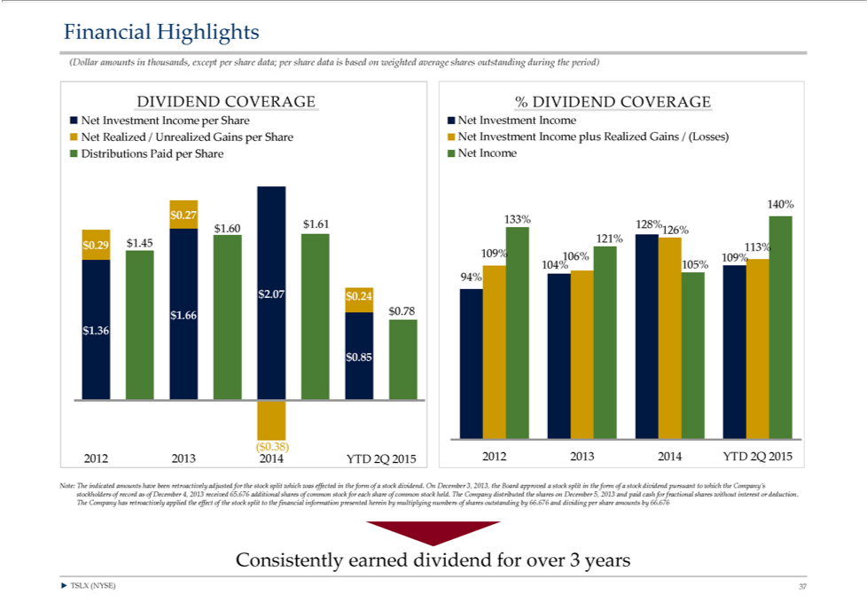

Financial Highlights
(Dollar amounts in thousands, except per share data; per share data is based on weighted average shares outstanding during the period)
DIVIDEND COVERAGE % DIVIDEND COVERAGE
Investment Income per Share Net Investment Income
Net Realized / Unrealized Gains per Share Net Investment Income plus Realized Gains / (Losses) Distributions Paid per Share Net Income
140% | 128%
$0.27 | 128% | 126% 121%
133%60 | 09 | 126% 121%
$0.29 | $1.45
113% 109% 106% 109% 104% 105% 94%
2 07 | 24
66 | $0.78
1 36
$0.85
($0.38)
2012 2013 2014 YTD 2Q 2015 2012 2013 2014 YTD 2Q 2015
Note: The indicated amounts have been retroactively adjusted for the stock split which was effected in the form of a stock dividend. On December 3, 2013, the Board approved a stock split in the form of a stock dividend pursuant to which the Company’_{interest}stockholders of record as of December 4, 2013 received 65.676 additional shares of common stock for each share of common stock held. The Company distributed the shares on December 5, 2013 and paid cash for fractional shares
without or deduction.
The Company has retroactively applied the effect of the stock split to the financial information presented herein by multiplying numbers of shares outstanding by 66.676 and dividing per share amounts by 66.676 Consistently earned dividend for over 3 years
? TSLX (NYSE) 37

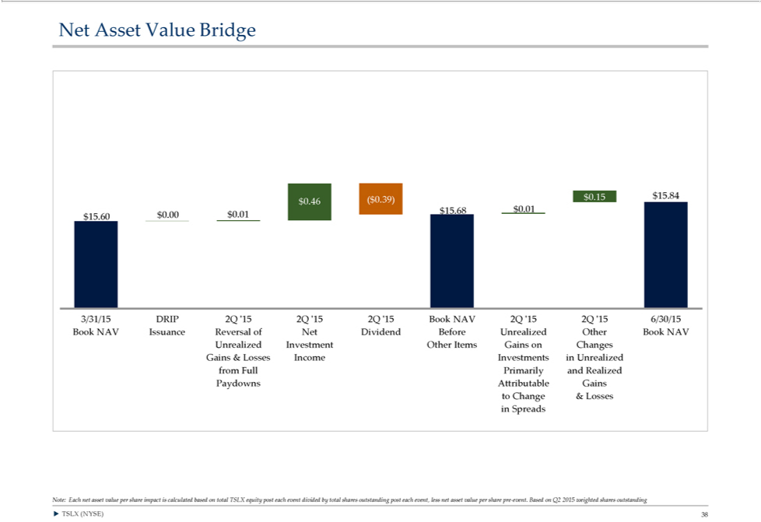

Net^{0.}15Asset$15.84Value Bridge
⁸
$15.6046($$0.39)0.00¹ $0.01
3/31/15 DRIP 2Q ‘15 2Q ‘15 2Q ‘15 Book NAV 2Q ‘15 2Q ‘15 6/30/15 Book NAV Issuance Reversal of Net Dividend Before Unrealized Other Book NAV
Unrealized Investment Other Items Gains on Changes Gains & Losses Income Investments in Unrealized from Full Primarily_{outstanding}Realized Paydowns Attributable Gains to Change & Losses in Spreads
Note: Each net asset value per share impact is calculated based on total TSLX equity post each event divided by total shares post each event, less net asset value per share pre-event. Based on Q2 2015 weighted shares outstanding ? TSLX (NYSE) 38

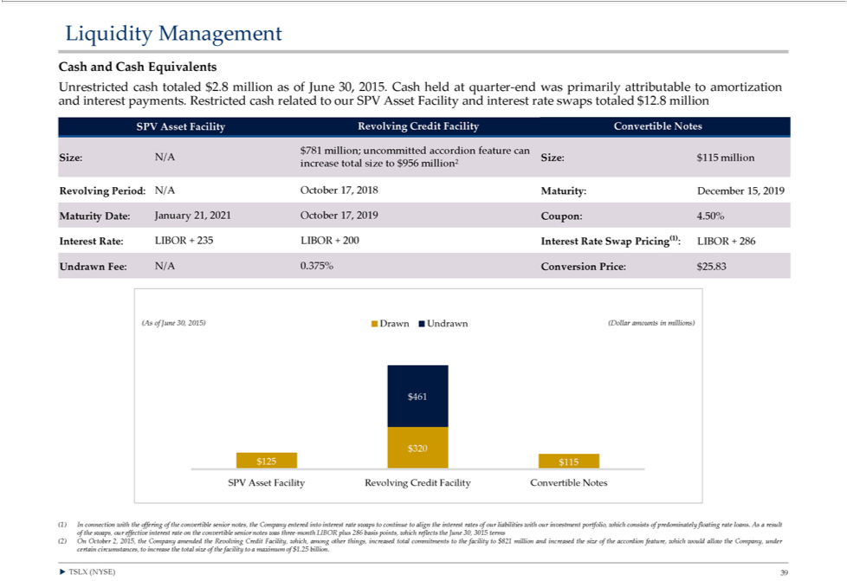

CashLiquidityand CashManagementEquivalents
Unrestricted cash totaled $2.8 million as of June 30, 2015. Cash held at quarter-end was primarily attributable to amortization and interest payments. Restricted cash related to our SPV Asset Facility and interest rate swaps totaled $12.8 million SPV Asset Facility Revolving Credit Facility Convertible Notes
$781 million; uncommitted accordion feature can
Size: N/A Size: $115 million increase total size to $956 million²
Revolving Period: N/A October 17, 2018 Maturity: December 15, 2019
_{Interest}Maturiy Date: January 21, 2021 October 17, 2019 Coupon: 4.50%
UndrawnRate:Fee:LIBORN/A²⁰¹⁵⁾.375%+235 ConversionLIBOR+200Price:Interest$25.83Rate Swap Pricing(1): LIBOR + 286
(As461of June 30, Drawn Undrawn (Dollar amounts in millions)
$0 $320 $125 $115
SPV Asset Facility Revolving Credit Facility Convertible Notes
(1) In connection with the offering of the convertible senior notes, the Company entered into interest rate swaps to continue to align the interest rates of our liabilities with our investment portfolio, which consists of predominately floating rate loans. As_{Facility}result of the swaps, our effective interest rate on the convertible senior notes was three-month LIBOR plus 286 basis points, which reflects the June 30, 3015 terms (2) On October 2, 2015, the Company amended the Revolving

Credit , which, among other things, increased total commitments to the facility to $821 million and increased the size of the accordion feature, which would allow the Company, under certain circumstances, to increase the total size of the facility to a maximum of $1.25 billion.
? TSLX (NYSE) 39

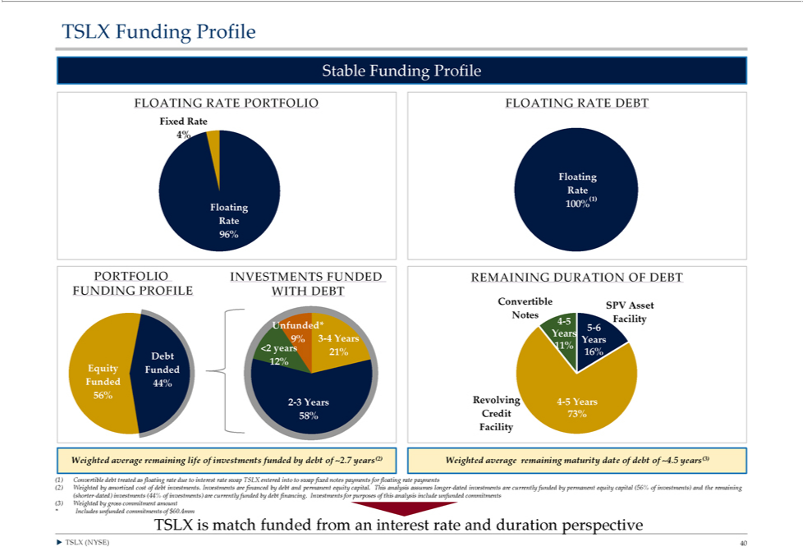

^{TSLX} Funding Profile
Stable
LOATING RATE PORTFOLIO FLOATING RATE DEBT
_{4%Fixed} Rate
Floating Rate
(1)
100% Floating Rate 96%
ConvertiblePORTFOLIO INVESTMENTS FUNDED REMAINING DURATION OF DEBT FUNDING PROFILE WITH DEBT
YearsSPVAsset Notes 4-5 Facility Unfunded* 5-6
9% 3-4 Years 11% Years <2 years 16% 21% Debt Equity 12% Funded Funded 44% 56% 2-3 Years Revolving 4-5 Years 58% Credit 73% Facility Weighted average remaining life of investments funded by debt of ~2.7 years(2) Weighted average remaining maturity date of debt of ~4.5 years(3)
⁽²⁾1) Convertible debt treated as floating rate due to interest rate swap TSLX entered into to swap fixed notes payments for floating rate payments
Weighted by amortized cost of debt investments. Investments are financed by debt and permanent equity capital. This analysis assumes longer-dated investments are currently funded by permanent equity capital (56% of investments) and the remaining (shorter-dated) investments (44% of investments) are currently funded by debt financing. Investments for purposes of this analysis include unfunded commitments (3) Weighted by gross commitment amount
* Includes unfunded commitments of $60.4mm
?TSLXTSLXis (NYSE)matchfunded40 from an interest rate and duration perspective

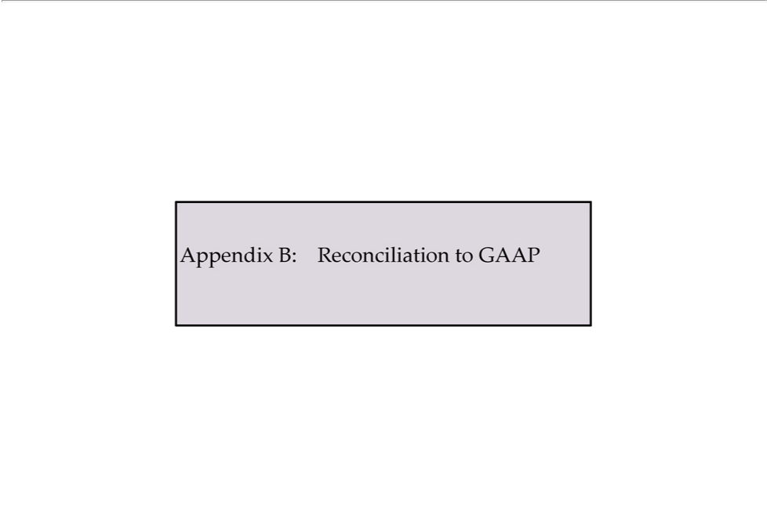

Appendix B: Reconciliation to GAAP

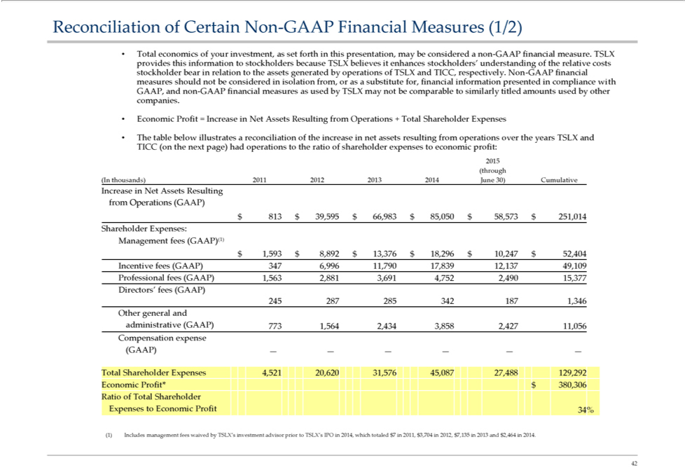

Reconciliation of Certain Non-GAAP Financial Measures (1/2)
Total economics of your | as set forth in this presentation, may be considered a non-GAAP financial measure. TSLX provides this information to stockholders because TSLX believes it enhances stockholders’ understanding of the
relative costs stockholder bear | relation to the assets generated by operations of TSLX and TICC, respectively. Non-GAAP financial measures should not be considered in isolation from, or as a substitute for, financial information presented
in compliance with GAAP and non-GAAP financial measures as used by TSLX may not be comparable to similarly titled amounts used by other companies.
Economic Profit = Increaseinvestment,NetAssets Resulting from Operations + Total Shareholder Expenses
The table below illustrates a reconciliation of the increase in net assets resulting from operations over the years TSLX and TICC (on the next page) had operations to the ratio of shareholder expenses to economic profit:
2015 (through
(In thousands) 2011 2012 2013 2014 June 30) Cumulative |  | $ 8,892 $ 13,376 $ 18,296 $ 10,247 $ 52,404 Incentive fees
Increase in Net Assets Resulting from Operations (GAAP) $ 813 $ 39,595 $ 66,983 $ 85,050 $ 58,573 $ 251,014 Shareholder Expenses: Management fees (GAAP)(1) $ 1,593 |  | $ 8,892 $ 13,376 $ 18,296 $ 10,247 $ 52,404 Incentive fees
(GAAP) 347 6,996 11,790 17,839 12,137 49,109 Professional fees (GAAP) 1,563 2,881 3,691 4,752 2,490 15,377
Directors’ fees (GAAP)
245 287 285 342 187 1,346
Other general and administrative (GAAP) 773 1,564 2,434 3,858 2,427 11,056 Compensation expense (GAAP) — — — — — —

Total Shareholder Expenses 4,521 20,620 31,576 45,087 27,488 129,292 Economic Profit* $ 380,306 Ratio of Total Shareholder Expenses to Economic Profit 34%
42(1) Includes management fees waived by TSLX’s investment advisor prior to TSLX’s IPO in 2014, which totaled $7 in 2011, $3,704 in 2012, $7,135 in 2013 and $2,464 in 2014.

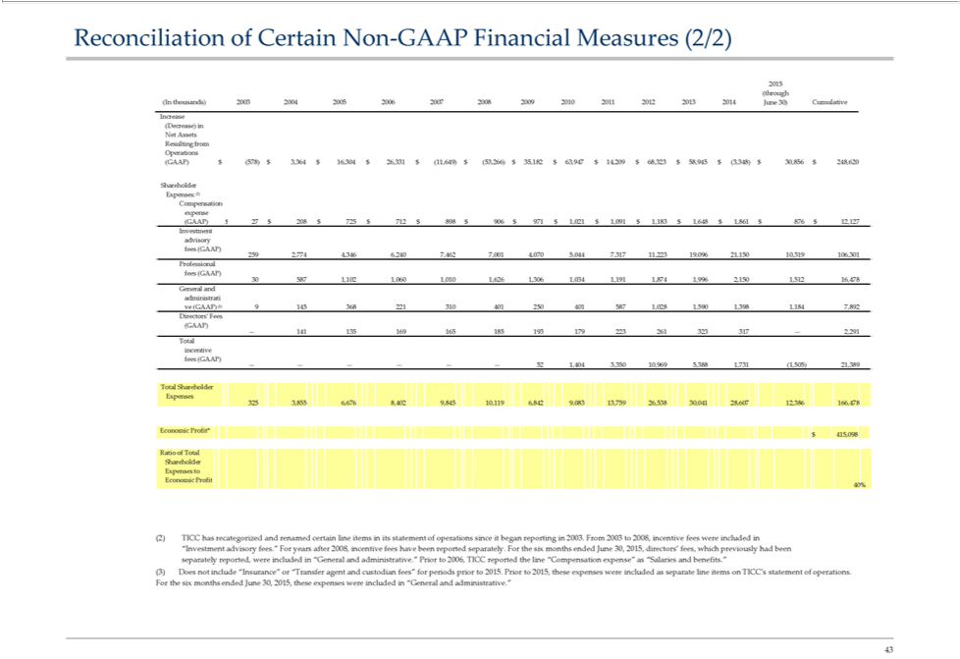

Reconciliation of Certain Non-GAAP Financial Measures (2/2)
2015 (through
(In thousands) 2003 2004 2005 2006 2007 2008 2009 2010 2011 2012 2013 2014 June 30) Cumulative Increase (Decrease) in Net Assets Resulting from Operations (GAAP) $ (578) $ 3,364 $ 16,304 $ 26,331 $ (11,649) $ (53,266) $ 35,182 $ 63,947 $ 14,209 $ 68,323 $ 58,945 $ (3,348) $ 30,856 $ 248,620
^{Expense}CompensationShareholder^{:(2)} expense
(GAAP) $ 27 $ 208 $ 725 $ 712 $ 898 $ 906 $ 971 $ 1,021 $ 1,091 $ 1,183 $ 1,648 $ 1,861 $ 876 $ 12,127 Investment advisory fees (GAAP) 259 2,774 4,346 6,240 7,462 7,001 4,070 5,044 7,317 11,223 19,096 21,150 10,319 106,301 Professional fees (GAAP)
30 587 1,102 1,060 1,010 1,626 1,306 1,034 1,191 1,874 1,996 2,150 1,512 16,478 General and administrati ve (GAAP) (3) 9 145 368 221 310 401 250 401 587 1,028 1,590 1,398 1,184 7,892 Directors’ Fees
(GAAP)
— 141 135 169 165 185 193 179 223 261_{1,649}323 317 — 2,291
Total incentive fees (GAAP) $ 16, 26, (1 53_{1,731}266) $ $ $ $ 58, (3, $
Total—— Shareholder———— Expenses521,404 3,350 10,969 5,388 (1,505) 21,389
Economic3253,855 6,676Profit*8,402 9,845 10,119 6,842 9,083 13,759 26,538 30,041 28,607 12,386 166,478
$ 415,098
EconomicRatioofTotalProfitShareholder Expenses to
40%
(2) TICC has recategorized and renamed certain line items in its statement of operations since it began reporting in 2003. From 2003 to 2008, incentive fees were included in
“Investment advisory fees.” For years after 2008, incentive fees have been reported separately. For the six months ended June 30, 2015, directors’ fees, which previously had been separately reported, were included in “General and administrative.” Prior to 2006, TICC reported the line “Compensation expense” as “Salaries and benefits.”
(3) Does not include “Insurance” or “Transfer agent and custodian fees” for periods prior to 2015. Prior to 2015, these expenses were included as separate line items on TICC’s statement of operations. For the six months ended June 30, 2015, these expenses were included in “General and administrative.”
43

