[Letterhead of TPG Specialty Lending, Inc.]

May 9, 2014

VIA EDGAR

Securities and Exchange Commission

100 F Street, N.E.

Washington, D.C. 20549

Re: TPG Specialty Lending, Inc.

Rule 17g-1(g) Fidelity Bond Filing

Ladies and Gentlemen:

On behalf of TPG Specialty Lending, Inc. (the “Company”), enclosed herewith for filing, pursuant to Rule 17g-1(g) under the Investment Company Act of 1940, are the following:

- copy of the fidelity bond covering the Company, which includes a statement as to the period for which premiums have been paid; and

- a Certificate of the Secretary of the Company containing the resolutions of the Board of Directors approving the amount, type, form and coverage of the Fidelity Bond and a statement as to the period for which premiums have been paid.

If you have any questions regarding this submission, please do not hesitate to call me at (415) 743-1534.

Very truly yours,

TPG Specialty Lending, Inc.

/s/ Jennifer Mello

Jennifer Mello

Vice President and Secretary

Enclosures

CERTIFICATE OF SECRETARY

The undersigned, Jennifer Mello, Vice President and Secretary of TPG Specialty Lending, Inc., a Delaware corporation (the “Company”), does hereby certify that:

- This certificate is being delivered to the Securities and Exchange Commission (the “SEC”) in connection with the filing of the Company’s fidelity bond (the “Bond”) pursuant to Rule 17g-1 of the Investment Company Act of 1940, as amended, and the SEC is entitled to rely on this certificate for purposes of the filing.

- The undersigned is the duly elected, qualified and acting Secretary of the Company, and has custody of the corporate records of the Company and is a proper officer to make this certification.

- Attached hereto as Exhibit A is a copy of the resolutions approved by the Board of Directors of the Company, including a majority of the Board of the Directors who are not “interested persons” of the Company, approving the amount, type, form and coverage of the Bond.

- Premiums have been paid for the period March 8, 2014 to March 8, 2015.

IN WITNESS WHEREOF, the undersigned has caused this certificate to be executed this 9th day of May, 2014.

/s/ Jennifer Mello

Jennifer Mello

Vice President and Secretary

Exhibit A

Excerpt from the minutes of the

meeting of the Board of Directors

of TPG Specialty Lending, Inc. held

on February 13, 2014

Approval of the Fidelity Bond

WHEREAS, Section 17(g) of the Investment Company Act of 1940 (the “1940 Act”) and Rule 17g-1(a) thereunder require a BDC, such as the Company, to provide and maintain a bond which shall be issued by a reputable fidelity insurance company, authorized to do business in the place where the bond is issued, to protect the Company against larceny and embezzlement, covering each officer and employee of the BDC who may singly, or jointly with others, have access to the securities or funds of the BDC, either directly or through authority to draw upon such funds of, or to direct generally, the disposition of such securities, unless the officer or employee has such access solely through his position as an officer or employee of a bank (each, a “covered person”); and

WHEREAS, Rule 17g-1 specifies that the bond may be in the form of (i) an individual bond for each covered person, or a schedule or blanket bond covering such persons, (ii) a blanket bond which names the Company as the only insured (a “single insured bond”), or (iii) a bond which names the Company and one or more other parties as insureds (a “joint insured bond”), as permitted by Rule 17g-1; and

WHEREAS, Rule 17g-1 requires that a majority of the Board of Directors who are not “interested persons” of the Company as defined in Section 2(a)(19) of the 1940 Act approve periodically (but not less than once every 12 months) the reasonableness of the form and amount of the bond, with due consideration to the value of the aggregate assets of the Company to which any covered person may have access, the type and terms of the arrangements made for the custody and safekeeping of such assets, and the nature of securities and other investments to be held by the Company, and pursuant to factors contained in the Rule which are described in the accompanying memorandum attached hereto; and

WHEREAS, under Rule 17g-1, the Company is required to make certain filings with the SEC and give certain notices to each member of the Board of Directors in connection with the bond, and designate an Officer who shall make such filings and give such notices;

NOW THEREFORE BE IT RESOLVED, that having considered the expected aggregate value of the securities and funds of the Company to which Officers or employees of the Company may have access (either directly or through authority to draw upon such funds or to direct generally the disposition of

such securities), the type and terms of the arrangements made for the custody of such securities and funds, the nature of securities and other investments to be held by the Company, the accounting procedures and controls of the Company, the nature and method of conducting the operations of the Company, and the requirements of Section 17(g) of the 1940 Act and Rule 17g-1 thereunder, it is determined that the amount, type, form, premium and coverage, covering the Officers and employees of the Company and insuring the Company against loss from fraudulent or dishonest acts, including larceny and embezzlement, issued by Chartis, having an aggregate coverage of $10,000,000 (the “Fidelity Bond”), is reasonable, and the Fidelity Bond be, and hereby is, approved by the Board of Directors of the Company; and

FURTHER RESOLVED, that having considered the expected aggregate value of the securities and funds of the Company to which Officers or employees of the Company may have access (either directly or through authority to draw upon such funds or to direct generally the disposition of such securities), the type and terms of the arrangements made for the custody of such securities and funds, the nature of securities and other investments to be held by the Company, the accounting procedures and controls of the Company, the nature and method of conducting the operations of the Company, and the requirements of Section 17(g) of the 1940 Act and Rule 17g-1 thereunder, it is determined that the amount, type, form, premium and coverage, covering the Officers and employees of the Company and insuring the Company against loss from fraudulent or dishonest acts, including larceny and embezzlement, issued by Chartis, having an aggregate coverage of $10,000,000 is reasonable, and the Fidelity Bond be, and hereby is, approved by a majority of the Independent Directors; and

FURTHER RESOLVED, that the Officers of the Company be, and they hereby are, authorized to take all appropriate actions, with the advice of legal counsel to the Company, to provide and maintain the Fidelity Bond on behalf of the Company; and

FURTHER RESOLVED, that the Chief Compliance Officer of the Company be, and hereby is, designated as the party responsible for making the necessary filings and giving the notices with respect to such bond required by paragraph (g) of Rule 17g-1 under the 1940 Act.

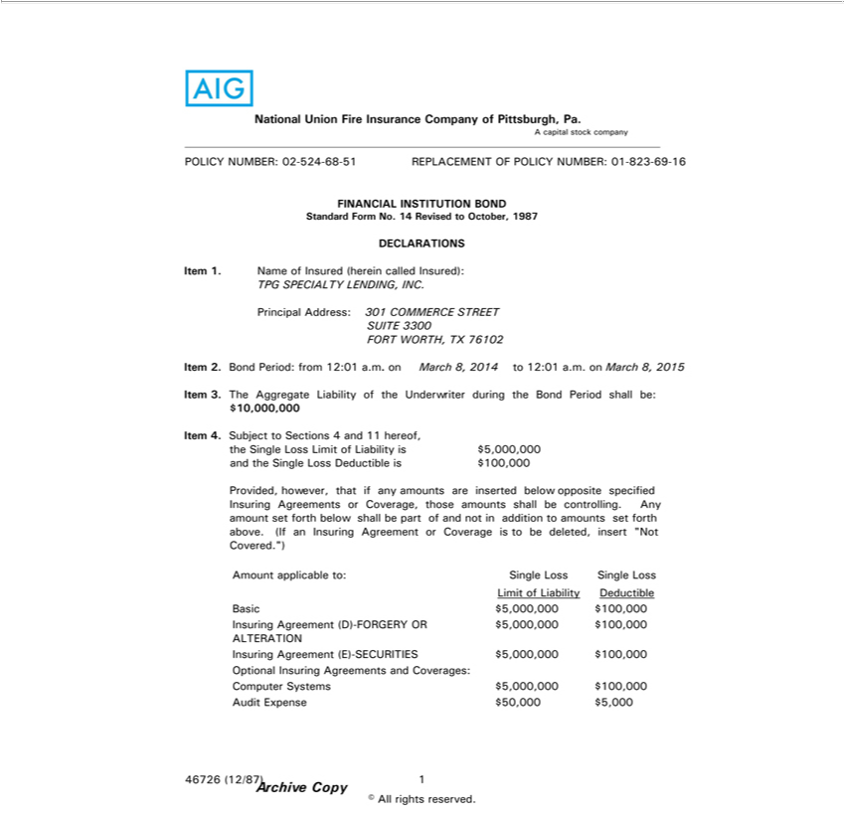

AIG
ANationalcapital Unionstock companyFireInsurance Company of Pittsburgh, Pa.
POLICY NUMBER: 02-524-68-51 REPLACEMENT OF POLICY NUMBER: 01-823-69-16
FINANCIAL INSTITUTION BOND
Standard Form No. 14 Revised to October, 1987
DECLARATIONS
Item 1. Name of Insured (herein called Insured):
TPG SPECIALTY LENDING, INC.
Principal2BondAddress:Period:301fromCOMMERCE12:01a.m. onSTREETMarch SUITE8,20143300to12:01FORTa.m.WORTH,onMarchTX8,761022015
^{Item .}
43 SubjectTheAggregatetoSectionsLiability4andof11thehereof,Underwriter during the Bond Period shall be: $10,000,000
andthe SingletheSingleLossLossLimitDeductibleofLiabilityis $is100,000$5,000,000

Provided, however, that if any amounts are inserted below opposite specified Insuring Agreements or Coverage, those amounts shall be controlling. Any amount set forth below shall be part of and not in addition to amounts set forth above. (If an Insuring Agreement or Coverage is to be deleted, insert “Not Covered.”)
LimitAmountof applicableLiabilityDeductibleto:Single Loss Single Loss
Basic $5,000,000 $100,000
Insuring Agreement (D)-FORGERY OR $5,000,000 $100,000
ALTERATION
OptionalInsuring AgreementInsuringAgreements(E)-SECURITIESandCoverages:$5,000,000 $100,000
AuditComputerExpenseSystems$50,000$5,000,000$5,000 $100,000
Archive46726(12/87)1Copy

© All rights reserved.

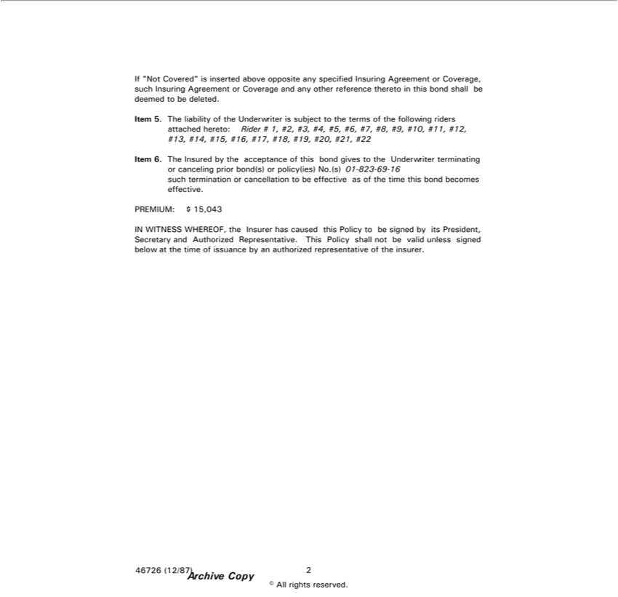

f “Not Covered” is inserted above opposite any specified Insuring Agreement or Coverage, such Insuring Agreement or Coverage and any other reference thereto in this bond shall be deemed to be deleted. ^{Item} 5. The liability of the Underwriter is subject to the terms of the following riders attached hereto: Rider # 1, #2, #3, #4, #5, #6, #7, #8, #9, #10, #11, #12, #13, #14, #15, #16, #17, #18, #19, #20, #21, #22 6 The Insured by the acceptance of this bond gives to the Underwriter terminating or canceling prior bond(s) or policy(ies) No.(s) 01-823-69-16 such termination or cancellation to be effective as of the

PREMIUM:timethisbond$ 15,043becomes effective.

IN WITNESS WHEREOF, the Insurer has caused this Policy to be signed by its President, Secretary and Authorized Representative. This Policy shall not be valid unless signed below at the time of issuance by an authorized representative of the insurer.
Archive46726(12/87)2Copy
© All rights reserved.

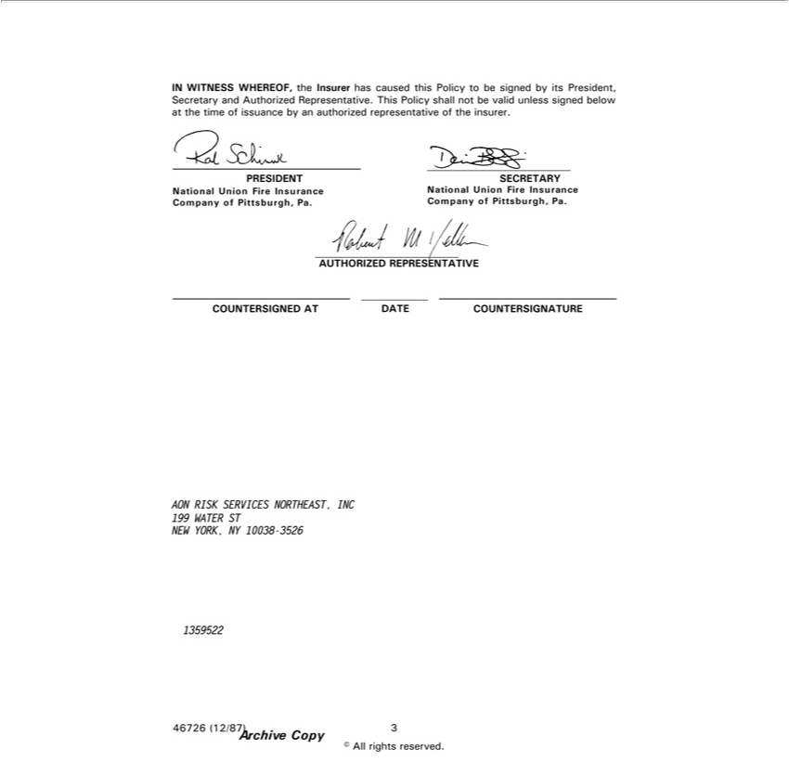

IN WITNESS WHEREOF, the Insurer has caused this Policy to be signed by its President, Secretary and Authorized Representative. This Policy shall not be valid unless signed below at the time of issuance by an authorized representative of the insurer.
PRESIDENT SECRETARY
CompanyNationalUnionofPittsburgh,FireInsurancePa.CompanyNationalofUnionPittsburgh,FireInsurancePa.
AUTHORIZEDCOUNTERSIGNED_{REPRESENT}ADATEATIVECOUNTERSIGNATURE
NEWAON RISKYORK,SERVICESNY10038NORTHEAST,-3526 INC 199 WATER ST
1359522
Archive46726(12/87)3Copy

© All rights reserved.

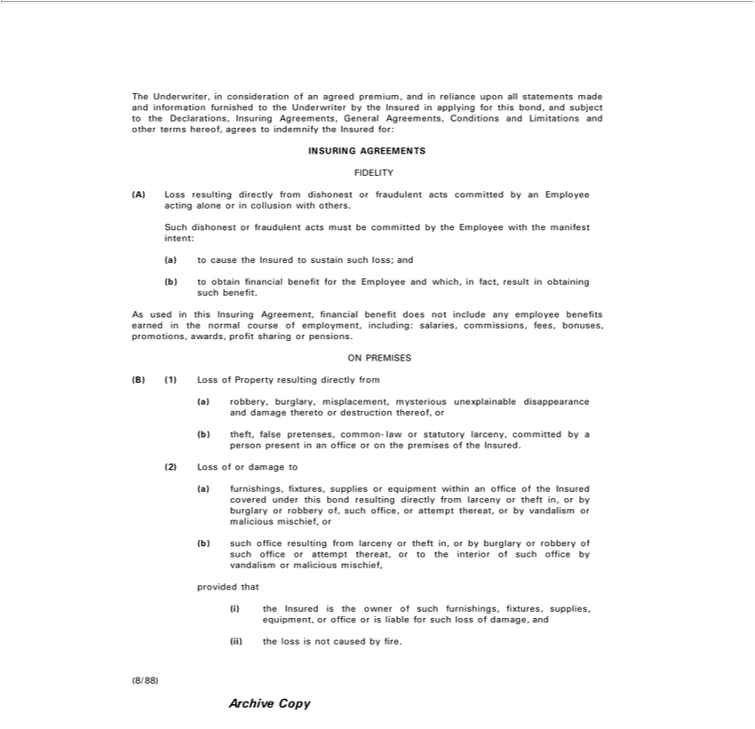

The Underwriter, consideration of an agreed premium, and in reliance upon all statements made and information furnished to the Underwriter by the Insured in applying for this bond, and subject to the
Declarations, Insuring Agreements, General Agreements, Conditions and Limitations and other terms hereof, agrees to indemnify the Insured for:
INSURING AGREEMENTS
FIDELITY
(A) Loss resulting directly from dishonest or fraudulent acts committed by an Employee acting alone or in collusion with others.
Such dishonest or fraudulent acts must be committed by the Employee with the manifest intent:
a) to cause the Insured to sustain such loss; and
(b) to | financial benefit for the Employee and which, in fact, result in obtaining such benefit.
As usedobtainthis Insuring Agreement, financial benefit does not include any employee benefits earned in the normal course of employment, including: salaries, commissions, fees, bonuses, promotions, awards,
profit sharing or pensions.
ON PREMISES
B) (1) Loss of Property resulting directly from |  | and damage thereto or | thereof, or
a) robbery, burglary misplacement, mysterious unexplainable |  | and damage thereto or | thereof, or
b) pretenses, disappearance destruction
²⁾ theft, false common-law or statutory larceny, committed by person present in an office or the premises of the Insured.
_{(a)} Loss of or damage to
furnishings, fixtures, supplies or equipment within an office of the Insured covered under this bond resulting directly from larceny or theft in, or by burglary or robbery of, such office, or attempt thereat, or by vandalism or malicious mischief, or
(b) such office resulting from larceny or theft in, or by burglary or robbery of such office or attempt thereat, or to the interior of such office by vandalism or malicious mischief, provided that
^{ii)}the Insured is the owner of such furnishings, fixtures, supplies, equipment, or office or is liable for such loss of damage, and _{(8/88)}the loss is not caused by fire.
Archive Copy

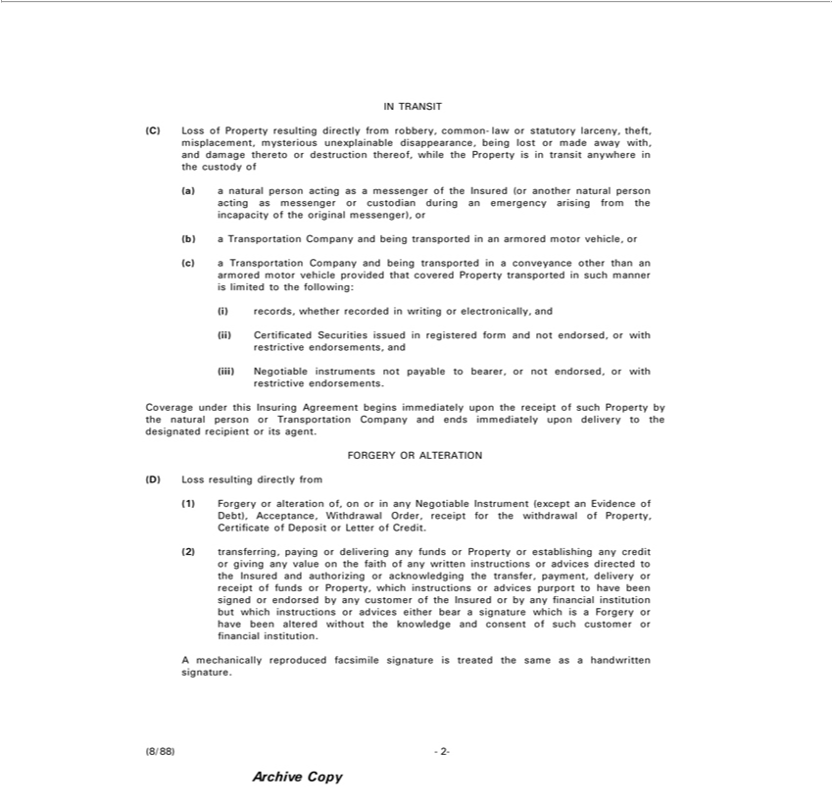

IN TRANSIT
(C) Loss of Property resulting directly from robbery, common-law or statutory larceny, theft, misplacement, mysterious unexplainable disappearance, being lost or made away with, and damage thereto or
destruction thereof, while the Property is in transit anywhere in |  | custody of
a) a natural person acting as a messenger of the Insured (or another natural person acting as messenger or custodian during an emergency arising from the incapacity of the original messenger), or
b) a Transportation Company and being transported in an armored motor vehicle, or
a Transportation Company and being transported in a conveyance other than an armored motor vehicle provided that covered Property transported in such manner is limited to the following:
c) records, whether recorded in | or electronically, and | or with restrictive endorsements, and
Certificated Securities issuedwritingregistered form and not |  | or with restrictive endorsements, and
(iii) Negotiable instruments not payable to bearer, or not endorsed,endorsed, with restrictive endorsements.
Coverage under this Insuring Agreement begins immediately upon the receipt of such Property by the natural person or Transportation Company and ends immediately upon delivery to the designated recipient
or its agent.
FORGERY OR ALTERATION
D) Loss resulting directly from | any Negotiable Instrument (except an Evidence of Debt), Acceptance, Withdrawal Order, receipt for the withdrawal of Property, Certificate of Deposit Letter of Credit.
1) Forgery or alteration of, on or
(2) transferring, paying or delivering any funds or Property or establishing any credit or giving any value on the faith of any written instructions_{endorsed}advices directed to the Insured and authorizing or
acknowledging the transfer, payment, delivery or receipt of funds or Property, which instructions or advices purport to have been signed or by any customer of the Insured or by any financial institution but which instructions or advices either_{signature}bearsignature w_{the}ich is a Forgery or have been altered without the knowledge and consent of such customer or financial institution.
(8/88)Amechanically-2- reproduced facsimile is treated same as a handwritten signature.
Archive Copy

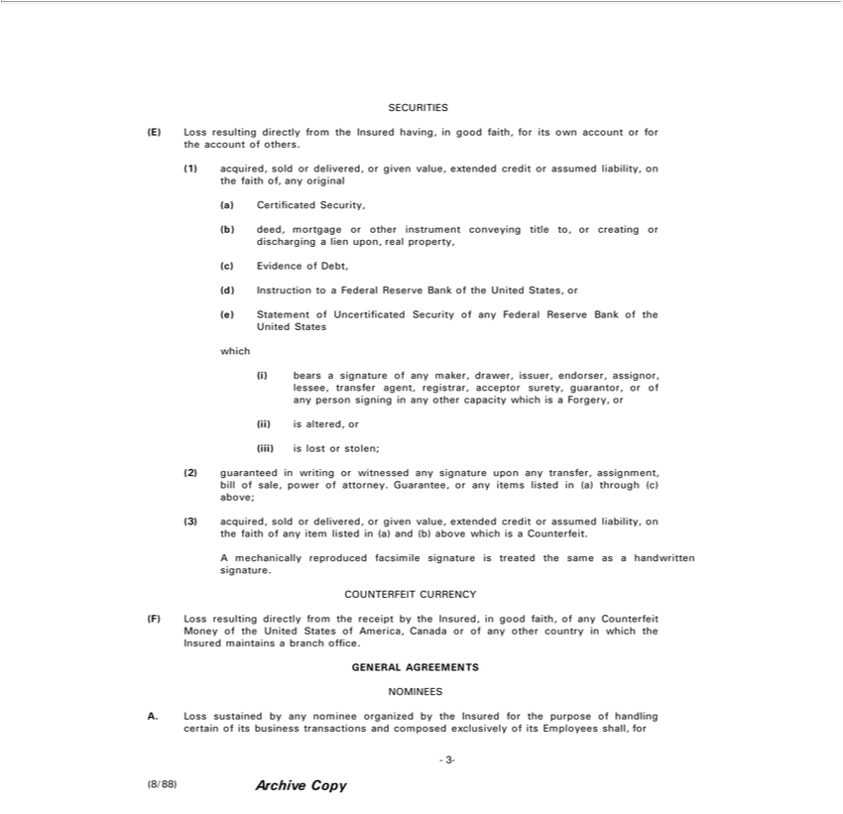

SECURITIES
E) Loss resulting directly from the Insured having, in good faith, for its own account or for the account of others.
1) acquired, sold or |  | or given value, extended credit or assumed liability, on the faith of, any original
a) | Certificated Securitydelivered,
b) deed, mortgage or other instrument conveying title to, or creating or discharging a lien upon, real property,
c) | Evidence of Debt,
d) | Ins ruction to Federal Reserve Bank of the United States, or
(e) Statement of Uncertificated |  | Security of any Federal Reserve Bank of the United States
which
 | bears signature of any maker, drawer, issuer, endorser, assignor, lessee, transfer agent, registrar, acceptor surety, guarantor, or of any person signing in any other capacity which is a Forgery, or
) is altered, or
iii) is lost or stolen; |  |  | bill of sale, power of attorney. Guarantee, or any items | in (a) through (c) above;
2) guaranteed in writing or witnessed any signature upon any transfer, |  |  | bill of sale, power of attorney. Guarantee, or any items | in (a) through (c) above;
(3) acquired, sold or delivered, or given value, extended credit or |  |  | assignment,liability on the faith of any item listed in (a) and (b) above whichlisteda Counterfeit.
A mechanically reproduced facsimile signature is treated the sameassumedhandwritten signature.
COUNTERFEIT CURRENCY
(F) Loss resulting directly from the receipt by the Insured, in good faith, of any Counterfeit Money of the United States of America, Canada or of any other country in which the Insured maintains a branch office.
NOMINEESGENERALAGREEMENTS

A. Loss sustained by any nominee organized by the Insured for the purpose of handling certain of its business transactions and composed exclusively of its Employees shall, for all the purposes of this bond and whether or not any partner of such nominee is implicated in such loss, be deemed to be loss sustained by the Insured.

-3-

(8/88) Archive Copy

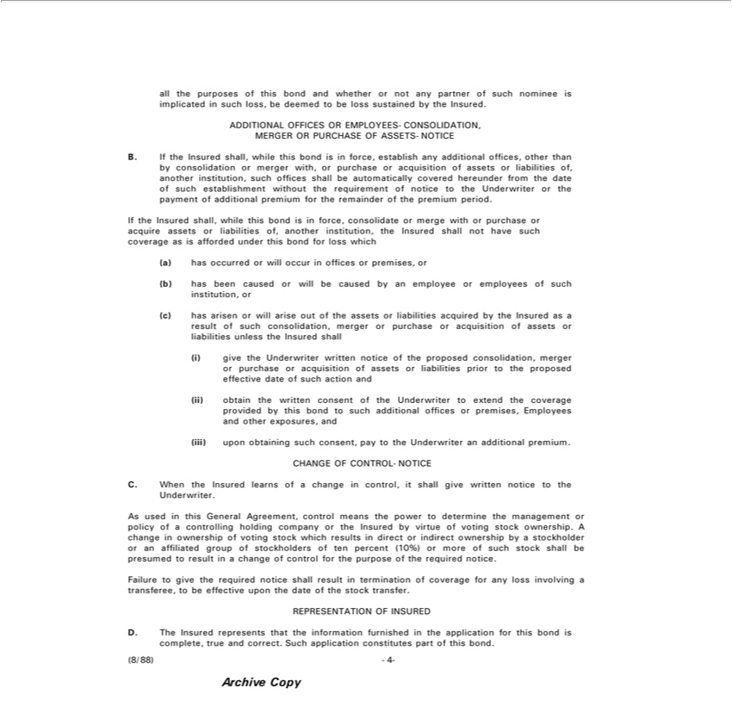

B.ADDITIONALIftheInsuredOFFICESshall,whileORthisEMPLOYEESbondisinforce,-CONSOLIDATION,establishanyadditionalMERGERoffices,OR otherPURCHASEthanby consolidationOFASSETS-NOTICEormerger with, or purchase or acquisition of assets or liabilities of, another institution, such offices shall be automatically covered hereunder from theconsolidateofsuch establishment without the requirement of notice to the Underwriter or the payment of additional premium for the remainder of the premium period.
forIfthelossInsuredwhichshall, while this bond is in force, or merge with or purchase or acquire assets or liabilities of, another institution, the Insured shall not have such coverage as is afforded under this bond b)a) has occurred or will occur in offices or premises, or
c) hashas arisenbeencausedorwillorarisewilloutbe ofcausedtheassetsbyanoremployeeliabilitiesoracquiredemployeesby theofsuchInsuredinstitution,aspurchaseresultor of such consolidation, merger or purchase or acquisition of assets or liabilities unless the Insured shall give the Underwriter written notice of the proposed consolidation, merger or or acquisition of assets or liabilities prior to the proposed effective date of such action and
(iii)obtainupon obtainingthewrittensuchconseconsent,ofthepayUnderwritertotheUnderwritertoextendantheadditionalcoveragepremium.provided by this bond to such additional offices or premises, Employees and other exposures, and CHANGE OF CONTROL-NOTICE

of voting stock which results in direct or indirect ownership by a stockholder ormanagementaffiliated group of stockholders of ten percent (10%) or more of such stock shall be presumed to result in a change of control for the purpose of the required notice.
Failure to give the required notice shall result in termination of coverage for any loss involving a transferee, to be effective upon the date of the stock transfer.
REPRESENTATION OF INSURED
(8/88)D.The-4Insured- represents that the information furnished in the application for this bond is complete, true and correct. Such application constitutes part of this bond.

Archive Copy

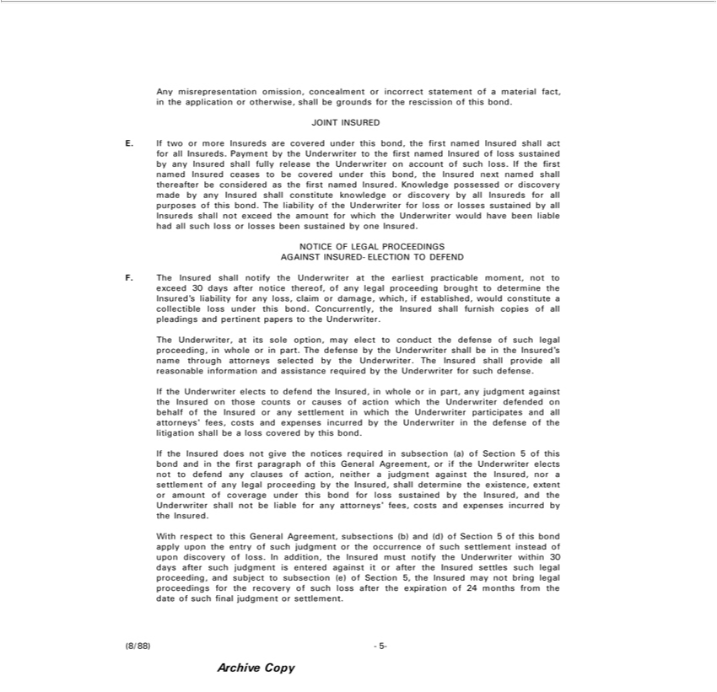

Any misrepresentation omission, concealment or incorrect statement of a material fact, in the application or otherwise, shall be grounds for the rescission of this bond.
JO NT INSURED |  |  |  | first named Insured of loss sustained by any Insured shall fully release
E. If two or more Insureds are covered under this bond, the first named Insured shall act for all Insureds. Payment by the Underwriter to
the Underwriter on account of such loss. If the first named Insured ceases to be covered under this bond, the Insured next named shall thereafter be considered as the first named Insured. Knowledge possessed or
discovery made by any Insured shall constitute knowledge or discovery by all Insureds for all purpos of this bond. The liability of the Underwriter for loss or losses sustained by all Insureds shall not exceed
the amount for which the Underwriter would have been liable had all such loss or losses been sustained by one Insured.
NOTICE OF LEGAL PROCEEDINGS AGAINST INSURED-ELECTION TO DEFEND
F. The Insured shall notify the Underwriter at the earliest practicable moment, not to exceed 30 days after notice thereof, of any legal proceeding brought to determine the Insured’s liability for any loss, claim or
damage, which, if established, would constitute a collectible loss under this bond. Concurrently, the Insured sh ll furnish copies of all pleadings and |  |  |  |  | papers to the Underwriter.
The Underwriter, at its sole option, may elect to conduct the defense of such legal proceeding, in whole or in part. The defense by the Underwriter shallpertinentbe the Insured’s name through attorneys selected by the
Underwrit . The Insured shall provide all reasonable |  | and assistance required by the Underwriter for such defense.
If the Underwriter elects to defend the Insured, in wholeinformationpart, any judgment against the Insured on those counts or causes of action which the Underwriter defended on behalf of the Insured or any
settlement in which the Underwriter participates and all attorneys’ fees, sts and expenses |  |  | by the Underwriter in the defense of the litigation shall be a loss covered by this bond.
If | Insured does not give the notices required in subsection (a) of Section 5 of this bond andincurredthe first paragraph of this General Agreement, or if the Underwriter elects not to defend any clauses of action,
 | a judgment against the Insured, or settlement of any legal proceeding by the Insured, shall determine the existence, extent or amount of coverage under this bond for loss sustained by the Insured, and
neitherUnderwriter shall not be liable for any attorneys’ fees, costs and expenses incurred by the Insured.
W respect to this General Agreement, subsections (b) and (d) of Section 5 of this bond apply upon the entry of such judgment or the occurrence of such settlement instead of upon discovery of loss. In addition, the Insured must notify the Underwriter within 30 days after such judgment is entered against it or after the Insured settles such legal proceeding, and subject to subsection (e) of Section 5, the Insured may not bring legal proceedings for the recovery of such loss after the expiration of 24 months from the date of such final judgment or settlement.
Archive(8/88)-5Copy-

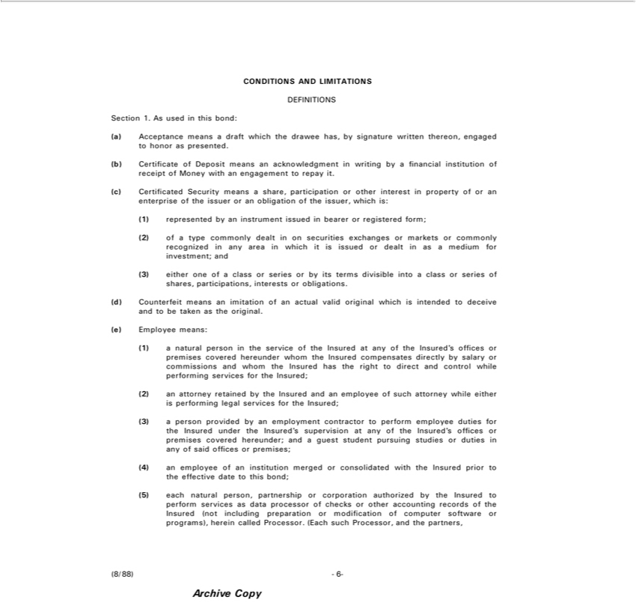

CONDITIONS AND LIMITATIONS
DEFINITIONS
Section 1. As used in this bond:
a) Acceptance means a draft which the drawee has, by signature written thereon, engaged to honor as presented.
b) | of Deposit means an acknowledgment in writing by a |  |  |  | institution of receipt of Money with an engagement to repay it.
c) Certificated Security means a share, participation or other interestfinancialproperty of or an enterprise of the issuer or an obligation of the issuer, which is:
1) represented by an |  | issued in bearer or registered form;
2) of a type commonlyinstrumentdealton securities exchanges or |  |  |  | or commonly recognized in any area which it is issued or dealt in as a medium for investment; and
3) either one of class or series or by its terms divisible intomarketsclass or series of shares, participations, interests or obligations.
d) | Counterf it means an imitation of an actual valid original which is intended to deceive and to be taken as the original.
e) Employee means:
(1) a natural person in the service of the Insured at any of the Insured’s offices or premises covered hereunder whom the Insured compensates directly by salary or commissions and whom the Insured has the
right to direct and control while performing services for the Insured;
2) n attorney retained by the Insured and an employee of such attorney while either is performing legal services for the Insured;
(3) a person provided by an employment |  |  | to perform employee duties for the Insured under the Insured’s supervision at any of the Insured’s offices or premises covered hereunder; and a guest student
pursuing studies or duties |  | any of said offices | premises;
⁽⁵⁾4) an employee of an institution merged contractorconsolidated with the Insured prior to the effective date to this bond;
each natural person, partnership or corporation authorized by the Insured to perform services as data processor of checks or other accounting records of the Insured (not including preparation or modification of computer software or programs), herein called Processor. (Each such Processor, and the partners,

Archive(8/88)-6Copy-

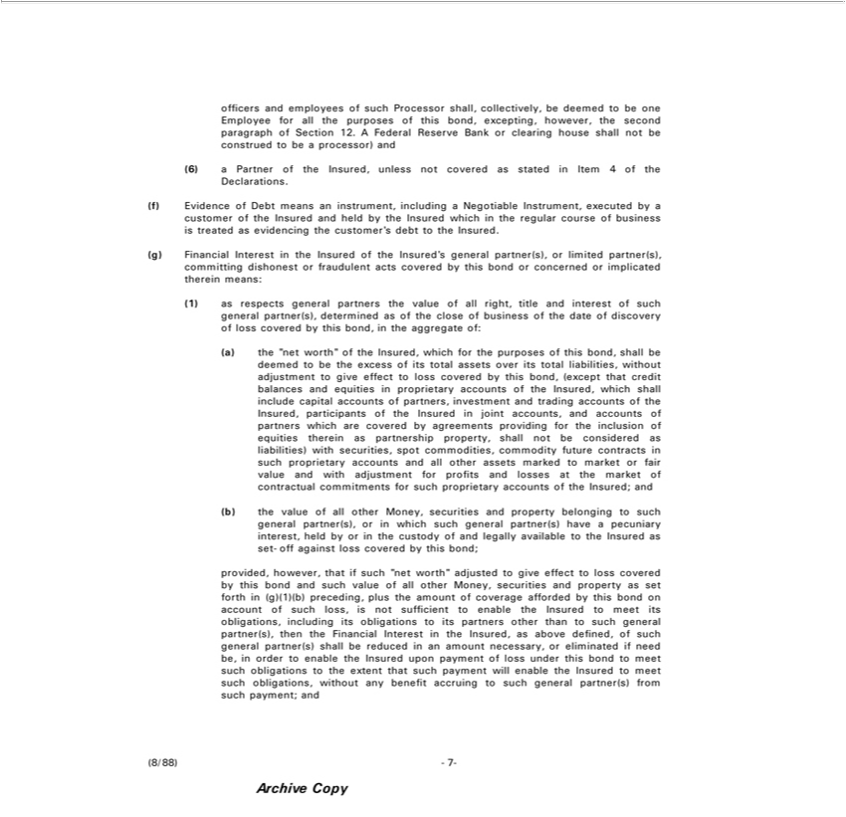

officers and employees of such Processor shall, collectively, be deemed to be one Employee for all the purposes of this bond, excepting, however, the second paragraph of Section 12. A Federal Reserve Bank or
clearing6)PartnerhouseofshalltheInsured,notbeconstruedunlessnot coveredbeprocessor)as andinItem 4 of the Declarations.
(f) Evidence of Debt means an instrument, includingstatedNegotiable Instrument, executed by a customer of the Insured and held by the Insured which in the regular course of business is treated as evidencing the customer’s debt to the Insured.
¹⁾g) Financial Interest in the Insured of the Insured’s general partner(s), or limited partner(s), committing dishonest or fraudulent acts covered by this bond or concerned or implicated therein means:
^{a)}
_{(except}theasrespects“networth”generalofthepartnersInsured,thewhichvalue offoralltheright,purposestitle andofthisinterestbond,ofshallsuchbegeneraldeemedpartner(s),tobethe determinedexcessofitsastotaloftheassetscloseoverof businessitstotal liabilities,ofthedatewithoutofdiscoveryadjustmentoflosstocoveredgiveeffectby thistolossbond,coveredinthe byaggregatethisbond,of:
that credit balances and equities in proprietary accounts of the Insured, which shall include capital accounts of partners, investment and trading accounts of the Insured, participants of the Insured in joint accounts, and accounts of partners which are covered by agreements providing for the inclusion of equities therein as partnership property, shall not be considered as liabilities) with securities, spot commodities, commodity future contracts in such proprietary accounts and all other assets marked to market or fair value and with adjustment for profits and losses at the market of contractual commitments for such proprietary accounts of the^{Money}Isured; and

(b) the value of all other , securities and property belonging to such general partner(s), or in which such general partner(s) have a pecuniary interest, held by or in the custody of and legally available to the Insured as set-off against loss covered by this bond;
provided, however, that if such “net worth” adjusted to give effect to loss covered by this bond and such value of all other Money, securities and property as set forth in (g)(1)(b) preceding, plus the amount of coverage afforded by this bond on account of such loss, is not sufficient to enable the Insured to meet its obligations, including its obligations to its partners other than to such general partner(s), then the Financial Interest in the Insured, as above defined, of such general partner(s) shall be reduced in an amount necessary, or eliminated if need be, in order to enable the Insured upon payment of loss under this bond to meet such obligations to the extent that such payment will enable the Insured to meet such obligations, without any benefit accruing to such general partner(s) from such payment; and
Archive(8/88)-7Copy-

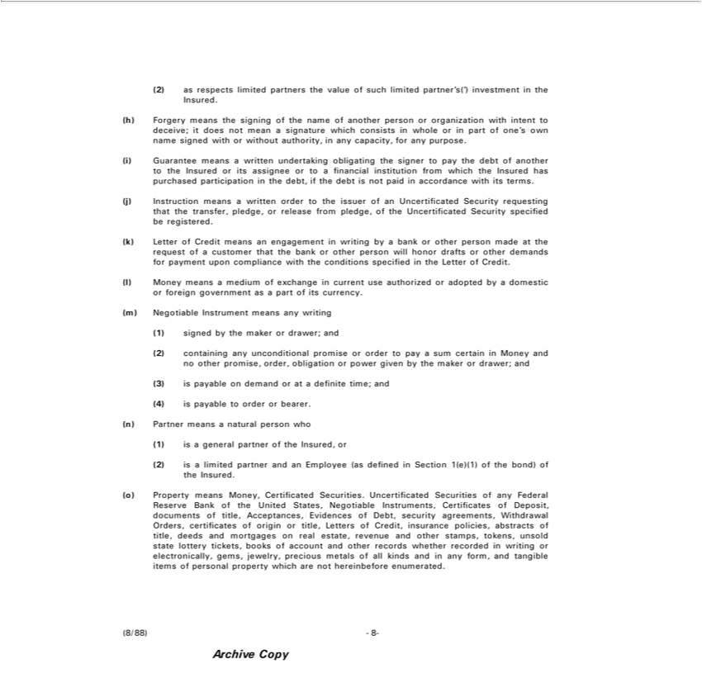

2) as respects limited partners the value of such limited partner’s(‘) investment in the Insured.
(h) | Forgery means the signing of the name of another person or organization with intent to deceive; it does not mean a signature which consists in whole or in part of one’s own name signed with or without
authority, in any |  | , for any purpose.
(i) Guarantee meanscapacitywritten undertaking obligating the signer to pay the debt of another to the Insured or its assignee or to a financial institution from which the Insured has purchased participation in the debt,
if the debt is not paid in accordance with its terms. |  |  |  | Security requesting that the | , pledge, or release from pledge, of the Uncertificated Security specified be registered.
j) Instruction means |  | written order to the issuer of an |  | Security requesting that the
(k) | Letter of Credit means an engagement in writing byUncertificatedbankorother person made at the requesttransferofcustomer that the bank or other person will honor drafts or other demands for payment upon compliance
with the conditions specified in the Letter of Credit.
l) Money means a medium of exchange current use authorized or adopted by a domestic or foreign government as a part of its currency.
m) Negotiable Instrument means any writing
1) signed by the maker or drawer; and
2) containing any |  |  | promise or order to pay a sum certain in Money and no other promise, order, obligation or power given by the maker or drawer; and
3) | on demandunconditionalorat definite time; and
4) is payable to order or bearer.
n) | Partn means natural person who
1) | general partner of the Insured, or
2) is a limited partner and an Employee (as defined in Section 1(e)(1) of the bond) of the Insured.
(o) | Property means Money, Certificated Securities. Uncertificated Securities of any Federal Reserve Bank of the United States, Negotiable Instruments, Certificates of Deposit, documents of title, Acceptances,
Evidences of Debt, security agreements, Withdrawal Orders, certificates of origin_{recorded}title, Letters of Credit, insurance policies, abstracts of title, deeds and mortgages on real estate, revenue and other stamps,
tokens, unsold state lottery tickets, books of account and other records whether in writing or electronically, gems, jewelry, precious metals of all kinds and in any form, and tangible items of personal property which are not hereinbefore enumerated.

Archive(8/88)-8Copy-

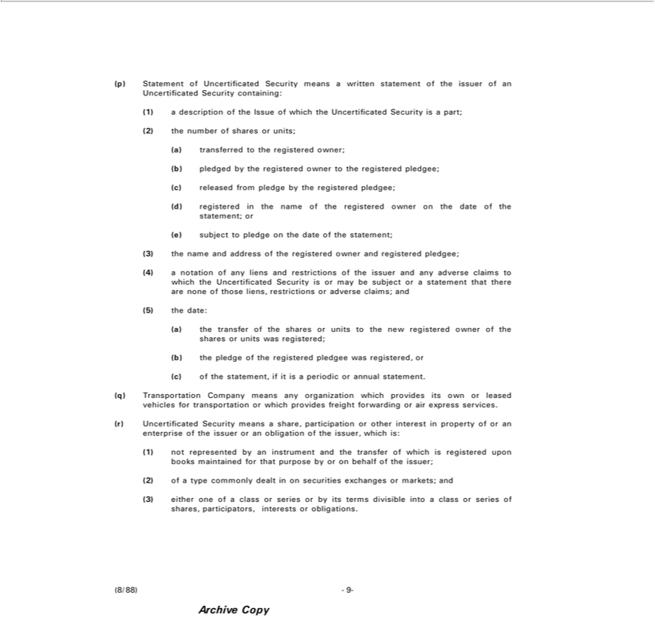

p) |  | of Uncertificated Security means writ |  | statement of the issuer of an Uncertificated Security containing:
1) | Statementdescripti n of the Issue of which the Uncertificated Security is a part; (2) the number of shares or units; (a) transferred to the registered owner; (b) pledged by the registered owner to the registered pledgee;
c) released from pledge by the registered pledgee;
d) registered in the name of the registered owner on the date of the statement; or
e) subject to pledge on the date of the statement;
3) the |  | me and address of the regis ered owner and registered pledgee;
(4) | notation of any liens and restrictions of the issuer and any adverse claims to which the Uncertificated Security is or may be subject or a statement that there are none of those liens, restrictions or adverse
claims; and
5) the date:
a) the transf r of the shares or units to the new registered owner of the shares or units was registered;
b) the pledge of the |  |  | pledgee was registered, or
c) of the statement, ifregistereditperiodic or annual statement.
q) | Transportation Company |  | any organization which provides its own or leased vehicles for transportation or which provides freight forwarding or air express services.
r) | Uncertificated Security meansmeans share, participation or other interest in property of or an enterprise of the issuer or an |  |  |  |  | of the | , which is:
1) not represented by an |  |  | and the transfer of which is registered upon books maintained for that purpose by or obligationbehalf of the issuer;
2) of a type commonly dealtinstrumentonsecurities exchanges or |  |  |  |  | and
3) either one of a class or series or by its terms divisible intomarkets;class or series of shares, participators, interests or obligations.
(8/88) |  | -9-
Archive Copy

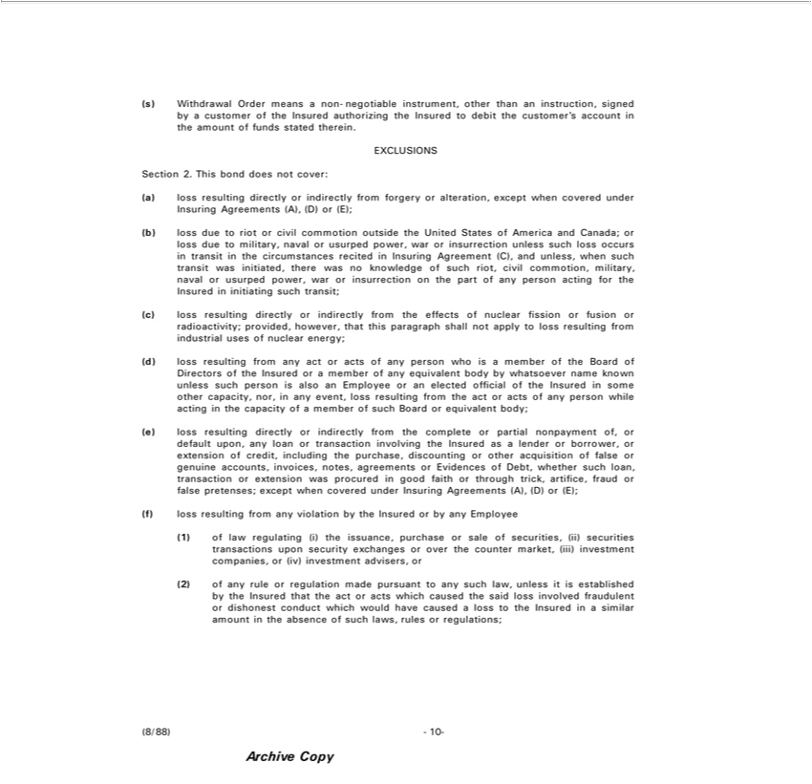

(s) Withdrawal Order means a non-negotiable instrument, other than an instruction, signed by a customer of the Insured authorizing the Insured to debit the customer’s account in the amount of funds stated
therein.
EXCLUSIONS
Section 2. This bond does not cover:
a) loss resulting directly or indirectly from forgery or alteration, except when covered under Insuring Agreements (A), (D) or (E);
(b) loss due to riot or civil commotion outside the United States of America and Canada; or loss due to military, naval or usurped power, war or insurrection unless such loss occurs transit in the circumstances
recited |  | Insuring Agreement (C), and unless, when such transit was initiated, there was no knowledge of such riot, civil commotion, military, naval or usurped power, war or insurrection on the part of any
person acting for the Insured |  |  | initiating such transit; | fission or fusion or radioactivity; provided, however, that this paragraph shall not apply to loss resulting from industrial uses of nuclear energy;
c) loss resulting directly or indirectly from the effects of
(d) loss resulting from any act or acts of any person who isnuclearmember of the Board of Directors of the Insured or member of any equivalent body by whatsoever name known unless such person is also an
Employee or an elected official of the Insured in some other capacity, nor, in any event, loss resulting from the act or acts of any person while acting in the capacity of a member of such Board or equivalent
body;
(e) loss resulting directly or indirectly from the complete or partial nonpayment of, or default upon, any loan or transaction involving the Insured as lender or borrower, or extension of credit, including the
purchase, discounting or other acquisition of false or genuine accounts, invoices, notes, agreements or Evidences of Debt, whether such loan, transaction or extension was procured in good faith or through trick,
artifice, fraud or false pretenses; except when covered under Insuring Agreements (A), (D) or (E);
f) loss resulting from any violation by the Insured or by any Employee
1) | law | egulating (i) the issuance, purchase or sale of |  | (ii) securities transactions upon security exchanges or over the counter market, (iii) investment companies, or (iv) investment advisers, or
(2) of |  | rule or regulation | pursuant to any such lawsecurities,unlessit is established by the Insured that the act or acts which caused the said loss involved fraudulent or dishonest conduct which would have
any made
(8/88)caused-10loss- to the Insured in similar amount in the absence of such laws, rules or regulations;

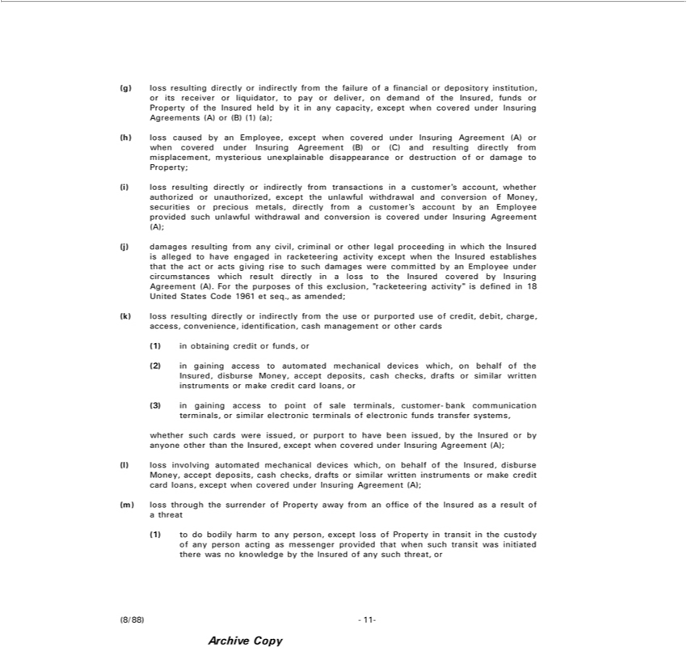

(g) loss resulting directly or indirectly from the failure of a financial or depository institution, or its receiver or liquidator, to pay or deliver, on demand of the Insured, funds or Property of the Insured held by it in
(h)anylosscapacity,causedexceptbyanwhenEmployee,coveredexceptunderwhenInsuringcoveredAgreementsunderInsuring(A)or Agreement(B)(1)(a); (A) or when covered under Insuring Agreement (B) or (C) and resulting directly from misplacement, mysterious unexplainable disappearance or destruction of or damage to Property;
(i) loss resulting directly or indirectly from transactions in a customer’s accoun , whether authorized or unauthorized, except the unlawful withdrawal and conversion of Money, securities or precious metals,
(j)directlydamagesfromresultingacustomer’sfrom accountanycivil,bycriminalanEmployeeEmployeeorotherprovidedlegalproceedingsuchunlawfulinwhichwithdrawaltheInsuredand conversionisallegedtoishavecoveredengagedunderinInsuringracketeeringAgreementactivity(A);except when the Insured establishes that the act or acts giving rise

isto definedsuchdamagesresulting18UnitedwerecommittedStatesCodeby1961an et seq., asunderamended;circumstances which result directly in loss to the Insured covered by Insuring Agreement (A). For the purposes of this exclusion, “racketeering activity” 1)k) loss directly or indirectly from the use or purported use of credit, debit, charge, access, convenience, identification, cash management or other cards
2) obta credit orautomatedfunds,or mechanical devices which, on behalf of the Insured, disburse Money, accept deposits, cash checks, drafts or similar written instruments or make credit card loans, or
(3) in gaining access to point of sale terminals, customer-bank communication terminals, or similar electronic terminals of electronic funds transfer systems,
whether such cards were issued, or purport to have been issued, by the Insured or by anyone other than the Insured, except when covered under Insuring Agreement (A);

(l) loss involving automated mechanical devices which, on behalf of the Insured, disburse Money, accept deposits, cash checks, drafts or similar written instruments or make credit card loans, except when covered under Insuring Agreement (A);
⁽¹⁾m) loss through the surrender of Property away from an office of the Insured as a result of a threat
to do bodily harm to any person, except loss of Property in transit in the custody of any person acting as messenger provided that when such transit was initiated there was no knowledge by the Insured of any such threat, or
Archive(8/88)-11Copy-

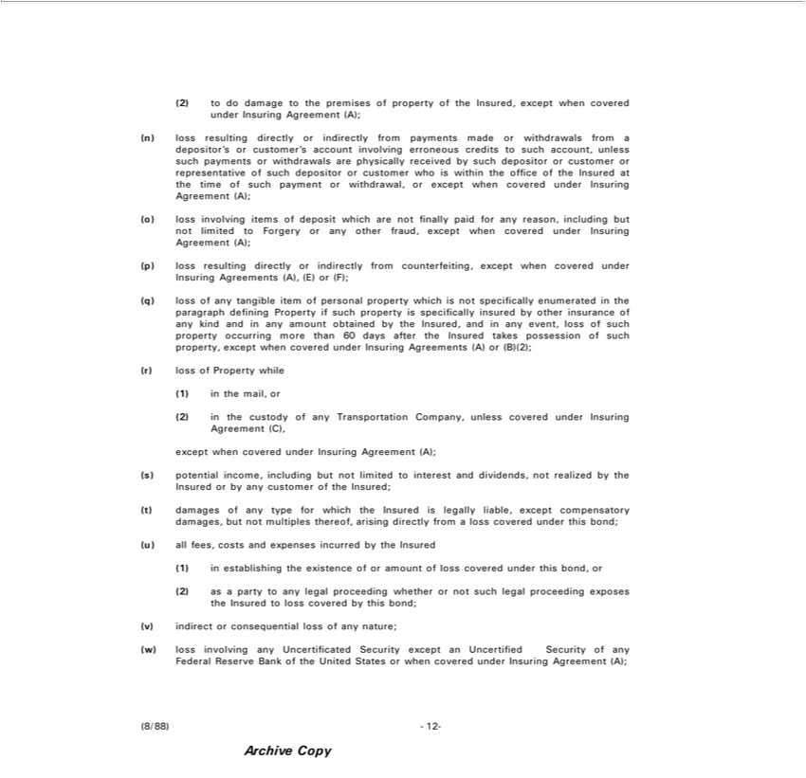

2) to do damage to the premises of property of the Insured, except when covered under |  |  | Agreement (A);
(n) loss resulting |  | or indirectly from payments made or withdrawals from a | Insuring’or customer’s account involving erroneous credits to such account, unless such payments or withdrawals are
physically rec iv directlybysuch depositor or customer or representative of such depositordepositorcustomer who is within the office of the Insured at the time of such payment or withdrawal, or except when covered under
Insuring Agreement (A);
o) | involving items of deposit which are not finally paid for any reason, including but not limited to Forgery or any other fraud, except when covered under Insuring Agreement (A);
p) | resulting directly or indirectly from counterfeiting, except when covered under Insuring Agreements (A), (E) or (F);
(q) loss of any tangible item of personal property which is not specifically enumerated in the paragraph defining Property if such property is specifically insured by other insurance of any kind and in any amount
obtained by the Insured, and in any event, loss of such property occurring more than 60 days after the Insured takes possession of such property, except when covered under Insuring Agreements (A) or (B)(2);
r) loss of Property while
1) | mail, or
(2) in the custody of any Transportation Company, unless covered under Insuring Agreement (C),
except when covered under Insuring Agreement (A);
s) potential income, including but not limited to interest and dividends, not realized by the Insured or by any customer of the Insured;
t) damages of any type for which the Insured is legally liable, except compensatory damages, but not multiples thereof, arising directly from a loss covered under this bond;
u) all fees, costs and expenses incurred by the Insured
1) in | the existence of or amount of loss covered under this bond, or
2) as establishingpartytoany legal proceeding whether or not such legal proceeding exposes the Insured to loss covered by this bond;
v) indirect r consequential loss of any nature;
w) loss involving any Uncertificated Security except an Uncertified Security of any Federal Reserve Bank of the United States or when covered under Insuring Agreement (A);
(8/88) | -12-
Archive Copy

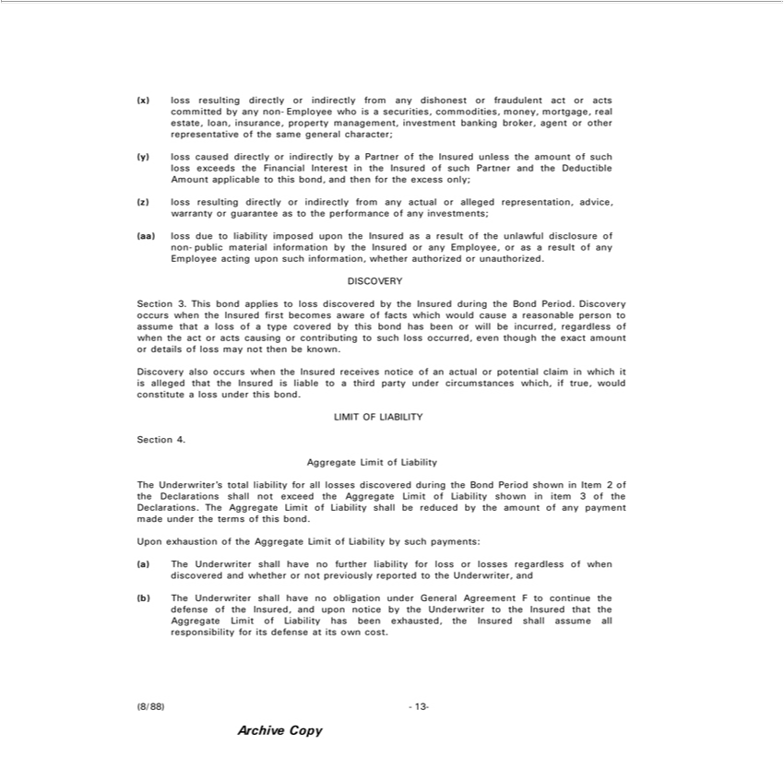

(x) loss resulting directly or indirectly from any dishonest or fraudulent act or acts committed by any non-Employee who is a securities, commodities, money, mortgage, real estate, loan, insurance, property management, investment banking broker, agent or representative of the same general character;
(y) loss caused directly or indirectly by a Partner ofotherInsured unless the amount of such loss exceeds the Financial Interest in the Insured of such Partner and the Deductible Amount applicable to this bond, and then for the excess only;
^{(aa)}z)loss resulting directly or indirectly from any actual or alleged representation, advice, warranty or guarantee as to the performance of any investments;
loss due to liability imposed upon the Insured as a result of the unlawful disclosure of non-public material information by the Insured or any Employee, or as a result of any Employee acting upon such information, whether authorized or unauthorized.
DISCOVERY
Section 3. This bond applies to loss discovered by the Insured during the Bond Period. Discovery occurs when the Insured first becomes aware of facts which would cause_{amount}reasonable person to assume that a
loss of a type covered by this bond has been or will be incurred, regardless of when the act or acts causing or contributing to such loss occurred, even though the exact or details of loss may not then be known.
Discovery also occurs when the Insured receives notice of an actual or potential claim in which it is alleged that the Insured is liable to a third party under circumstances which, if true, would constitute a loss under this bond.
SectionLIMIT OF4. LIABILITY
Aggregate Limit of Liability
The Underwriter’s total liability for all losses discovered during the Bond Period shown in Item 2 of the Declarations shall not exceed the Aggregate Limit of Liability shown in item 3 of the Declarations. The Aggregate Limit of Liability shall be reduced by the amount of any payment made under the terms of this bond.
Upon^{The}xhaustion of the Aggregate Limit of Liability by such payments:
^{(b)}a) Underwriter shall have no further liability for loss or losses regardless of when discovered and whether or not previously reported to the Underwriter, and
The Underwriter shall have no obligation under General Agreement F to continue the defense of the Insured, and upon notice by the Underwriter to the Insured that the Aggregate Limit of Liability has been exhausted, the Insured shall assume all responsibility for its defense at its own cost.

Archive(8/88)-13Copy-

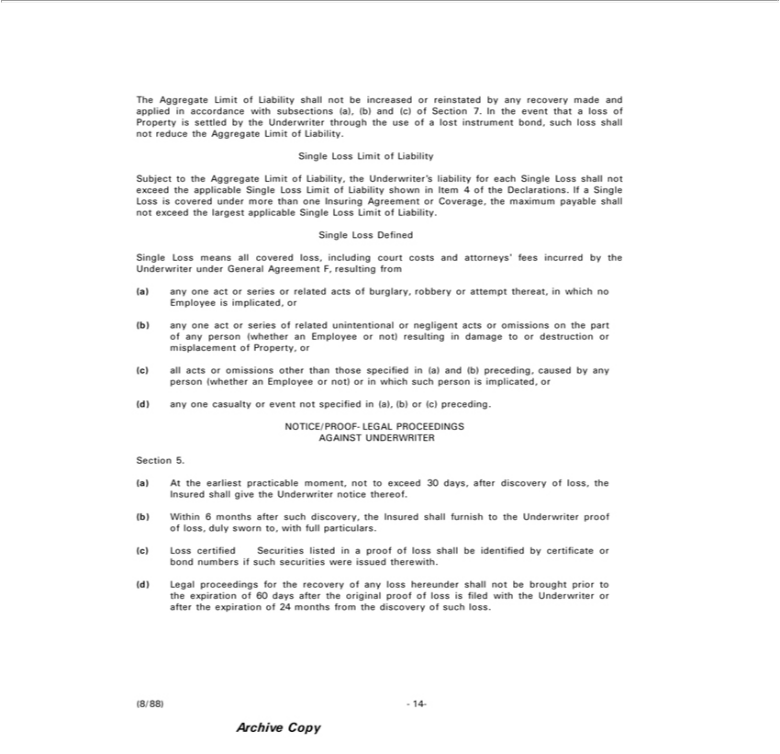

The Aggregate Limit of Liability | not be increased or reinstated by any recovery made and applied in accordance with subsections (a), (b) and (c) of Section 7. In the event that a loss of Property is settled by
the Underwriter through the use ofshalllost instrument bond, such loss shall not reduce the Aggregate Limit of Liability.
ingle Loss Limit of Liability
Subject to the Aggregate Limit of Liability, the Underwriter’s liability for each Single Loss shall not exce d the applicable Single Loss Limit of Liability shown in Item 4 of the Declarations. If a Single Loss is
covered under more than one Insuring Agreement or Coverage, the maximum payable shall not exceed the largest applicable Single Loss Limit of Liability.
Defined |  | by the Underwriter under General Agreement F, resulting from
Single Loss means all covered loss, including court costs and attorneys’ fees |  | by the Underwriter under General Agreement F, resulting from
a) any one act or series or related acts of burglary, robbery or attempt thereat,incurredwhich no Employee is implicated, or
b) any one act or series of related unintentional or negligent acts or omissions on the part of any person (whether an Employee or not) resulting in damage to or destruction or misplacement of Property, or
c) all acts or omissions other than those specified in (a) and (b) preceding, caused by any person (whether an Employee or not) or in which such person is implicated, or
(d) any one casualty or event not specified in (a), (b) or (c) preceding.
NOTICE/PROOF-LEGAL PROCEEDINGS AGAINST UNDERWRITER
Section 5.
a) At the earliest practicable moment, not to exceed 30 days, after discovery of loss, the Insured shall give the Underwriter notice thereof.
b) Within 6 months after such discovery, the Insured shall furnish to the Underwriter proof of loss, duly sworn to, with full particulars.
c) Loss certified Securities listed in a | of loss shall be identified by certificate | bond numbers if such securities were issued therewith.
(d) Legal proceedings for the recovery proofany loss hereunder shall not be brought prior to the expiration of 60 days after the original proof of loss is filed with the Underwriter or after the expiration of 24 months from the discovery of such loss.
Archive(8/88)-14Copy-

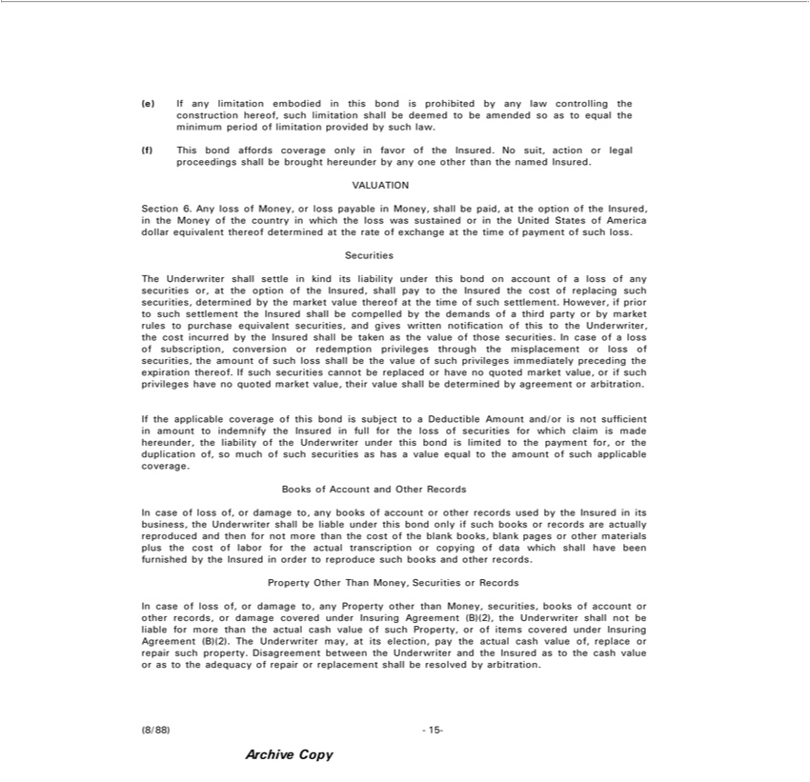

(e) If any limitation embodied in this bond is prohibited by any law controlling the construction hereof, such limitation shall be deemed to be amended so as to equal the minimum period of limitation provided
by such law.
(f) This bond affords coverage only in favor of the Insured. No suit, action or legal proceedings shall be brought hereunder by any one other than the named Insured.
VALUATION
Section 6. Any loss of Money, or loss payable in Money, shall be paid, at the option of the Insured, in the Money of the country in which the loss was sustained or in the United States of America dollar
equivalent thereof determined at the rate of exchange at the time of payment of such loss.
Securities
The Und rwriter shall settle in kind its liability under this bond on account of a loss of any securities or, at the option of the Insured, shall pay to the Insured the cost of replacing such securities, determined by
the market value thereof the time of such settlement. However, if prior to such settlement the Insured shall be compelled by the demands of a third party or by market rules to purchase equivalent securities,
and gives written notification | f this to the Underwriter, the cost incurred by the Insured shall be taken as the value of those securities. In case of a loss of subscription, conversion or redemption privileges
through the misplacement or loss of securities, the amount of such loss shall be the value of such privileges immediately preceding the expiration thereof. If such securities cannot be replaced or have no quoted
market value, or if such privileges have no quoted |  | value, their value shall be determined by agreement or arbitration.
If the applicable coverage of this bond is subject tomarketDeductible Amount and/or is not sufficient in amount to indemnify the Insured in full for the loss of securities for which claim is made hereunder, the
liability of the Underwriter under this bond is limited to the payment for, or the duplication of, so much of such securities as has a value equal to the amount of such applicable coverage.
Books of Account and Other | Records |  | used by the Insured in its business, the Underwriter shall be liable under this bond only if such books or recor s are actually reproduced and
In case of loss of, or damage to, any books of account or other
then for not more than the cost of the blank books, blank pagesrecordsother materials plus the cost of labor for the actual transcription or copying of data which shall have been furnished by the Insured in order to reproduce such books and other records.
Property Other Than Money, Securities or Records
In case of loss of, or damage to, any Property other than Money, securities, books of account or other records, or damage covered under Insuring Agreement (B)(2), the Underwriter shall not be liable for more than the actual cash value of such Property, or of items covered under Insuring Agreement (B)(2). The Underwriter may, at its election, pay the actual cash value of, replace or repair such property. Disagreement between the Underwriter and the Insured as to the cash value or as to the adequacy of repair or replacement shall be resolved by arbitration.
Archive(8/88)-15Copy-

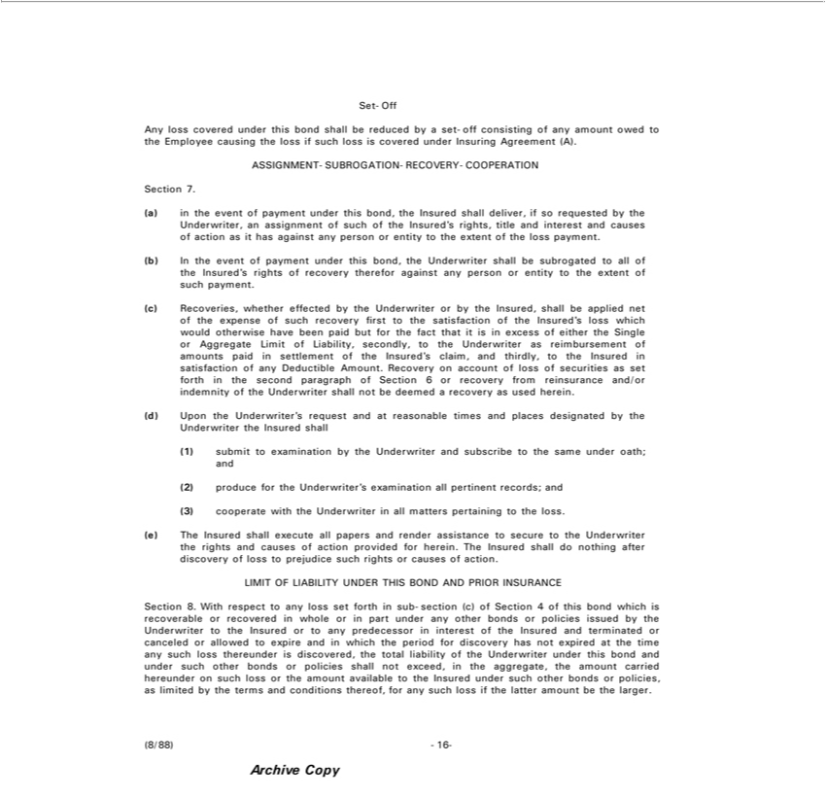

Set-Off
ny loss covered under this bond shall be reduced by a set-off consisting of any amount owed to the Employee causing the loss if such loss is covered under Insuring Agreement (A).
ASSIGNMENT-SUBROGATION-RECOVERY-COOPERATION
Section 7.
(a) in the event of payment under this bond, the Insured shall deliver, if so requested by the Underwriter, an assignment of such of the Insured’s rights, title and interest and causes of action as it has against any
person or entity to the extent of the loss payment.
b) In the event of payment under this bond, the Underwriter shall be subrogated to all of the Insured’ rights of recovery therefor against any person or entity to the extent of such payment.
(c) Recoveries, whether effected by the Underwriter or by the Insured, shall be applied net of the expense of such recovery first to the satisfaction of the Insured’s loss which would otherwise have been paid but
for the | that it is in excess of either the Single or Aggregate Limit of Liability, secondly, to the Underwriter as reimbursement of amounts paid in settlement of the Insured’s claim, and thirdly, to the Insured in
 | of any Deductible Amount. Recovery on account of loss of securities as set forth in the second paragraph of Section 6 or recovery from reinsurance and/or indemnity of the Underwriter shall not be
satisfactiondeemedrecovery as used herein.
d) Upon the Underwriter’s request and at reasonable times and places designated by the Underwriter the Insured shall
1) submit to examination by the Underwriter and subscribe to the same under oath; and
2) produce for the Underwriter’s |  | all pertinent records; and
3) cooperate with the Underwriterexaminationallmatters pertaining to the loss.
(e) The Insured shall execute all papers and render assistance to secure to the Underwriter the rights and causes of action provided for herein. The Insured shall do nothing after discovery of loss to prejudice such
rights or causes of action.
LIMIT OF LIABILITY UNDER THIS BOND AND PRIOR INSURANCE |  |  | Underwriter to the
Section 8. With respect to any loss set forth in sub-section (c) of Section 4 of this bond which is recoverable or recovered in whole or in part under any other bonds or policies issued by |  |  | Underwriter to the
Insured or to any predecessor in interest of the Insured and terminated or canceled or allowed to expire and in which the period for discovery has not expired at the time any such loss thereunder is discovered, the total liability of the Underwriter under this bond and under such other bonds or policies shall not exceed, in the aggregate, the amount carried hereunder on such loss or the amount available to the Insured under such other bonds or policies, as limited by the terms and conditions thereof, for any such loss if the latter amount be the larger.
Archive(8/88)-16Copy-

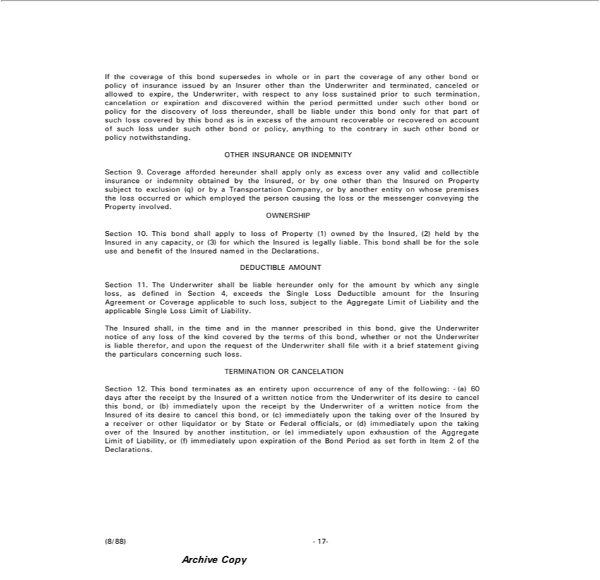

If the coverage of this bond supersedessustainedwholepriorin part the coverage of any other bond or policy of insurance issued by an Insurer other than the Underwriter and terminated, canceled or allowed to expire, theUnderwriter,withrespecttoanylosstosuchtermination,cancelationorexpirationanddiscoveredwithintheperiodpermittedundersuchotherbondorpolicyforthediscoveryofloss ,
shall be liable under this bond only for that part of such loss covered by this bond as is in excess of the amount recoverable or recovered on account of such loss under such other bond or policy, anythingthereunderto contrary in such other bond or policy notwithstanding.
OTHER INSURANCE OR INDEMNITY
Section 9. Coverage afforded hereunder shall apply only as excess over any valid and collectible insurance or indemnity obtained by the Insured, or by one other than the Insured on Property subject to exclusion
(q) or by a Transportation Company, or by another entity on whose premises the loss occurred or which employed the person causing the loss or the messenger conveying the Property involved.
OWNERSHIP

Section 10. This bond shall apply to loss of Property (1) owned by the Insured, (2) held by the Insured in any capacity, or (3) for which the Insured is legally liable. This bond shall be for the sole use and benefit of the Insured named in the Declarations.
DEDUCTIBLE AMOUNT

_{applicable}Secton11. The Underwriter shall be liable hereunder only for the amount by which any single loss, as defined in Section 4, exceeds the Single Loss Deductible amount for the Insuring Agreement or Coverage to such loss, subject to the Aggregate Limit of Liability and the applicable Single Loss Limit of Liability.
The Insured shall, in the time and in the manner prescribed in this bond, give the Underwriter notice of any loss of the kind covered by the terms of this bond, whether or not the Underwriter is liable therefor, and upon the request of the Underwriter shall file with it a brief statement giving the particulars concerning such loss.

TERMINATION OR CANCELATION
Section 12. This bond terminates as an entirety upon occurrence of any of the following: -(a) 60 days after the receipt by the Insured_{immediately}ofwritten notice from the Underwriter of its desire to cancel this_{liquidator}bond,
(b) immediately upon the receipt by the Underwriter of a written notice from the Insured of its desire to cancel this bond, or (c) upon the taking over of the Insured by a receiver or other or by State or Federal officials, or (d) immediately upon the taking over of the Insured by another institution, or (e) immediately upon exhaustion of the Aggregate Limit of Liability, or (f) immediately upon expiration of the Bond Period as set forth in Item 2 of the Declarations.
Archive(8/88)-17Copy-



This bond terminates as to any Employee or any partner, officer or employee of any Processor - (a) as soon as any Insured, or any director or officer not_{Insuring}collusion with such person, learns of any dishonest or

fraudulent act committed by such person at any time, whether in the employment of the Insured or otherwise, whether or not of the type covered under Agreement (A), against the Insured or any other person or entity, without prejudice to the loss of any Property then in transit in the custody of such person, or (b) 15 days after the receipt by the Insured of a written notice from the Underwriter of its desire to cancel this bond as to such person.
Termination_{whereof,}thebond as to any Insured terminates liability for any loss sustained by such Insured which is discovered after the effective date of such termination.
(8/88)Inwitness-18- the Underwriter has caused this bond to be executed on the Declarations page.

Archive Copy

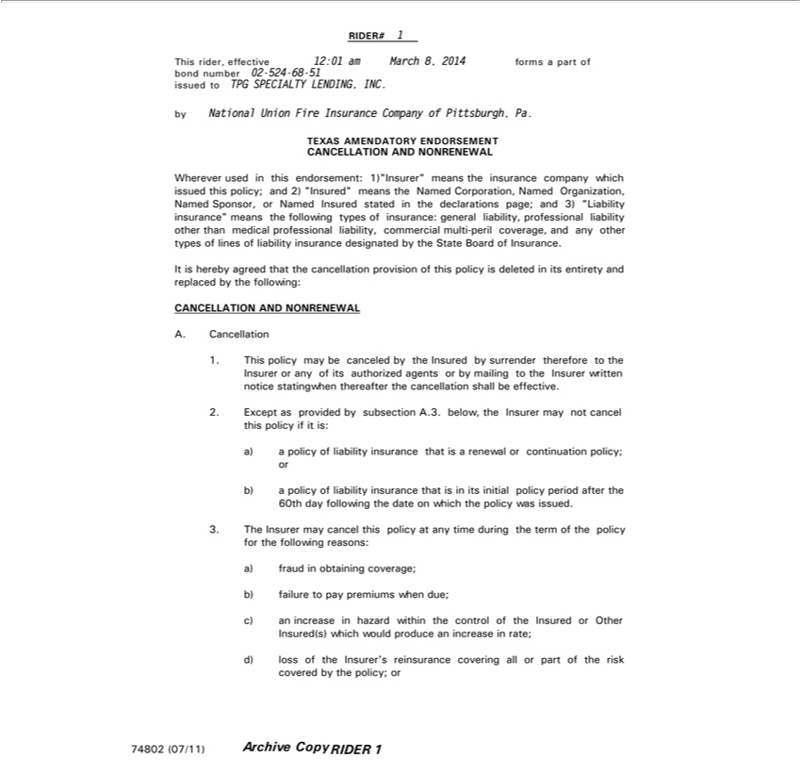

RIDER# 1
This rider, effective 12:01 am March 8, 2014 forms a part of
^{by}
ondNationalnumberUnion02-524Fire-68Insurance-51issuedCompanytoTPGSPECIALTYofPittsburgh,LENDING,Pa. INC.
TEXAS AMENDATORY ENDORSEMENT
CANCELLATION AND NONRENEWAL
Wherever used in this endorsement: 1) “Insurer” means the insurance company which issued this policy; and 2) “Insured” means the Named Corporation, Named Organization, Named Sponsor, or Named
Insured stated in the declarations page; and 3) “Liability insurance” means the following types of insurance: general liability, professional liability other than medical professional liability, commercial multi-peril coverage, and any other types of lines of liability insurance designated by the State Board of Insurance.
It is hereby agreed that the cancellation provision of this policy is deleted in its entirety and replaced by the following:
_{CANCELLA}TION AND NONRENEWAL
. Cancellation

1. This policy may be canceled by the Insured by surrender therefore to the Insurer or any of its authorized agents or by mailing to the Insurer written notice statingwhen thereafter the cancellation shall be effective.
a)2. Exceptapolicyasofprovidedliability byinsurancesubsectionthat A.3.isarenewalbelow,theor continuationInsurermay notpolicy;cancelor this policy if it is:
b) a policy of liability insurance that is in its initial policy period after the 60th day following the date on which the policy was issued.
a)3. ThefraudInsurerinobtainingmaycancelcoverage;this policy at any time during the term of the policy for the following reasons:
b) failure to pay premiums when due;
c) an increase in hazard within the control of the Insured or Other Insured(s) which would produce an increase in rate; d) loss of the Insurer’s reinsurance covering all or part of the risk covered by the policy; or

74802 (07/11) Archive Copy RIDER 1

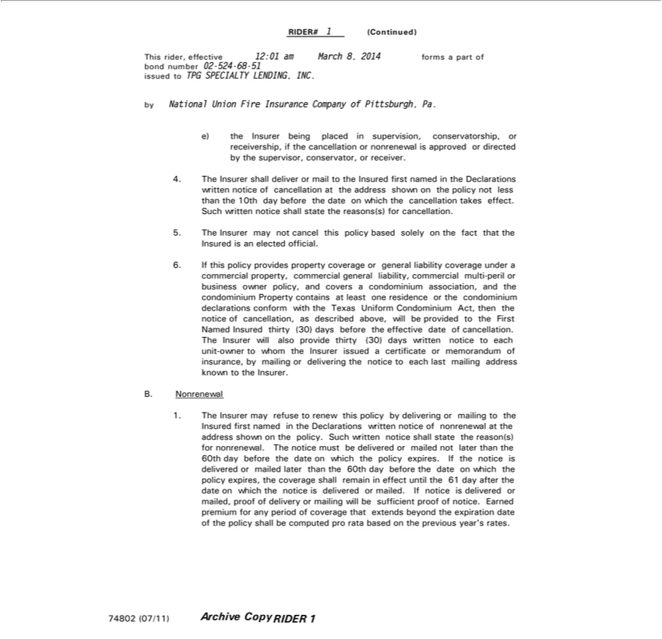

RIDER# 1 (Continued)
This rider, effective 12:01 am March 8, 2014 forms a part of
ond number 02-524-68-51 issued to TPG SPECIALTY LENDING, INC.
by National Union Fire Insurance Company of Pittsburgh, Pa.
e) the Insurer being placed in supervision, conservatorship, or receivership, if the cancellation or nonrenewal is approved or directed by the supervisor, conservator, or receiver.
4. The Insurer shall deliver or mail to the Insured first named in the Declarations written notice of cancellation at the address shown on the policy not less than the 10th day before the date on which the
cancellation takes effect. |  | .
Such written notice shall state the reasons(s) for |  | .
5 | The Insurer may not cancel this policy based solelycancellationthe fact that the Insured is an elected official.
6. | If this policy provides property coverage or general liability coverage under a commercial property, commercial general liability, commercial multi-peril or business owner policy and covers a condominium
ssociation, and the condominium Property contains at least one residence or the condominium declarations conform with the Texas Uniform Condominium Act, then the notice of cancellation, as described
above, will be provided to the First Named Insured thirty (30) days before the effective date of cancellation.
The Insurer will also provide thirty (30) days written notice to each unit-owner to whom the Insurer issued a certificate or memorandum of insurance, by mailing or delivering the notice to each last mailing
address known to the Insurer.
B. Nonrenewal
1. The Insurer may refuse to renew this policy by delivering or mailing to the Insured first named in the Declarations written notice of nonrenewal at the address shown on the policy. Such written notice shall
state the reason(s) for nonrenewal. The notice must be delivered or mailed not later than the 60th day before the date on which the policy expires. If the notice is delivered or mailed later than the 60th day before
the date on which the policy expires, the coverage shall remain in effect until the 61 day after the date |  |  | which the notice is delivered or mailed. If notice is delivered or mailed, proof of delivery or mailing will
be sufficient proof of notice. Earned premium for any period of coverage that extends beyond the expiration date of the policy shall be computed pro rata based on the previous year’s rates. 74802 (07/11)

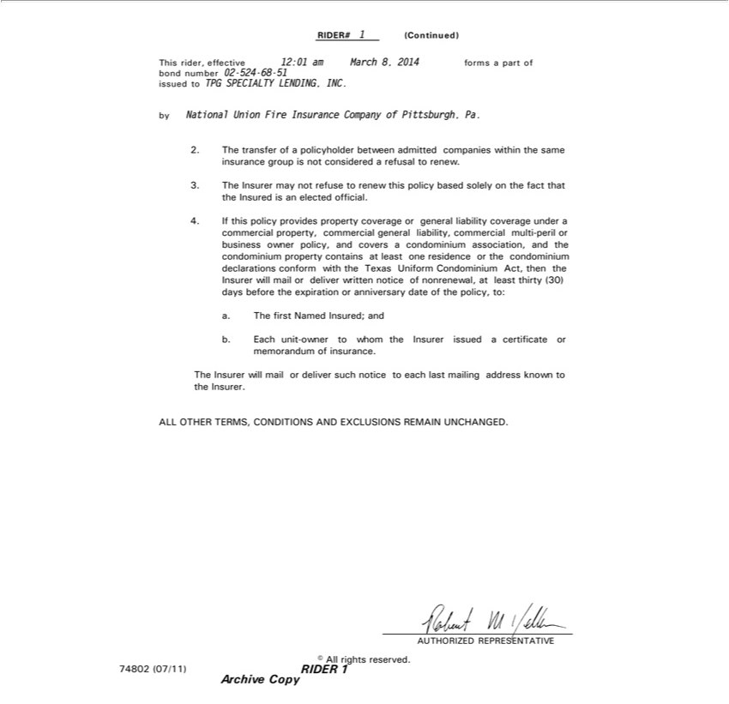

RIDER# 1 (Continued)
This rider, effective 12:01 am March 8, 2014 forms a part of
 | ond number 02-524-68-51 issued to TPG SPECIALTY LENDING, INC.
by National Union Fire Insurance Company of Pittsburgh, Pa.
2 |  | transfer of a policyholder between admitted companies within the same insurance group is not considered a refusal to renew.
3 | The Insurer may not refuse to renew this policy based solely on the fact that the Insured is an elected official.
4. If this policy provides property coverage or general liability coverage under a commercial property, commercial general liability, commercial multi-peril or business owner policy, and covers a condominium
association, and the condominium property contains at least one residence or the condominium declarations conform with the Texas Uniform Condominium Act, then the Insurer will mail or deliver written
notice of nonren wal, at least thirty (30) days before the expiration or anniversary date of the policy, to:
a. The first Named Insured; and
b. Each unit-owner to whom the Insurer issued certificate or memorandum of insurance.
The Insurer will mail or deliver such notice to each last mailing address known to the Insurer.
 | LL OTHER TERMS, CONDITIONS AND EXCLUSIONS REMAIN UNCHANGED.
AUTHORIZED REPRESENTATIVE
C All rights reserved.
74802 |  | 1)
(07/1
ArchiveRIDER Copy

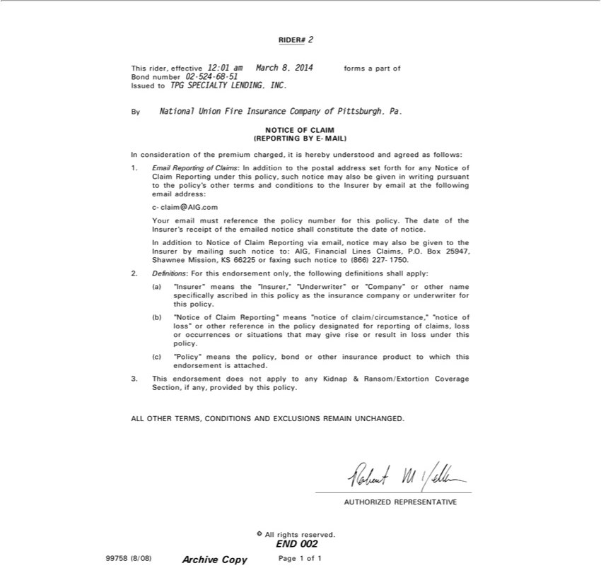

RIDER# 2
This rider, effective 12:01 am March 8, 2014 forms a part of
Bond number 02-524-68-51
Issued to TPG SPECIALTY LENDING, INC.
By National Union Fire Insurance Company of Pittsburgh, Pa.
NOTICE OF CLAIM (REPORTING BY E-MAIL) | and agreed as follows: 1. Email Reporting of Claims: In addition to the postal address set forth for any Notice of Claim Reporting under this
In consideration of the premium charged, is hereby
policy, such notice may also be given in writing pursuantunderstoodthepolicy’s other terms and conditions to the Insurer by email at the following email address: c-claim@AIG.com Your email must reference the policy
number for this policy. The date of the Insurer’s receipt of the emailed notice shall constitute the date of notice.
In addition to Notice of Claim Reporting via email, notice may also be given to the Insurer by mailing such notice to: AIG, Financial Lines Claims, P.O. Box 25947, Shawnee Mission, KS 66225 or faxing such
notice to (866) 227-1750.
2. Definitions: For this endorsement only, the following definitions shall apply:
a) “Insurer” means the “Insurer,” “Underwriter” or “Company” or other name specifically ascribed in this policy as the insurance company underwriter for this policy.
(b) “Notice of Claim Reporting” means “notice of claim/circumstance,” “notice of loss” or other reference in the policy designated for reporting of claims, loss or occurrences or situations that may give rise or
result in loss under this policy. | which this endorsement is attached.
(c) “Policy” means the policy, bond or other insurance product | which this endorsement is attached.
3. This endorsement does not apply to any Kidnap & Ransom/Extortion Coverage Section, if any, provided by this policy.

AUTHORIZEDLLOTHERTERMS, CONDITIONS AND EXCLUSIONS REMAIN UNCHANGED.REPRESENTATIVE
99758 (8/08)
PageArchive1ofCopy1

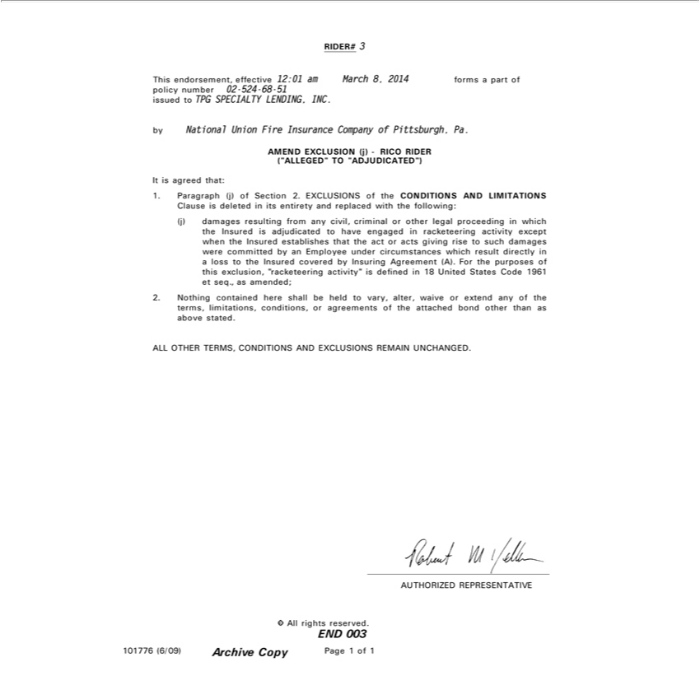

RIDER# 3
issuedThisendorsement,toTPGSPECIALTYeffective 12:01LENDING,amMarchINC.8, 2014 forms a part of policy number 02-524-68-51
by National Union Fire Insurance Company of Pittsburgh, Pa.
ItAMENDisagreedEXCLUSIONthat: (j) - RICO RIDER (“ALLEGED” TO “ADJUDICATED”)

1. Paragraph (j) of Section 2. EXCLUSIONS of the CONDITIONS AND LIMITATIONS Clause is deleted in its entirety and replaced with the following: (j) damages resulting from any civil, criminal or other legal proceeding in which the Insured is _{adjudicated} to have engaged in racketeering activity except when the Insured establishes that the act or acts giving rise to such damages were committed by an Employee under circumstances which result directly in loss to the Insured covered by Insuring Agreement (A). For the purposes of this exclusion, “racketeering activity” is defined in 18 United States Code 1961 et seq., as amended; 2. Nothing contained here shall be held to vary, alter, waive or extend any of the terms, limitations, conditions, or agreements of the attached bond other than as above stated.
_{AUTHORIZED}LLOTHERTERMS,REPRESENTATIVECONDITIONS AND EXCLUSIONS REMAIN UNCHANGED.
ENDCAll 003rights reserved.
101776 (6/09)
PageArchive1ofCopy1

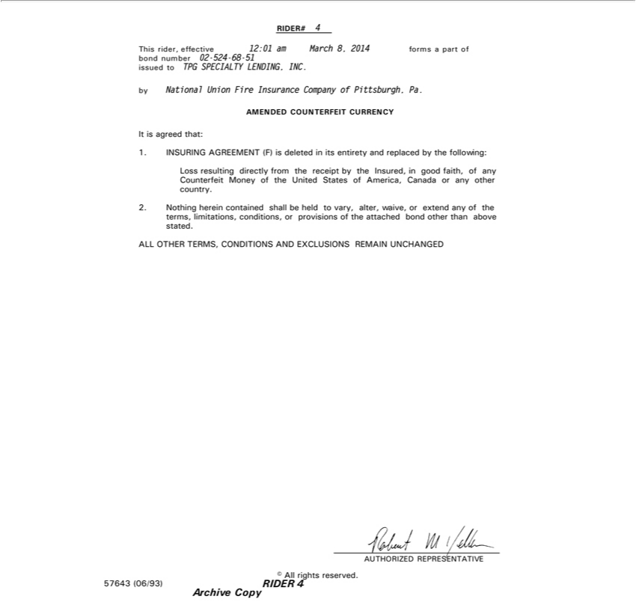

RIDER# 4
This rider, effective 12:01 am March 8, 2014 forms a part of
^{by}
ondNationalnumberUnion02-524Fire-68Insurance-51issuedCompanytoTPGSPECIALTYofPittsburgh,LENDING,Pa. INC.
ItAMENDEDisagreedthat:COUNTERFEIT CURRENCY
1. INSURING AGREEMENT (F) is deleted in its entirety and replaced by the following:
Loss resulting directly from the receipt by the _{Insured,} in good faith, of any Counterfeit Money of the United States of America, Canada or any other country.
2. Nothing herein contained shall be held to vary alter, waive, or extend any of the terms, limitations, conditions, or provisions of the attached bond other than above stated.
_{AUTHORIZED}LLOTHERTERMS,REPRESENTATIVECONDITIONS AND EXCLUSIONS REMAIN UNCHANGED
© All rights reserved.
Archive57643(06/93)Copy RIDER 4

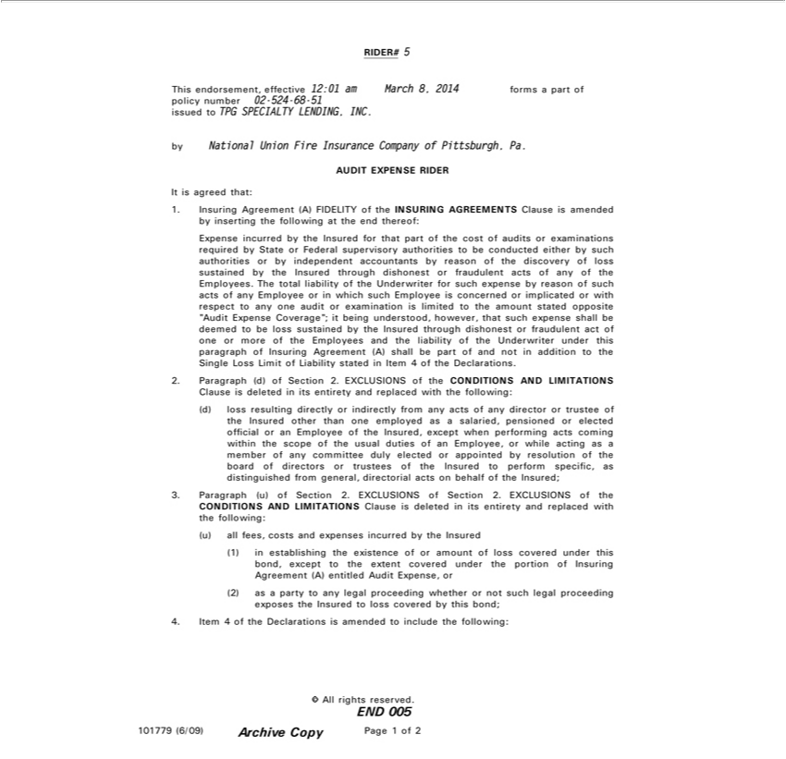

RIDER# 5
This endorsement, effective 12:01 am March 8, 2014 forms a part of policy number 02-524-68-51
issued to TPG SPECIALTY LENDING, INC.
by National Union Fire Insurance Company of Pittsburgh, Pa.
AUDIT EXPENSE RIDER
It is ag eed that: | by the Insured for that part of the cost of audits or
1. Insuring Agreement (A) FIDELITY of the INSURING AGREEMENTS Clause is amended by inserting the following at the end thereof: Expense
examinations required by State or Federal supervisory auth rities to be conducted either by such authorities or by independent accountants by reason incurredofthe | scovery of loss sustained by the Insured through
di honest or fraudulent acts of any of the Employees. The total liability of the Underwriter for such expense by reason of such acts of any Employee or in which such Employee is concerned or implicated or with
respect to any one audit or examination is limited to the amount stated opposite “Audit Expense Coverage”; it being understood, however, that such expense shall be deemed to be loss sustained by the Insured
through dishonest or fraudulent act of one or more of the Employees and the liability of the Underwriter under this paragraph of Insuring Agreement (A) shall be part of and not in addition to the Single Loss
Limit of Liability stated in Item 4 of the Declarations.
2. Paragraph (d) of S ction 2. EXCLUSIONS of the CONDITIONS AND LIMITATIONS Clause is deleted in its entirety and replaced with the following: (d) loss resulting directly or indirectly from any acts of
any director or trustee of the Insured other than one employed as a salaried, pensioned or elected official or an Employee of the Insured, except when performing acts coming within the scope of the usual duties
of an Employee, or while acting as a member of any committee duly elected or appointed by resolution of the board of directors or trustees of the Insured to perform specific, as |  | from general,
directorial acts on behalf of the Insured; 3. Paragraph (u) of Section 2. EXCLUSIONS of Section 2. EXCLUSIONS of the CONDITIONS AND LIMITATIONS Clause is deleteddistinguisheditsentirety and replaced with the following: (u) all fees, costs and expenses incurred by the Insured_{proceeding}(1)establishing the existence of or amount of loss covered under this bond, except to the extent covered under the portion of Insuring
Agreement (A) entitled Audit Expense, or (2) as a party to any legal whether or not such legal proceeding exposes the Insured to loss covered by this bond; 4. Item 4 of the Declarations is amended to include the following:
END©All 005rights reserved.

101779 (6/09) Archive Copy Page 1 of 2

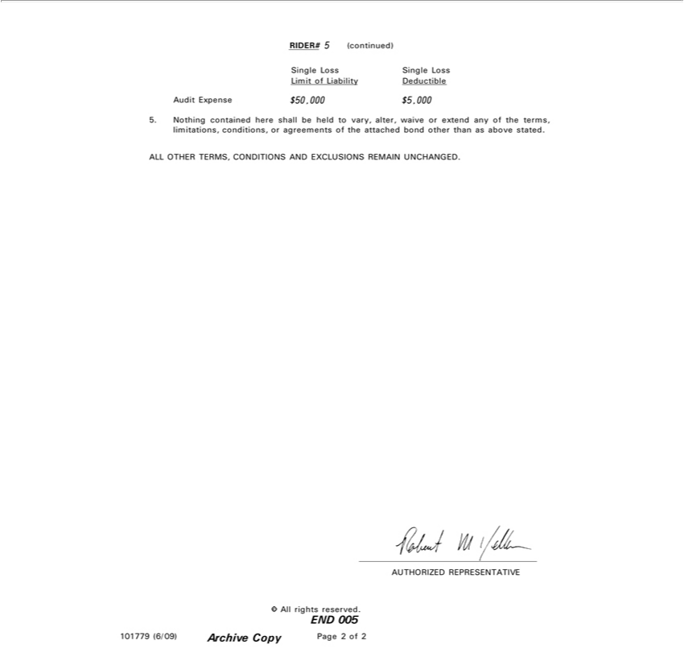

RIDER# 5 (co_{Single}tinued)
AuditSingleExpenseLoss $50,000Loss $Limit5,000of Liability Deductible
5. Nothing contained here shall be held to vary, alter, waive or extend any of the terms, limitations, conditions, or agreements of the attached bond other than as above stated.
_{AUTHORIZED}LLOTHERTERMS,REPRESENTATIVECONDITIONS AND EXCLUSIONS REMAIN UNCHANGED.
END©All 005rights reserved.

101779 (6/09) Archive Copy Page 2 of 2

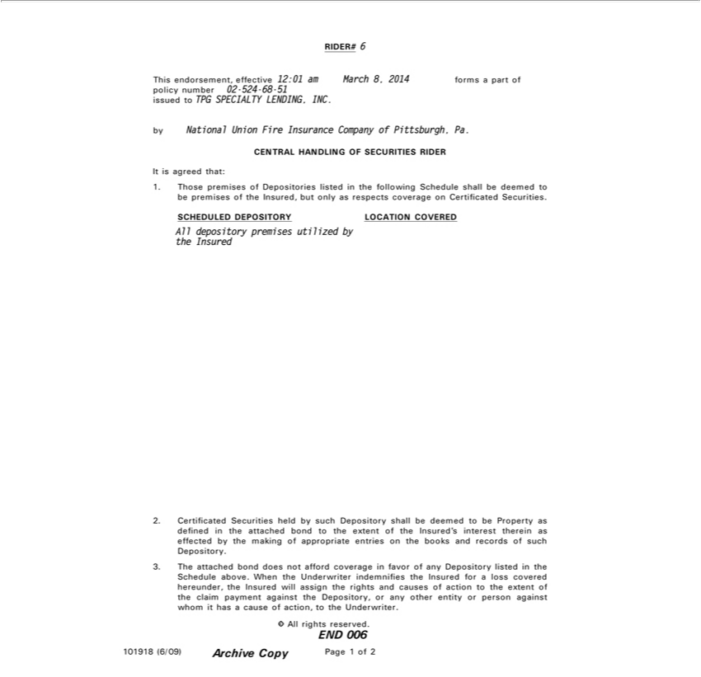

RIDER# 6
issuedThisendorsement,toTPGSPECIALTYeffective 12:01LENDING,amMarchINC.8, 2014 forms a part of policy number 02-524-68-51
by National Union Fire Insurance Company of Pittsburgh, Pa.
ItCENTRALisagreed that:HANDLING OF SECURITIES RIDER
1. Those premises of Depositories listed in the following Schedule shall be deemed to be premises of the Insured, but only as respects coverage on Certificated Securities.
AllSCHEDULEDdepository premisesDEPOSITORYutilizedLOCATIONby COVERED
the Insured
2. Certificated Securities held by such Depository shall be deemed to be Property as defined in the attached bond to the extent of the Insured’s interest therein as effected by the making of appropriate entries on the books and records^{does}ofuch Depository.
3. The attached bond not afford coverage in favor of any Depository listed in the Schedule above. When the Underwriter indemnifies the Insured for a loss covered hereunder, the Insured will assign the rights and causes of action to the extent of the claim payment against the Depository, or any other entity or person against whom it has a cause of action, to the Underwriter.
END©All 006rights reserved.

101918 (6/09) Archive Copy Page 1 of 2

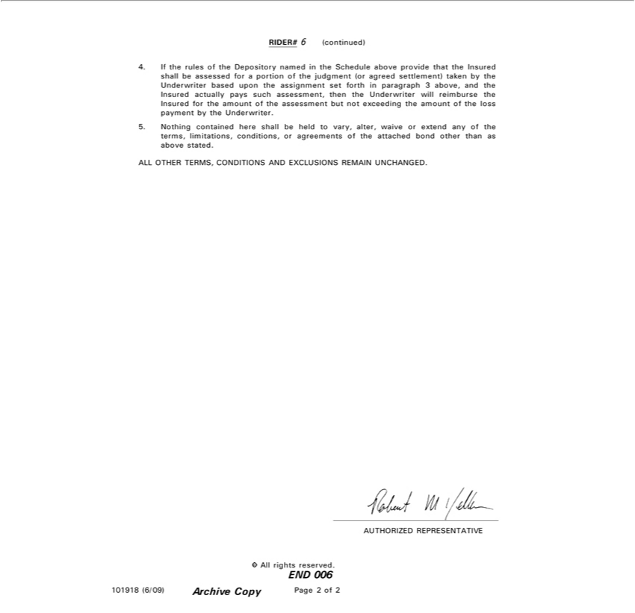

RIDER# 6 (continued)
4. If the rules of the Depository named in the Schedule above provide that the Insured shall be assessed for a portion of the judgment (or agreed settlement) taken by the Underwriter based upon the assignment set forth in paragraph 3 above, and the Insured actually pays such assessment, then the Underwriter will reimburse the Insured for the amount of the assessment but not exceeding the amount of the loss payment by the Underwriter.
5. Nothing contained here shall be held to vary, alter, waive or extend any of the terms, limitations, conditions, or agreements of the attached bond other than as above stated.
_{AUTHORIZED}LLOTHERTERMS,REPRESENTATIVECONDITIONS AND EXCLUSIONS REMAIN UNCHANGED.
END©All 006rights reserved.

101918 (6/09) Archive Copy Page 2 of 2

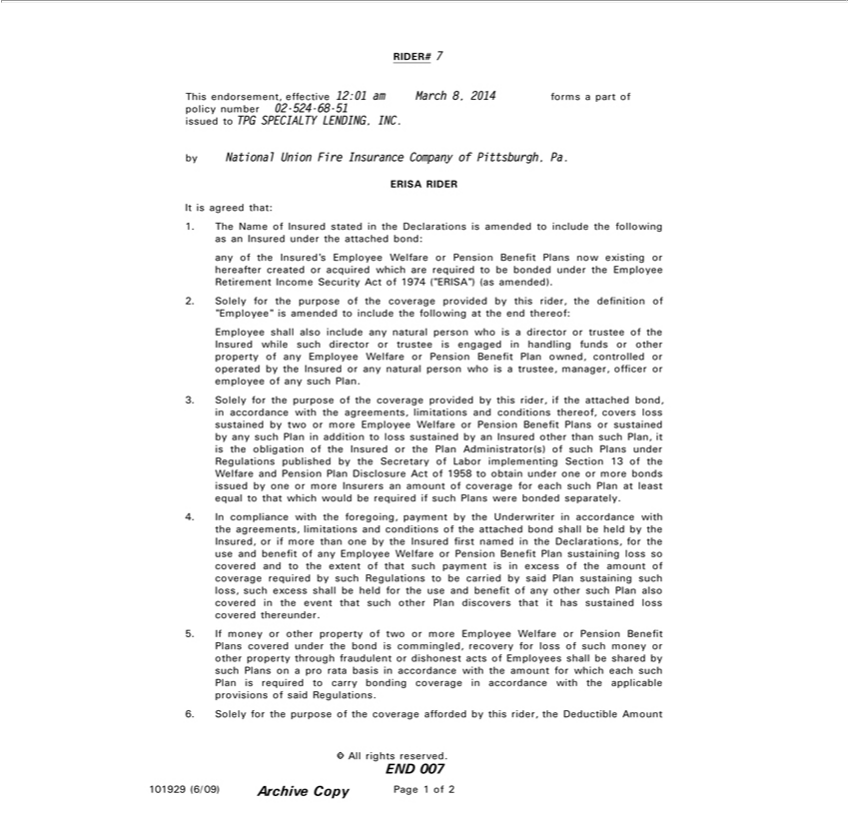

RIDER# 7
This endorsement, effective 12:01 am March 8, 2014 forms a part of policy number 02-524-68-51
issued to TPG SPECIALTY LENDING, INC.
by National Union Fire Insurance Company of Pittsburgh, Pa.
ERISA RIDER
It is agreed that:
1. | The Name of Insured stated in the Declarations is amended to include the following as an Insured under the attached bond: any of the Insured’s Employee Welfare or Pension Benefit Plans now existing or
hereafter created or acquired which are required to be bonded under the Employee Retirement Income Security Act of 1974 (“ERISA”) (as amended).
2. | Solely for the purpose of the coverage provided by this rid r, the |  |  | of “Employee” is amended to include the following at the end thereof: Employee shall also include any natural person who is a
director or trustee of the Insured while such director or trustee is engageddefinitionhandling funds or other property of any Employee Welfare or Pension Benefit Plan owned, controlled or operated by the Insured or
any natural person who is a trustee, manager, officer or employee of any such Plan. |  |  |  |  | with the agreements, | and conditions | covers loss sustained by two | more Employee
3. | Solely | the purpose of the coverage provided by this rider, if the attached bond,
Welfare |  | forPension Benefit Plans or sustained by any such Plan in addition to loss sustainedaccordancebyInsured other than suchlimitationsPlan,is the obligation ofthereof,Insured or the Plan |  |  |  |  |  | of such Plans under
Regulations published by the Secretary of Labor implementing Section 13 of the Welfare and Pension Plan Disclosure Act of 1958 to obtain under one or more bonds issued Administrator(s)byonemoreInsurers an amount of
coverage for each such Plan at least equal to that which would be required if such Plans were bonded separately.
4. | compliance with the foregoing, payment by the Underwriter in accordance with the agre ments, limitations and conditions of the attached bond shall be held by the Insured, or if more than one by the
Insured fi st named in the Declarations, for the use and benefit of any Employee Welfare or Pension Benefit Plan sustaining loss so covered and to the extent of that such payment is in excess of |  |  |  |  |  |  |  |  | amount of
coverage required by such Regulations to be carried by said Plan sustaining such loss, such excess shall be held for the use and benefit of any other such Plan also covered in the event that such other Plan
discovers that it has sustained loss covered thereunder. |  |  | or Pension Benefit Plans covered under the bond is ommingled, recovery for loss of such money or other property through fraudulent or
5. | If money or other property of two or more Employee W
dishonest acts of Employees shall be shared by such Planselfareonpro rata basis in accordance with the amount for which each such Plan is required to carry bonding coverage in accordance with the applicable
provisions of said Regulations.
6. | Solely for the purpose of the coverage afforded by this rider, the Deductible Amount
© All rights reserved.
END 007
101929 (6/09) Archive Copy Page 1 of 2

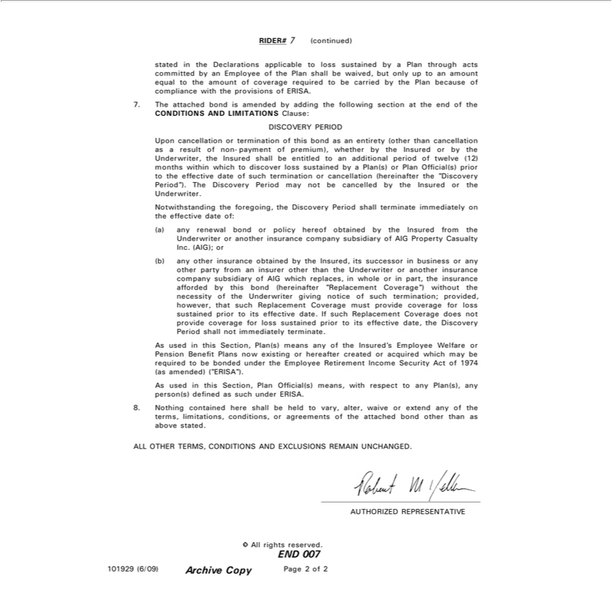

RIDER# 7 (continued)
stated in the Declarations applicable to loss sustained by a Plan through acts committed by an Employee of the Plan shall be waived, but only up to an amount equal to the amount of coverage required to be
carried by the Plan because of compliance with the provisions of ERISA.
7. The attached bond is amended by adding the following section at the end of the
CONDITIONS AND LIMITATIONS Clause:
DISCOVERY PERIOD
Upon cancellation or termination of this bond as an entirety (other than cancellation as result of non-payment of premium), whether by the Insured or by the Underwriter, the Insured shall be entitled to an
additional period of twelve (12) months within which to discover loss sustained by a Plan(s) or Plan Official(s) prior to the effective date of such termination or cancellation (hereinafter the “Discovery Period”).
The Discovery Period may not be cancelled by the Insured or the Underwriter.
Notwithstanding the foregoing, the Discovery Period shall terminate immediately on the effective date of: (a) any renewal bond policy hereof obtained by the Insured from the Underwriter or another
insurance company subsidiary of AIG Property Casualty Inc. (AIG); or (b) any other insurance obtained by the Insured, its successor in business or any other party from an insurer other than the Underwriter or
another insurance company subsidiary of AIG which replaces, in whole or in part, the insurance afforded by this bond (hereinafter “Replacement Coverage”) without the necessity of the Underwriter giving
notice of such termination; provided, however, that such Replacement Coverage must provide coverage for loss sustained prior to its effective date. If such Replacement Coverage does not provide coverage for
loss | prior to its effective date, the Discovery Period shall not immediately terminate.
As usedsustainedthis Section, Plan(s) means any of the Insured’s Employee Welfare or Pension Benefit Plans now existing or hereafter created or acquired which may be required to be bonded under the Employee
Retirement Income Security Act of 1974 (as amended) (“ERISA”).
As used | this Section, Plan Official(s) means, with respect to any Plan(s), any person(s) defined as such under ERISA.
8. Nothing contained here shall be held to vary, alter, waive or extend any of the terms, limitations, conditions, or agreements of the attached bond other than as above stated.
_{AUTHORIZED}LLOTHERTERMS,REPRESENTATIVECONDITIONS AND EXCLUSIONS REMAIN UNCHANGED.
END©All 007rights reserved.
101929 (6/09)
Archive Copy Page 2 of 2

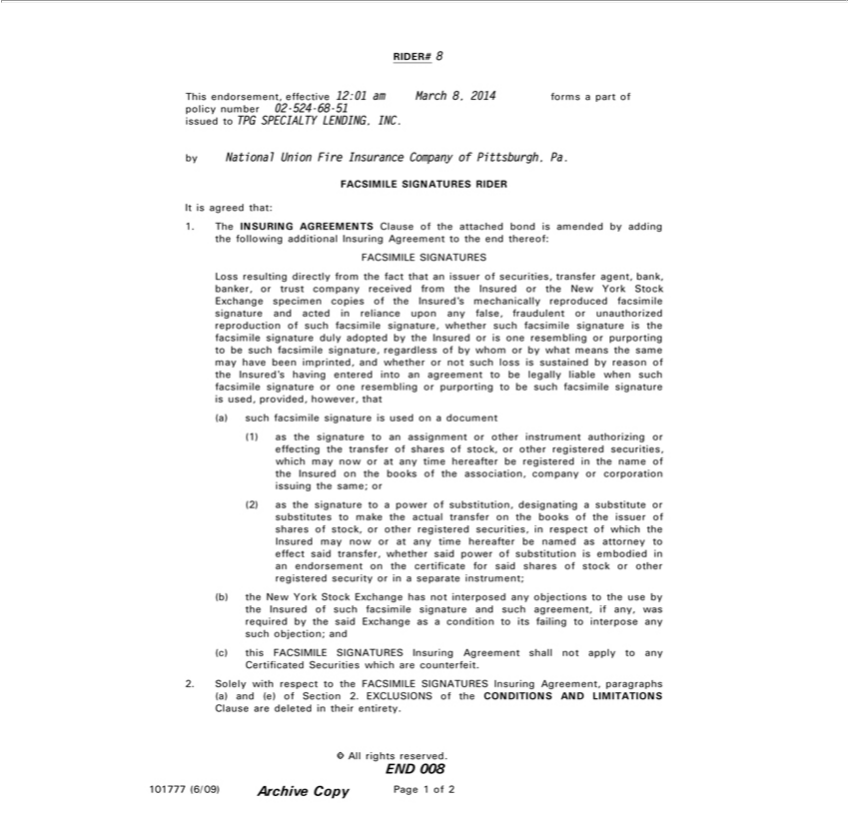

RIDER# 8
This endorsement, effective 12:01 am March 8, 2014 forms a part of policy number 02-524-68-51
issued to TPG SPECIALTY LENDING, INC.
by National Union Fire Insurance Company of Pittsburgh, Pa.
FACSIMILE SIGNATURES RIDER
It is agreed that:
1. The INSURING AGREEMENTS Clause of the attached bond is amend d by adding the following additional Insuring Agreement to the end thereof: FACSIMILE SIGNATURES
Loss resulting directly from the fact that an issuer of securities, transfer agent, bank, banker, or trust company received from the Insured or the New York Stock Exchange specimen copies of the Insured’
mechanically reproduced facsimile signature and acted reliance upon any false, fraudulent or unauthorized reproduction of such facsimile signature, whether such facsimile signature is the facsimile signature
duly adopted by the Insured or is one resembling or purporting to be such facsimile signature, regardless of by whom or by what means the same may have been imprinted, and whether or not such loss is
sustained by reason of the Insured’s having entered into an agre ment to be legally liable when such facsimile signature one resembling or purporting to be such facsimile signature used, provided, however,
that (a) such facsimile signature | used on a document (1) as the signature to an assignment or other instrument authorizing or effecting the transfer of shares of stock, or other registered securities, which
now or at any time hereafter be registered in the name of the Insured on the books of the association, company or corporation |  | the same; or (2) as the signature to a power of substitution, designatingmay
substitute or substitutes to make | actual transfer on the books of the issuer of shares of stock, or other registered securities, issuingrespect of which the Insured may now or at any time hereafter be named as
attorney effect said transfer, whether said power of substitution is embodied in an endorsement on the certificate for said shares of stock or other registered security or in a |  |  | instrument; (b) the New
York Stock Exchange has not interposed any objections to the use by the Insured of such facsimile signature and such agreement, if any, was required by the said Exchange asseparatecondition to its failing to interpose any such objection; and (c) this FACSIMILE SIGNATURES Insuring Agreement shall not apply to any Certificated Securities which are counterfeit.

2. Solely with respect to the FACSIMILE SIGNATURES Insuring Agreement, paragraphs (a) and (e) of Section 2. EXCLUSIONS of the CONDITIONS AND LIMITATIONS Clause are deleted in their entirety.
END©All 008rights reserved.
101777 (6/09) Archive Copy Page 1 of 2

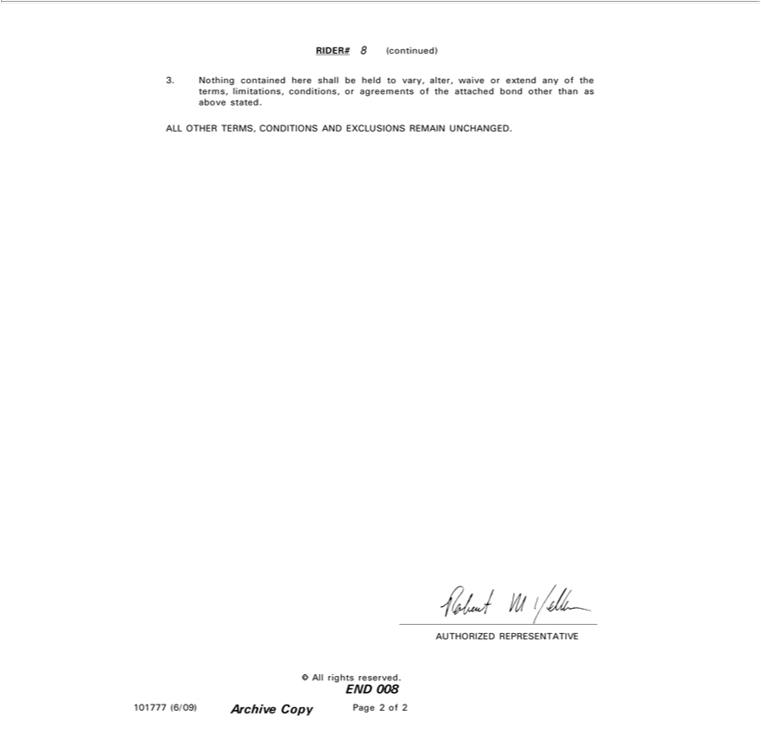

RIDER# 8 (continued)
3. Nothing contained here shall be held to vary, alter, waive or extend any of the terms, limitations, conditions, or agreements of the attached bond other than as above stated.
_{AUTHORIZED}LLOTHERTERMS,REPRESENTATIVECONDITIONS AND EXCLUSIONS REMAIN UNCHANGED.
END©All 008rights reserved.

101777 (6/09) Archive Copy Page 2 of 2

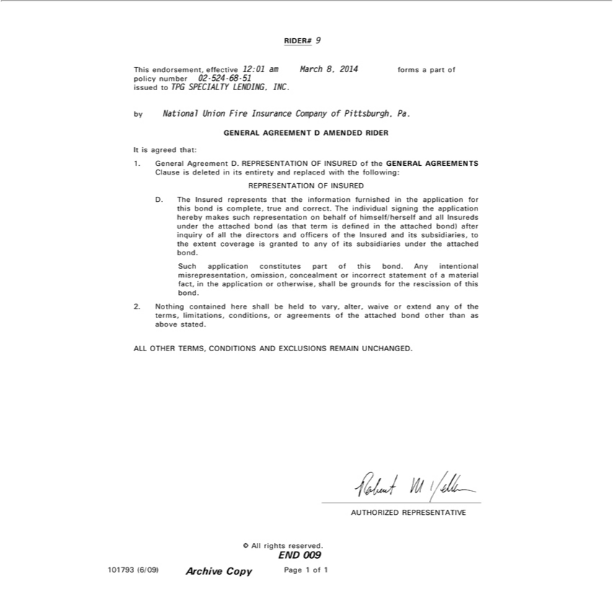

RIDER# 9
issuedThisendorsement,toTPGSPECIALTYeffective 12:01LENDING,amMarchINC.8, 2014 forms a part of policy number 02-524-68-51
by National Union Fire Insurance Company of Pittsburgh, Pa.
ItGENERALisagreed that:AGREEMENT D AMENDED RIDER

1. General Agreement D. REPRESENTATION OF INSURED of the GENERAL AGREEMENTS Clause is deleted in its entirety and replaced with the following: REPRESENTATION OF INSURED D. The Insured represents that the information furnished in the application for this bond is complete, true and correct. The individual signing the application hereby makes such representation on behalf of himself/herself and all Insureds under the attached bond (as that term is defined in the attached bond) after inquiry of all the directors and officers of the Insured and its subsidiaries, to the extent coverage is granted to any of its subsidiaries under the attached bond.

Such application constitutes part of this bond. Any intentional misrepresentation, omission, concealment or incorrect statement of a material fact, in the application or otherwise, shall be grounds for the rescission of this bond.
2. Nothing contained here shall be held to vary, alter, waive or extend any of the terms, limitations, conditions, or agreements of the attached bond other than as above stated.
_{AUTHORIZED}LLOTHERTERMS,REPRESENTATIVECONDITIONS AND EXCLUSIONS REMAIN UNCHANGED.
END©All 009rights reserved.

101793 (6/09) Archive Copy Page 1 of 1

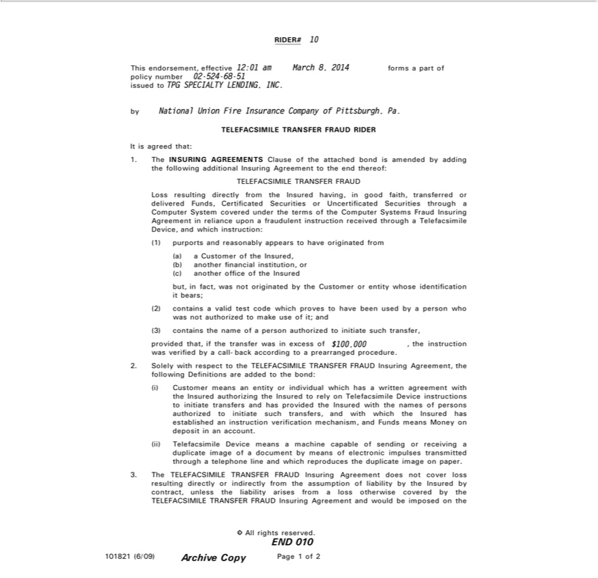

RIDER# 10
This endorsement, effective 12:01 am March 8, 2014 forms a part of policy number 02-524-68-51
issued to TPG SPECIALTY LENDING, INC.
by National Union Fire Insurance Company of Pittsburgh, Pa.
TELEFACSIMILE TRANSFER FRAUD RIDER
It is agreed that:
1. The INSURING AGREEMENTS Clause of the attached bond is amended by adding the follow ng additional Insuring Agreement to the end thereof: TELEFACSIMILE TRANSFER FRAUD
Loss resulting directly from the Insured having, in good faith, |  | or delivered Funds, Certificated Securities or Uncertificated Securities through a Computer System covered under the terms of the
C puter Systems Fraud Insuring Agreement in reliance upontransferredfraudulent instruction received through a Telefacsimile Device, and which instruction: (1) purports and reasonably appears to have
from (a) a Customer of the Insured, (b) | financial instituti n, | (c) another office of the Insured but, fact, was not |  | by the | or entity whose identification it bears; (2) contains valid
test code which proves to have been usedanotherbyperson who was not authorized to make use of it; and (3) contains the name oforiginatedperson authorizedCustomerinitiate such transfer, provided that, if the transferoriginatedwas
excess of $100,000 , the instruction was verified by a call-back according to a prearranged procedure.
2. Solely with respect to the TELEFACSIMILE TRANSFER FRAUD Insuring Agreement, the following Definitions are added to the bond: (i) Customer means an entity or individual which has a written
greement with the Insured authorizing the Insured to rely Telefacsimile Device instructions to initiate transfers and has provided the Insured with the names of persons authorized to initiate such transfers,
and with which the Insured has | an instruction verification | and Funds | Money on deposit in an account.
(ii) Telefacsimile Device meansestablishedmachine capable of sending or receivingmechanism,duplicate image ofmeansdocument by means of electronic impulses transmitted through a telephone line and which reproduces the duplicate image on paper.

3. The TELEFACSIMILE TRANSFER FRAUD Insuring Agreement does not cover loss resulting directly or indirectly from the assumption of liability by the Insured by contract, unless the liability arises from a loss otherwise covered by the TELEFACSIMILE TRANSFER FRAUD Insuring Agreement and would be imposed on the
END©All 010rights reserved.
101821 (6/09) Archive Copy Page 1 of 2

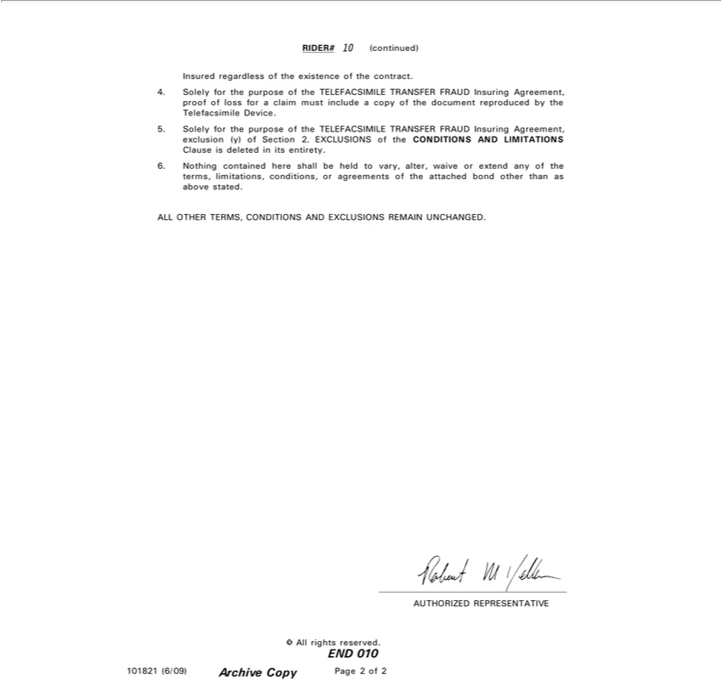

RIDER# 10 (continued)
Insured regardless of the existence of the contract. |  | FRAUD Insuring | proof of loss for a claim must include a copy of the document reproduced by the elefacsimile Device.
4 |  | FRAUD Insuring
5. Solely for the purpose of the TELEFACSIMILE TRANSFER FRAUD Insuring Agreement, exclusion (y) of Section 2. EXCLUSIONS of the CONDITIONS AND LIMITATIONS
Clause is deleted | its entirety.
6. Nothing contained here shall be held to vary, alter, waive or extend any of the terms, limitations, conditions, or agreements of the attached bond other than as above stated.
_{AUTHORIZED}LLOTHERTERMS,REPRESENTATIVECONDITIONS AND EXCLUSIONS REMAIN UNCHANGED.
END©All 010rights reserved.

101821 (6/09) Archive Copy Page 2 of 2

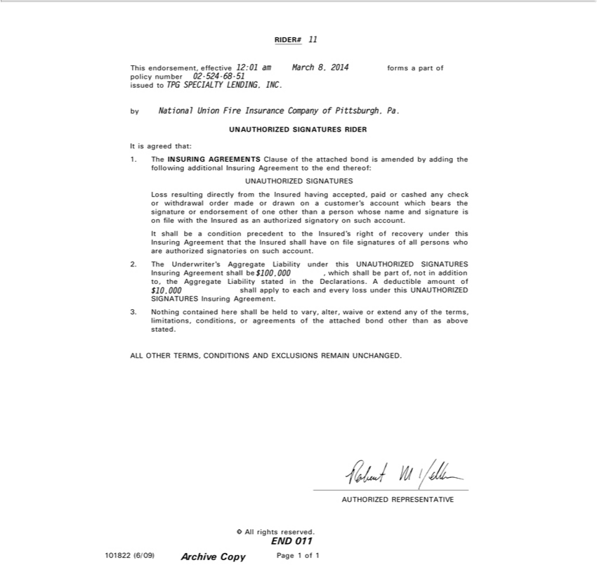

RIDER# 11
issuedThisendorsement,toTPGSPECIALTYeffective 12:01LENDING,amMarchINC.8, 2014 forms a part of policy number 02-524-68-51
by National Union Fire Insurance Company of Pittsburgh, Pa.
ItUNAUTHORIZEDisagreedthat: SIGNATURES RIDER
1. The INSURING AGREEMENTS Clause of the attached bond is amended by adding the following additional Insuring Agreement to the end thereof: UNAUTHORIZED SIGNATURES
Loss resulting directly from the Insured having accepted, paid or cashed any check_{signatory}withdrawal order made or drawn on a customer’s account which bears the signature or endorsement of one other than a
person whose name and signature is on file with the Insured as an authorized on such account.
It shall be a condition precedent to the Insured’s right of recovery under this Insuring Agreement that the Insured shall have on file signatures of all persons who are authorized signatories on such account.
2. The Underwriter’s Aggregate Liability under this UNAUTHORIZED SIGNATURES Insuring Agreement shall be $100,000 , which shall be part of, not in addition to, the Aggregate Liability stated in the Declarations. A deductible amount of $10,000 shall apply to each and every loss under this UNAUTHORIZED
SIGNATURES Insuring Agreement.
3. Nothing contained here shall be held to vary, alter, waive or extend any of the terms, limitations, conditions, or agreements of the attached bond other than as above stated.
_{AUTHORIZED}LLOTHERTERMS,REPRESENTATIVECONDITIONS AND EXCLUSIONS REMAIN UNCHANGED.
END©All 011rights reserved.

101822 (6/09) Archive Copy Page 1 of 1

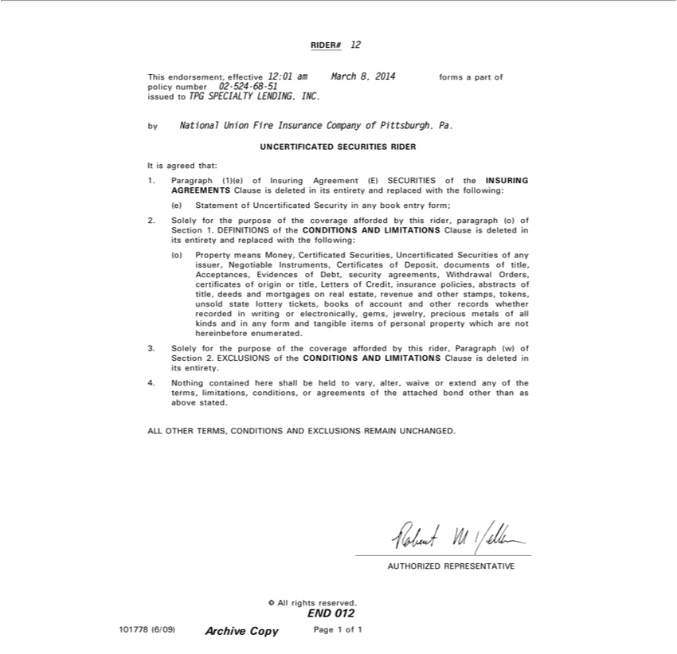

RIDER# 12
issuedThisendorsement,toTPGSPECIALTYeffective 12:01LENDING,amMarchINC.8, 2014 forms a part of policy number 02-524-68-51
by National Union Fire Insurance Company of Pittsburgh, Pa.
ItUNCERTIFICATEDisagreedthat: SECURITIES RIDER

1. Paragraph (1)(e) of Insuring Agreement (E) SECURITIES of the INSURING AGREEMENTS Clause is deleted in its entirety and replaced with the following: (e) Statement of Uncertificated Security in any book entry form; 2. Solely for the purpose of the coverage afforded by this rider, paragraph (o) of Section 1. DEFINITIONS of the CONDITIONS AND LIMITATIONS Clause is deleted in its entirety and replaced with the following: (o) Property means Money_{Orders,}Certificated Securities, Uncertificated Securities of any issuer_{policies,}Negotiable Instruments, Certificates of Deposit, documents of title, Acceptances,
Evidences of Debt, security agreements, Withdrawal certificates of origin_{recorded}title, Letters of Credit, insurance abstracts of title, deeds and mortgages on real estate, revenue and other stamps,
tokens, unsold state lottery tickets, books of account and other records whether in writing or electronically, gems, jewelry, precious metals of all kinds and in any form and tangible items of personal property which are not hereinbef_{coverage}reenumerated.
3. Solely for the purpose of the afforded by this rider, Paragraph (w) of Section 2. EXCLUSIONS of the CONDITIONS AND LIMITATIONS Clause is deleted in its entirety.
4 Nothing contained here shall be held to vary, alter, waive or extend any of the terms, limitations, conditions, or agreements of the attached bond other than as above stated.
_{AUTHORIZED}LLOTHERTERMS,REPRESENTATIVECONDITIONS AND EXCLUSIONS REMAIN UNCHANGED.
END©All 012rights reserved.

101778 (6/09) Archive Copy Page 1 of 1

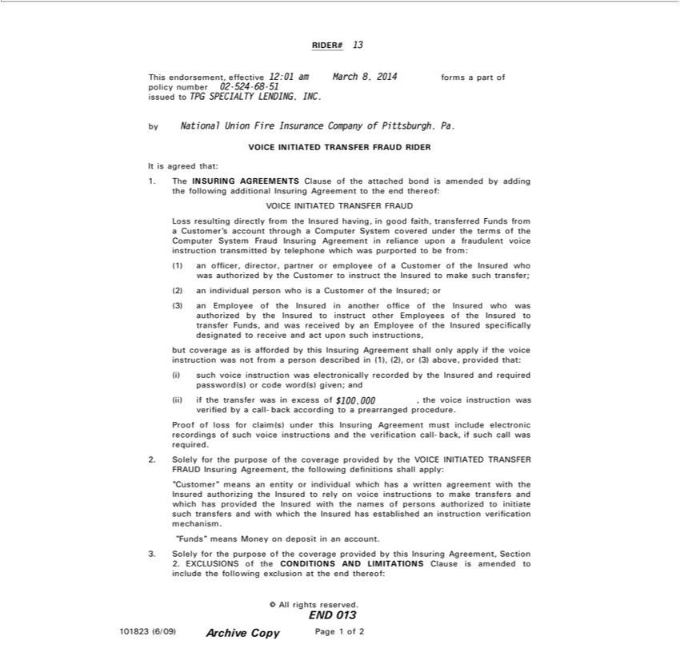

RIDER# 13
This endorsement, effective 12:01 am March 8, 2014 forms a part of policy number 02-524-68-51
issued to TPG SPECIALTY LENDING, INC.
by National Union Fire Insurance Company of Pittsburgh, Pa.
VOICE INITIATED TRANSFER FRAUD RIDER
It is agreed that: |  |  |  |  |  | the following additional Insuring Agreement to the end thereof: VOICE INITIATED TRANSFER FRAUD
1. The INSURING AGREEMENTS Clause of the attached bond is amended by
Loss |  |  | directly from the Insured having, good faith, transferred Funds addingfrom |  |  | Customer’s account through a Computer System covered under the terms of the Computer System Fraud Insuring
Agreementresulting reliance upon fraudulent voice instruction transmitted by telephone which was purported be from:
1) officer, director, partner or employee of a Customer of the Insured who was authorized by the Customer to instruct the Insured to make such transfer;
2) |  | individual person who is a Customer of the Insured; or
(3) an Employee of the Insured in another office of the Insured who was authorized by the Insured to instruct other Employees of the Insured to transfer F nds, and was received by an Employee of the Insured
specifically designated to receive and act upon such instructions, but coverage as is afforded by this Insuring Agreement shall only apply if the voice instruction was not from a person described in (1), (2), or
 |  | above, provided that: |  | was electronically recorded by the Insured and required p ssword(s) or code word(s) given; and
3) such voice
(ii) if the transferinstructionwasexcess of $100,000 , the voice instruction was verified by a call-back according to a prearranged procedure.
Proof of loss for claim(s) under this Insuring Agreement must include electronic recordings of such voice instructions and the verification call-back, if such call was required.
2. Solely for the purpose of the coverage provided by |  |  |  |  | VOICE INITIATED TRANSFER FRAUD Insuring Agreement, the following defi itions shall apply: “Customer” means an entity or individual which
has a written agreement with the Insured authorizing |  |  |  |  | theInsured to rely on voice instructions to make transfers and which has provided the Insured with the names of persons authorized to initiate such transfers
and with which the Insured has established an instruction verification mechanism.
“Funds” means Money on deposit in n account.
3 | Solely for the purpose of the coverage provided by this Insuring Agreement, Section
2. | EXCLUSIONS of the CONDITIONS AND LIMITATIONS Clause is amended to include the following exclusion at the end thereof:
© All rights reserved.
END 013
101823 (6/09)
Archive Copy
Page 1 of 2

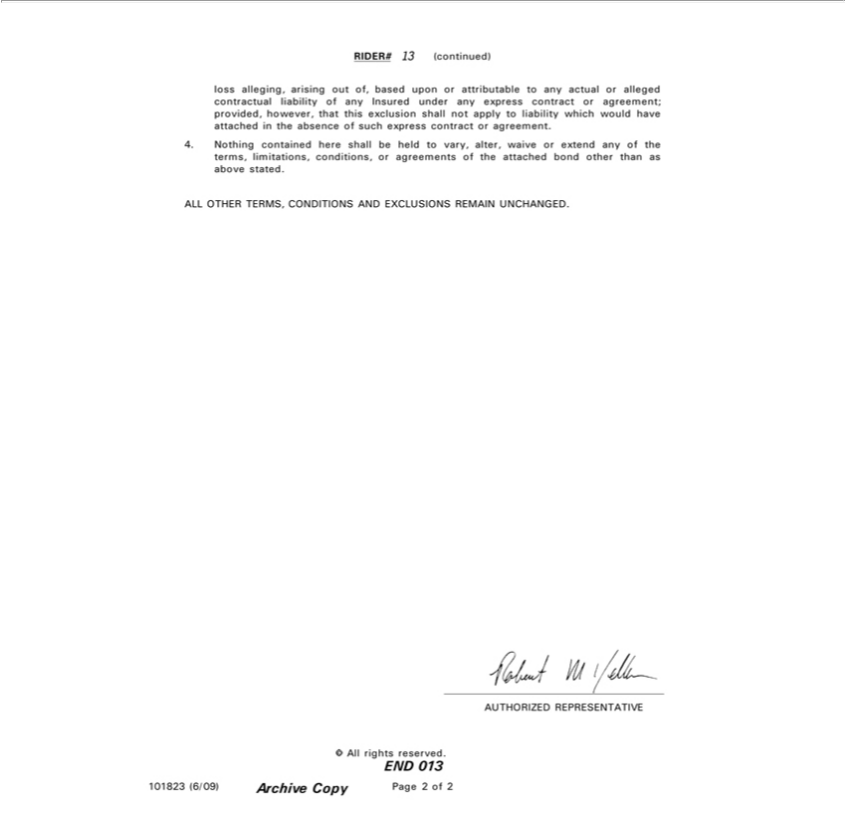

RIDER# 13 (continued)
^{to}lss alleging, arising out of, based upon or attributable to any actual or alleged contractual liability of any Insured under any express contract or agreement; provided, however, that this exclusion shall not apply liability which would have attached in the absence of such express contract or agreement.
4. Nothing contained here shall be held to vary, alter, waive or extend any of the terms, limitations, conditions, or agreements of the attached bond other than as above stated.
_{AUTHORIZED}LLOTHERTERMS,REPRESENTATIVECONDITIONS AND EXCLUSIONS REMAIN UNCHANGED.
END©All 013rights reserved.
101823 (6/09)
PageArchive2ofCopy2

RIDER# 14
This rider, effective 12:01 am March 8, 2014 forms a part of bond number 02-524-68-51 issued to TPG SPECIALTY LENDING, INC.
by National Union Fire Insurance Company of Pittsburgh, Pa.
AMENDED DEFINITION OF EMPLOYEE
In consideration of the premium charged, it is hereby understood and agreed that in the CONDITIONS AND LIMITATIONS section, Definition (e) Employee is deleted in its entirety and replaced with the
following:
a) “Employ e”
1) | Insured’means: officers, partners, or employees, and
(2) any of the officers or employees of any predecessor of the Insured whose principal assets are acquired by the Insured by consolidation or merger with, or purchase of assets or capital stock of such
predecessor, and
(3) attorneys retained by the Insured to perform legal services for the Insured and the employees of such attorneys while such attorneys or the employees of such attorneys are performing such services for the
Insured, and |  | any of the Insured’s offices, and
4) guest students pursuing their studies or duties |  | any of the Insured’s offices, and | keeper, or | authorized by written agreement to keep financial
(5) directors or trustees of the Insured, the investment advisor, underwriter (distributor), transfer agent, or shareholder accounting |  |  | keeper, or | authorized by written agreement to keep financial
and/or other required records, but only while performing acts coming within the scope of the usual duties of an officer or employeerecordwhile acting asadministratormemberof any committee duly elected or appointed to
examine or audit or have custody of or access to the Property of the Insured, and
(6) any individual or individuals assigned to perform the usual duties of an employee within the premises of the Insured, by contract, or by any agency furnishing temporary personnel on a contingent or part-
time basis, and |  | by written agreement with the Insured to perform services as electronic data processor of checks or other accounting records of the Insured, but
(7) each natural person, partnership or corporation
authorized
excluding any such processor who acts as transfer agent_{Handling}any other agency capacity in issuing checks, drafts or securities for the Insured, unless included under Sub-section (9) hereof, and
(8) those persons so designated in Section 15, Central of Securities, and

MNSCPT

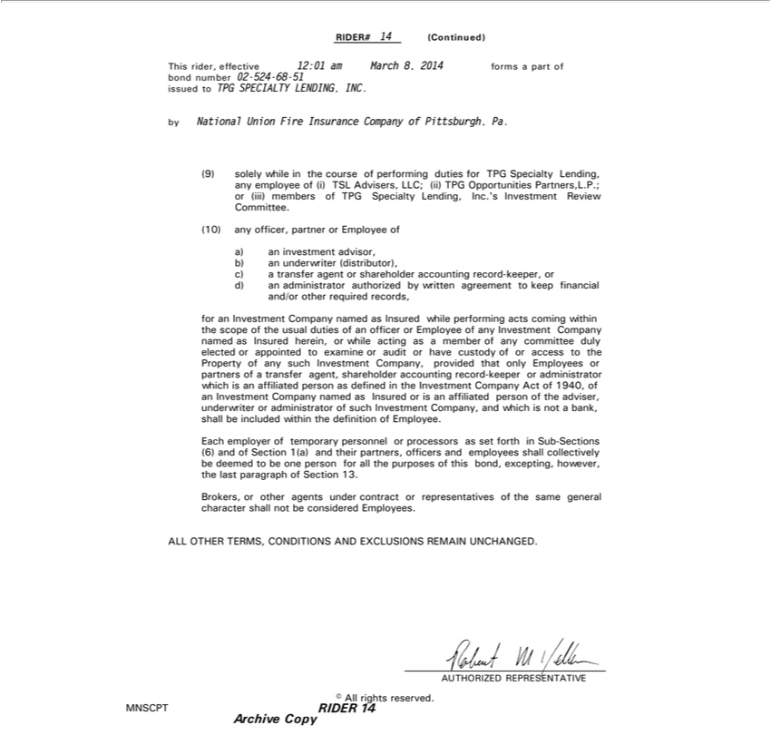

RIDER# 14 (Continued)
byThisNationalrider,effectiveUnionFire12:01InsuranceamMarchCompany8,2014offormsPittsburgh,apart ofPa.bond number 02-524-68-51 issued to TPG SPECIALTY LENDING, INC.
Investment(9)solelywhileReviewintheCommittee.courseof performing duties for TPG Specialty Lending, any employee of (i) TSL Advisers, LLC; (ii) TPG Opportunities Partners,L.P.; or (iii) members of TPG Specialty Lending, Inc.’s (10) any officer, partner or Employee of
a) an investment advisor
c)b) aantransferuderwriteragent (distributor),shareholder accounting record-keeper, or
ford)ananadministratorInvestmentCompanyauthorizednamedbywrittenasInsuredagreementwhile toperformingkeepfinancialactscomingand/or otherwithinrequiredthescoperecords,ofthe usual duties of an officer or Employee of any Investment Company named as Insured herein, or while acting agent,smember of any committee duly elected or appointedadministratorexamine or audit or have custody of or access to the PropertyCompanyofsuch Investment Company, provided that only Employees or partners offiliatedtransfer
personshareholderoftheadviser,accountingunderwriterrecord-keeper of such Investmentwhichis Companyaffiliated,andpersonwhichasisdefinednotabank,intheshallInvestmentbeincluded withinActtheofdefinition1940,ofof Employee.Investment Company named as Insured or is an af
Each employer of temporary personneladministratorprocessors as set forth in Sub-Sections (6) and of Section 1(a) and their partners, officers and employees shall collectively be deemed to be one person for all the purposes of this bond, excepting, however, the last paragraph of Section 13.
Brokers, or other agents under contract or representatives of the same general character shall not be considered Employees.
_{AUTHORIZED}LLOTHERTERMS,REPRESENTATIVECONDITIONS AND EXCLUSIONS REMAIN UNCHANGED.
© All rights reserved.
MNSCPT
ArchiveRIDER 14Copy

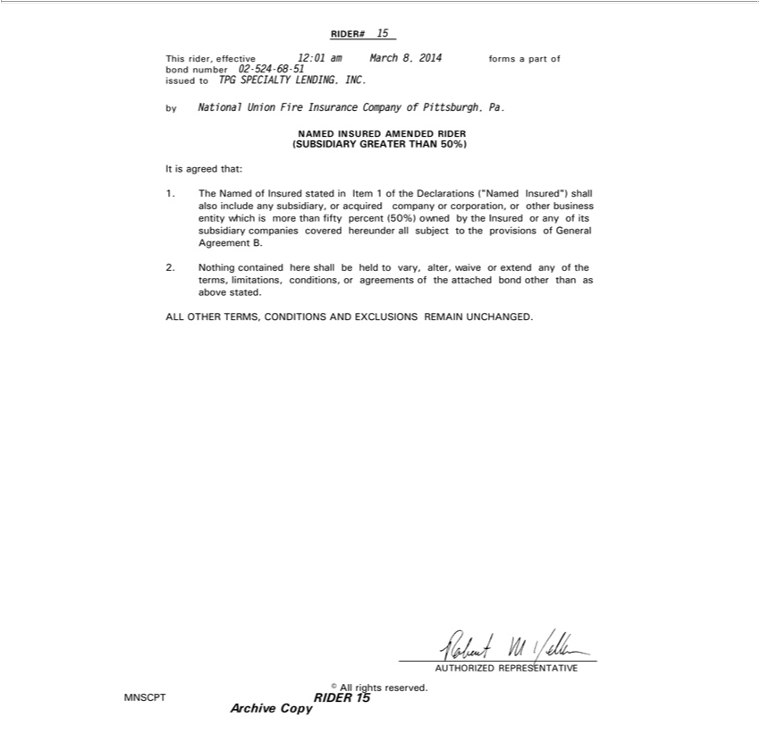

RIDER# 15
byThisNationalrider,effectiveUnionFire12:01InsuranceamMarchCompany8,2014offormsPittsburgh,apart ofPa.bond number 02-524-68-51 issued to TPG SPECIALTY LENDING, INC.
NAMED INSURED AMENDED RIDER
It(SUBSIDIARYisagreedthat: GREATER THAN 50%)
^{shall}
(50%)1.The ownedNamedbyof theInsuredInsuredstatedor anyinItemofits1 subsidiaryoftheDeclarationscompanies(“NamedcoveredInsured”)hereunder subjectalsoincludetotheanyprovisionssubsidiary,ofGeneraloracquiredAgreementcompanyB. or corporation, or other business entity which is more than fifty percent
2. Nothing contained here shall be held to vary, alter, waive or extend any of the terms, limitations, conditions, or agreements of the attached bond other than as above stated.
_{AUTHORIZED}LLOTHERTERMS,REPRESENTATIVECONDITIONS AND EXCLUSIONS REMAIN UNCHANGED.
© All rights reserved.
MNSCPT
ArchiveRIDER 15Copy

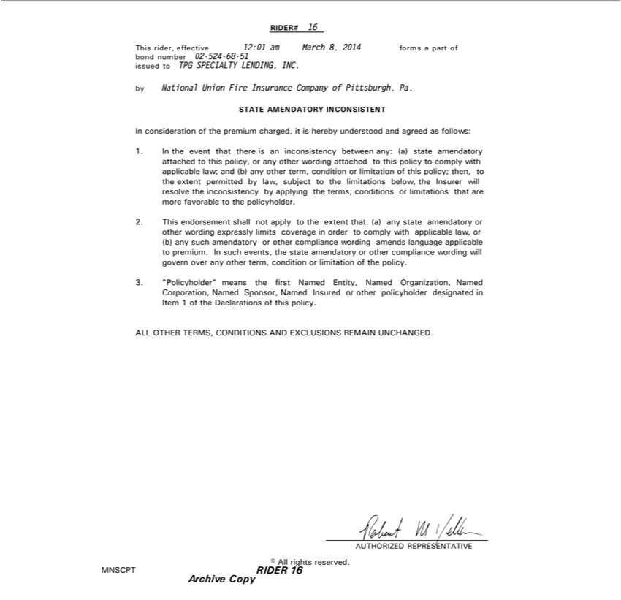

RIDER# 16
This rider, effective 12:01 am March 8, 2014 forms a part of bond number 02-524-68-51 issued to TPG SPECIALTY LENDING, INC.
STATEbyNationalAMENDATORYUnionFireInsuranceINCONSISTENTCompany of Pittsburgh, Pa.
1.In Inconsiderationtheeventthatof therepremiumisaninconsistencycharged,it isbetweenhereby any:understood(a)stateandamendatoryagreedas attachedfollows: to this policy, or any other wording attached to this policy to comply with applicable law; and (b) any other term, condition or limitation of this policy; then, to the extent permitted by law, subject to the limitations below, the Insurer will resolve the inconsistency by applying the terms, conditions or limitations that are more
2.favorableThisendorsementtothepolicyholder.shallnot apply to the extent that: (a) any state amendatoryamendatoryother wording expressly limits coverage in order to comply with applicable law, or (b) any such amendatory or other compliance wording amends language applicable to premium. In such events, the state other compliance wording will govern over any other term, condition or limitation of the policy.
3. “Policyholder” means the first Named Entity, Named Organization, Named Corporation, Named Sponsor, Named Insured or other policyholder designated in Item 1 of the Declarations of this policy.
_{AUTHORIZED}LLOTHERTERMS,REPRESENTATIVECONDITIONS AND EXCLUSIONS REMAIN UNCHANGED.
© All rights reserved.
MNSCPT
ArchiveRIDER 16Copy

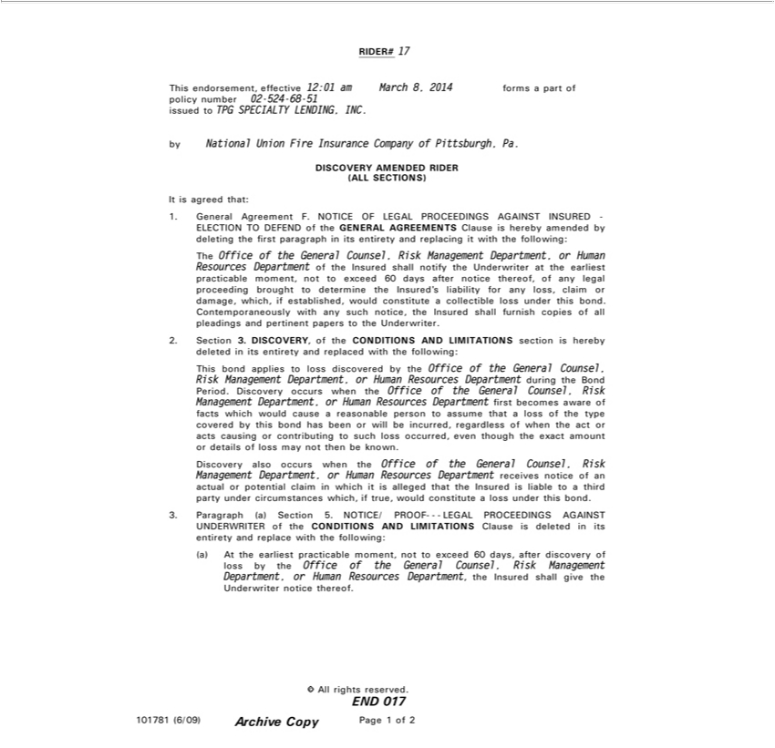

RIDER# 17
This endorsement, effective 12:01 am March 8, 2014 forms a part of policy number 02-524-68-51
issued to TPG SPECIALTY LENDING, INC.
by National Union Fire Insurance Company of Pittsburgh, Pa.
DISCOVERY AMENDED RIDER (ALL SECTIONS)
It is agreed that:
1. General Agreement F. NOTICE OF LEGAL PROCEEDINGS AGAINST INSURED - ELECTION TO DEFEND of the GENERAL AGREEMENTS Clause is hereby amended by deleting the first paragraph
in its entirety and replacing it with the following:
The Office of the General Counsel, Risk Management Department, or Human
Resources Department of the Insured shall notify the Underwriter at the earliest practicable moment, not to exceed 60 days after notice thereof, of any legal proceeding brought to determine the Insured’s liability
for any loss, claim or damage, which, if established, would constitute a collectible loss under this bond. Contemporaneously with any such notice, the Insured shall furnish copies of all pleadings and pertinent
papers to the Underwriter.
2. Section 3. DISCOVERY, of the CONDITIONS AND LIMITATIONS section is hereby deleted in its entirety and replaced with the following: This bond applies to loss discovered by the Office of the General
Counsel,
Risk Management Department, or Human Resources Department during the Bond Period. Discovery occurs when the Office of the General Counsel, Risk Management Department, or Human Resources
Department first becomes aware of
facts which would cause reasonable person to assume that a loss of the type covered by this bond has been or will be incurred, regardless of when the act or acts causing or contributing to such loss occurred,
even though the exact amount or details of loss may not then be known. | or Human Resources Department receives notice of an actual or potential claim in which it is alleged that the
also occurs when the Office of the General Counsel, Risk Management
DiscoveryInsured liable to a third party under circumstances which, if true, would constituteDepartment,lossunder this bond.
3. Paragraph (a) Section 5. NOTICE/ PROOF- - - LEGAL PROCEEDINGS AGAINST UNDERWRITER of the CONDITIONS AND LIMITATIONS Clause is deleted in its entirety and replace with the following: (a) At the earliest practicable moment, not to exceed 60 days, after discovery of loss by the Office of the General Counsel, Risk Management Department, or Human Resources Department, the Insured shall give the Underwriter notice thereof.

END©All 017rights reserved.
101781 (6/09)
PageArchive1ofCopy2

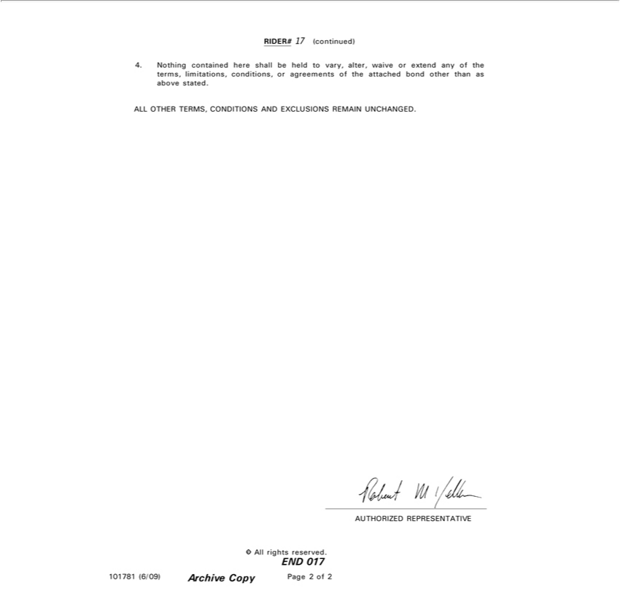

RIDER# 17 (continued)
4. Nothing contained here shall be held to vary, alter, waive or extend any of the terms, limitations, conditions, or agreements of the attached bond other than as above stated.
_{AUTHORIZED}LLOTHERTERMS,REPRESENTATIVECONDITIONS AND EXCLUSIONS REMAIN UNCHANGED.
END©All 017rights reserved.
101781 (6/09)
PageArchive2ofCopy2

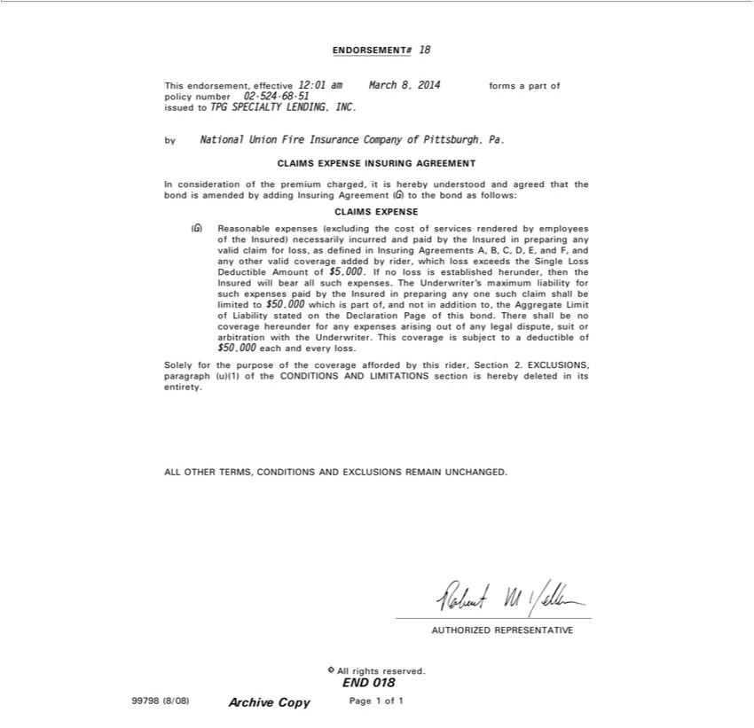

ENDORSEMENT# 18
issuedThisendorsement,toTPGSPECIALTYeffective 12:01LENDING,amMarchINC.8, 2014 forms a part of policy number 02-524-68-51
by National Union Fire Insurance Company of Pittsburgh, Pa.
InCLAIMSconsiderationEXPENSEoftheINSURINGpremiumcharged,AGREEMENTitishereby understood and agreed that the bond is amended by adding Insuring Agreement (G) to the bond as follows:
(G)CLAIMSReasonableEXPENSEexpenses (excluding the cost of services rendered by employees of the Insured) necessarily incurred and paid by the Insured in preparing any valid claim for loss, as defined in Insuring Agreements A, B, C, D, E, and F, and any other valid coverage added by rider, which loss exceeds the Single Loss Deductible Amount of $5,000. If no loss is established herunder, then the Insured will bear all
Limitsuchexpenses.of ThestatedUnderwriter’sontheDeclarationmaximumPageliabilityofthisforbond.such Thereexpensesshallpaidbe byno thecoverageInsuredhereunderinpreparingforanyanyexpensesonesuch arisingclaimshalloutofbeanylimitedlegaltodispute,$50,000suitwhichorarbitrationpartof,withand notthe Underwriter.inadditionto,Thisthe Aggregatecoverageis
subject toLiabilitydeductible of $50,000 each and every loss.
Solely for the purpose of the coverage afforded by this rider, Section 2. EXCLUSIONS, paragraph (u)(1) of the CONDITIONS AND LIMITATIONS section is hereby deleted in its entirety.
_{AUTHORIZED}LLOTHERTERMS,REPRESENTATIVECONDITIONS AND EXCLUSIONS REMAIN UNCHANGED.
END©All 018rights reserved.
99798 (8/08)
PageArchive1ofCopy1

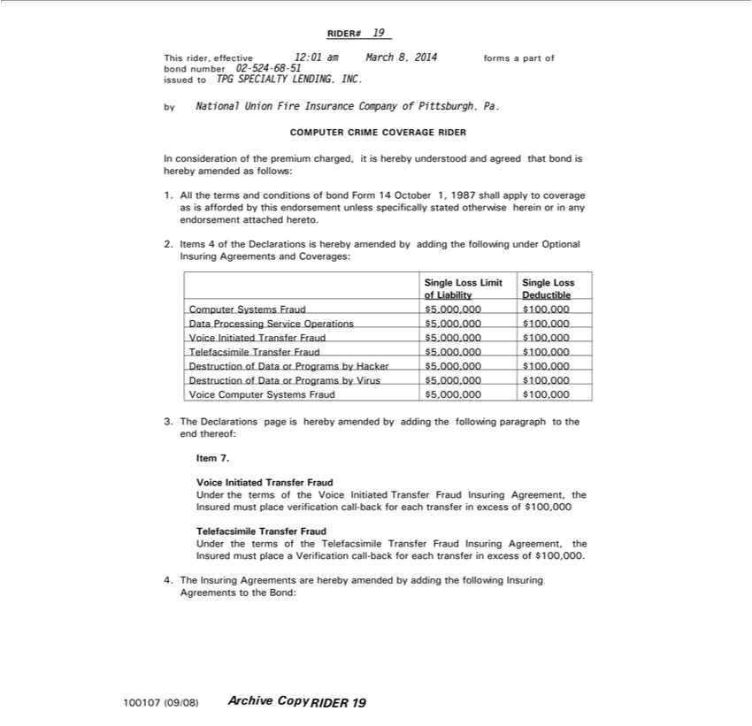

RIDER# 19
This rider, effective 12:01 am March 8, 2014 forms a part of
^{by}
ondNationalnumberUnion02-524Fire-68Insurance-51issuedCompanytoTPGSPECIALTYofPittsburgh,LENDING,Pa. INC.
COMPUTER CRIME COVERAGE RIDER
In consideration of the premium charged, it is hereby understood and agreed that bond is hereby amended as follows:
1. All the terms and conditions of bond Form 14 October 1, 1987 shall apply to coverage as is afforded by this endorsement unless specifically stated otherwise herein or in any endorsement attached hereto.
_{Single}2Items_{Loss}4ofLimittheDeclarationsofLiability is hereby amended by adding the following under Optional Insuring Agreements and Coverages:
Deductible
$Computer_{100,000}5,00,000Systems Fraud
$Data_{100,000}5,00Processing,000 Service Operations
$Voice100,000^{5,00}Initiated^{,000} Transfer Fraud
$Telefacsimile100,000^{5,00,000} Transfer Fraud
$Destruction_{100,000}5,00,000 of Data or Programs by Hacker
$Destruction100,000^{5,00,000} of Data or Programs by Virus
$Voice100,000^{5,00}Computer^{,000} Systems Fraud

Item3.The7.Declarations page is hereby amended by adding the following paragraph to the end thereof:
Voice Initiated Transfer Fraud
Under the terms of the Voice Initiated Transfer Fraud Insuring Agreement, the Insured must place verification call-back for each transfer in excess of $100,000 Telefacsimile Transfer Fraud
Under the terms of the Telefacsimile Transfer Fraud Insuring Agreement, the Insured must place a Verification call-back for each transfer in excess of $100,000.
4. The Insuring Agreements are hereby amended by adding the following Insuring Agreements to the Bond:
100107 (09/08)
RIDERArchive 19Copy

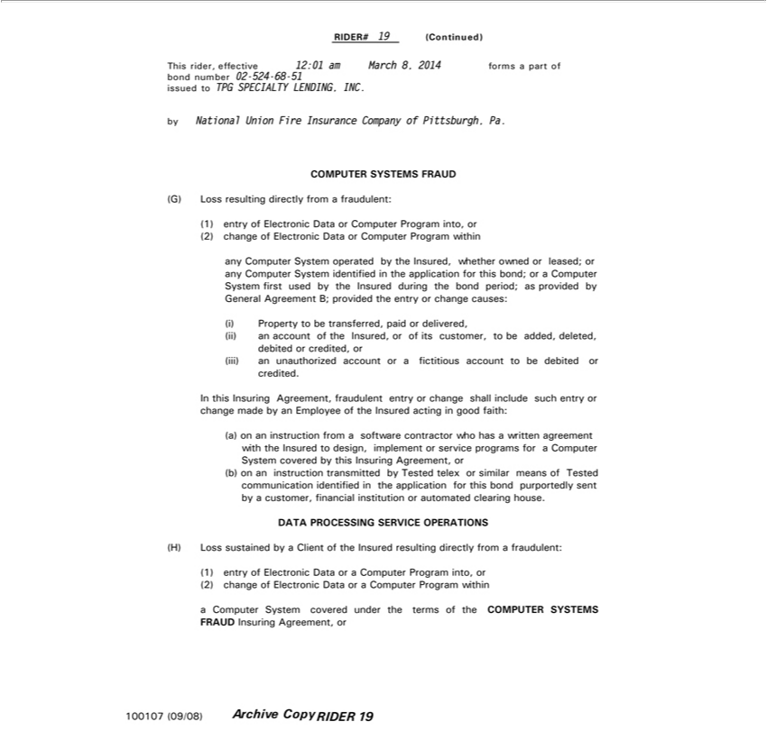

RIDER# 19 (Continued)
byThisond rider,numbereffective02-52412:01-68-51amissuedMarchto 8,TPG2014SPECIALTYformsapartLENDING,of INC.
National Union Fire Insurance Company of Pittsburgh, Pa.
COMPUTERG)1)LossresultingSYSTEMSdirectlyFRAUDfromComputerafradulent:
entry of Electronic Data or Program into, or
any(2)changeComputerofElectronicSystemoperatedDataorbyComputertheInsured,Programwhetherwithinowned or leased; or any Computer System identified in the application for this bond; or a Computer System first used by the Insured during the bond
period; as provided by General Agreement B; provided the entry or change causes:
(iii))Propertyanaccountto beof theransferred,Insured, paidoroforitsdelivered,customer, to be added, deleted, debited or credited, or
In thisan InsuringunauthorizedAgreement,accountfraudulentorfictitiousentryaccountchangetobe debitedincludeorcredited.suchentry or change made by an Employee of the Insured acting in good faith:
_{(b)}a) on an instruction f_{transmitted}omsoftware contractor who hashallwritten agreement with the Insured to design, implement or service programs for a Compu_{sent}er System covered by this Insuring Agreement, or
on an instruction by Tested telex or similar means of Tested communication identified in the application for this bond purportedly by a customer, financial institution or automated clearing house.
DATA PROCESSING SERVICE OPERATIONS
¹⁾H) Loss sustained by a Client of the Insured resulting directly from a fraudulent:
⁽²⁾
changeentryofofElectronicElectronicDataDataorora ComputeraComputerProgramPrograminto,withinor

a Computer System covered under the terms of the COMPUTER SYSTEMS FRAUD Insuring Agreement, or 100107 (09/08)

RIDERArchive 19Copy

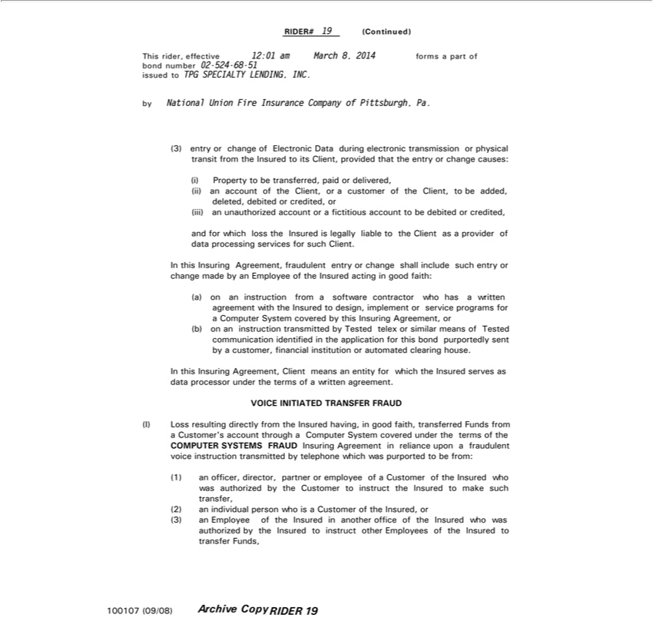

RIDER# 19 (Continued)
This rider, effective 12:01 am March 8, 2014 forms a part of
ond number 02-524-68-51 issued to TPG SPECIALTY LENDING, INC.
by | National Union Fire Insurance Company of Pittsburgh, Pa.
 | entry or change of Electronic Data during electronic transmission or physical transit from the Insured to its Client, provided that the entry or change causes:
3) Property to be ransferred, |  | or delivered,
 | an account of the Client, or | customer of the Client, to be a ded, deleted, debited or credited, or
(iii) an unauthorized account orpaidfictitious account to be debited or credited, and for which loss the Insured is legally liable to the Client as a provider of data processing services for such Client.
In this Insuring Agreement, fraudulent entry |  |  | change | include such entry or change made by an Employee of the Insured acting in good faith:
a) on an instruction f om software contractor who hashallwritten agreement with the Insured to design, implement or service programs for a Compu er System covered by this Insuring Agreement, or
(b) on an instruction transmitted by Tested telex or similar means of Tested communication identified in the application for this bond purportedly sent by a customer, financial institution or automated clearing
house.
In this Insuring Agreement, Client means an entity for which the Insured serves as data processor under the terms of a written agreement.
VOICE INITIATED TRANSFER FRAUD
(I) Loss resulting directly from the Insured having, in good faith, transferred Funds from a Customer’ account through a Computer System covered under the terms of the COMPUTER SYSTEMS FRAUD
Insuring Agreement in reliance upon a |  |  | voice instruction transmitted by telephone which was purported to be from:
1) officer, director, partner or employeefraudulentofCustomer of the Insured who was authorized by the Customer to instruct the Insured to make such transfer,
2) | individual person who is a Customer of the Insured, or
(3) an
100107Employee(09/08) of the Insured in another office of the Insured who was authorized by the Insured to instruct other Employees of the Insured to transfer Funds,

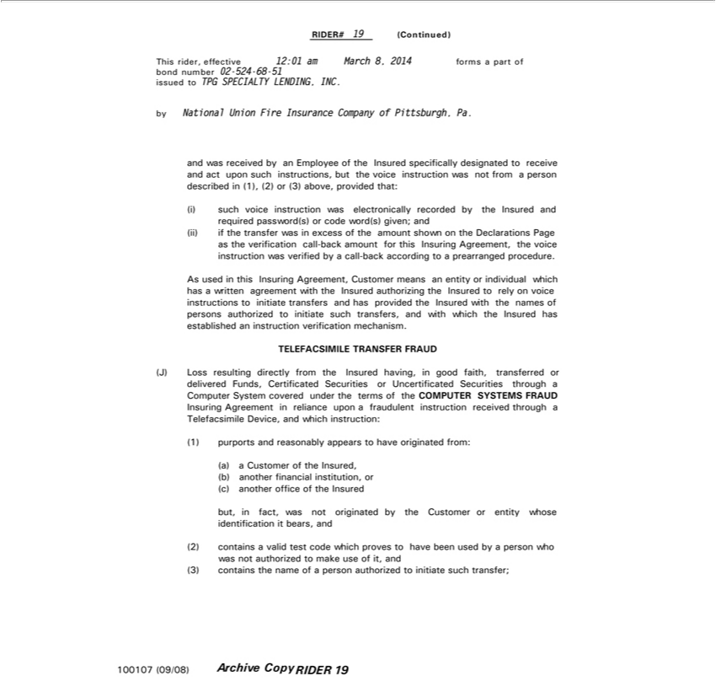

RIDER# 19 (Continued)
This rider, effective 12:01 am March 8, 2014 forms a part of
ond number 02-524-68-51 issued to TPG SPECIALTY LENDING, INC.
by National Union Fire Insurance Company of Pittsburgh, Pa.
and was received by an Employ of the Insured specifically designated to receive and act upon such instructions, but the voice instruction was not from a person described in (1), (2) or (3) above, provided that:
(i) such voice instruction was electronically recorded by the Insured and required password(s) or code word(s) given; and (ii) if the transfer was in excess of the amount shown on the Declarations Page as the
verification call-back amount for this Insuring Agreement, the voice instruction was verified by a call-back according to a prearranged procedure.
As used in this Insuring Agreement, Customer means an entity or individual which has a written agreement with the Insured authorizing the Insured to rely on voice instructions to initiate transfers and has
provided the Insured with the names of persons authorized to initiate such transfers, and with which the Insured has established an instruction verification mechanism.
TELEFACSIMILE TRANSFER FRAUD
(J) Loss resulting directly from the Insured having, in good faith, transferred or delivered Funds, Certificated Securities or Uncertificated Securities through a Computer System covered under the terms of the
COMPUTER SYSTEMS FRAUD
Insuring Agreement in reliance upon a fraudulent instruction received through a Telefacsimile Device, and which instruction:
1) purports and reasonably appears to have originated from:
a) a Customer of the Insured,
b) another financial institution, or
(c) another office of the Insured |  | or entity whose | it bears, and
but, f ct, | not originated by the | or entity whose | it bears, and
2) | wasvalid test code which proves | have been used by identificationpersonwho was not authorized to make use of it, and
(3) contains the name of a person authorizedCustomer initiate such transfer;
100107 (09/08)
Archive Copy RIDER 19

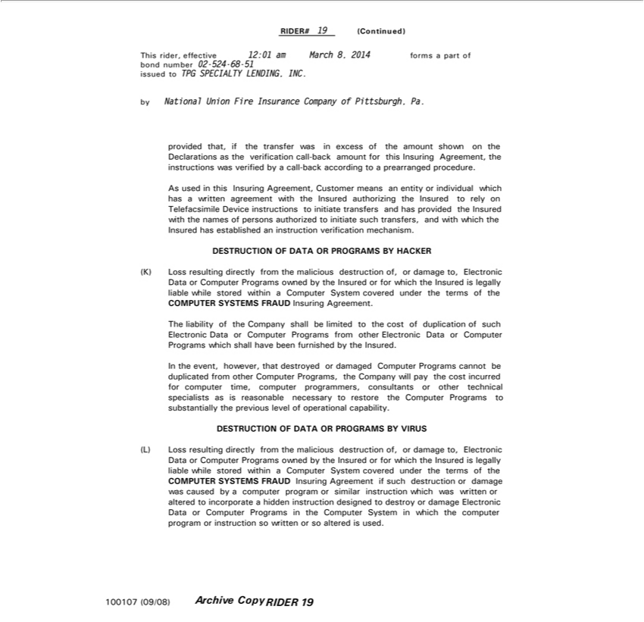

RIDER# 19 (Continued)
bondThis rider,numbereffective02-52412:01-68-51am March 8, 2014 forms a part of
issued to TPG SPECIALTY LENDING, INC.
by National Union Fire Insurance Company of Pittsburgh, Pa.

_{prearranged}ovidedthat, if the transfer was in excess of the amount shown on the Declarations as the verification call-back amount for this Insuring Agreement, the instructions was verified by a call-back according to a procedure.
As used in this Insuring Agreement, Customer means an entity or individual which has a written agreement with the Insured authorizing the Insured _{instruction}torelyTelefacsimile Device instructions to initiate
transfers and has provided the Insured with the names of persons authorized to initiate such transfers, and with which the Insured has established an verification mechanism.
DESTRUCTION OF DATA OR PROGRAMS BY HACKER
(K) Loss resulting directly from the malicious destruction of, or damage to, Electronic Data or Computer Programs owned by the Insured or for which the Insured is legally liable while stored within a Computer System covered under the terms of the
COMPUTER SYSTEMS FRAUD Insuring Agreement.

The liability of the Company shall be limited to the cost of duplication of such Electronic Data or Computer Programs from other Electronic Data or Computer Programs which shall have been furnished by the ^{In}sured.
the event, however, that destroyed or damaged Computer Programs cannot be duplicated from other Computer Programs, the Company will pay the cost incurred for computer time, computer programmers, consultants or other technical specialists as is reasonable necessary to restore the Computer Programs to substantially the previous level of operational capability.
DESTRUCTION OF DATA OR PROGRAMS BY VIRUS
(L) Loss resulting directly from the malicious destruction of, or damage to, Electronic Data or Computer Programs owned by the Insured or for which the Insured is legally liable while stored within a C^{or}mputer System covered under the terms of the COMPUTER SYSTEMS FRAUD Insuring Agreement if such destruction or damage was caused by a computer program or similar instruction which was written altered to incorporate a hidden instruction designed to destroy or damage Electronic Data or Computer Programs in the Computer System in which the computer program or instruction so written or so altered is used.
100107 (09/08)

Archive Copy RIDER 19

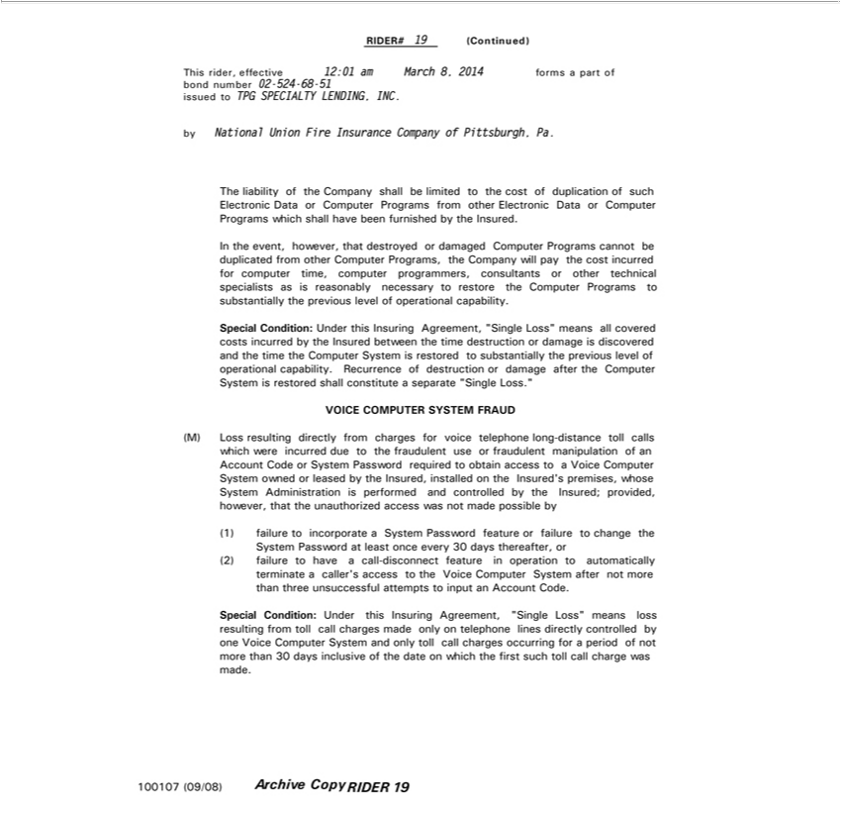

RIDER#Thisrider,19effective(Continued)12:01 am March 8, 2014 forms a part of bond number 02-524-68-51 issued to TPG SPECIALTY LENDING, INC.
ThebyNationalliability Unionofthe FireCompanyInsuranceshallCompanybelimitedoftoPittsburgh,thecostof Pa.duplication of such Electronic Data or Computer Programs from other Electronic Data or Computer Programs which shall have been furnished by the Insured.

consultantstheevent,orhowever,othertechnicalthatdestroyedspecialistsordamagedasisreasonablyComputernecessaryProgramsto restorecannot thebe duplicatedComputer ProgramsfromothertoComputersubstantiallyPrograms,theprevioustheCompanylevelof willoperationalpaythe capability.costincurred for computer time, computer programmers, Special Condition: Under this Insuring Agreement, “Single Loss” means all covered costs incurred by the Insured between the time destruction or damage is discovered and the time the Computer System is
restored to substantially the previous level of operational capability. Recurrence of destruction or damage after the Computer System is restored shall constitute a separate “Single Loss.”
(M)VOICELossCOMPUTERresultingdirectlySYSTEMfrom chargesFRAUDfor voice telephone long-distance toll calls which were incurred due to the fraudulent use or fraudulent manipulation of an Account Code or System Password required to
theobtainunauthorizedaccesstoaaccessVoice ComputernotmadeSystempossibleownedby or leased by the Insured, installed on the Insured’s premises, whose System Administration is performed and controlled by the Insured; provided, however, that
(1) failure to incorporatewasSystem Password feature or failure to change the System Password at least once every 30 days thereafter, or (2) failure to have a call-disconnect feature in operation to automatically terminate a caller’s access to the Voice Computer System after not more than three unsuccessful attempts to input an Account Code.
Special Condition: Under this Insuring Agreement, “Single Loss” means loss resulting from toll call charges ^{char}mde only on telephone lines directly controlled by one Voice Computer System and only toll call
charges occurring for a period of not more than 30 days inclusive of the date on which the first such toll call ge was made.

100107 (09/08) Archive Copy RIDER 19

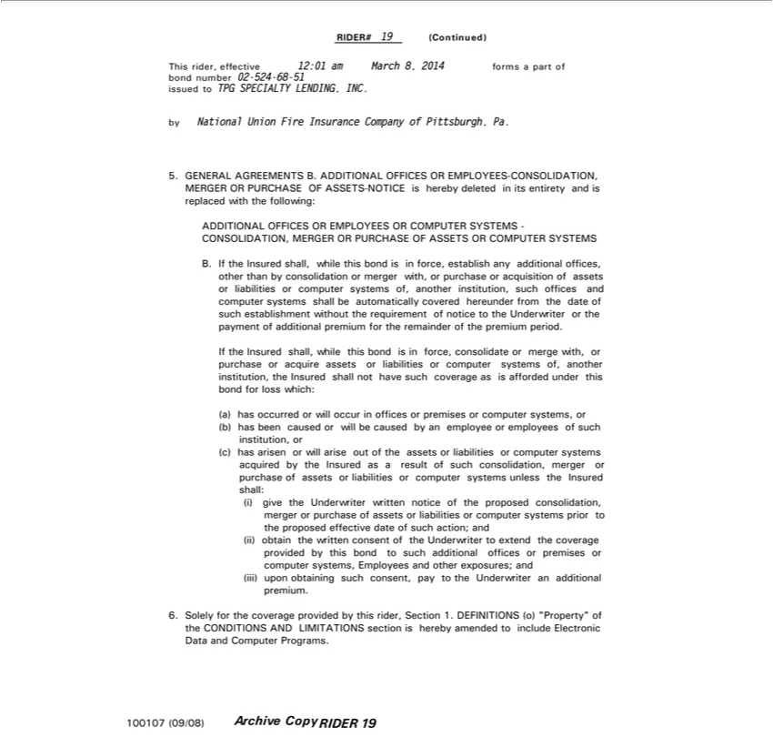

RIDER# 19 (Continued)
byThisNationalrider,effectiveUnionFire12:01InsuranceamMarchCompany8,2014offormsPittsburgh,apart ofPa.bond number 02-524-68-51 issued to TPG SPECIALTY LENDING, INC.

5. GENERAL AGREEMENTS B. ADDITIONAL OFFICES OR EMPLOYEES-CONSOLIDATION, MERGER OR PURCHASE OF ASSETS-NOTICE is hereby deleted in its entirety and is replaced with the following:
ADDITIONAL OFFICES OR EMPLOYEES OR COMPUTER SYSTEMS - CONSOLIDATION, MERGER OR PURCHASE OF ASSETS OR COMPUTER SYSTEMS

B. If the Insured shall, while this bond is in force, establish any additional offices, other than by consolidation or merger with, or purchase or acquisition of assets or liabilities or computer systems of, another institution, such offices and computer systems shall be automatically covered hereunder from the date of such establishment without the requirement of notice to the Underwriter or the payment of additional premium for the remainder of the premium period.
If the Insured shall, while this bond is in force, consolidate or merge with, or purchase or acquire assets or liabilities or computer systems of, another institution, the Insured shall not have such coverage as is afforded under this bond for loss which:
(a) has occurred or will occur in offices or premises or computer systems, or (b) has been caused or will be caused by an employee or employees of such institution, or (c) has arisen or will arise out of the assets or liabilities or computer systems acquired by the Insured as ^{assets}result of such consolidation, merger or purchase of assets or liabilities or computer systems unless the Insured shall: (i) give the Underwriter written

notice of the proposed consolidation, merger or purchase of or liabilities or computer systems prior to the proposed effective date of such action; and (ii) obtain the written consent of the Underwriter to extend the coverage provided by this bond to such additional offices or premises or computer systems, Employees and other exposures; and (iii) upon obtaining such consent, pay to the Underwriter an additional premium.
6. Solely for the coverage provided by this rider, Section 1. DEFINITIONS (o) “Property” of the CONDITIONS AND LIMITATIONS section is hereby amended to include Electronic Data and Computer Programs.
100107 (09/08) Archive Copy RIDER 19

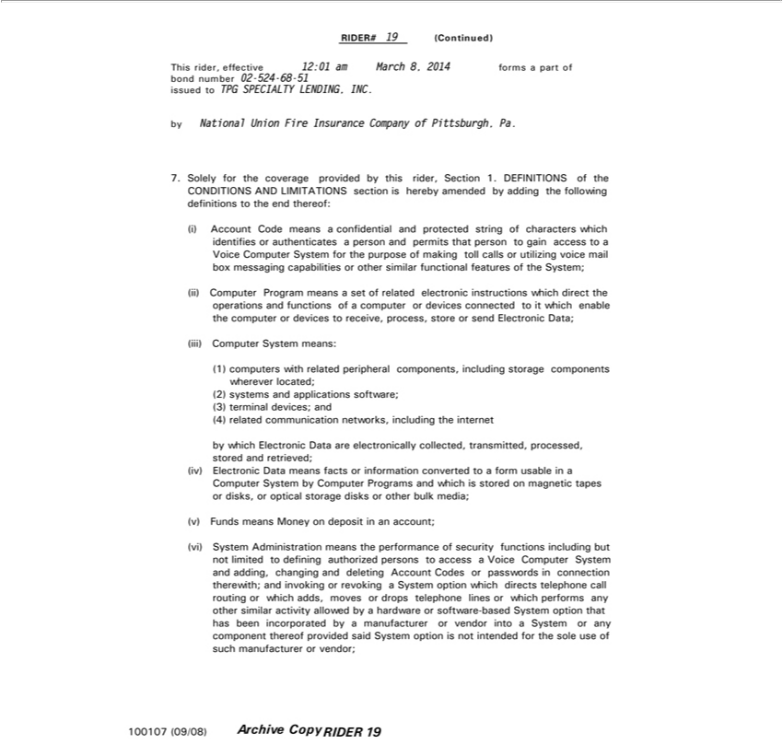

RIDER# 19 (Continued)
This rider, effective 12:01 am March 8, 2014 forms a part of bond number 02-524-68-51 issued to TPG SPECIALTY LENDING, INC.
by National Union Fire Insurance Company of Pittsburgh, Pa.
7. Solely for the coverage provided by this rider, Section 1. DEFINITIONS of the CONDITIONS AND LIMITATIONS section is hereby amended by adding the following definitions to the end
(i) Account Code means a confidential and protected string of characters which identifies or |  |  |  | a person and permits that person to gain access to a Voice Computer System for the purposethereof:making
toll calls or utilizing voice mail box messaging capabilities or other similar functional featuresauthenticatesofSystem;
(ii) Computer Program means a set of related electronic instructions which direct the operations and functions of a computer or devices connected to it which enable the computer or devices to receive, process,
store or send Electronic Data;
iii) Computer System means:
(1) computers with related peripheral components, including storage components wherever located; (2) systems and applications software; (3) terminal devices; and (4) related communication networks,
including the internet |  | collected, transmitted, processed, | and retrieved; (iv) Electronic Data means facts or information converted to a form usable in a Computer System by Computer
by which Electronic Data are |  | collected, transmitted, processed,
Programs and which is stored electronicallymagnetictapes or disks, or optical storage disksstored other bulk media;
Funds means Money on deposit in an account;
(vi) System | means | performance of security functions including but not limited to defining authorized persons to access a Voice Computer System and adding, changing and deleting Account
Codes or passwords | connection therewith; and invoking or revoking System option which directs telephone call routing or which adds, moves or drops telephone lines or which performs any other similar
Administration has
activity allowed by _{manufacturer}hardwareor software-based System option that been incorporated by a manufacturer or vendor into a System or any component thereof provided said System option is not intended for
100107thesole (09/08)useofsuchArchive Copy RIDERorvendor;19

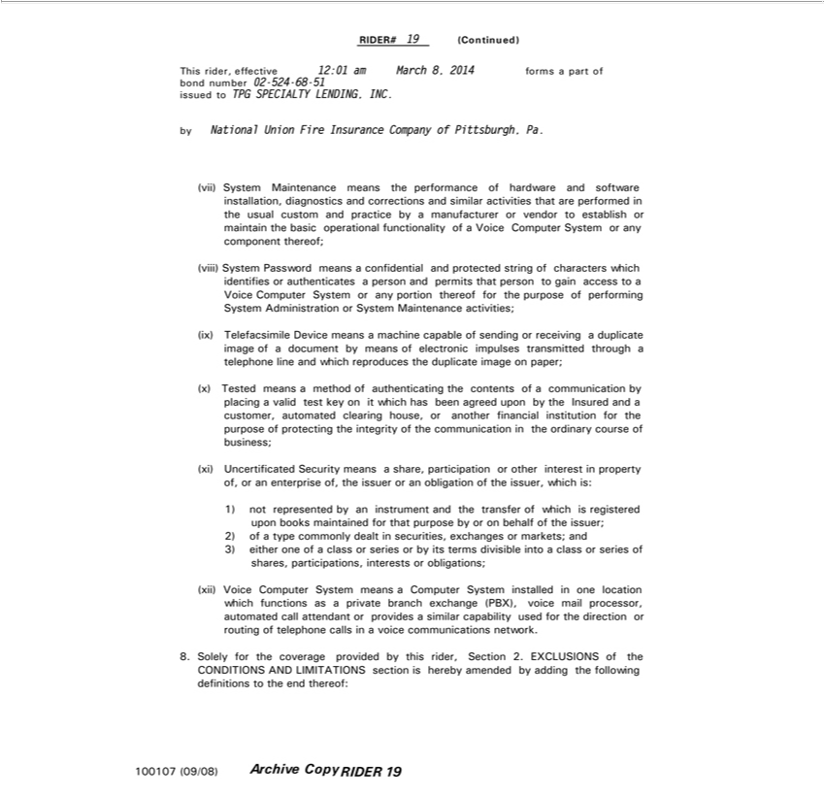

RIDER# 19 (Continued)
This rider, effective 12:01 am March 8, 2014 forms a part of bond number 02-524-68-51 issued to TPG SPECIALTY LENDING, INC.
by National Union Fire Insurance Company of Pittsburgh, Pa. |  | installation, diagnostics and corrections and similar activities that are performed in the usual custom and practice by a manufacturer or
(vii) System Maintenance means the performance of hardware and
vendor to establish maintain the basic operational functionality ofsoftwareVoice Computer System or any component thereof;
(viii) System Password means a confidential and protected string of characters which identifies or authenticates a person and permits that person to gain access to a Voice Computer System or any portion thereof
for the purpose of performing System Administration or System |  | activities;
(ix) Telefacsimile Device means a machine capable of sending orMaintenancereceivingduplicate image of a document by means of electronic impulses transmitted through a telephone line and which reproduces the
duplicate image on paper; |  |  | a valid test key on it which has been agreed upon by the Insured and a customer, automated clearing house, or another
(x) Tested means a method of authenticating the contents of a communication by
financial institution for the purpose of protecting the integrity of the communicationplacingthe ordinary course of business;
(xi) Uncertificated Security means a share, participation or other interest in property of, or an enterprise of, the |  |  |  |  | or an obligation of the issuer, which is:
1) not represented by an instrument and the transfer of which is registered upon books maintained for that purpoissuerby or |  |  |  |  |  | behalf of the issuer; 2) of a type commonly dealt in securities, exchanges or markets;
and 3) either one of a class or series or by its terms divisible into a class or series of shares, |  |  |  | interests or obligations;
(xii) Voice Computer System means a Computer System | in one location which functionsparticipations,asprivate branch exchange (PBX), voice mail processor, automated call attendant or provides a similar
capability used for the direction or routing of telephone callsinstalledvoice communications network.
1001078.Solely(09/08)fortheArchivecoverageCopyprovidedRIDERby 19this rider, Section 2. EXCLUSIONS of the CONDITIONS AND LIMITATIONS section is hereby amended by adding the following definitions to the end thereof:

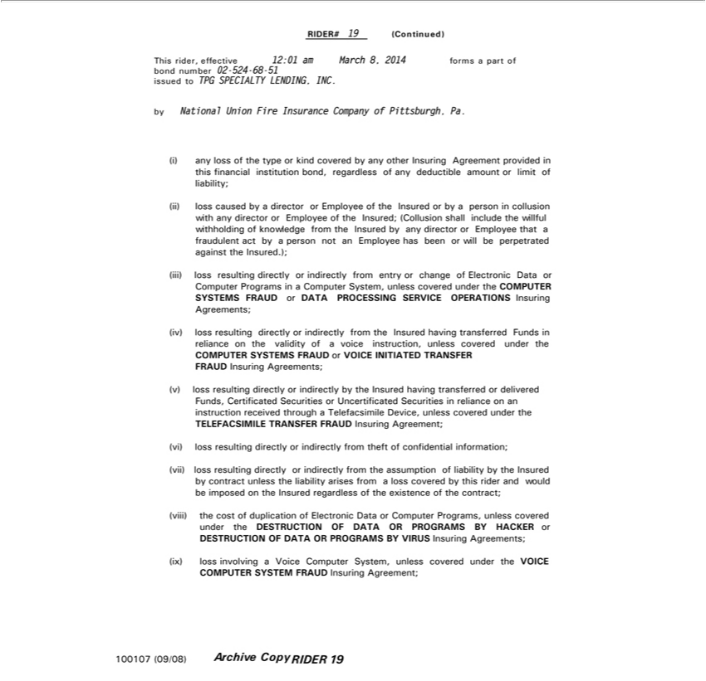

RIDER# 19 (Continued)
byThisNationalrider,effectiveUnionFire12:01InsuranceamMarchCompany8,2014offormsPittsburgh,apart ofPa.bond number 02-524-68-51 issued to TPG SPECIALTY LENDING, INC.
_{(ii)}any loss of the type_{director}kind covered by any other Insuring Agreement provided in this financial institution bond, regardless of any deductible amount or limit of liability;
loss caused by a or Employee of the Insured or by a person in collusion with any director or Employee of the _{Insured;} (Collusion shall include the willful withholding of knowledge from the Insured
by(iii)anylossdirectorresultingor directlyEmployeeor thatindirectlyafraudulentfromentryactbyor achangepersonofnotElectronicanEmployeeData hasorComputerbeenorwillProgramsbeperpetratedinComputeragainst System,the unless.); covered under the COMPUTER
- loss resulting directly or indirectly from the Insured having transferred Funds_{Insuring}reliance on the validity of a voice instruction, unless covered under the
COMPUTER SYSTEMS FRAUD or VOICE INITIATED TRANSFER FRAUDAgreements;

- loss resulting directly or indirectly by the Insured having transferred or delivered Funds, Certificated Securities or Uncertificated Securities in reliance on an instruction received through a Telefacsimile Device, unless covered under the
TELEFACSIMILE TRANSFER FRAUD Insuring Agreement;

_{(vii)}loss resulting directly or indirectly from _{theft} of confidential information;
loss resulting directly or indirectly from assumption of liability by the Insured by contract unless the liability arises from a loss covered by this rider and would be imposed on the Insured regardless the existence of the contract;
- the cost of duplication of Electronic Data or Computer Programs, unless covered under the DESTRUCTION OF DATA OR PROGRAMS BY HACKER or DESTRUCTION OF DATA OR PROGRAMS BY VIRUS Insuring Agreements;
- loss involving a Voice Computer System, unless covered under the VOICE COMPUTER SYSTEM FRAUD Insuring Agreement;

100107 (09/08) Archive Copy RIDER 19SYSTEMSFRAUDorDATAPROCESSING SERVICE OPERATIONS Insuring Agreements;of

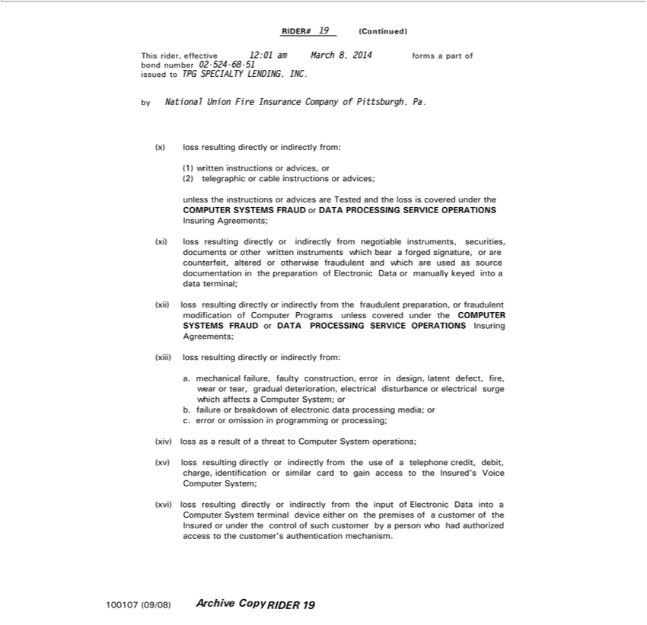

RIDER# 19 (Continued)
This rider, effective 12:01 am March 8, 2014 forms a part of bond number 02-524-68-51 issued to TPG SPECIALTY LENDING, INC.
by National Union Fire Insurance Company of Pittsburgh, Pa.
x) loss resulting directly or indirectly from:
1) written instructions or advices, or
(2) telegraphic or cable instructions or advices;
unless the instructions or advices are Tested and the loss is covered under the
COMPUTER SYSTEMS FRAUD or DATA PROCESSING SERVICE OPERATIONS
Insuring Agreements; | from negotiable instruments, securities, documents or other written instruments which bear a forged signature, or are counterfeit, altered or otherwise fraudulent and which
(xi) loss resulting directly or
are used as source documentationindirectlythe preparation of Electronic Data or manually keyed_{modification}intodata terminal;
(xii) loss resulting directly or indirectly from the fraudulent preparation, or fraudulent of Computer Programs unless covered under the COMPUTER SYSTEMS FRAUD or DATA PROCESSING SERVICE OPERATIONS Insuring Agreements;
(xiii) loss resulting directly or indirectly from:

_{breakdown}.mechanical failure, faulty construction, error in design, latent defect, fire, wear or tear, gradual deterioration, electrical disturbance or electrical surge which affects a Computer System; or b. failure or of electronic data processing media; or c. error or omission in programming or processing;
_{iv)} loss as a result of a threat to Computer System _{operations;}
_{(xvi)}loss resulting directly or indirectly from the use of telephone credit, debit, charge, identification or similar card to gain access to the Insured’_{customer}Voice Computer System;
loss resulting directly or indirectly from the input of Electronic Data into a Computer System terminal device either on the premises of a of the Insured or under the control of such customer by a person who had authorized access to the customer’s authentication mechanism.
100107 (09/08) Archive Copy RIDER 19

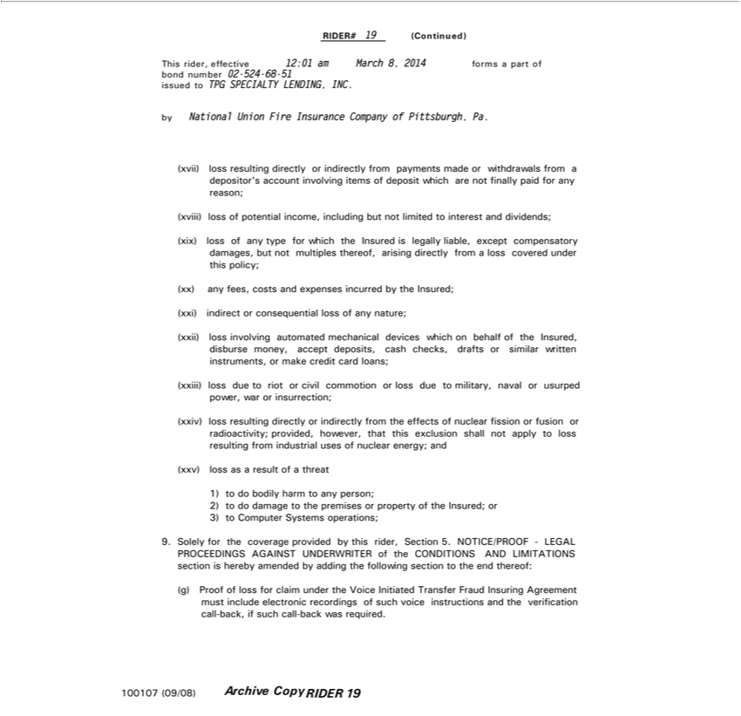

RIDER# 19 (Continued)
byThisNationalrider,effectiveUnionFire12:01InsuranceamMarchCompany8,2014offormsPittsburgh,apart ofPa.bond number 02-524-68-51 issued to TPG SPECIALTY LENDING, INC.
ix)viii)losslossresultingofpotentialdirectlyincome,orindirectlyincludingfrombutnotpaymentslimited madetointerestorwithdrawalsanddividends;from a depositor’s account involving items of deposit which are not finally paid for any reason; loss of any type for which the Insured is legally liable, except compensatory damages, but not multiples thereof, arising directly from a loss covered under this policy;
any fees, costs and expenses incurred by the Insured;
ii)indirectlossinvolvingorconsequentialautomatedlossmechanicalofanynature;devices which on behalf of the Insured, disburse money, accept deposits, cash checks, drafts or similar written instruments, or make credit card loans;
(xxiv) lossloss resultingduetoriotdirectlyorcivilorcommotionindirectly fromorlossthedueeffectstomilitary,ofnuclearnavalfissionorusurpedorfusionpower,orradioactivity;warorinsurrection;provided, however, that this exclusion shall not apply to loss resulting from industrial uses of nuclear energy; and
1)(xxv) lossbodilyasa resultharm ofto anythreatperson;

2) do
^{3) to}
ComputerdamageSystemstothepremisesoperations;orproperty of the Insured; or
9. Solely for the coverage provided by this rider, Section 5. NOTICE/PROOF - ^{LEGAL}
PROCEEDINGS AGAINST UNDERWRITER of the CONDITIONS AND LIMIT TIONS section is hereby amended by adding the following section to the end thereof:

(g) Proof of loss for claim under the Voice Initiated Transfer Fraud Insuring Agreement must include electronic recordings of such voice instructions and the verification call-back, if such call-back was required. 100107 (09/08) Archive Copy RIDER 19

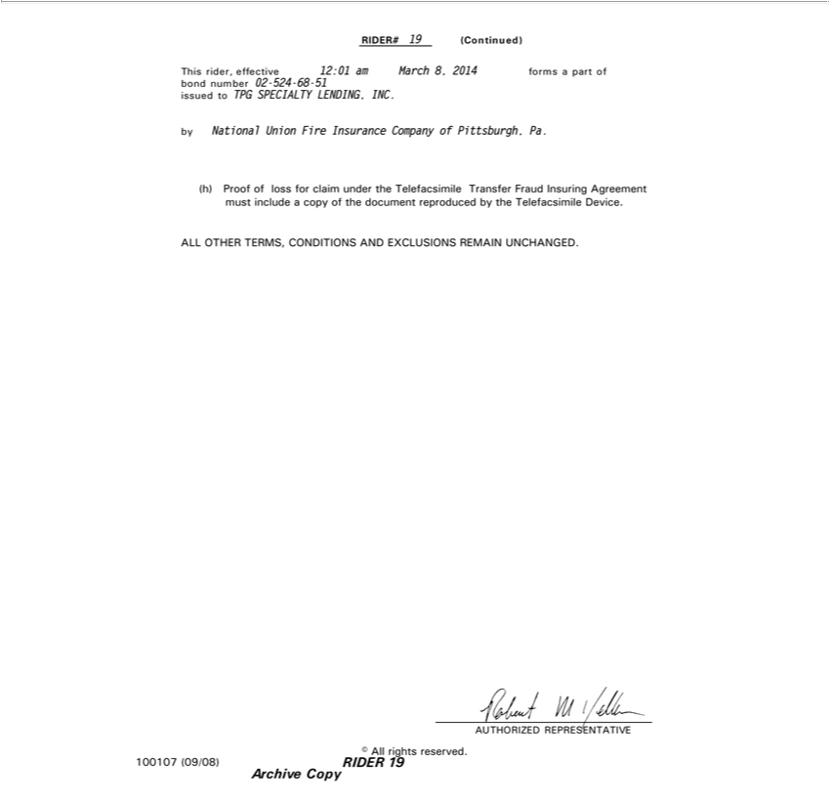

RIDER# 19 (Continued)
byThisNationalrider,effectiveUnionFire12:01InsuranceamMarchCompany8,2014offormsPittsburgh,apart ofPa.bond number 02-524-68-51 issued to TPG SPECIALTY LENDING, INC.
(h) Proof of loss for claim_{CONDITIONS}undertheelefacsimile Transfer Fraud Insuring Agreement must include a copy of the document reproduced by the Telefacsimile Device.
_{AUTHORIZED}LLOTHERTERMS,REPRESENTATIVE AND EXCLUSIONS REMAIN UNCHANGED.
© All rights reserved.
Archive100107 (09/08)Copy RIDER 19

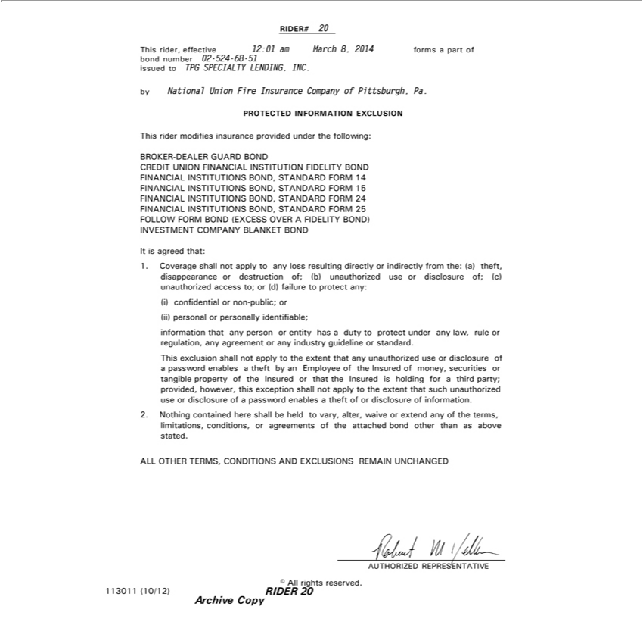

RIDER# 20
This rider, effective 12:01 am March 8, 2014 forms a part of bond number 02-524-68-51 issued to TPG SPECIALTY LENDING, INC.
by National Union Fire Insurance Company of Pittsburgh, Pa.
PROTECTED INFORMATION EXCLUSION
This rider modifies insurance provided under the following:
B OKER-DEALER GUARD BOND | FIDELITY BOND FINANCIAL INSTITUTIONS BOND, STANDARD FORM 14 FINANCIAL INSTITUTIONS BOND, STANDARD FORM 15
CREDIT UNION FINANCIAL
FINANCIAL INSTITUTIONS BOND,INSTITUTIONANDARD FORM 24 FINANCIAL INSTITUTIONS BOND, STANDARD FORM 25 FOLLOW FORM BOND (EXCESS OVER A FIDELITY BOND)
NVESTMENT COMPANY BLANKET BOND
It is agreed that:
1. Coverage shall not apply to any loss resulting directly or indirectly from the: (a) theft, disappearance or destruction of; (b) unauthorized use or disclosure of; (c) unauthorized access to; or (d) failure to protect
any: (i) confidential or non-public; or (ii) personal or personally identifiable; information that any person or entity has a duty to protect under any law, rule or regulation, any agreement or any industry guideline
or standard.
This exclusion shall not apply to the extent that any unauthorized use or disclosure of a password enables a theft by an Employee of the Insured of money, securities or tangible property of the Insured or that the
Insured is holding for a third party; provided, however, this exception shall not apply to the extent that such |  | use or disclosure of a password enables theft of or disclosure of information.
2. Nothing contained here shall be held to vary, alter, waive or extend any of the terms, limitations, conditions,unauthorizedagreements of the attached bond other than as above stated.
_{AUTHORIZED}LLOTHERTERMS,REPRESENTATIVECONDITIONS AND EXCLUSIONS REMAIN UNCHANGED
© All rights reserved.
Archive113011(10/12)Copy RIDER 20

RIDER # 21
IssuedThisrider,to:TPGeffectiveSPECIALTYat12:01 amLENDING,March8, INC.2014 forms a part of Bond number 02-524-68-51
By: National Union Fire Insurance Company of Pittsburgh, Pa.
ECONOMICTHISRIDER SANCTIONSCHANGESTHERIDERPOLICY. PLEASE READ IT CAREFULLY.
^{The}is rider modifies insurance provided under the following:
Insurer shall not_{benefit}deemed to provide cover and the Insurer shall not be liable to pay any claim or provide any benefit hereunder to the extent that the provision of such cover, payment of such claim or
provision of such would expose the Insurer, its parent company or its ultimate controlling entity to any sanction, prohibition or restriction under United Nations resolutions or the trade or economic sanctions, laws or regulations of the European Union or the United States of America.
©AUTHORIZEDAllrightsreserved.REPRESENTATIVE
END 021
Archive89644(6/13)CopyPage 1 of 1

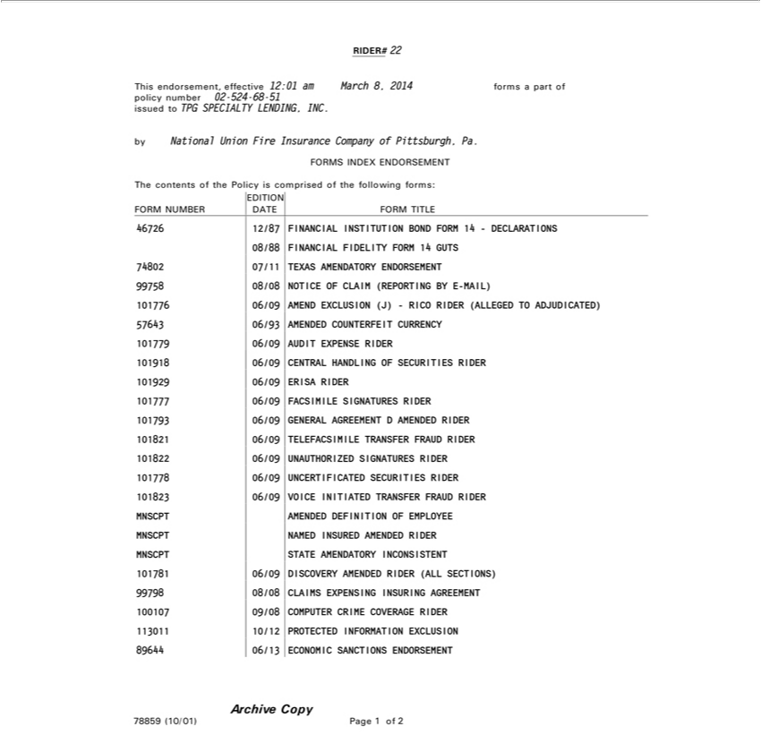

RIDER# 22
This endorsement, effective 12:01 am March 8, 2014 forms part of policy number 02-524-68-51 issued to TPG SPECIALTY LENDING, INC.
by National Union Fire Insurance Company of Pittsburgh, Pa.
FORMS INDEX ENDORSEMENT
The contents of the Policy is comprised of the following forms:
FORM NUMBER EDITION DATE FORM TITLE
46726 | 12/87 FINANCIAL INSTITUTION BOND FORM 14 - DECLARATIONS
08/88 FINANCIAL FIDELITY |  |  |  | 14 GUTS
74802 | 7 11 TEXAS AMENDATFORMY
99758 | 08/08 NOTICE OF CLAIM (REPORTINGENDORSEMENTBY-MAIL)
101776 |  | 06/09 | EXCLUSION (J) - RICO RIDER (ALLEGED TO ADJUDICATED)
57643 | 06/93 AMENDED COUNTERFEIT CURRENCY
779 |  |  | AUDIT EXPENSE RIDER
18 |  |  | CENTRAL HANDLING OF SECURITIES RIDER
929 |  |  | ERISA RIDER
77 |  |  | FACSIMILE SIGNATURES RIDER
793 |  |  | GENERAL AGREEMENT D AMENDED RIDER
 | 1 |  | TELEFACSIMILE TRANSFER FRAUD RIDER
822 |  |  | AUTHORIZED SIGNATURES RIDER
778 |  | 06/09 | UNCERTIFICATED SECURITIES RIDER
101823 |  | 06/09 | VOICE INITIATED TRANSFER FRAUD RIDER
 |  | AMEN ED DEFINITION OF EMPLOYEE
 |  |  | INSURED AMENDED RIDER
MNSCPT NAMEDSTTEAMENDATORY INCONSISTENT
1017 1 |  | 06/09 DISCOVERY AMENDED RIDER (ALL SECTIONS)
99798 | 08/08 CLAIMS EXPENSING INSURING AGREEMENT
1130100107 |  | 09/08 COMPUTER CRIME COVERAGE RIDER
 |  | 10/12 PROTECTED INFORMATION EXCLUSION
89644 | 06/13 ECONOMIC SANCTIONS ENDORSEMENT
Archive Copy
78859 | (10/01) Page 1 of 2

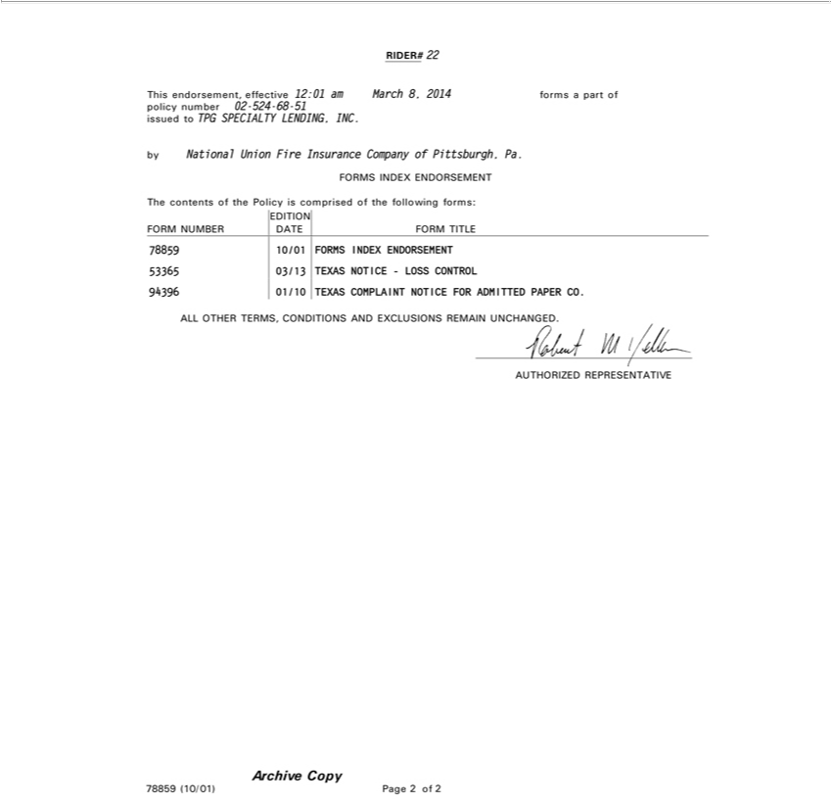

RIDER#Thisendorsement,22 effective 12:01 am March 8, 2014 formsPa part of policy number 02-524-68-51 issued to TPG SPECIALTY LENDING, INC.
by National Union Fire Insurance Company of Pittsburgh, .
TheFORMScontentsINDEXoftheENDORSEMENTPolicyiscomprised of the following forms:
FORM NUMBER EDITION DATE FORM TITLE
94396537885965 01/103013 TEXASFORMS NOTICEINDEXENDORSEMENT-LOSSCONTROL
COMPLAINT NOTICE FOR ADMITTED PAPER CO.
ArchiveLLUTHORIZEDOTHERTERMS,REPRESENTATIVECONDITIONS AND EXCLUSIONS REMAIN UNCHANGED.
78859 (10/01)Copy Page 2 of 2

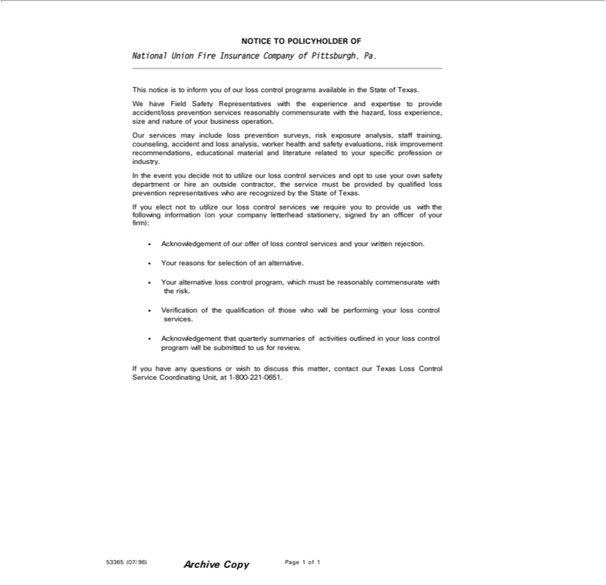

_{National}OTICE TO POLICYHOLDER OF
Union Fire Insurance Company of Pittsburgh, Pa.

This notice is to inform you of our loss control programs available in the State of Texas. We have Field Safety Representatives with the experience and expertise to provide accident/loss prevention services reasonably comme_{include}surate with the hazard, loss experience, size and nature of your business operation.
Our services may loss prevention surveys, risk exposure analysis, staff training, counseling, accident and loss analysis, worker health and safety evaluations, risk improvement recommendations, educational material and literature related to your specific profession or industry.
In the event you decide not to utilize our loss control services and opt to use your own safety department or hire an outside contractor, the service must be provided by qualified loss prevention representatives who are recognized by the State of Texas.
AcknowledgementIfyouelectnottoutilizeofourourofferlossof controllosscontrolservicesserviceswerequireandyouryouwrittentoproviderejection.uswith the following information (on your company letterhead stationery, signed by an officer of your firm):
^{Your} reasons for selection of an alternative.
Verificationalternativeofthelossqualificationcontrolprogram,ofthosewhichwho mustwillbebeperformingreasonably yourcommensuratelosscontrolwithservices.therisk.
Acknowledgement that quarterly summaries of activities outlined in your loss control program will be submitted to us for review.
If you have any questions or wish to discuss this matter, contact our Texas Loss Control Service Coordinating Unit, at 1-800-221-0651.

53365 (07/96) Archive Copy Page 1 of 1

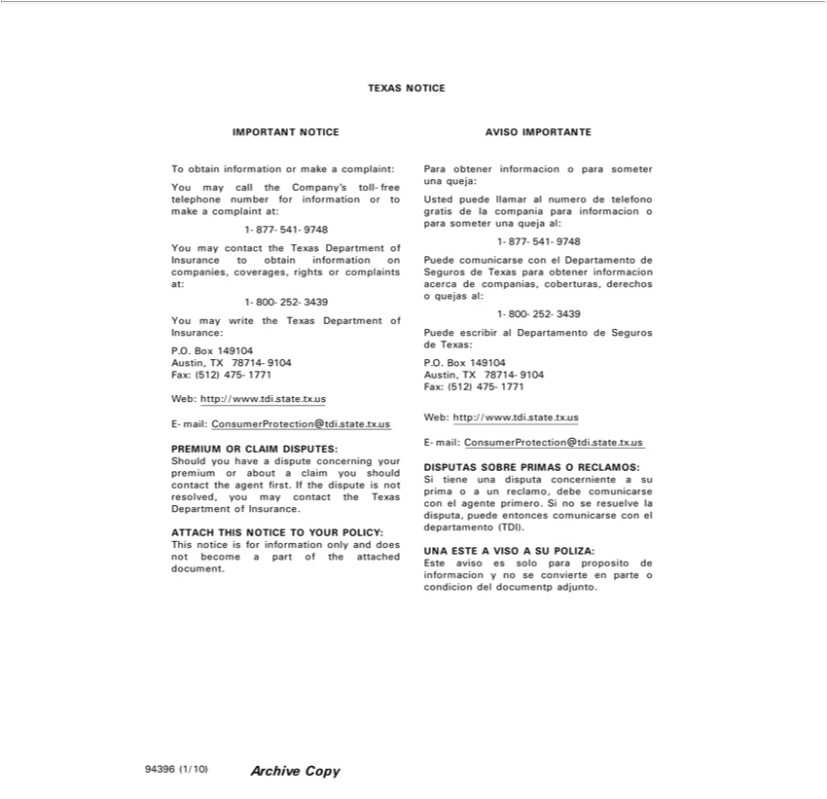

TEXAS NOTICE
IMPORTANT NOTICE
To obtain information make a complaint: You may call the Company’ toll-free telephone number for information or to make complaint at: 1-877-541-9748 You may contact the Texas Department of
Insurance to obtain information on companies, coverages, rights or complaints at: 1-800-252-3439 You may write the Texas Department of Insurance: P.O. Box 149104 Austin, TX 78714-9104 Fax: (512) 475-
1771 | .state.tx.us
Web: http://www. | .state.tx.us
-mail: ConsumerProtection@tdi.state.tx.us
PREMIUM OR CLAIM DISPUTES:
Should you have a dispute concerning your premium or about a claim you should contact the agent first. If the dispute is not resolved, you may contact the Texas Department of Insurance.
ATTACH THIS NOTICE TO YOUR POLICY:
This notice is for information only and does not become a part of the attached document.
AVISO IMPORTANTE
Para obtener informacion o para someter una queja: Usted puede llamar al numero de telefono gratis la compania para informacion o para someter una queja al: 1-877-541-9748 Puede comunicarse con el
Departamento de Seguros de Texas para obtener informacion acerca de companias, coberturas, derechos o quejas al: 1-800-252-3439 Puede escribir al Departamento de Seguros de Texas: P.O. Box 149104
Austin, TX 78714-9104 Fax: (512) 475-1771
Web: http://www. | .state.tx.us
E-mail: ConsumerProtection@tdi.state.tx.us
DISPUTAS SOBRE PRIMAS O RECLAMOS:
Si tiene una disputa concerniente a su prima o a un reclamo, debe comunicarse con el agente primero. Si no se resuelve la disputa, puede entonces comunicarse con el departamento (TDI).
UNA ESTE A VISO A SU POLIZA:
Este aviso es solo para proposito de informacion y no se convierte en parte o condicion del documentp adjunto.
94396 (1/10) Archive Copy

