UNITED STATES

SECURITIES AND EXCHANGE COMMISSION
Washington, D.C. 20549

FORM 8-K

CURRENT REPORT

Pursuant to Section 13 or 15(d)
of the Securities Exchange Act of 1934

Date of Report (Date of earliest event reported): March 16, 2020

TPG Specialty Lending, Inc.

(Exact name of registrant as specified in charter)

Delaware | 001-36364 | 27-3380000
(State or Other Jurisdiction | (Commission | (I.R.S. Employer
of Incorporation) | File Number) | Identification No.)
2100 McKinney Avenue, Suite 1500
Dallas, TX |  | 75201
(Address of Principal Executive Offices) |  | (zip code)

Registrant’s telephone number, including area code: (469) 621-3001

Check the appropriate box below if the Form 8-K filing is intended to simultaneously satisfy the filing obligation of the registrant under any of the following provisions:

- Written communications pursuant to Rule 425 under the Securities Act (17 CFR 230.425)

- Soliciting material pursuant to Rule 14a-12 under the Exchange Act (17 CFR 240.14a-12)

- Pre-commencement communications pursuant to Rule 14d-2(b) under the Exchange Act (17 CFR 240.14d-2(b))

- Pre-commencement communications pursuant to Rule 13e-4(c) under the Exchange Act (17 CFR 240.13e-4(c))

Securities registered pursuant to Section 12(b) of the Act:

Title of each class |  | Trading |  | Name of each exchange
 |  | Symbol(s) |  | on which registered
Common Stock, par value $0.01 per share |  | TSLX |  | The New York Stock Exchange

Indicate by check mark whether the registrant is an emerging growth company as defined in Rule 405 of the Securities Act of 1933 (§230.405 of this chapter) or Rule 12b-2 of the Securities Exchange Act of 1934 (§240.12b-2 of this chapter).

Emerging growth company ☐

If an emerging growth company, indicate by check mark if the registrant has elected not to use the extended transition period for complying with any new or revised financial accounting standards provided pursuant to Section 13(a) of the Exchange Act. ☐

Item 7.01 – Regulation FD Disclosure

On March 16, 2020, the registrant issued a press release, included herewith as Exhibit 99.1, and by this reference incorporated herein.

The information disclosed under this Item 7.01, including Exhibit 99.1 hereto, is being furnished and shall not be deemed “filed” for purposes of Section 18 of the Securities Exchange Act of 1934, and shall not be deemed incorporated by reference into any filing made under the Securities Act of 1933, except as expressly set forth by specific reference in such filing.

Item 9.01 – Financial Statements and Exhibits

- Exhibits:

Exhibit

Number Description

99.1 Press release, dated March 16, 2020

SIGNATURES

Pursuant to the requirements of the Securities Exchange Act of 1934, as amended, the Registrant has duly caused this report to be signed on its behalf by the undersigned hereunto duly authorized.

TPG SPECIALTY LENDING, INC.

(Registrant)

Date: March 16, 2020 By: /s/ Ian Simmonds

Ian Simmonds

Chief Financial Officer

Exhibit 99.1


TPG Specialty Lending Inc. Provides Business and Portfolio Update

NEW YORK—(BUSINESS WIRE)—March 16, 2020—TPG Specialty Lending, Inc. (NYSE: TSLX, or the “Company”) today sent the following letter to update its stakeholders on its business and portfolio.

March 16, 2020

Dear Stakeholder,

First and foremost in our minds is the health and well-being of our broader community. As we together face the challenges of the coronavirus (COVID-19), our thoughts are with everyone who has been affected (both directly and indirectly) by this unprecedented event. We recognize that uncertainty, especially when it pertains to the health of our loved ones and our communities, can result in significant anxiety and concern. We believe the ongoing implications of COVID-19 will have a significant impact on the real global economy, and we, like many others, are executing contingency plans for this public health and economic event. In the meantime, our priority remains maintaining close dialogue and providing the highest possible level of transparency with all our stakeholders, including our shareholders, bondholders, rating agencies, portfolio companies, sponsors, and referral partners. Please know that we are vigilantly monitoring this continually evolving situation and have implemented steps to keep our people safe while ensuring full business continuity.

Portfolio Positioning

We have long operated with a late-cycle mindset and have taken a number of steps to proactively manage risk in our portfolio. Specifically, we have been primarily focused on investing at the top of the capital structure in businesses with limited commodity and cyclical exposure. Since our IPO in Q1 2014 to year-end 2019, we’ve increased the first lien composition of our portfolio from 82.4% to 96.5% of the portfolio on a fair value basis. Over this period, we’ve also decreased the cyclical exposure in our portfolio from 19.0% to 2.9% of the portfolio on a fair value basis. Note that this excludes our asset-based loans in retail and reserve- and asset-based loans in energy.

Our energy exposure at year-end was limited to four portfolio companies representing 4.2% of the portfolio by fair value. The largest position, Verdad Resources, representing 1.8% of the portfolio at fair value or approximately 44% of our total energy exposure, is a first lien reserve-based loan in an upstream company with significantly hedged production volume through 2023 and hedged collateral value. Our second largest position is Energy Alloys, which represents 0.9% of the portfolio at fair value or approximately 23% of our total energy exposure. This is an asset-based loan secured by working capital collateral, which we believe provides more downside protection than the typical energy services loan.

Across our core portfolio companies, our average net attachment point and last-dollar leverage at year-end 2019 was relatively conservative at 0.2x and 4.2x, respectively. As of year-end 2019, we had no investments on non-accrual status. We continue to stay close to our portfolio companies with regular conversations with C-suite executives to proactively assess and manage potential risks across our portfolio. While things are evolving given the underlying uncertainty in the broader markets, in the spirit of transparency, we wanted to provide a substantive update on our current portfolio positioning.

Liquidity, Funding Profile and Capital

Given our ongoing focus on liability management, we believe we have ample and diverse funding sources with long-dated maturities to support our capital needs in the period ahead. Currently, we have in excess of $925 million of capacity available and expect that to increase to over $1.0 billion in the near-term given

1

scheduled investment repayments. Our total unfunded commitments across our investment portfolio currently stands at approximately $210 million, with less than $115 million of this amount currently available to be drawn based on contractual requirements in the underlying loan agreements. We have limited forward pipeline commitments, and therefore, we have capacity to provide new commitments at the appropriate level of risk-adjusted returns. This January, we completed a maturity extension to our revolving credit facility through January 2025 and an upsize of total commitments. We have no near-term maturities; as illustrated in the chart below, our nearest maturity obligation is August 2022. Our revolver syndicate, which is broad and deep through our 20 bank partners, are all investment grade-rated counterparties.
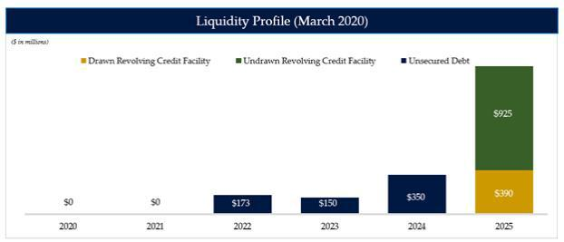

As illustrated by the chart below, our business continues to have a stable funding profile. As of December 31, 2019, the weighted average remaining life of investments funded with debt was approximately 2.4 years, compared to a weighted average remaining maturity on our debt of approximately 4.6 years.
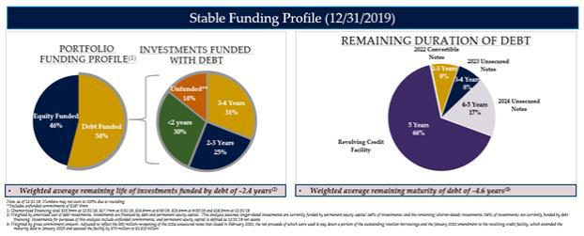

Based on our experience, sometimes the best investment opportunities exist during periods of elevated volatility and credit market dislocation. That is why, in addition to boosting our liquidity position, we have significant capital and have been operating below the top end of our target leverage range of 0.9x to 1.25x to preserve our reinvestment option to create high risk-adjusted returns. Given the limited net fundings this quarter, we estimate that we are currently at the bottom of our target leverage range.

2

At this moment in time, we feel good about the level of capital and the significant amount of liquidity we have for what could be an extended period of market volatility ahead. In addition, we have significant dry powder across the Sixth Street platform that we’re able to deploy to invest alongside TSLX given our SEC exemptive order to support our investing activities.

Interest Rate Considerations – Asset and Liabilities Sensitivities

In the past couple of weeks, the Federal Reserve System and other central banks around the world have applied stimulus tools available to them, including but not limited to the reduction of short-term interest rates, to help mitigate the economic impact of COVID-19 on global economies. These actions have resulted in a drastic decrease in the spot LIBOR and a downward shift in the forward LIBOR curve, as illustrated in the graph below.
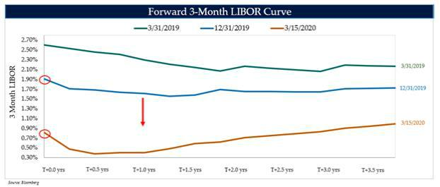

As it relates to the left hand side of our balance sheet (asset sensitivity), over 95% of our debt investments based on fair value are currently subject to LIBOR floors, and the average LIBOR floor of our debt portfolio is currently 1.1%. As a result, we believe that the earnings power of our portfolio is well protected in the near- and medium-term given that we’ve truncated our asset sensitivity with LIBOR floors.

On the right hand side of our balance sheet (liability sensitivity), central to our risk management philosophy is mitigating non-credit risk in our portfolio, including interest rate risk. We achieve this through matching the interest rate exposure of our assets and liabilities. More specifically, in order to align the nature of our liabilities with the primarily floating rate nature (in combination with LIBOR floors) of our investment portfolio, we’ve entered into a series of fixed-to-floating interest rate swaps on all of our fixed rate liabilities so that our overall borrowing costs generally move in line with broader movements in interest rates. As of today, over 99% of our debt investments based on fair value bore interest at floating rates (when including investment specific hedges) and 100% of our debt liabilities outstanding are effectively floating rate obligations.

In today’s environment, where LIBOR has dropped below our average LIBOR floor, we would experience net interest margin expansion. As illustrated below by the interest rate sensitivity table based on our balance sheet as of December 31, 2019, on an annualized basis, this would amount to an estimated net interest margin expansion of $0.02 per share at March 31, 2020 and $0.06 per share at June 30, 2020 based on the current forward 3-month LIBOR curve. As a result, we believe we will continue to have one of the strongest interest coverage profiles amongst of our peers.

3

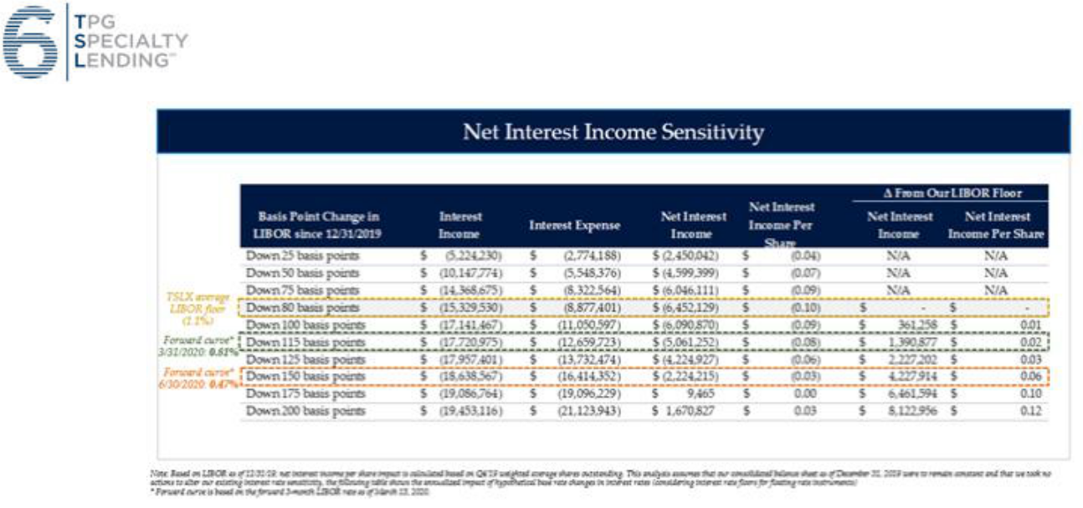

Our Business Continuity Plan (BCP)

In the coming weeks and months, we will continue to focus on the continuity of our operations, on portfolio and business risk management, and on our responsibility to our communities. We have encouraged our teams across our global offices to work from home, abstain from non-essential business travel, and have implemented rotating teams of our market-facing businesses to remain nimble in this evolving market environment. Our BCP is centered on relentless communication (both internally and with our counterparties). We’ve redoubled our efforts to maintain the flow of insights and information sharing that is central to our business.

We understand that these are challenging times for everyone and their families, and we are committed to supporting our people and all our counterparties. We will continue to work hard for all our stakeholders and look forward to maintaining our dialogue with you during this period.

Sincerely,


Joshua Easterly

Chief Executive Officer and Chairman of the Board

4

About TPG Specialty Lending

TSLX is a specialty finance company focused on lending to middle-market companies. The Company seeks to generate current income primarily in U.S.-domiciled middle-market companies through direct originations of senior secured loans and, to a lesser extent, originations of mezzanine loans and investments in corporate bonds and equity securities. The Company has elected to be regulated as a business development company, or a BDC, under the Investment Company Act of 1940 and the rules and regulations promulgated thereunder. TSLX is externally managed by TSL Advisers, LLC, a Securities and Exchange Commission (“SEC”) registered investment adviser. TSLX leverages the deep investment, sector, and operating resources of Sixth Street Partners, a global finance and investment firm with over $33 billion of assets under management as of September 30, 2019. For more information, visit the Company’s website at www.tpgspecialtylending.com.

About Sixth Street Partners

Sixth Street Partners is a global multi-asset class investment business with over $33 billion in assets under management as of September 30, 2019. Sixth Street operates eight diversified, collaborative investment platforms across our growth investing, direct lending, par liquid credit, fundamental public strategies, infrastructure, agriculture, special situations and adjacencies businesses. Our long-term oriented, highly flexible capital base and “One Team” cultural philosophy allows us to invest thematically across sectors, geographies and asset classes. Founded in 2009, Sixth Street has more than 275 team members including over 140 investment professionals operating from nine locations around the world. For more information, visit www.tssp.com.

Forward-Looking Statements

Statements included herein may constitute “forward-looking statements,” which relate to future events or the Company’s future performance or financial condition, including the impact of COVID-19 and related changes in base interest rates and market volatility on our business, our portfolio companies, our industry and the global economy. These statements are not guarantees of future performance, conditions or results and involve a number of risks and uncertainties. Actual results may differ materially from those in the forward-looking statements as a result of a number of factors, including those described from time to time in the Company’s filings with the Securities and Exchange Commission. The Company assumes no obligation to update any such forward-looking statements.

Source: TPG Specialty Lending, Inc.

Investors:

Lucy Lu, 212-601-4753

IRTSL@tpg.com

or

Media: Patrick Clifford, 617-793-2004

PClifford@tssp.com

5

