UNITED STATES

SECURITIES AND EXCHANGE COMMISSION
Washington, D.C. 20549

SCHEDULE 14A INFORMATION

PROXY STATEMENT PURSUANT TO SECTION 14(a) OF THE

SECURITIES EXCHANGE ACT OF 1934

Filed by the Registrant ☐

Filed by a Party other than the Registrant ☒

Check the appropriate box:

- Preliminary Proxy Statement

- Confidential, for Use of the Commission Only (as permitted by Rule 14a-6(e)(2))

- Definitive Proxy Statement

- Definitive Additional Materials

- Soliciting Material Pursuant to §240.14a-12

TICC CAPITAL CORP.

(Name of Registrant as Specified In Its Charter)

TPG Specialty Lending, Inc.

(Name of Person(s) Filing Proxy Statement, if other than the Registrant)

Payment of Filing Fee (Check the appropriate box):

- Fee not required.

- Fee computed on table below per Exchange Act Rules 14a-6(i)(1) and 0-11.

  - Title of each class of securities to which transaction applies:

  - Aggregate number of securities to which transaction applies:

  - Per unit price or other underlying value of transaction computed pursuant to Exchange Act Rule 0-11 (set forth the amount on which the filing fee is calculated and state how it was determined):

  - Proposed maximum aggregate value of transaction:

  - Total fee paid:

- Fee paid previously with preliminary materials.

- Check box if any part of the fee is offset as provided by Exchange Act Rule 0-11(a)(2) and identify the filing for which the offsetting fee was paid previously. Identify the previous filing by registration statement number, or the Form or Schedule and the date of its filing.

  - Amount Previously Paid:

  - Form, Schedule or Registration Statement No.:

  - Filing Party:

  - Date Filed:

On August 29, 2016, TPG Specialty Lending, Inc. issued the following press release:

TPG Specialty Lending, Inc. Sends Letter to Independent Directors of TICC Capital Corp. Seeking an Objective Evaluation of TICC’s Recent Financial Performance and Actions

TSLX Highlights Discrepancies in TICC’s Public Statements Compared to the Reality of its Investment Portfolio and Recently Reported Financial Results

Calls for TICC’s Independent Directors to Resign if Directors Are Unwilling or Unable to Fulfill Their Duties to Stockholders

TSLX Poses Six Important Questions on Behalf of All Stockholders to TICC’s Board Regarding the State of Stockholders’ Investment in TICC

TSLX Encourages TICC Stockholders to Vote the GOLD Proxy Card to Terminate TICC’s External Adviser’s Advisory Contract and Elect T. Kelley Millet to the TICC Board of Directors at the 2016 Annual Meeting on September 2, 2016

NEW YORK – (BUSINESS WIRE) – TPG Specialty Lending, Inc. (“TSLX”; NYSE: TSLX), a specialty finance company focused on lending to middle-market companies, has delivered a letter to Mr. Steven P. Novak, Mr. G. Peter O’Brien and Ms. Tonia L. Pankopf, the independent members of the Board of Directors of TICC Capital Corp. (“TICC”; NASDAQ:TICC), urging that they answer six important questions for all stockholders as part of an objective evaluation of the facts regarding TICC’s underperformance. In the letter, TSLX notes several discrepancies between TICC’s public statements and the reality of its investment portfolio and recently reported financial performance.

TSLX strongly encourages stockholders to sign and return the GOLD proxy card today. TSLX urges stockholders to ignore TICC’s self-serving actions and discard any WHITE proxy cards. Even if a WHITE card has been submitted, stockholders can still change their vote, simply by returning the GOLD proxy card now. Voting instructions and TSLX’s proxy materials are also available through the SEC’s website and at www.changeTICCnow.com.

A copy of the letter follows:

Mr. Steven P. Novak

Mr. G. Peter O’Brien

Ms. Tonia L. Pankopf

TICC Capital Corp.

8 Sound Shore Drive, Suite 255

Greenwich, CT 06830

Dear Independent Directors,

We are writing as the largest single stockholder of TICC Capital Corp. (“TICC” or the “Company”) to urge you to critically evaluate TICC’s recent performance and public statements. Although it may be difficult, given TICC’s substantial underperformance during your tenure, we are hoping that you will take a step back and look at the facts objectively.

Like many others in the investment community, we continue to be frustrated by the actions taken by TICC’s external adviser to avoid a constructive dialogue regarding the Company’s operations and results. A case in point is TICC’s refusal to issue its quarterly report on Form 10-Q prior to conducting its earnings call with stockholders. Not only does this demonstrate a profound lack of respect for the views of TICC’s stockholders and equity research analysts, it prevents any meaningful public discourse regarding TICC’s performance, strategy and execution, thereby enabling poor performance to continue unchecked. As a result, we feel obligated to raise publicly several important questions to TICC’s Board on behalf of all stockholders regarding the state of their investment:

- What drove the change in the level yield at which TICC recognized GAAP revenue from CLO equity investments in the second quarter of 2016 – the quarter immediately preceding the annual meeting at which stockholders will vote on a proposal to terminate the external adviser’s contract?

Based on the schedule of investments included in TICC’s Form 10-Q filing, it appears that substantially all of the reported increase in investment income per share resulted from a change in the level yield assumptions that TICC utilizes to recognize GAAP revenue from its Collateralized Loan Obligation (“CLO”) equity investments.1 During the second quarter of 2016, the level yield at which TICC recognized revenue from CLO equity investments increased by approximately 50.6%, to 12.8% from 8.5% in the preceding quarter.2 This increase included an approximately 24.8% increase in the cost-weighted average level yield applied to existing positions compared to the yield used for the three months prior.

We note that, by contrast, the key metrics reflecting the underlying strength of your CLO equity investments appear to have deteriorated. For example, cash-on-cash distributions declined by approximately 14% quarter-over-quarter and 27% year-over-year while junior over-collateralization cushions, which measure the health of CLOs and can be

used as a means to predict possible future cash distributions to equity holders, declined by approximately 5% quarter-over-quarter and 17% year-over-year.3 Although GAAP permits management to revisit level yield assumptions from time to time, as a stockholder, we want to understand the underlying rationale that drove TICC to undertake discretionary changes to these assumptions in the second quarter of 2016, at a time when the external adviser’s performance is being questioned by numerous independent analysts and advisors and the termination of its contract is up for a vote of stockholders.

- Why was the $0.14 per share in realized losses not highlighted to stockholders?

Although TICC reported $0.13 per share in GAAP net investment income (“NII”) for the second quarter of 2016, the Company’s statement of operations show that this was driven principally by reduced expenses and the change in level yield at which TICC recognized revenue on its CLO equity investments discussed above, neither of which have much to do with the Company’s investment strategy or ability to deliver future earnings.4

Even more important to stockholders, we believe the Company’s second quarter earnings release glosses over the magnitude of TICC’s net realized losses. Put simply, the $0.13 per share in GAAP NII that TICC reported in Q2 2016 is more than offset by $0.14 per share in losses realized during the quarter.5 That means the economic value within the control of management (excluding unrealized gains) that TICC delivered to stockholders in the most recent quarter was NEGATIVE. It is not lost on stockholders that realized losses represent a permanent impairment of stockholder capital.

- Why did TICC’s external adviser collect an NII incentive fee in the second quarter of this year when the Company reported realized losses of $7.3 million? How can it justify any fee at all?

The Company paid its external adviser an incentive fee of approximately $1.2 million6 during the most recent quarter, at the same time that the Company reported realized losses of $7.3 million. We were surprised to learn that this was a quid pro quo for the so-called “best-in-class” fee waiver that was trumpeted by the Board earlier this year as a stockholder-friendly measure. In connection with the fee waiver, the Board agreed that the look-back reference date for the payment of NII incentive fees would be reset to April 1, 2016. As a result, any losses suffered by TICC’s portfolio prior to April 1, 2016, whether realized or unrealized, will not affect the adviser’s ability to reap NII incentive fees going forward. Using the term “waiver” to describe this is itself thus a misnomer. There was no unilateral concession by the external adviser; instead the Board agreed to wipe clean the slate of accumulated losses. This certainly cannot be in the best interest of stockholders, given the external adviser’s past performance. Through this reset, the external adviser gets to start over, despite the decade of underperformance delivered prior to the resetting of the threshold. As a result, TICC could realize losses of up to approximately $155.3 million7 and still be in a position that it might have to pay incentive fees, this most recently completed quarter being a case in point. We suspect that long-suffering TICC stockholders wish they could similarly wipe clean their losses in TICC’s shares.

- Has the Company actually implemented a new investment strategy?

In a November 18, 2015 public statement, the Company announced the sale of certain syndicated corporate loans and stated that “a rotation out of lower-yielding corporate loan assets held within a leveraged credit facility into higher-yielding loans held on a less levered basis represents a compelling strategy,” and on March 10, 2016, TICC CEO Jonathan Cohen announced on the fourth quarter of 2015 earnings call that management was “committed to rotating out of CLO equity over time.” Your actions, however, appear to contradict your stated intent to implement a new investment strategy.

Instead of exiting CLO equity investments, however, TICC reported a meaningful increase in CLO equity investments during the second quarter of 2016, with $37.9 million of CLO equity purchased during the quarter, which represented 51.6% of the second quarter’s new investment activity.8 CLO equity investments now represent approximately 32% of TICC’s total investment portfolio at fair value, a meaningful increase from the first quarter of 2016.9

- Why did TICC state that its new investment strategy is “already yielding results”?

In its August 18, 2016 public statement, TICC claimed that “[t]he Company has revised its investment strategy, which is already yielding results.” Setting aside the increase in CLO equity investments, which is certainly a part of the old strategy, we must note that the Company’s financial statements show that interest income from debt investments (where the impact of new middle market originations would be presented in your income statement) actually decreased to $8.7 million in the second quarter of 2016 versus $8.9 million in the first quarter of 2016,10 resulting in virtually no change in these debt investments’ contribution to total investment income on a per share basis.11 Does a quarter-over-quarter decrease in income from debt investments really equate to “yielding results”? How does TICC explain the discrepancy between how the Board describes its investment strategy and the reality of the performance of its portfolio?

- Shouldn’t stockholders judge the performance of the Company for as long as management has been in charge and not from the bottom of the market?

We agree with TICC’s August 18, 2016 public statement that the Company’s performance should be “evaluated over a longer period.” On this point the facts are clear: TICC has underperformed nearly every significant benchmark since its IPO in 2003.

Since 2003, the Company has delivered underperformance of NEGATIVE 182.9% as compared to the BDC Composite.12 TICC’s Board and external advisor have been the stewards of an investment strategy that has resulted in a 52% decline in net asset

value (“NAV”) per share since 2004.13 How can the Company continue to defend this drastic level of underperformance?

You have argued that stockholders should look only at a single period of time – since 2009. However, we find it misleading to only look at the Company’s results since 2009, because your results since that point essentially reflect a recovery from your severe underperformance relative to peers prior to and during the financial crisis.14 We note your attempt to cherry-pick results didn’t persuade ISS or the other proxy advisors. In fact, TICC has delivered year-to-date returns of 14.7% in 2016, compared to 17.5% for the BDC Composite, demonstrating that even TICC’s recent performance has been subpar.

As TICC’s largest single stockholder, we continue to reiterate our commitment to enhancing the value of stockholders’ investment in the Company. The above questions are critical to helping us and our fellow stockholders understand the leadership decisions being made by you, TICC’s Board, and management. Stockholders deserve real answers.

We genuinely hope that the TICC board will look critically at its strategies, capital allocation policies and corresponding performance. Independent experts have overwhelmingly expressed concern with TICC’s actions and underperformance, and have urged stockholders to support our campaign for change. All three leading proxy advisors have recommended that stockholders support our efforts. Even if you ignore the facts outlined above, consider what well-respected independent third parties have said:

- “As a result of the current advisor’s investment strategy, TICC has delivered negative [Total Shareholder Return] and underperformed peers and the index over the past five years . . . As such, terminating the current advisor appears to be in the best interest of TICC shareholders.”

– ISS proxy advisory report, Aug. 17, 2016

- “[W]e believe that voting FOR the [TSLX] nominee and voting FOR the termination of the investment advisory agreement is in the best interest of the Company and its shareholders. In arriving at that conclusion, we have considered the following factors: 1. Our belief that the [e]xisting [a]dviser’s investment strategy did not work on the benefit of the Company and its stockholders. 2. We believe that [TSLX] would work on offering an opportunity to the Company to be under a reputable external adviser with a reasonable amount of investment adviser fees to protect and maximize stockholder value.”

– Egan-Jones proxy advisory report, Aug. 23, 2016

- “The overriding fact facing shareholders is that the board failed to take action while overseeing five years of TICC underperformance, which by itself signals that change is needed at the board level. Moreover, the long tenure of this board, with each of its five members having served for 13 years as directors, suggests that the company should welcome fresh perspectives to the board. As such, there seems to be a compelling case that change is warranted at this time.

– ISS proxy advisory report, Aug. 17, 2016

- “[W]e consider the appointment of Mr. Millet affords important benefits above and beyond his financial expertise, most notably with respect to his ability to immediately inject a fresh, outside perspective and a willingness to thoughtfully evaluate TICC’s present circumstances . . . [W]e consider the election of Mr. Millet represents a more favorable outcome for unaffiliated investors by a wide margin.”

– Glass Lewis proxy advisory report, Aug. 19, 2016

We continue to be very disappointed in your repeated and continued assertions that we have not articulated a plan and that terminating the existing investment advisory agreement could result in TICC being left with no investment adviser, no management team and no operational infrastructure. As ISS correctly pointed out, this risk “appears to be utterly within the board’s control . . . literally by identifying a new advisor.” In ISS’s words, “[t]o the extent shareholders have a risk here, . . . it would appear the root cause of the risk would be the current director’s unwillingness to fulfil [sic] their responsibilities to shareholders by taking any action at all.”

We find it wholly inappropriate for you, the independent directors, to argue that your stockholders should vote against change because that change may present the risk that TICC’s independent directors will fail to act in accordance with their fiduciary duties. If you are saying that you are unable or unwilling to fulfill your duties to stockholders, we respectfully request that you resign.

As a long-term participant in the BDC space, we have an interest in seeing that TICC and other BDCs employ best-in-class corporate governance principles, provide stockholders with real transparency, and deliver strong results for stockholders, including through sound capital allocation and active management. Therefore, we hope that our efforts to date, on behalf of all TICC stockholders, will lead you to genuinely re-examine the Company’s practices so that stockholders have the opportunity to benefit from the changes they need and deserve.

Respectfully,

TPG SPECIALTY LENDING, INC.

Joshua Easterly

Chairman and Co-Chief Executive Officer

Michael Fishman

Co-Chief Executive Officer

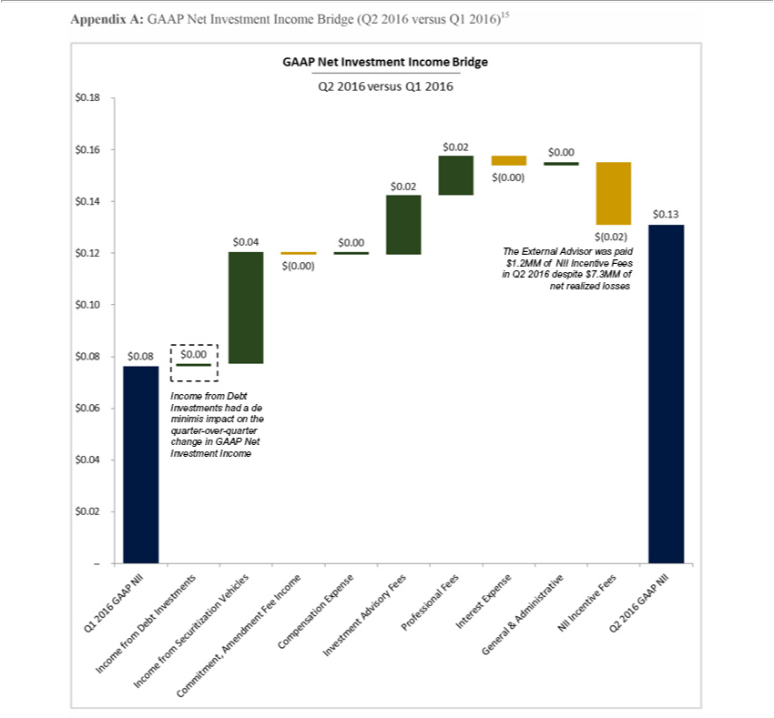

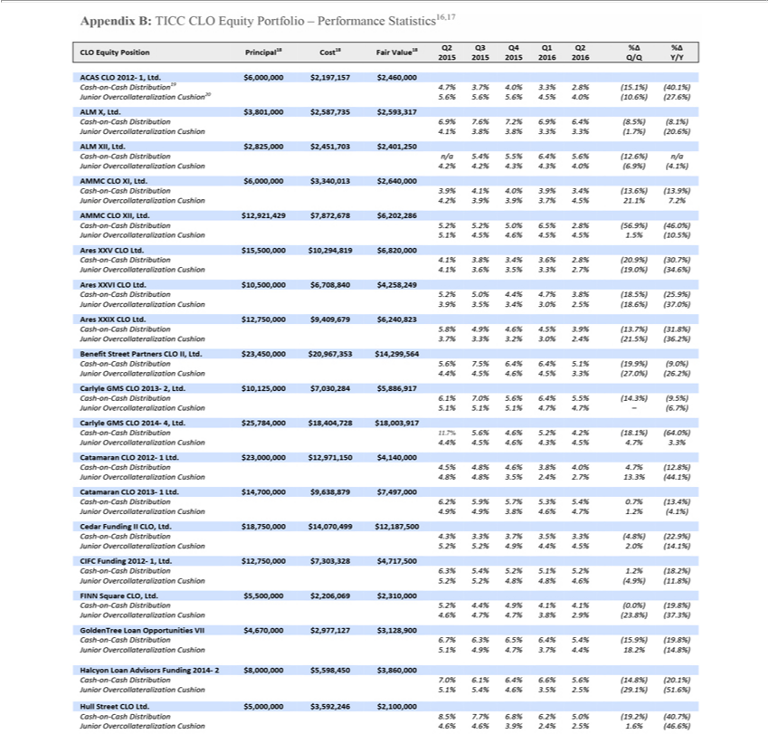

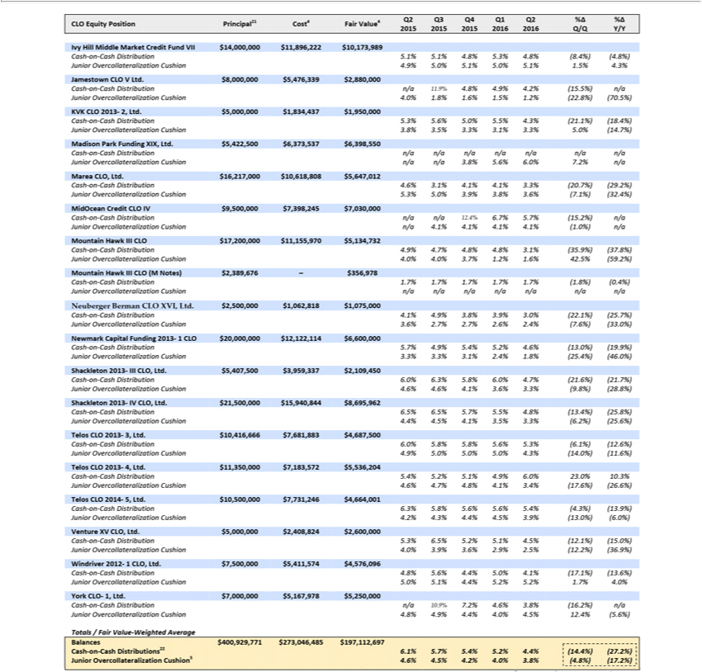

Cash-on-cash distributions and junior

overcollateralization cushions decreased

meaningfully on a Q/Q and Y/Y basis in Q2 2016

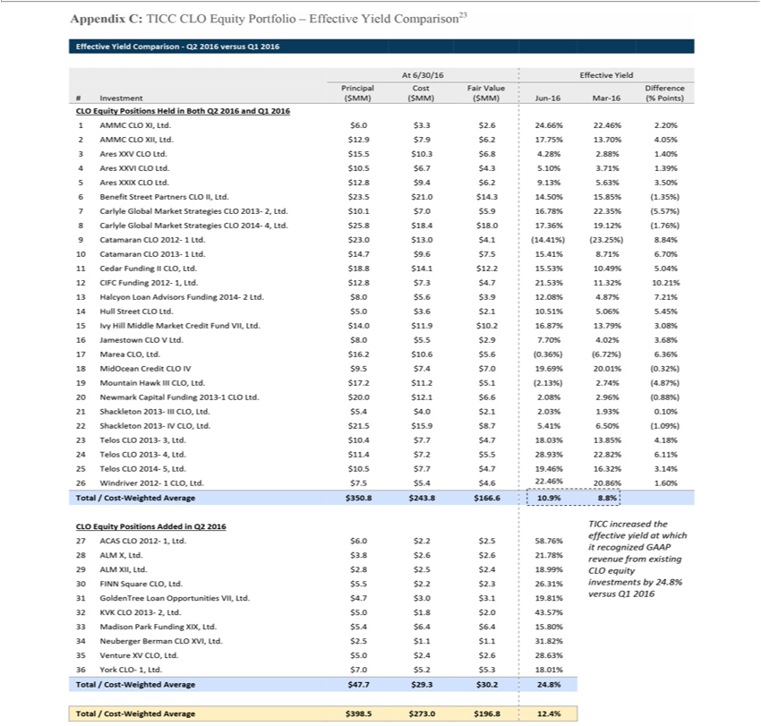

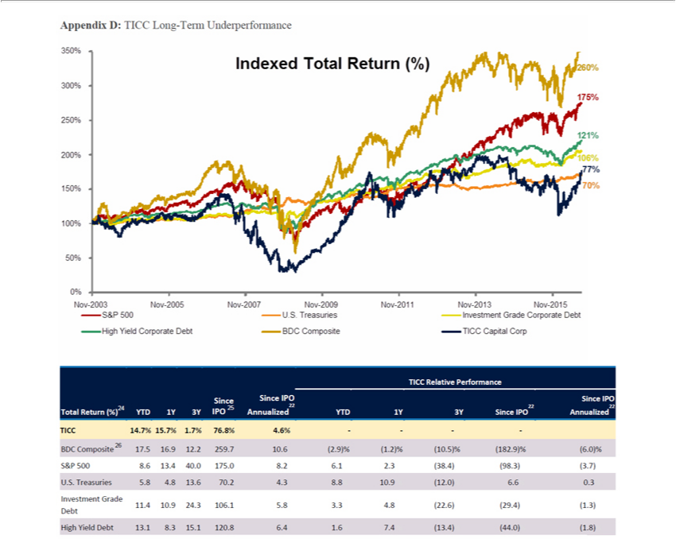

Note: Market data as of August 23, 2016

Source: Bloomberg, fixed income benchmark data from Markit iBoxx

- Total return calculation includes share price appreciation and cumulative dividends paid.

- BDC Composite comprised of ACAS, AINV, ARCC, BKCC, FSC, GBDC, HTGC, MAIN, MCC, NMFC, PNNT, PSEC, SLRC, TCAP, and TCRD

Note: Market data as of August 23, 2016

Source: Bloomberg

About TPG Specialty Lending

TPG Specialty Lending, Inc. (“TSLX” or the “Company”) is a specialty finance company focused on lending to middle-market companies. The Company seeks to generate current income primarily in U.S.-domiciled middle-market companies through direct originations of senior secured loans and, to a lesser extent, originations of mezzanine loans and investments in corporate bonds and equity securities. The Company has elected to be regulated as a business development company, or BDC, under the Investment Company Act of 1940 and the rules and regulations promulgated thereunder. TSLX is externally managed by TSL Advisers, LLC, a Securities and Exchange Commission registered investment adviser. TSLX leverages the deep investment, sector, and operating resources of TPG Special Situations Partners, the dedicated special situations and credit platform of TPG, with over $16 billion of assets under management as of March 31, 2016, and the broader TPG platform, a global private investment firm with over $74 billion of assets under management as of March 31, 2016. For more information, visit the Company’s website at www.tpgspecialtylending.com.

Forward-Looking Statements

Information set forth herein may contain forward-looking statements, including, but not limited to, statements with regard to the expected future financial position, results of operations, cash flows, dividends, portfolio, financing plans, business strategy, budgets, capital expenditures, competitive positions, growth opportunities, plans and objectives of management of TICC Capital Corp. (“TICC”), statements with regard to the expected future financial position, results of operations, cash flows, dividends, portfolio, financing plans, business strategy, budgets, capital expenditures, competitive positions, growth opportunities, plans and objectives of management of TPG Specialty Lending, Inc. (“TSLX”), and statements with regard to TSLX’s proposed business combination transaction with TICC (including any financing required in connection with a possible transaction and the benefits, results, effects and timing of a possible transaction). Statements set forth herein concerning the business outlook or future economic performance, anticipated profitability, revenues, expenses, dividends or other financial items, and product or services line growth of TSLX, TICC and/or the combined businesses of TSLX and TICC, including, but not limited to, statements containing words such as “anticipate,” “approximate,” “believe,” “plan,” “estimate,” “expect,” “project,” “could,” “would,” “should,” “will,” “intend,” “may,” “potential,” “upside” and other similar expressions, together with other statements that are not historical facts, are forward-looking statements that are estimates reflecting the best judgment of TSLX based upon currently available information.

Such forward-looking statements are inherently uncertain, and stockholders and other potential investors must recognize that actual results may differ materially from TSLX’s expectations as a result of a variety of factors including, without limitation, those discussed below. Such forward-looking statements are based upon TSLX’s current expectations and include known and unknown risks, uncertainties and other factors, many of which TSLX is unable to predict or control, that may cause TSLX’s plans with respect to TICC or the actual results or performance of TICC, TSLX or TICC and TSLX on a combined basis to differ materially from any plans, future results or performance expressed or implied by such forward-looking statements. These statements involve risks, uncertainties and other factors discussed below and detailed from time to time in TSLX’s filings with the Securities and Exchange Commission (“SEC”).

Risks and uncertainties related to a possible transaction include, among others, uncertainty as to whether TSLX will further pursue, enter into or consummate a transaction on the terms set forth in its proposal or on other terms, uncertainty as to whether TICC’s board of directors will engage in good faith, substantive discussions or negotiations with TSLX concerning its proposal or any other possible transaction, potential adverse reactions or changes to business relationships resulting from the announcement or completion of a transaction, uncertainties as to the timing of a transaction, adverse effects on TSLX’s stock price resulting from the announcement or consummation of a transaction or any failure to complete a transaction, competitive responses to the announcement or consummation of a transaction, the risk that regulatory or other approvals and any financing required in connection with the consummation of a transaction are not obtained or are obtained subject to terms and conditions that are not anticipated, costs and difficulties related to a potential integration of TICC’s businesses and operations with TSLX’s businesses and operations, the inability to obtain, or delays in obtaining, cost savings and synergies from a transaction, unexpected costs, liabilities, charges or expenses resulting from a transaction, litigation relating to a transaction, the inability to retain key personnel, and any changes in general economic and/or industry specific conditions.

In addition to these factors, other factors that may affect TSLX’s plans, results or stock price are set forth in TSLX’s Annual Report on Form 10-K and in its reports on Forms 10-Q and 8-K.

Many of these factors are beyond TSLX’s control. TSLX cautions investors that any forward-looking statements made by TSLX are not guarantees of future performance. TSLX disclaims any obligation to update any such factors or to announce publicly the results of any revisions to any of the forward-looking statements to reflect future events or developments.

Third Party-Sourced Statements and Information

Certain statements and information included herein have been sourced from third parties. TSLX does not make any representations regarding the accuracy, completeness or timeliness of such third party statements or information. Except as expressly set forth herein, permission to cite such statements or information has neither been sought nor obtained from such third parties. Any such statements or information should not be viewed as an indication of support from such third parties for the views expressed herein. All information in this communication regarding TICC, including its businesses, operations and financial results, was obtained from public sources. While TSLX has no knowledge that any such information is inaccurate or incomplete, TSLX has not verified any of that information. TSLX reserves the right to change any of its opinions expressed herein at any time as it deems appropriate. TSLX disclaims any obligation to update the data, information or opinions contained herein.

Proxy Solicitation Information

In connection with TSLX’s solicitation of proxies for the 2016 annual meeting of TICC stockholders in favor of (a) the election of TSLX’s nominee to serve as a director of TICC and (b) TSLX’s proposal to terminate the Investment Advisory Agreement, dated as of July 1, 2011, by and between TICC and TICC Management, LLC, as contemplated by Section 15(a) of the Investment Company Act of 1940, as amended, TSLX filed an amended definitive proxy statement in connection therewith on Schedule 14A with the SEC on July 14, 2016 (the “TSLX Proxy Statement”). TSLX has mailed the TSLX Proxy Statement and accompanying GOLD proxy card to stockholders of TICC. This communication is not a substitute for the TSLX Proxy Statement.

TSLX STRONGLY ADVISES ALL STOCKHOLDERS OF TICC TO READ THE TSLX PROXY STATEMENT AND THE OTHER PROXY MATERIALS AS THEY BECOME AVAILABLE BECAUSE THEY CONTAIN IMPORTANT INFORMATION. SUCH TSLX PROXY MATERIALS ARE AND WILL BECOME AVAILABLE AT NO CHARGE ON THE SEC’S WEB SITE AT HTTP://WWW.SEC.GOV AND ON TSLX’S WEBSITE AT HTTP://WWW.TPGSPECIALTYLENDING.COM. IN ADDITION, TSLX WILL PROVIDE COPIES OF THE TSLX PROXY STATEMENT WITHOUT CHARGE UPON REQUEST. REQUESTS FOR COPIES SHOULD BE DIRECTED TO TSLX’S PROXY SOLICITOR AT TPG@MACKENZIEPARTNERS.COM.

The participants in the solicitation are TSLX and T. Kelley Millet, and certain of TSLX’s directors and executive officers may also be deemed to be participants in the solicitation. As of the date hereof, TSLX beneficially owned 1,633,719 shares of common stock of TICC. As of the date hereof, Mr. Millet did not directly or indirectly beneficially own any shares of common stock of TICC.

Security holders may obtain information regarding the names, affiliations and interests of TSLX’s directors and executive officers in TSLX’s Annual Report on Form 10-K for the year ended December 31, 2015, which was filed with the SEC on February 24, 2016, its proxy statement for the 2016 annual meeting of TSLX stockholders, which was filed with the SEC on April 8, 2016, and certain of its Current Reports on Form 8-K. These documents can be obtained free of charge from the sources indicated above. Additional information regarding the interests of these participants in the proxy solicitation and a description of their direct and indirect interests, by security holdings or otherwise, is available in the TSLX Proxy Statement and other relevant materials to be filed with the SEC (if and when available).

This document shall not constitute an offer to sell, buy or exchange or the solicitation of an offer to sell, buy or exchange any securities, nor shall there be any sale of securities in any jurisdiction in which such offer, solicitation or sale would be unlawful prior to registration or qualification under the securities laws of any such jurisdiction. No offering of securities shall be made except by means of a prospectus meeting the requirements of Section 10 of the Securities Act of 1933, as amended.

1 See Appendix A for further detail

2 Source: TICC Investor Presentation for the quarter ended June 30, 2016, page 4; See Appendix C for further detail

3 See Appendix C for further detail

4 See Appendix A for further detail

5 Source: TICC Capital Corp. Form 10-Q for the period ended June 30, 2016, page 16; Calculated as $7,327,598 of realized losses divided by 51,479,409 shares outstanding

6 Source: TICC Capital Corp. Form 10-Q for the period ended June 30, 2016, page 16

7 Source: TICC Capital Corp. Form 10-Q for the period ended March 31, 2016, page 1

8 Source: TICC Capital Corp. Form 10-Q for the period ended June 30, 2016, page 32

9 Source: TICC Capital Corp. Form 10-Q for the period ended June 30, 2016, page 34

10 Source: TICC Capital Corp. Form 10-Q for the period ended June 30, 2016, page 16 and TICC Capital Corp. Form 10-Q for the period ended March 31,

2016, page 16

11 See Appendix A for further detail

12 BDC Composite comprised of ACAS, AINV, ARCC, BKCC, FSC, GBDC, HTGC, MAIN, MCC, NMFC, PNNT, PSEC, SLRC, TCAP, and TCRD Note:

Market data as of August 23, 2016

13 Source: Net asset value per share has declined from $13.71 at December 31, 2004 to $6.54 at June 30, 2016. TICC Capital Corp. public filings

14 See Appendix E for further detail

15 Source: TICC Capital Corp. public filings (Form 10-Q for the period ended June 30, 2016, page 16 and Form 10-Q for the period ended March 31, 2016, page 16)

16 Source: Intex Solutions

17 Excludes Windriver 2012-1 CLO, Ltd. equity side letter investment

18 As of 6/30/16

19 Calculated as the quotient of (i) the amount distributed to the equity tranche in each respective quarter, divided by (ii) the original balance of the equity tranche

20 Calculated as the quotient of (i) the difference between the actual overcollateralization value and the limit overcollateralization value, divided by (ii) the limit overcollateralization value

21 As of 6/30/16

22 Excludes investments for which there were no distributions and/or there was no overcollateralization tests in each respective period

23 Source: TICC Capital Corp. public filings (Form 10-Q for the period ended 6/30/16, pages 4–7 and Form 10-Q for the period ended 3/31/16, pages 5–7)

24 Total return calculation includes share price appreciation and cumulative dividends paid

25 TICC and benchmark returns indexed to November 21, 2003.

26 BDC Composite comprised of ACAS, AINV, ARCC, BKCC, FSC, GBDC, HTGC, MAIN, MCC, NMFC, PNNT, PSEC, SLRC, TCAP, and TCRD

Contacts

Investors:

TPG Specialty Lending, Inc.

Lucy Lu, 212-601-4753

llu@tpg.com

or

MacKenzie Partners, Inc.

Charlie Koons, 800-322-2885

tpg@mackenziepartners.com

or

Media:

TPG Specialty Lending, Inc.

Luke Barrett, 212-601-4752

lbarrett@tpg.com

or

Abernathy MacGregor

Tom Johnson or Pat Tucker

212-371-5999

tbj@abmac.com / pct@abmac.com

