UNITED STATES

SECURITIES AND EXCHANGE COMMISSION

Washington, D.C. 20549

SCHEDULE 14A INFORMATION

PROXY STATEMENT PURSUANT TO SECTION 14(a) OF THE

SECURITIES EXCHANGE ACT OF 1934

Filed by the Registrant ☐

Filed by a Party other than the Registrant ☒

Check the appropriate box:

- Preliminary Proxy Statement

- Confidential, for Use of the Commission Only (as permitted by Rule 14a-6(e)(2))

- Definitive Proxy Statement

- Definitive Additional Materials

- Soliciting Material Pursuant to §240.14a-12

TICC CAPITAL CORP.

(Name of Registrant as Specified In Its Charter)

TPG Specialty Lending, Inc.

(Name of Person(s) Filing Proxy Statement, if other than the Registrant)

Payment of Filing Fee (Check the appropriate box):

- Fee not required.

- Fee computed on table below per Exchange Act Rules 14a-6(i)(1) and 0-11.

- Title of each class of securities to which transaction applies:

- Aggregate number of securities to which transaction applies:

- Per unit price or other underlying value of transaction computed pursuant to Exchange Act Rule 0-11 (set forth the amount on which the filing fee is calculated and state how it was determined):

- Proposed maximum aggregate value of transaction:

- Total fee paid:

- Fee paid previously with preliminary materials.

- Check box if any part of the fee is offset as provided by Exchange Act Rule 0-11(a)(2) and identify the filing for which the offsetting fee was paid previously. Identify the previous filing by registration statement number, or the Form or Schedule and the date of its filing.

- Amount Previously Paid:

- Form, Schedule or Registration Statement No.:

- Filing Party:

- Date Filed:

TPG Specialty Lending, Inc. (“TSLX”) has filed a definitive proxy statement with the Securities and Exchange Commission and an accompanying GOLD proxy card to be used to solicit votes against TICC Capital Corp.’s (the “Company”) proposal to approve a new advisory agreement between the Company and TICC Management, LLC, to take effect upon a change of control of TICC Management, LLC, and certain related proposals, at a special meeting of stockholders of the Company scheduled to be held on October 27, 2015.

On October 7, 2015, representatives of TSLX gave a presentation to representatives of Institutional Shareholder Services Inc. regarding the Company (the “ISS Presentation”). Slides for the ISS Presentation are attached hereto.

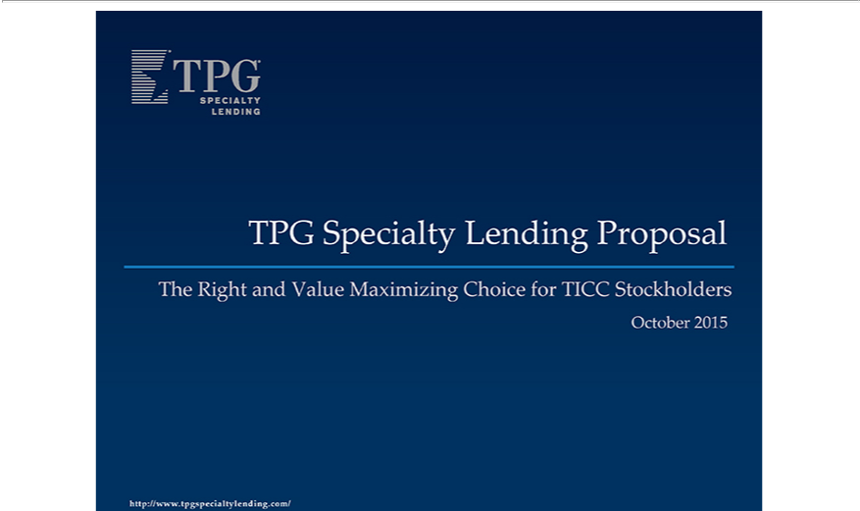

TPG Specialty Lending Proposal The Right and Value Maximizing Choice for TICC Stockholders October 2015 http://www.tpgspecialtylending.com/

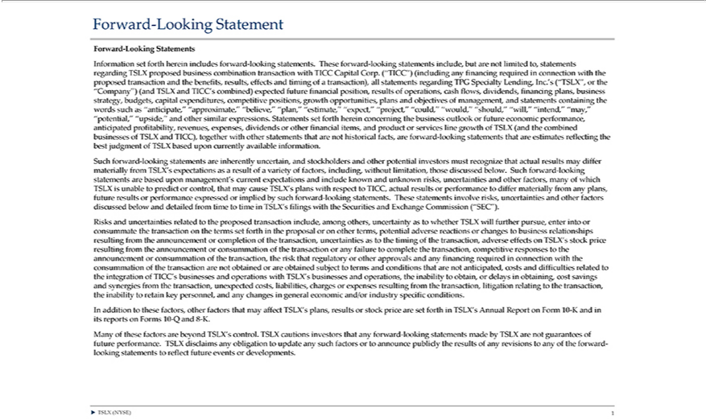

Forward-Looking Statement Forward-Looking Statements Information set forth herein includes forward-looking statements. These forward-looking statements include, but are not limited to, statements regarding
TSLX proposed business combination transaction with TICC Capital Corp. (“TICC”) (including any financing required in connection with the proposed transaction and the benefits, results, effects and timing of a
transaction), all statements | egarding TPG Specialty Lending, Inc.’s (“TSLX”, or the “Company”) (and TSLX and TICC’ combined) expected future financial position, results of operations, cash flows, dividends,
financing plans, business strategy, budgets, capital expenditures, competitive positions, growth opportunities, plans and objectives of management, and statements containing the words such as “anticipate,”
“approximate,” “believe,” “plan,” “estimate,” “expect,” “project,” |  | “would,” “should,” “will,” “intend,” “may,” “potential,” “upside,” and other similar expressions. Statements set forth herein concerning the
business outlook or future economic performance, anticipated profitability“could,” revenues, expenses, dividends or other financial items, and product or services line growth of TSLX (and the combined businesses of TSLX
and TICC), together with other statements that are not historical facts, are forward-looking statements that are estimates reflecting the best judgment of TSLX |  |  |  |  | upon currently |  | information. Such forward-
looking statements are inherently uncertain, and stockholders and other potential investors must recognize that actual results may differ materially from TSLX’basedexpectations as |  |  |  |  |  | resultavailableofvariety of factors, including,
without limitation, those discussed below. Such forward-looking statements are based upon management’s current expectations and include known and unknown risks, uncertainties and other |  |  |  |  |  |  |  | many of which
TSLX is unable to predict or control, that may cause TSLX’s plans with respect to TICC, actual results or performance to differ materially from any |  |  |  | future results or performance expressedfactors,implied by such
forward-looking statements. These statements involve risks, uncertainties and other factors discussed below and detailed from time to time in TSLX’plans,filings with the Securities and Exchange Commission (“SEC”).
Risks and uncertainties related to the proposed transac ion include, among others, uncertainty as to whether TSLX will further pursue, enter into or consummate the transaction on the terms set forth in the proposal or
on other terms, potential adverse reactions or changes to business relationships resulting from the announcement or completion of the transaction, uncertainties as to the timing of the transaction, adverse effects
TSLX’s stock price resulting from the announcement or consummation of the transaction or any failure to complete the transaction, competitive responses to the announcement or consummation of the transaction, the
risk that regulatory or other approvals and any financing required in connection with the |  |  | of the transaction are not obtained or are | subject to terms and conditions that are not anticipated, costs
and difficulties related to the inte ration of TICC’ bus esses and operations with TSLX’consummationbusinessesand operations, the inability to obtain, or delaysobtainedobtai |  |  |  |  | ing, cost | and synergies from the transaction,
unexpected costs, liabilities, charges or expenses resulting from the |  | litigation relating to the transaction, the inability to retain key |  | and any changessavingsgeneral economic |  |  |  | industry specific
conditions. In addition to | factors, other factors that may affecttransaction,TSLX’plans, results or stock price are set forth in TSLX’ Annual Reportpersonnel,Form 10-K and in its reports on Forms 10-Qand/or8-K. Many of these
_{factors} are beyond TSLX’thesecontrol. TSLX cautions investors that any forward-looking statements made by TSLX are not guarantees of future performance. TSLX disclaims any obligation to update any such factors or announce publicly the results of any revisions to any of the forward-looking statements to reflect future events or developments. ? TSLX (NYSE) 1

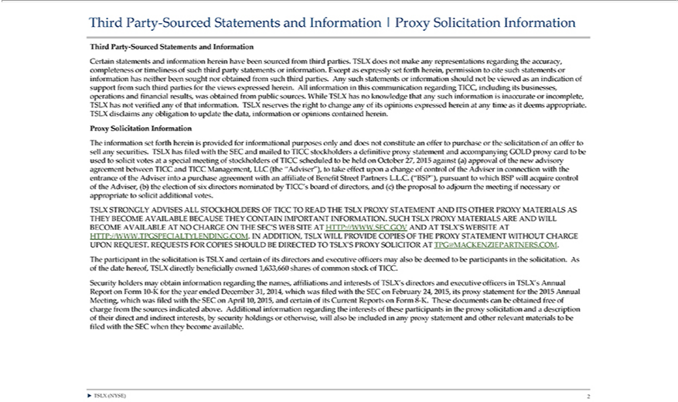

hird Party-Sourced Statements and Information | Proxy Solicitation Information Third Party-Sourced Statements and |  |  |  | Certain statements and information herein have been sourced from third parties.
TSLX does not make any representati |  | ns regarding the accuracy, completeness or timeliness of such third party statementsInformationinformation. Except as expressly set forth herein, permission to cite such statements or
has neither been sought nor obtained from such third parties. Any such statements or information should not be viewed as an indication of support from such third parties for the views expressed herein. All
this communication regarding TICC, including its businesses, operations and financial results, was obtained from public sources. While TSLX has no knowledge that any such information is inaccurate
informationincomplete, TSLX has not verified any of that information. TSLX reserves the right to change any of its opinions expressed herein any time as it deems appropriate. TSLX disclaims any obligation to update the
data, information or opinions contained herein. Proxy Solicitation Information The information set forth herein is provided for informational purposes only and does not constitute an offer to |  |  |  |  |  |  | or the solicitation
of an offer to sell any securities. TSLX has filed with the SEC and mailed to TICC stockholders definitive proxy statement and accompanying GOLD proxy card to be used to solicit votes at |  |  |  |  |  |  | special meeting of
stockholders of TICC scheduled to be held on October 27, 2015 |  |  | (a) approval of the new advisory agreement between TICC and TICC Management, LLC (the “Adviser”), to take effectpurchaseupon change of control
of the Adviser in connection with the entrance of the Adviser intoagainstpurchase agreement with an affiliate of Benefit Street Partners L.L.C. (“BSP”), pursuant to which BSP will acquire control of the Adviser, (b) the
election of six directors nominated by TICC’s board of directors, and (c) the proposal to adjourn the meeting if necessary or appropriate to solicit additional votes. TSLX STRONGLY ADVISES ALL
STOCKHOLDERS OF TICC | O READ THE TSLX PROXY STATEMENT AND ITS OTHER PROXY MATERIALS AS THEY BECOME AV |  |  |  | BECAUSE THEY CONT | IMPORTANT
INFORMATION. SUCH TSLX PROXY MATERIALS ARE AND WILL BECOME A AILABLE AT NO CHARGE ON THE SEC’S WEB SITEAILABLETHTTP://WWW.SEC.GOV ANDAIN TSLX’S WEBSITE AT
HTTP://WWW. | TYLENDING.COM. IN |  | TSLX WILL PROVIDE COPIES OF THE PROXY STATEMENT WITHOUT CHARGE UPON REQUEST. REQUESTS FOR COPIES
SHOULD BE DIRECTEDTPGSPECIALO TSLX’S PROXY SOLICITORADDITION,TPG@MACKENZIEPARTNERS.COM. The participant in the solicitation is TSLX and certain of its directors and executive officers may also be
deemed to be participants in the |  | . As of the date | TSLX directly beneficially owned 1,633,660 shares of common stock of TICC. Security holders may obtain |  |  | regarding the names,
affiliations and interests of TSLX’solicitationdirectors and executive hereof,ficers in TSLX’s Annual Report on Form 10-K for the year ended December 31, 2014, which was filed with the SECinformationFebruary 24, 2015, its proxy
above.statementAdditionalforthe2015informationAnnual regardingMeeting, whichtheinterestswasfiledof thesewith theparticipantsSECon Aprilin 10,proxy2015,solicitationandcertainandofa itsdescriptionCurrentReportsoftheir ondirectFormand8-indirectK.Theseinterests,documentsby securitycanbeobtainedholdingsfreeor otherwise,ofcharge fromwill alsothe sourcesbeincludedindicatedany
proxy statement and other relevant materials to be filed with the SEC when they become available. ? TSLX (NYSE) 2

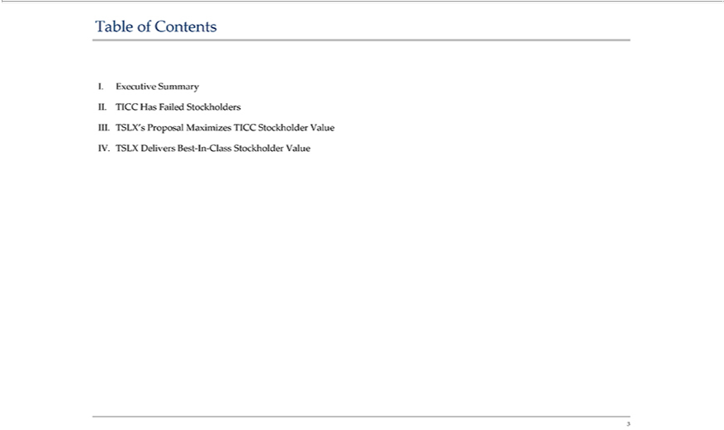

Table of Contents I. Executive Summary II. TICC Has Failed Stockholders III. TSLX’s Proposal Maximizes TICC Stockholder Value IV. TSLX Delivers Best-In-Class Stockholder Value 3

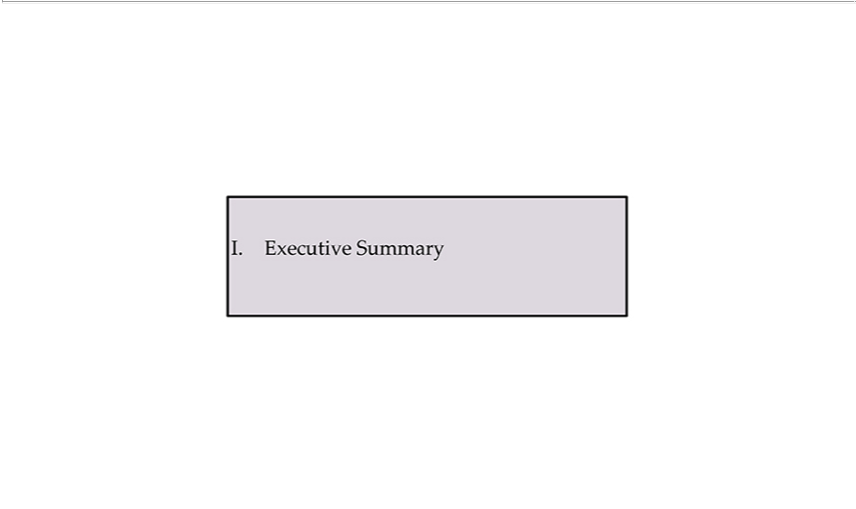

I. Executive Summary

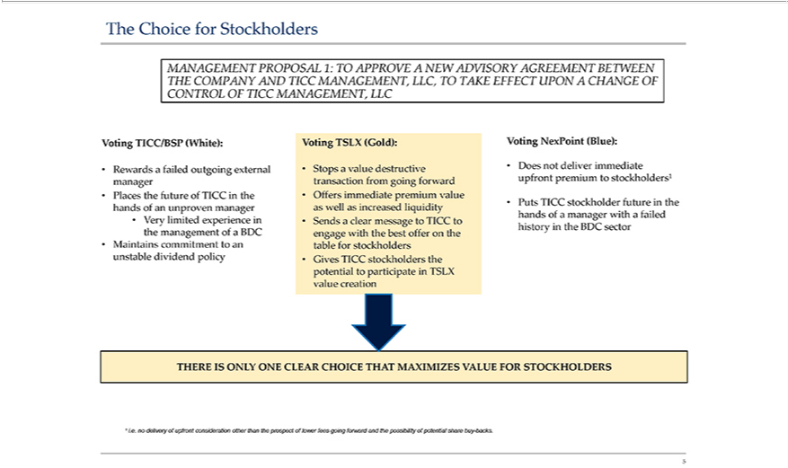

The Choice for Stockholders MANAGEMENT PROPOSAL THE COMPANY AND TICC MANAGEMENT, 1: TO APPROVE A NEW ADVISORY AGREEMENT LLC, TO TAKE EFFECT UPON A CHANGE
experienceBETWEENincreasedOFtheCONTROLmanagementimmediateOFofTICCBDCMANAGEMENT,•MaintainscommitmentLLCVotingtoanTICC/BSPunstabledividend(White):policy•RewardsVotingafailedTSLXoutgoing(Gold): •externalStopsamanagervaluedestructive•Places thetransactionfutureoffromTICCgoingtheforwardhands of•Offersanunprovenimmediatemanagerpremium•Veryvaluelimitedas well as liquidity • Sen s a clear message to TICC engage with the best offer on the table for stockholders • Gives TICC stockholders the potential to participate in TSLX value creation Voting NexPoint (Blue): • Does not deliver upfront premium to Puts TICC stockholder future in the hands of a manager with a failed history in the BDC sector THERE IS ONLY ONE CLEAR CHOICE

THAT MAXIMIZES VALUE FOR STOCKHOLDERS ¹ istockholders¹•..nodelivery of upfront consideration other than the prospect of lower fees going forward and the possibility of potential share buy-backs. 5

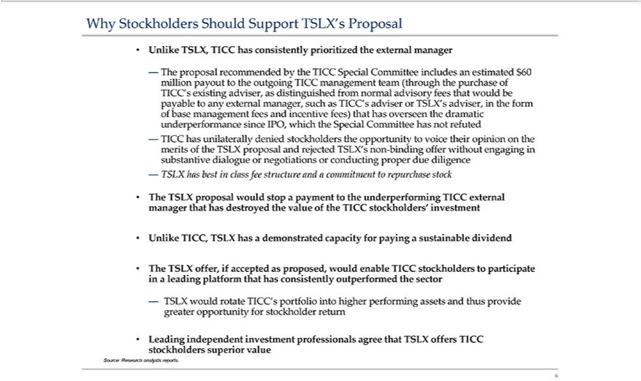

Why Stockholders Should Support TSLX’s Proposal • Unlike TSLX, TICC has consistently prioritized the external manager — The proposal recommended by the TICC Special Committee includes million payout totheoutgoingTICCmanagementteam(throughthepurchaseofanestimated$60TICC’payabletoexistingadviser,anyexternalmanager,asdistinguishedsuchasTICC’sadviserorfromnormaladvisoryfeesthat TSLX’proposaladviser, would be in the form of base management fees and incentive fees) that has underperformance since IPO, which the Special Committee has not overseen the dramatic refuted — TICC has merits of theandrejecteduniterallydeniedstockholdersTSLX’snon-bindingofferwithoutengagingintheopportunitytovoicetheiropiniononthesubstantivedialogueororconductingproperdue class negotiationshasbestinfeestructureandacommitmenttorepurchasestock•TheTSLXthathasproposaldestroyedtheoftheTICCstockholders’wouldstoppayment to the diligence — TSLX

underperforming investment TICC external • Unlike TICC, TSLX has a demonstrated capacity for payingmanagersustainable dividend • The TSLX invalueleading platform that has consistently outperformed offer, if accepted as proposed, would enable TICC the sector stockholders_{stockholders}participate — TSLX would rotate TICC’s greater opportunity for stockholder return portfolio into higher performing assets and thus provide • Leading
independent investment professionals agree that superior value TSLX offers TICC Source: Research analysts reports. 6

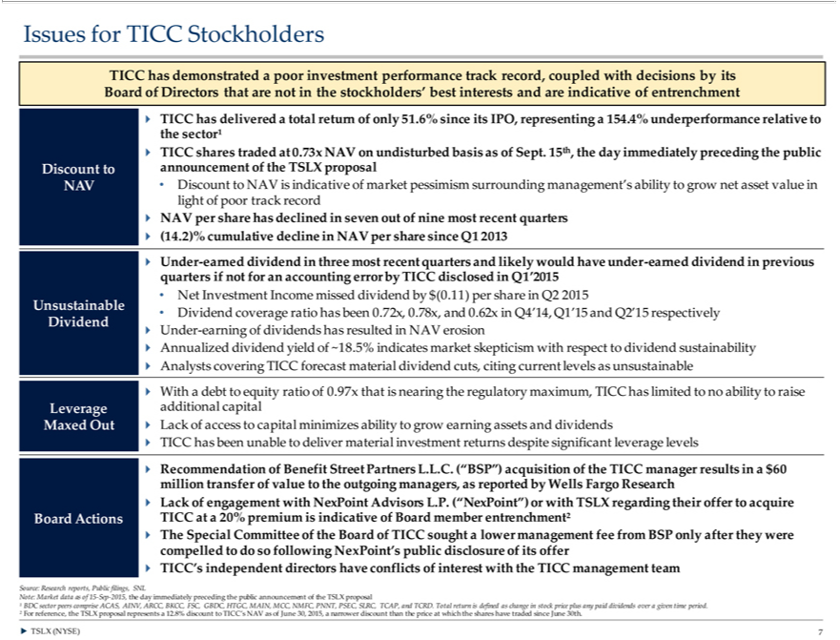

Issues for TICC Stock olders TICC has demonstrated a poor investment perfo mance track record, coupl with decisions by its Board of Directors that |  |  | not in the stockholders’ best interests and are indicative of
entrench ent ? TICC has delivered a total return of only 51.6% since its IPO, representing a 154.4% underperformance relative to the sector¹ ? TICC shares traded at 0.73x NAV on undisturbed basis of Sept. 15th,
the day immediately preceding the public Discount to announcement of the TSLX proposal NAV • Discount to NAV is |  | of market pessimism surrounding management’s ability to grow net asset value in light
of poor track record ? NAV per share has | in seven out of nine most recent quarters ? (14.2)% cumulative declineindicativeNAV per share since Q1 2013 ? Under-earned dividend in three most recent quarters and
likely would have under-earned dividend declinedprevious quarters if not for an accounting error by TICC disclosed in Q1’2015 • Net Investment Income missed dividend by $(0.11) per share in Q2 2015 Unsustainable •
Dividend coverage ratio has been 0.72x, 0.78x, and 0.62x in Q4’14, Q1’15 and Q2’15 respectively Dividend ? Under-earning of dividends has resulted in NAV erosion ? Annualized dividend yield of ~18.5% indicates
market skepticism with respect to dividend | ? Analysts covering TICC forecast material dividend cuts, citing current levels as unsustainable ? With a debt to equity ratio of 0.97x that is nearing the
regulatory maximum, TICC has limited to nosustainabilitytoraise Leverage additional capital Maxed Out ? Lack of access to capital minimizes ability to grow earning assets and dividends ? TICC has been unable to deliver
terial investment returns despite significant leverage levels ? Recommendation of Benefit Street Partners L.L.C. (“BSP”) acquisition of the TICC manager results in a $60 million |  |  |  |  | of value to the outgoing
managers, as reported by Wells Fargo Research ? Lack of engagement with NexPoint Advisors L.P. (“NexPoint”) or with TSLX regarding their offer to acquire Board Actions TICC at |  |  |  |  | 20% premium is indicative of
Board member entrenchment² ? The Special Committee of the Board of TICC sought lower management fee from BSP only after they were compelled to do so following NexPoint’transferpublic disclosure of its offer ?
TICC’s independent directors have conflicts of interest with the TICC management team Source: Research reports, Public filings, SNL Note: Market data as of 15-Sep- |  |  |  | the day immediately preceding the public
announcement of the TSLX proposal ¹ BDC sector peers comprise ACAS, AINV, ARCC, BKCC, FSC, GBDC, HTGC, MAIN, MCC, NMFC, PNNT, PSEC, SLRC, TCAP2015,and TCRD. Total return is defined as change in stock price plus any paid dividends over a given time period. ² For reference, the TSLX proposal represents a 12.8% discount to TICC’s NAV as of June 30, 2015, a narrower discount than the price at which the shares have traded since June 30th. TSLX (NYSE) ? 7

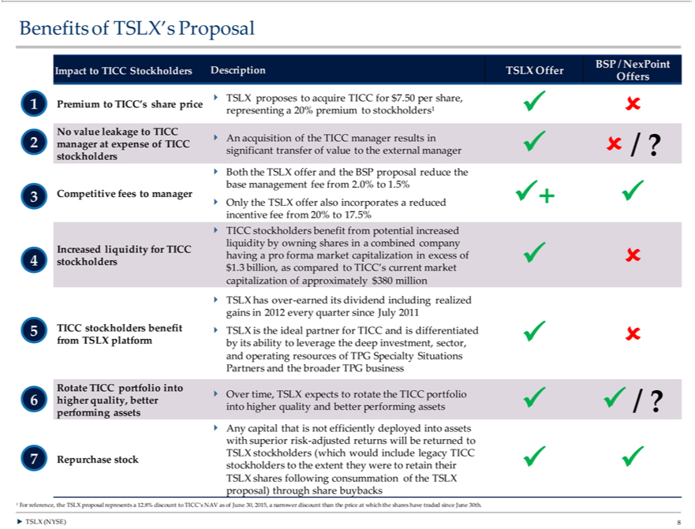

Benefits of TSLX’ | Proposal BSP / NexPoint Impact to TICC Stockholders Description TSLX Offer Offers ? TSLX proposes to acquire TICC for $7.50 per share, 1 Premium to TICC’s share price representing a 20%
premium to stockholders¹ ? ? No value leakage to TICC 2 ? An acquisition of the TICC manager results in manager at expense of TICC significant transfer of value to the external manager ? ? / ? |  |  | ? Both
the TSLX offer and the BSP proposal reduce the base management fee from 2.0% to 1.5% 3 Competitive fees to manager ??+ ? Only the TSLX offer also incorporates reduced incentive fee fromstockholders20%17.5% ?
TICC | benefit from potential increased liquidity by owning shares in a combined company Increased liquidity for TICC having pro forma market capitalization in excess of 4 stockholders ? ? $1.3 billion,
as comparedstockholdersTICC’s current market capitalization of approximately $380 million ? TSLX has over-earned its dividend including realized gains |  | 2012 every quarter since July 2011 5 TICC stockholders benefit ?
TSLX is the ideal partner for TICC and is differentiated from TSLX platform by its ability to leverage the deep investment, sector, ? ? and operating resources of TPG Specialty Situations Partners and the broader TPG business Rotate TICC portfolio into ? Over time, TSLX expects to rotate the TICC portfolio 6 higher quality, better into higher quality and better performing assets ? ? / ? performing assets ? Any capital that is not efficiently deployed into assets with superior risk-adjusted returns will be returned to TSLX stockholders (which would include legacy TICC 7 Repurchase stock stockholders to the extent they were to retain their ? ? TSLX shares following consummation of the TSLX proposal) through share buybacks ¹ For reference, the TSLX proposal represents a 12.8% discount to TICC’s NAV as of June 30, 2015, a narrower discount than the price at which the shares have traded since June 30th. ? TSLX (NYSE) 8

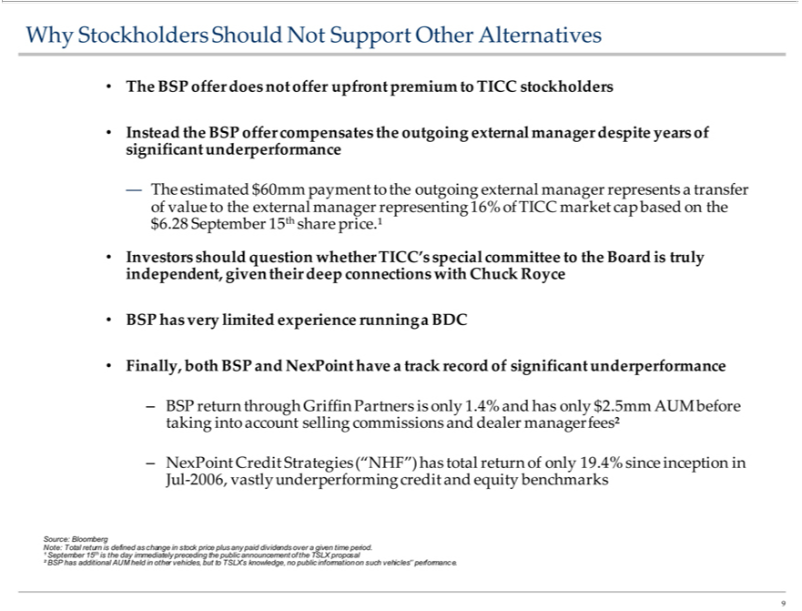

Why Stockholders Should Not Support Other Alternatives • The BSP offer does not offer upfront premium to TICC stockholders • Instead the BSP offer compensates significant underperformance the outgoing
Septemberexternalmanager15thsharedespiteprice.¹•yearsindofNexPoint—pendent,TheofInvestorsvalue estimatedshouldquestiontheexternalgiven $their60mmdeeppaymentconnectionsmanagerwithtoChuckrepresentingRoyce 16%whetherofTICCTICC’PartnersmarketspecialcapcommitteetheoutgoingtotheexternalBoardmanageristruly•representsBSPhasverytransferlimitedbasedexperienceonthe $running6.28 a BDC • Finally, both BSP and have a track record of significant underperformance – BSP taking return through Griffin is only into account selling commissions and 1.4% dealer manager and has
returnonly$2.5mmisdefinedfees²as AUMchangebeforeinstock–Julprice-2006,plusNexPointanypaidvastlydividendsunderperformingoverinformationgiven timeCreditperiod.Strategies¹September(“NHF”)15thhas iscreditthedayandimmediatelyequitytotal returnprecedingofonlythe 19.4%public announcementbenchmarkssinceoftheinceptionTSLX proposalinSource:² BSPBloomberhasadditionalNote:Total AUM held other vehicles, but TSLX’ knowledge, no public on such vehicles’’ performance. 9

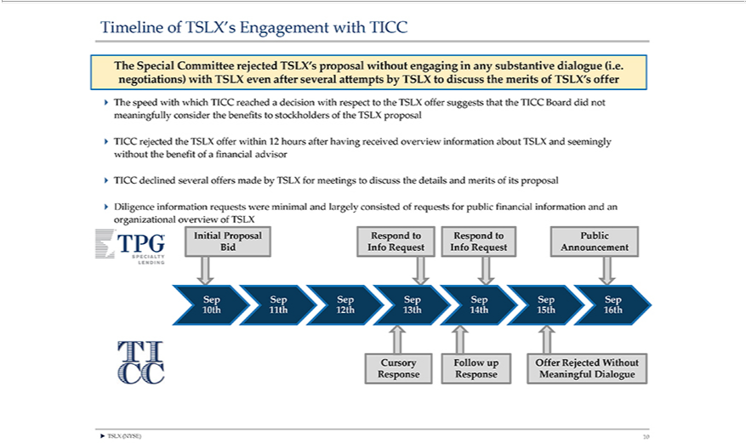

Timeline of TSLX’s Engagement with TICC The Special Committee rejected TSLX’s proposal without engaging in any substantive dialogue (i.e. negotiations) with TSLX even after several attempts by TSLX to discuss the merits of TSLX’s offer ? The speed with which TICC reached a decision with respect to the TSLX offer suggests that the TICC Board did not meaningfully consider the benefits to stockholders of the TSLX proposal ? TICC rejected the TSLX offer within 12 hours after having received overview information about TSLX and seemingly without the benefit of a financial advisor ? TICC declined several offers made by ^{TSLX} for meetings to discuss the details and merits of its proposal ? Diligence information requests were minimal and largely consisted of requests for public financial information and an organizational overview of

Initial Proposal Respond to Respond to Public Bid Info Request Info Request Announcement 10th Sep 11th Sep 12th Sep 13th Sep 14th Sep 15th Sep 16th Sep Cursory Follow up Offer Rejected Without Response Response Meaningful Dialogue ? TSLX (NYSE) 10

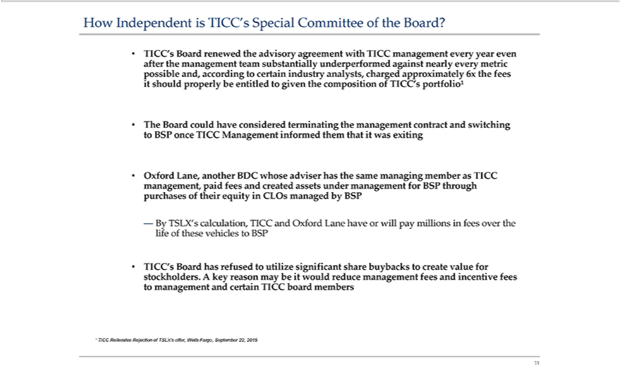

How Independent is TICC’shouldSpecial Committee of the Board? • TICC’s Board after the management renewed team the advisory agreement substantially underperformed against nearly with TICC management everyeverymetricyearevenitproperlybeentitledpossibleand,accordingtocertainindustryanalysts,togiventhecompositionchargedofTICC’portfolioąapproximately6xthefees•toBSPTheBoardcould have considered once TICC Management informed terminating them that it was exiting the management contract and switching • Oxford management, Lane, another BDC paid fees and created whose adviser has thesameassetsundermanagementBSPmemberasthroughTICCpurchasesoftheirequityinCLOsmanagedbyBSP—BylifeofthesevehiclestoTSLX’calculation,TICCandOxfordLanehaveor will
pay millionsmanaging BSP fees over the • stockholders. A TICC’_{Reiterates}Board has refused to utilize significant key reason may be it would reduce management share buybacks to fees and incentive fees create value for to
management and certain TICC board members ¹ TICC Rejection of TSLX’s offer, Wells Fargo, September 22, 2015 11

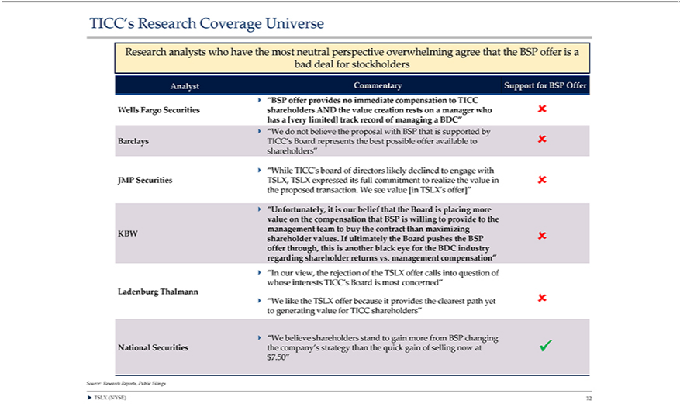

TICC’providesResearch Coverage Universe Research analysts who have the most neutral perspective overwhelming agree that the BSP offer is a bad deal for stockholders Analyst Commentary Support for BSP Offer ? “BSP
theofferproposal withno immediateBSPthatiscompensationsupportedby BarclaystoTICC WellsTICC’sFargoBoardSecuritiesrepresentsshareholdersthebestpossibleAND theoffervalueavailablecreationto ?restsshareholders”onmanager?“Whilewho? TICC’shas[veryboardlimited]ofdirectorstrack recordlikely declinedofmanagingtoengageBDC”with? “WeJMP doSecuritiesnotbelieve TSLX, TSLX expressed its full commitment to realize the value in ? the proposed transactionKBW.e see value [in TSLX’ offer]” ? “Unfortunately, it is our belief that the Boardthisplacing more value on the compensation
industrythatBSPregardingiswilling shareholdertoprovidetoreturnsthemanagementvs.managementteam tocompensation”buythecontract?“Inthanourmaximizingview,therejectionshareholderoftheTSLXvalues.of callsIfultimatelyintoquestiontheBoardofwhosepushesintereststheBSPTICC’s?offerBoardthrough,ismost concerned”isanotherblackLadenburgeyeforThalmanntheBDC ?
_{strategy}“Wlike the TSLX offer because it provides the clearest path yet ? to generating value for TICC shareholders” ? “Wfer believe shareholders stand to gain more from BSP changing National Securities the company’s than the quick gain of selling now at ? $7.50” Source: Research Reports, Public Filings ? TSLX (NYSE) 12

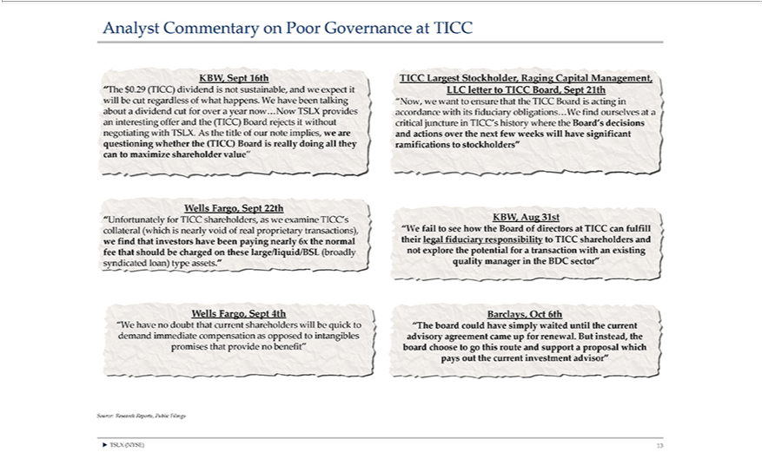

Analyst Commentary on Poor Governance at TICC KBW, Sept 16th “The $0.29 (TICC) dividend is not sustainable, and we expect it will be cut regardless of what happensquestioning.Whave been talking aboutBoarddividend cutforoveryearnow…NowTSLXprovidesaninterestingofferandthe(TICC)BoardrejectsitwithoutnegotiatingwithTSLX.Asthetitleofournoteimplies,wearewhetherthe(TICC)isreally doing all they can to maximize shareholder value” Wells Fargo, Sept 22th “Unfortunately for TICC shareholders, as we examine TICC’assetscollateral (which is nearly void of real proprietary transactions), we find thathavebeenpayingnearly6xthenormalfeethatshouldbechargedontheselarge/liquid/BSL(broadlysyndicatedloan)type.”WellsFargo,Spt4th“Whavenodoubtthatcurrentshareholderswill investors Management, letter bequickdemandimmediatecompensationasopposedtointangiblespromisesthatnobenefit”TICCLargestStockholder,RagingCapitalLLCtoTICCBoard,Sept21th“Now,wewant to

ensure that the TICC Board is acting in accordance with its fiduciary obligations…Wprovidefind ourselves at a critical juncture in TICC’s history where the Board’s decisions and actions over the next few weeks will have significant ramifications to stockholders” KBW, Aug 31st_{sector”}“Wfail to see how the Board of directors at TICC can fulfill their legal fiduciary responsibility to TICC shareholders and not explore the potential for a
^{this}ransaction with an existing quality manager in the BDC Barclays, Oct 6th “The board could have simply waited until the current advisory agreement came up for renewal. But instead, the board choose to go route and support a proposal which pays out the current investment advisor” Source: Research Reports, Public Filings ? TSLX (NYSE) 13

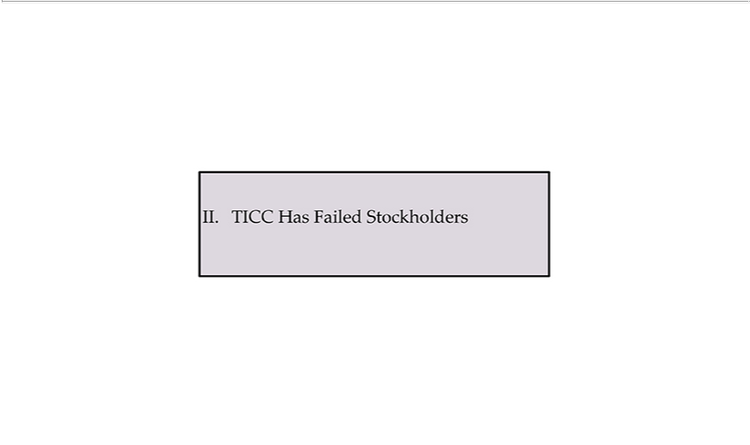

II. TICC Has Failed Stockholders

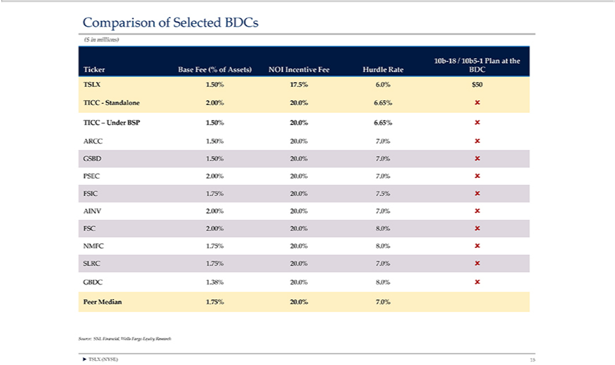

Comparison of Selected BDCs ($ in millions) 10b-18 / 10b5-1 Plan at the Ticker Base Fee (% of Assets) NOI Incentive Fee Hurdle Rate BDC TSLX 1.50% 17.5% 6.0% $50 TICC—Standalone 2.00% 20.0% 6.65% ? TICC – Under BSP 1.50% 20.0% 6.65% ? ARCC 1.50% 20.0% 7.0% ? GSBD 1.50% 20.0% 7.0% ? PSEC 20.00% 20.0% 7.0% ? FSIC 1.75% 20.0% 7.5% ? AINV 2.00% 20.0% 7.0% ? FSC 2.00% 20.0% 8.0% ?NMFC1.75%20.0%8.0%?SLRC1.75%20.0%7.0%?GBDC1.38%20.0%8.?PeerMedian1.75%.7.0%Source:SNLFinancial,WellsFargoEquityResearch?TSLX(NYSE)15

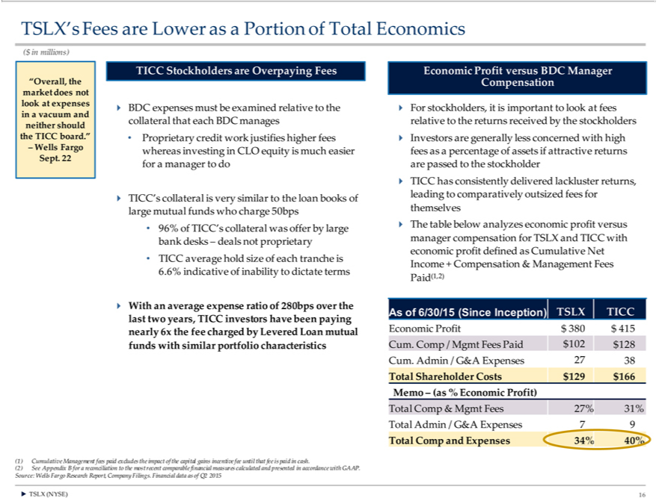

TSLX’s Fees are Lower as a Portion of Total Economics ($ in millions) “Overall, the market does not look at expenses in a vacuum and neither should the TICC board.” – Wells Fargo Sept. 22 TICC Stockholders are
Overpaying Fees ? BDC expenses must be examined relative to the collateral that each BDC manages • Proprietary credit work justifies higher fees whereas investing in CLO equity is much easier for a manager to do
? TICC’s ollateral is very similar to the loan books of lar mutual funds who charge 50bps • 96% of TICC’ collateral was offer by large bank desks – deals not proprietary • TICC average hold size of each tranche is
6.6% indicative of inability to dictate terms ? With an average expense ratio of 280bps over the last two years, TICC investors have been paying nearly 6x the fee charged by Levered Loan mutual funds with similar
portfolio characteristics Economic Profit Compensation versus BDC Manager ? For stockholders, it is important to look at fees relative to the returns received by the stockholders ? Investors are generally less
concerned with high fees as a percentage of assets if attractive returns are passed to the stockholder ? TICC has consistently delivered lackluster returns, leading to comparatively outsized fees for themselves ? The
table below analyzes economic profit versus manager compensation for TSLX and TICC with economic profit defined as Cumulative Net Income + Compensation & Management Fees Paid(1,2) As 6/30/15 (Since
Inception) TSLX TICC Economic Profit $ 380 $ 415 Cum. Comp / Mgmt Fees Paid $ 102 $128 Cum. Admin / G&A Expenses 27 38 Total Shareholder Costs $ 129 $166 Memo – (as % Economic Profit) Total
Comp & Mgmt Fees 27% 31% Total Admin / G&A Expenses 7 9 Total Comp and Expenses 34% 40% (1) Cumulative Management fees paid excludes the impact of the capital gains incentive fee until that fee is paid
in | . (2) See Appendix B for a reconciliation to the most recent comparable financial measures calculated and presented in accordance with GAAP. Source: Wells Fargo Research Report, Company Filings. Financial
datacash of Q2 2015 ? TSLX (NYSE) 16

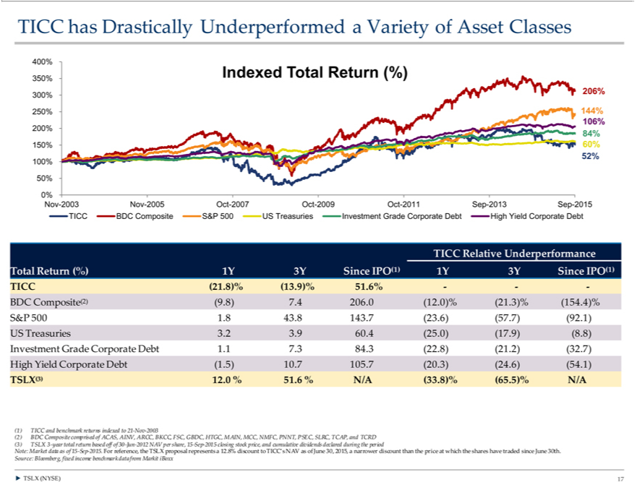

2009TICCOcthas-2011DrasticallySep-2013UnderperformedSep-2015TICCaVarietyBDCCompositeofAssetClassesS&P500400%US350%TreasuriesIndexedInvestmentTotalReturnGrade(%)Corporate300%206%Debt250%High 144%Yield Corporate106%200%Debt84%TICC150%Relative60%52%Underperformance100%50%0% TotalNov-2003ReturnNov(%)-20051Y 3YOctSince-2007 Oct-IPO(1) 1Y 3Y Since IPO(1) TICC (21.8)% (13.9)% 51.6% ——BDC Composite(2) (9.8) 7.4 206.0 (12.0)% (21.3)% (154.4)% S&P 500 1.8 43.8 143.7 (23.6) (57.7) (92.1) US Treasuries 3.2 3.9 60.4
benchmark(25.0)(17.9)returns(8.8) Investmentindexedto 21Grade-NovCorporate-2003(2) DebtBDC Composite.17.384.3 comprised(22.8)(21.of ACAS,(32.7)HighAINV,YieldARCC,CorporateBKCC,DebtFSC,(1.5)GBDC,10.7 105.7HTGC,(20.3)MAIN,(24.6)MCC,(54.1)NMFC,TSLX(3)PNNT,12.0PSEC,%51.6SLRC,%N/ATCAP(33.8)%reference,and(65.5)%TCRD(3)N/ATSLX(1) TICC3-yearand total return based off of 30-Jun-2012 NAV per share, 15-Sep-2015 closing stock price, and dividends declared during the period Note: Market data as of 15-Sep-2015. For the TSLX proposal
represents a 12.8% discount to TICC’s NAV as of June 30, 2015, a narrower discount than thecumulativeprice which the shares have traded since June 30th. Source: Bloomberg, fixed income benchmark data from Markit iBoxx ? TSLX (NYSE) 17

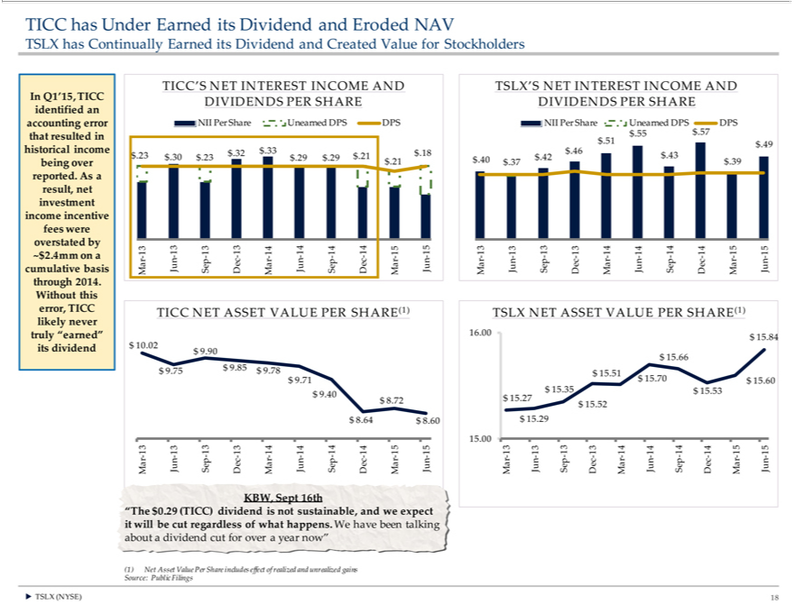

TICC has Under Earned its Dividend and Eroded NAV TSLX has Continually Earned its Dividend and Created Value for Stockholders In Q1’15, TICC identified an accounting error that resulted in historical income
being over reported. As a result, net investment income incentive fees were overstated by | .4mm on a cumulative basis through 2014. Without this error, TICC likely never truly “earned” its dividend TICC’S NET
INTEREST INCOME AND DIVIDENDS PER SHARE NII Per Share Unearned DPS DPS | .32 $.33 $.18 $.23 | $.30 $.23 $.29 $.29 | $.21 $.21 Mar-13 Jun-13 Sep-13 Dec-13 Mar-14 Jun-14 Sep-14 Dec-14 Mar-15 Jun-
15 TICC NET ASSET VALUE PER SHARE(1) $ 10.02 $ 9.90 $ 9.75 $ 9.85 $ 9.78 $ 9.71~$29.40 $ 8.72 $ 8.64 |  | $ 8.60 Mar-13 Jun-13 Sep-13 Dec-13 Mar-14 Jun-14 Sep-14 Dec-14 Mar-15 Jun-15 KBW, Sept 16th
“The $0.29 (TICC) dividend is not sustainable, and we expect it will be cut regardless of what happens. We have been talking about |  |  | dividend cut for over a year now” (1) Net Asset Value Per Share includes effect of
realized and unrealized gains Source: Public Filings TSLX’S NET INTEREST INCOME AND DIVIDENDS PER SHARE NII Per |  |  | Share | Unearned DPS $.57 DPS $.55 $.51 $.49 | $.46 $.43 $.40 $.42 $.39 $.37 Mar-13
TSLX NET ASSET VALUE PER SHARE(1) 16.00 $ 15.84 $ |  |  | 15.66 | $ 15.51 $ 15.70 $ 15.60 $ 15.35 $ 15.53 | $ 15.27 $ 15.52 $ 15.29 15.00 Mar-13
Jun-13 Sep-13 Dec-13 Mar-14 Jun-14 Sep-14 Dec-14 Mar-15 Jun-15 ? TSLX (NYSE) 18

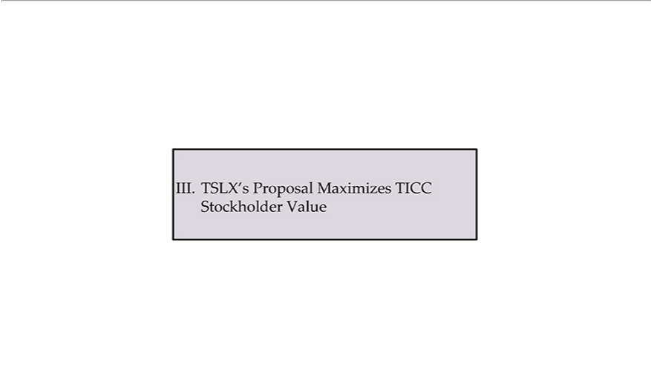

III. TSLX’s Proposal Maximizes TICC Stockholder Value

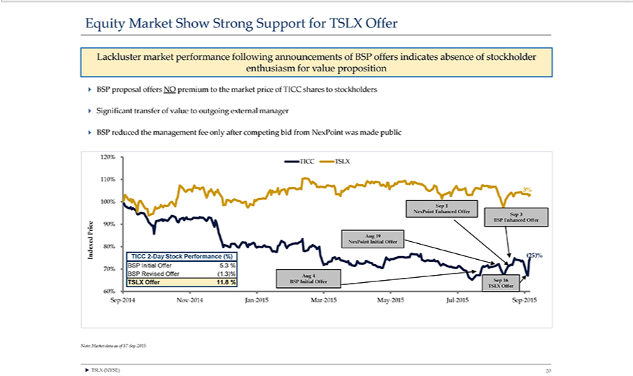

Equity Market Show Strong Support for TSLX Offer Lackluster market performance following announcements of BSP offers indicates absence of stockholder enthusiasm for value proposition ? BSP proposal offers NO premium to the market price of TICC shares to stockholders ? Significant transfer of value to outgoing external manager ? BSP reduced the management fee only after competing bid from NexPoint was made public 120% TICC TSLX 110% 3% 100% Sep 1 NexPoint Enhanced Offer Sep 3 Price 90% BSP Enhanced Offer Aug 19 Indexed NexPoint Initial Offer 80% TICC²⁰¹⁵-Day Stock Performance (%) (25)% 70% BSP
Initial Offer 5.3 % BSP Revised Offer (1.3)% Aug 4 TSLX Offer 11.8 % BSP Initial Offer Sep 16 TSLX Offer 60% Sep-2014 Nov-2014 Jan-2015 Mar-2015 May- Jul-2015 Sep-2015 Note: Market data as of 17-Sep-2015 ? TSLX (NYSE) 20

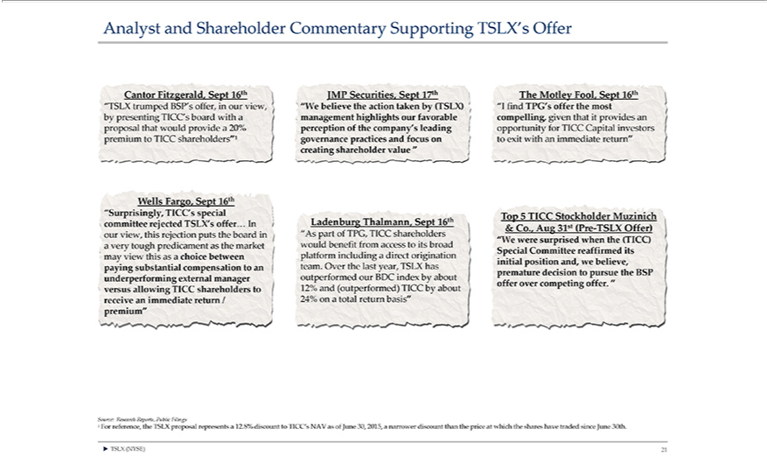

Analyst and Shareholder Commentary Supporting“SurprisinglyTSLX’Offer Cantor Fitzgerald, Sept 16th “TSLX trumped BSP’s offer, in our view, by presenting TICC’s board with a proposal that would providemay 20% premiumtoTICCshareholders”ąWellsFargo,Sept16th,TICC’sspecialcommitteerejectedTSLX’soffer…Inourview,thisrejectionputstheboardinaverytoughpredicamentasthemarketviewthisasa choice between paying substantial compensation to an underperforming external manager versus allowing TICC shareholders to receive an immediate return / premium” JMP Securities, Sept 17th “We believe the action taken by (TSLX) management highlights our favorable perception of the company’s leading governance practices and focus on creating shareholder value “ Ladenburg Thalmann, Sept 16th “As part of TPG, TICC would benefit from access to its broad platform including a direct origination team. Over the last year, TSLX has our BDC index by about 12% and (outperformed) TICC by about
24% onshareholderstotalreturn basis” The Motley Fool, Sept 16th “I find TPG’_{surprised}offerthe most compelling, given that_{Committee}provid_{reaf}san opportunityoutperformedTICCCapital investors to exit with an immediate return” Top 5 TICC

Stockholder Muzinich & Co., Aug 31st (Pre-TSLX Offer) “We were when the (TICC) Special firmed its initial position and, we believe, premature decision to pursue the BSP offer over competing offer. “ Source: Research Reports, Public Filings ¹ For reference, the TSLX proposal represents a 12.8% discount to TICC’s NAV as of June 30, 2015, a narrower discount than the price at which the shares have traded since June 30th. ? TSLX (NYSE) 21

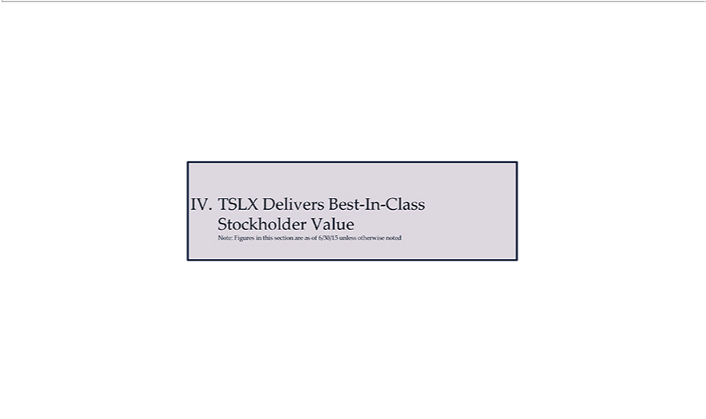

IV. TSLX Delivers Best-In-Class Stockholder Value Note: Figures in this section are as of 6/30/15 unless otherwise noted

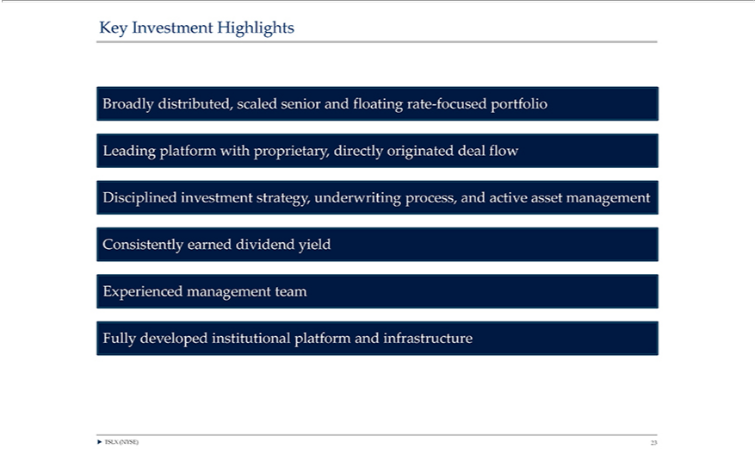

Key Investment Highlights Broadly distributed, scaled senior and floating rate-focused portfolio Leading platform with proprietary, directly originated deal flow Disciplined investment strategy, underwriting process, and active asset management Consistently earned dividend yield Experienced management team Fully developed institutional platform and infrastructure ? TSLX (NYSE) 23

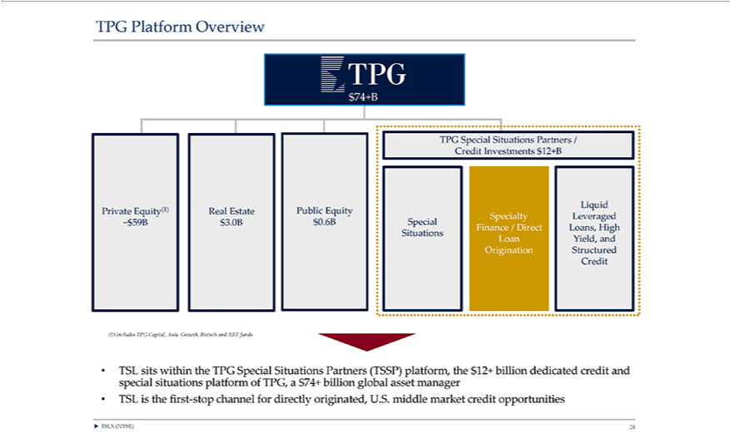

TPG Platform Overview $74+B TPG Special Situations Partners / Credit Investments $12+B Liquid Private Equity(1) Real Estate Public Equity Specialty Leveraged ~$59B $3.0B $0.6B Special Finance / Direct Loans, High Situations Loan Yield, and Origination Structured Credit (1) Includes TPG Capital, Asia, Growth, Biotech and ART funds • TSL sits special situations platform of TPG, within the TPG Special Situations Partners a $74+ billion global asset (TSSP) platform, the $12+ manager billion dedicated credit and • TSL is the first-stop channel for directly originated, U.S. middle market credit opportunities ? TSLX (NYSE) 24

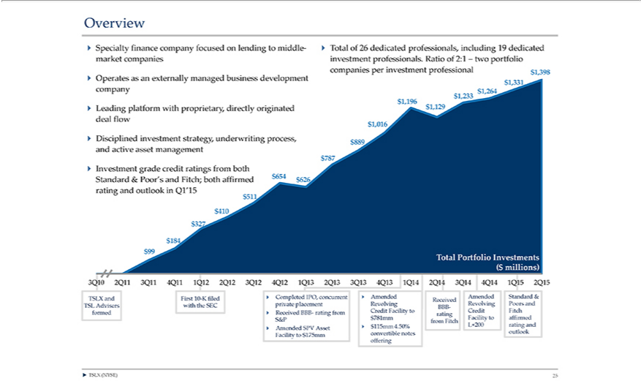

Overview ? Specialty finance company focused on lending to middle-market companies ? Operates as an externally managed6% business development company ? Leading platform with proprietary, directly originated deal flow ? Disciplined investment strategy, underwriting process, and active asset management ? Investment grade credit ratings from both Standard & Poor’s and Fitch; both affirmed rating and outlook in Q1’15 ? Total of 26 dedicated professionals, including 19 dedicated investment professionals. Ratio of 2:1 – two portfolio companies per investment professional $99 $184 $327 $410 $51^{1Q15}$654 $626 $787 $889 $1,016 $1,196
$1,129 $1,233 $1,264 $1,331 $1,398 Total Portfolio Investments ($ millions) 3Q10 2Q11 3Q11 4Q11 1Q12 2Q12 3Q12 4Q12 1Q13 2Q13 3Q13 4Q13 1Q14 2Q14 3Q14 4Q14 2Q15 TSLX and First 10-K filed ? Completed IPO, concurrent ? Amended Received Amended Standard & TSL Advisers with the SEC private placement Revolving BBB- Revolving Poors and formed ? Received BBB- rating from Credit Facility to rating Credit Fitch S&P $781mm from Fitch Facility to affirmed ? Amended SPV Asset ? $115mm 4.50% L+200 rating and Facility to $175mm convertible notes outlook offering ? TSLX (NYSE) 25

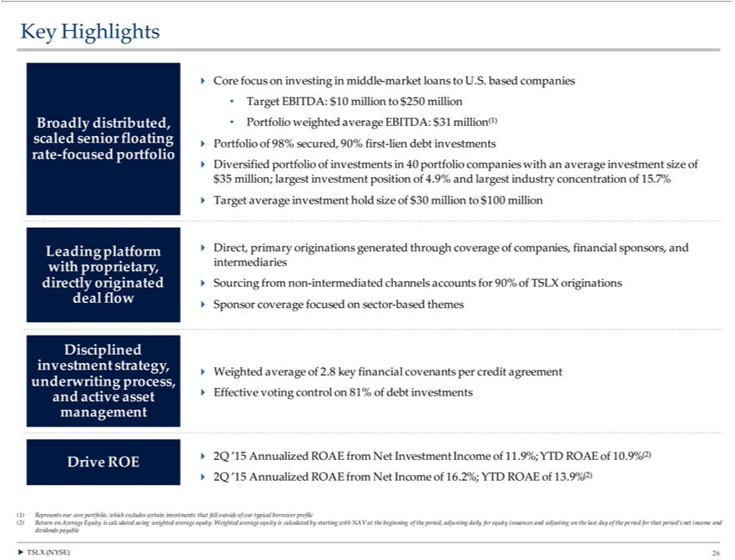

K y Highlights scaled senior Broad y distributed, floating rate-focused portfolio ? Core focus on investing in middle-market loans to U.S. based companies • Target EBITDA: $10 million to $250 million • Portfolio
weighted average EBITDA: $31 million(1) ? Portfolio of 98% secured, 90% first-lien debt investments ? Diversified portfolio of investments in 40 portfolio companies with an average investment size of $35 million;
largest investment position of 4.9% and largest industry concentration of 15.7% ? Target average investment hold size of $30 million to $100 million Leading | proprietary, directly originated deal flow ?
Direct, primary originations generated through coverage of companies, financial sponsors, and intermediaries ? Sourcing from non-intermediated channels accountsplatformwith90% of TSLX originations ? Sponsor coverage
focused on sector-based themes investment strategy, Disciplined underwriting process, and active asset management ? Weighted average of 2.8 key financial covenants per credit agreement ? Effective voting control on
81% of debt investments Drive ROE ? 2Q ’15 Annualized ROAE from Net Investment Income of 11.9%; YTD ROAE of 10.9% (2) ? 2Q ’15 Annualized ROAE from Net Income of 16.2%; YTD ROAE of 13.9%
(2) (1) Represents our core portfolio, which excludes certain investments that fall outside of our typical borrower profile (2) Return on Average Equity is calculated | weighted average equity. Weighted average
equity is calculated by starting with NAV at the beginning of the period, adjusting daily for equity issuances and adjusting on the last day of the period for that period’usingnet income and dividends payable ? TSLX (NYSE) 26

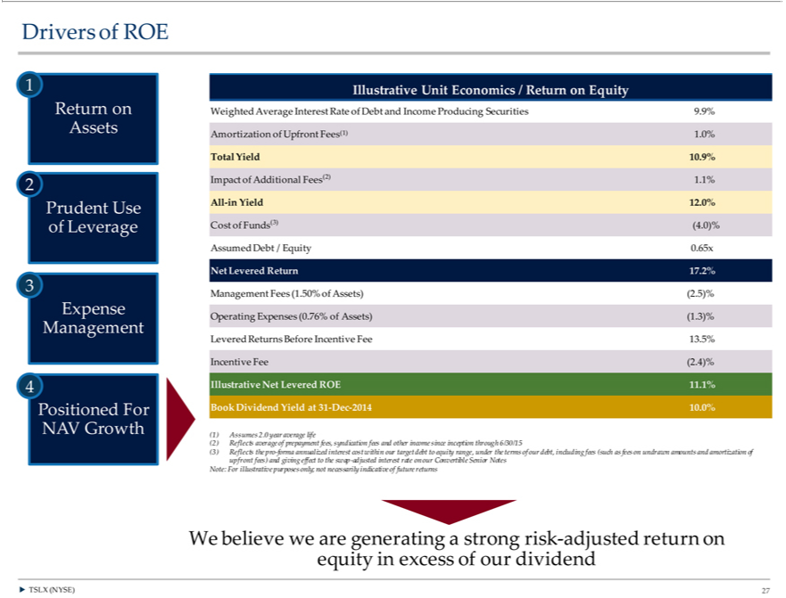

IncomeDrivers ProducingofROE1ReturnSecuritiesonAssets9.9%Amortization2PrudentUseofofUpfrontLeverageFees(1)3Expense1.0% ManagementTotalYield10.9%4PositionedImpact ofForAdditionalNAVGrowthFees(2)Illustrative1.1%AllUnit-in YieldEconomics12.0%/ CostReturnof onFunds(3)Equity (4.0)%WeightedAssumedverageDebtInterest/EquityRate0.65xofDebtNetandLevered Return 17.2% Management Fees (1.50% of Assets) (2.5)% Operating Expenses (0.76% of Assets) (1.3)% Levered Returns Before Incentive Fee 13.5% Incentive Fee (2.4)% Illustrative Net Levered ROE 11.1% Book
annualizedDividendYieldinterestat31cost-Decwithin-2014our10.0%target(1)debtAssumestoequity.0 range,yearaverageunder thelifeterms(2)Reflectsofour debt,averageincludingofprepaymentfees(suchfees,as feessyndicationundrawnfees andamountsotherandincome since inceptionofupfrontthroughfees)6/30/15andgiving(3) Reflectsfectto thethe proswap-forma-adjusted
interest rate on our Convertible Senior Notes Note: For illustrative purposes only; not necessarily indicative of future returns We believe we are generatingamortizationstrong risk-adjusted return on equity in excess of our dividend ? TSLX (NYSE) 27

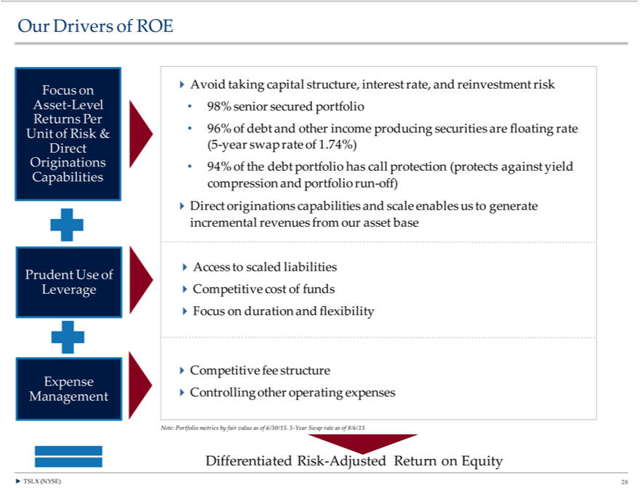

Our Drivers of ROE Asset-LevelFocus on Unit _{Returns} Per of Risk & Originations Direct Capabilities Prudent Use Leverage of Management Expense ?Avoid taking capital structure, interest rate, and reinvestment risk • 98% senior secured portfolio • 96% of_{capabilities}deandother income producing securities are floating rate (5-year swap rate of 1.74%) • 94% of the debt portfolio has call protection (protects against yield compression

and portfolio run-off) ?Direct originations and scale enables us to generate incremental revenues from our asset base ?Access to scaled liabilities ?Competitive cost of funds ?Focus on duration and flexibility ?Competitive fee structure ?Controlling other operating expenses Note: Portfolio metrics by fair value as of 6/30/15. 5-Year Swap rate as of 8/6/15 Differentiated Risk-Adjusted Return on Equity ? TSLX (NYSE) 28

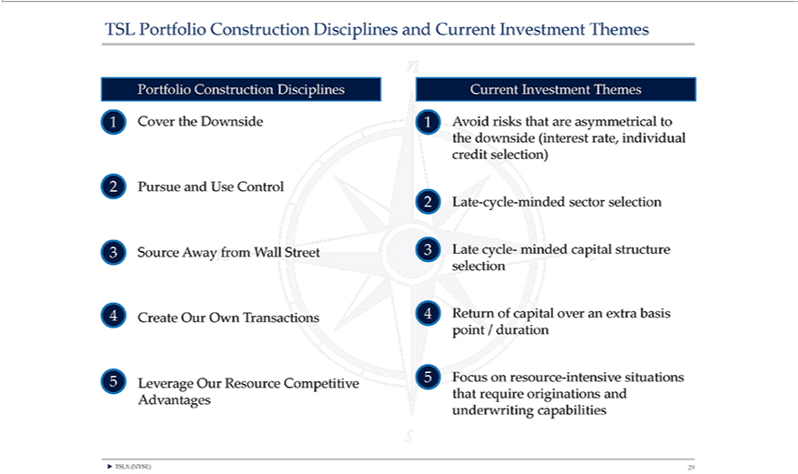

^{T}SL Portfolio Construction Disciplines and Current Investment Themes Portfolio Construction Disciplines 1 Cover the Downside 2 Pursue and Use Control 3 Source Away from Wall Street 4 Create Our Own ransactions 5 Leverage Our Resource Competitive Advantages Current Investment Themes 1 Avoid risks that are asymmetrical to the downside (interest rate, individual credit selection) 2 Late-cycle-minded sector

selection 3 Late cycle- minded capital structure selection 4 Return of capital over an extra basis point / duration 5 Focus on resource-intensive situations that require originations and underwriting capabilities ? TSLX (NYSE) 29

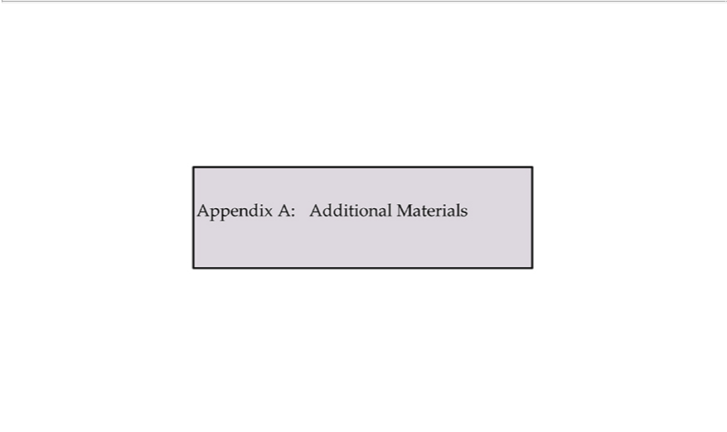

Appendix A: Additional Materials

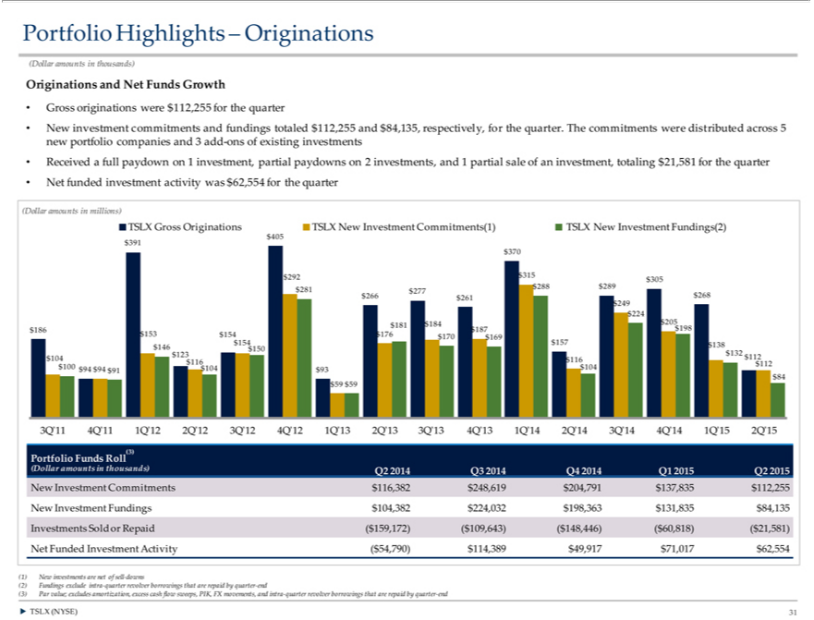

Portfolio Highlights – Originations (Dollar amounts in thousands) Originations and Net Funds Growth • Gross originations were $112,255 for the quarter • New investment commitments and fundings totaled $1
and $84,135, respectively, for the quarter. The commitments were distributed across 5 new portfolio companies and 3 add-ons of existing investments • Received a full paydown on 1 investment, partial paydowns12,255on
investments, and | partial sale of an investment, totaling $21,581 for the quarter • Net funded investment activity was $62,554 for the quarter (Dollar amounts in millions) TSLX Gross Originations TSLX New
Investment Commitments(1) TSLX New Investment Fundings(2) $405 |  | $391 $370 $292 $315 $305 | $281 $288 $289 $277 $268 $266 $ 61 $249 $224 $205 $181 $184 $186 | $187 $198 $153 $154$ 154 $176 $170 $169
$157 $146 $150 | $138 $132 $104 $123 $112 $116 $116 $112 $100 $94 | $94 $91 $104 $93 $104 $84 | $59 $59 3Q’11 4Q’11 1Q’12 2Q’12 3Q’12 4Q’12 1Q’13 2Q’13 3Q’13 4Q’13 1Q’14 2Q’14 3Q’14 4Q’14 1Q’15
2Q’15 Portfolio Funds Roll(3) (Dollar amounts in thousands) Q2 2014 Q3 2014 Q4 2014 Q1 2015 Q2 2015 New Investment Commitments $116,382 $248,619 $204,791 |  |  |  | $112,255 New Investment Fundings
$104,382 $224,032 $198,363 $131,835 $84,135 Investments Sold or Repaid ($159,172) ($109,643) ($148,446) ($60,818) ($21,581) Net Funded Investment Activity ($54,790)$137,83514,389 $49,917 $71,017 $62,554
(1) New investments are net of sell-downs (2) Fundings exclude intra-quarter revolver borrowings that are repaid by quarter-end (3) Par value; excludes amortization, excess cash flow sweeps, PIK, FX movements, and intra-quarter revolver borrowings that are repaid by quarter-end ? TSLX (NYSE) 31

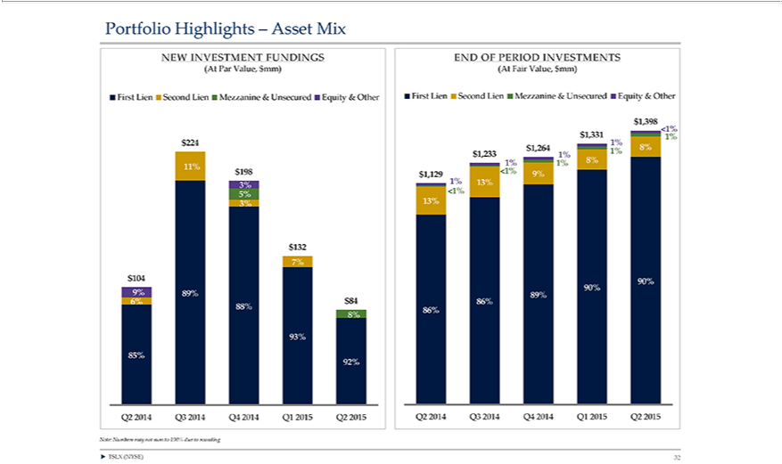

Portfolio Highlights – Asset Mix NEW INVESTMENT FUNDINGS (At Par Value, $mm) First Lien Second Lien Mezzanine & Unsecured Equity & Other $224 0% 0% 11% $198 5% 3% 3% $132 0% 7% 0% $104 6% 9% 89% $84 88% 0% 0% 8% 0% 93% 85% 92% Q2 2014 Q3 2014 Q4 2014 Q1 2015 Q2 2015 Note: Numbers may not sum to 100% due to rounding END OF PERIOD INVESTMENTS (At Fair Value, $mm) First Lien Second Lien Mezzanine & Unsecured Equity & Other $1,398 <1% $1,331 1% 1% $1,264 1% 8% $1,233 1% 1% 1% 8% $1,129 <1% 9% 1% 13% <1% 13% 90% 90% 89% 86% 86% Q2 2014 Q3 2014 Q4 2014 Q1 2015 Q2 2015 ? TSLX (NYSE) 32

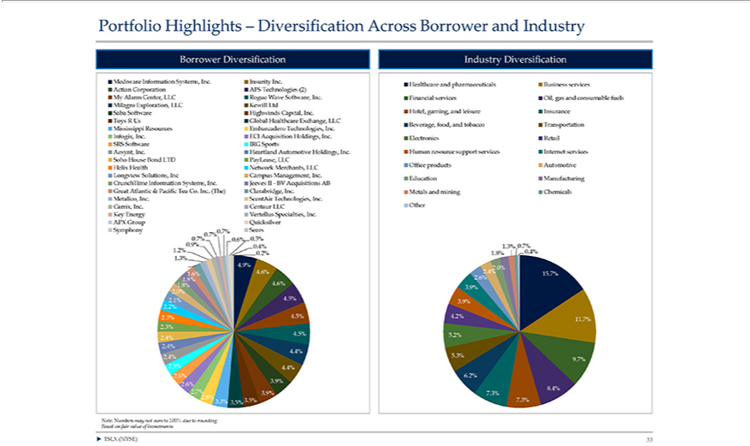

Portfolio Highlights – Diversification Across Borrower and Industry Borrower Diversification Mediware Information Systems, Inc. Insurity Inc. Actian Corporation AFS Technologies (2) My Alarm Center, LLC Rogue Wave Software, Inc. Milagro Exploration, LLC Kewill Ltd Saba Software Highwinds Capital, Inc. Toys R Us Global Healthcare Exchange, LLC Mississippi Resources Embarcadero Technolog_{Longview}s, Inc. Infogix,
. ECI Acquisition Holdings, Inc. SRS Software IRG Sports Aesynt, Inc. Heartland Automotive Holdings, Inc. Soho House Bond LTD PayLease, LLC Helix Health Network Merchants, LLC Solutions, ^{Inc} Campus Management, Inc. CrunchTime Information Systems, Inc. Jeeves II—BV Acquisitions AB Great Atlantic & Pacific Tea Co. Inc. (The) Clarabridge, Inc. Metalico, Inc. ScentAir Technologies, Inc. Carrix,
. Centaur LLC Key Energy Vertellus Specialties, Inc. APX Group Quicksilver Symphony 0.7% Sears 0.7% 0.7% 0.6% 0.5% 0.9% 0.4% 1.2% 0.2% 1.6% 1.3% 4.9% 1.6% 4.6% 1.8%^{100%}.8% 4.6% 2.0% 2.1% 4.5%
2.2% 2.3% 4.5% 2.3% 4.5% 2.4% 2.4% 4.4% 2.4% 2.5% 4.4% 2.6% 2.6% 3.9% 2.7% 3.9% 2.8% 3.5% 3.3% 3.5% Note: Based on fair value of investments Numbers may not sum to due to rounding Industry Diversification Healthcare and pharmaceuticals Business services Financial services Oil, gas and consumable fuels Hotel, gaming, and leisure Insurance Beverage, food, and tobacco Transportation Electronics Retail Human resource support services Internet services Office products Automotive Education Manufacturing Metals and mining Chemicals Other 1.3% 0.7% 1.8% 0.4% 2.0% 2.4% 15.7% 2.6% 3.9% 3.9% 4.2% 11.7% 5.2% 5.3% 9.7% 6.2% 8.4% 7.3% 7.3% ? TSLX (NYSE) 33

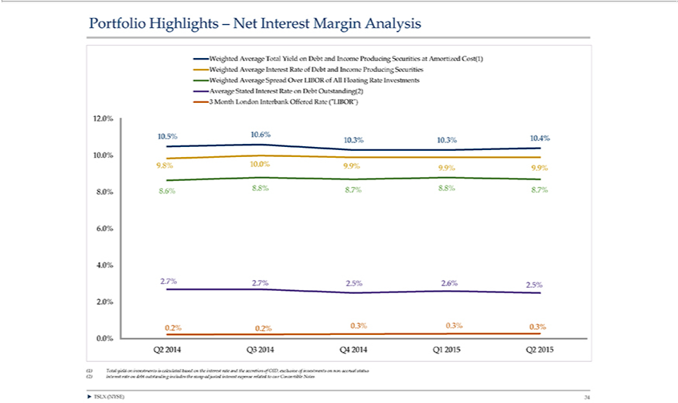

Portfolio Highlights – Net Interest Margin Analysis Weighted Average Total Yield on Debt and Income Producing Securities at Amortized Cost(1) Weighted Average Interest Rate of Debt and Income Producing Securities Weighted Average Spread Over LIBOR of All Floating Rate Investments Average Stated Interest Rate on Debt _{Outstanding(2)} 3 Month London Interbank Offered Rate (“LIBOR”) 12.0% 10.5% 10.6%
10.²⁰¹⁵4% 10.3% 10.3% 10.0% 9.8% 10.0% 9.9% 9.9% 9.9% 8.0% 8.6% 8.8% 8.7% 8.8% 8.7% 6.0% 4.0% 2.7% 2.7% 2.5% .6% .5% .0% 0.2% 0.2% 0.3% 0.3% 0.3% 0.0% Q2 2014 Q3 2014 Q4 2014 Q1 2015 Q2
(1) Total yield on investments is calculated based on the interest rate and the accretion of OID, exclusive of investments on non-accrual status (2) Interest rate on debt outstanding includes the swap-adjusted interest expense related to our Convertible Notes ? TSLX (NYSE) 34

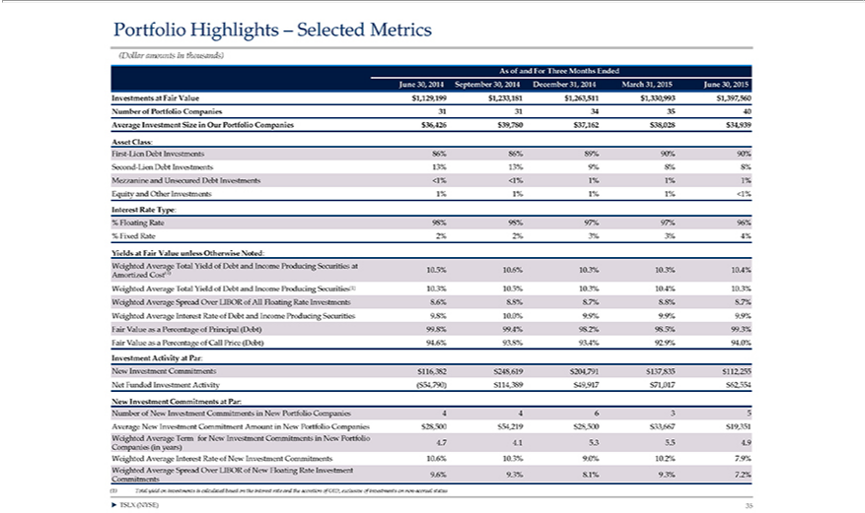

Portfolio Highlights – Selected Metrics (Dollar amounts in thousands) As of and For Three Months Ended June 30, 2014 September 30, 2014 December 31, 2014 March 31, 2015 June 30, 2015 Investments at Fair
Value $1,129,199 $1,233,181 $1,263,511 $1,330,993 $1,397,560 Number of Portfolio Companies 31 31 34 35 40 Average Investment Size in Our Portfolio Companies $36,426 $39,780 $37,162 $38,028 |  |  | $34,939 Asset
Class: First-Lien Debt Investments |  | 86% 89% 90% 90% Second-Lien Debt Investments 13% 13% 9% 8% 8% Mezzanine and Unsecured Debt Investments <1% <1% 1% 1% 1% Equity and Other Investments 1%
1% 1% 1% <1% Interest Rate Type:86%Floating Rate 98% 98% 97% 97% 96% % Fixed Rate 2% 2% 3% 3% 4% Yields at Fair Value unless Otherwise Noted: Weighted Average Total Yield of Debt and Income
Producing Securities 10.5% 10.6% 10.3% 10.3% 10.4% Amortized Cost(1) Weighted Average Total Yield of Debt and Income Producing Securities(1) 10.3% 10.5% 10.3% 10.4% 10.3% Weighted Average Spread
Over LIBOR of All Floating Rate Investments 8.6% 8.8% 8.7% 8.8% 8.7% Weighted Average Interest Rate of Debt and Income Producing Securities 9.8% 10.0% 9.9% 9.9% 9.9% Fair Value as a Percentage of
Principal (Debt) 99.8% 99.4% 98.2% 98.5% 99.3% Fair Value as a Percentage of Call Price (Debt) 94.6% 93.8% 93.4% 92.9% 94.0% Investment Activity at Par: New Investment Commitments $116,382 $248,619
$204,791 | $112,255 Net Funded Investment Activity ($54,790) $114,389 $49,917 $71,017 $62,554 New Investment Commitments at Par: Number of New Investment Commitments in New Portfolio
Companies$137,835446 | 5 Average New Investment Commitment Amount in New Portfolio Companies $28,500 $54,219 $28,500 $33,667 $19,351 Weighted Average Term for New Investment Commitments |  | New
Portfolio Companies (in years) 4.7 4.1 5.3 5.5 4.9 Weighted Average Interest Rate of New Investment Commitments 10.6% 10.3% 9.0% 10.2% 7.9% Weighted Average Spread Over LIBOR of New Floating Rate Investment Commitments 9.6% 9.3% 8.1% 9.3% 7.2% (1) Total yield on investments is calculated based on the interest rate and the accretion of OID, exclusive of investments on non-accrual status ? TSLX (NYSE) 35

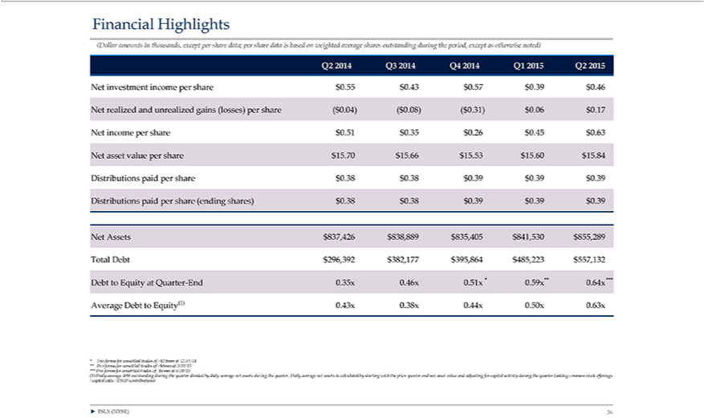

Financial Highlights (Dollar amounts in thousands, except per share data; per share data is based on weighted average shares outstanding during the period, except as otherwise noted) Q2 2014 Q3 2014 Q4 2014 Q1 _{$0837,426}15Q22015 Net investment income per share $0.55 $0.43 $0.57 $0.39 $0.46 Net realized and unrealized gains (losses) per share ($0.04) ($0.08) ($0.31) $0.06 $0.17 Net income per share $0.51 $0.35 $0.26 $0.45
.63 Net asset value per share $15.70 $15.66 $15.53 $15.60 $15.84 Distributions paid per share $0.38 $0.38 $0.39 $0.39 $0.39 Distributions paid per share (ending shares) $0.38 $0.38 $0.39 $0.39 $0.39 Net Assets $838,889 $835,405 $841,530 $855,289 Total Debt $296,392 $382,177 $395,864 $485,223 $557,132 Debt to Equity at Quarter-End 0.35x 0.46x 0.51x * 0.59x** 0.64x *** Average Debt to Equity(1) 0.43x 0.38x 0.44x 0.50x 0.63x * Pro-forma for unsettled trades of ~$29mm at 12/31/14 ** Pro-forma for unsettled trades of ~$8mm at 3/31/15 *** Pro-forma for unsettled trades of -$6mm at 6/30/15 (1) Daily average debt

outstanding during the quarter divided by daily average net assets during the quarter. Daily average net assets is calculated by starting with the prior quarter end net asset value and adjusting for capital activity during the quarter (adding common stock offerings / capital calls / DRIP contributions) ? TSLX (NYSE) 36

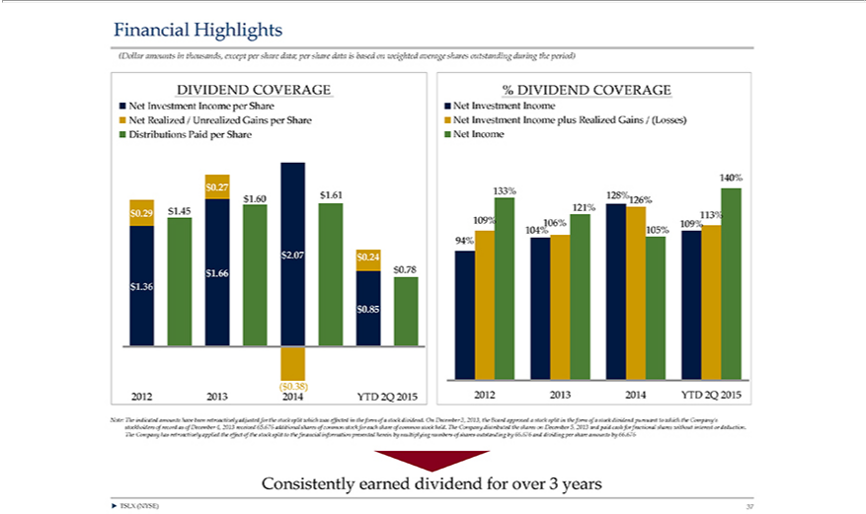

Financial Highlights (Dollar amounts in thousands, except per share data; per share data is based on weighted average shares outstanding during the period) DIVIDEND COVERAGE Net Investment Income per Share
Net InvestmentRealized/UnrealizedIncomeNetGainsInvestmentperShareIncomeDistributionsplusRealizedPaid perGainsShare/(Losses)$0.27$Net1.60Income$1.61$140%1.09$133%0.29$128%1.45$2.07126%$0.24121%$1.66113%$0.78109%$1.36106%$0.85109%($0.38)94% 104%20122013105%20142012YTD20132Q20142015YTD%DIVIDEND2Q2015Note:COVERAGEThe indicated amounts have been retroactively adjusted for the stock split which was effected in the formadditionalofstock dividend. On December 3, 2013, the Board approved a stock split in the form of a stock dividend
Decemberpursuantto5,which2013 the Company’spaidcashforstockholdersfractional sharesofrecordwithoutasof interestDecemberordeduction.4,2013receivedTheCompany65.676 has retroactivelyshares ofappliedcommonthe effectstock foroftheeachstocksharesplitof commontothefinancialstock held.informationTheCompanypresenteddistributedhereinbythemultiplyingshareson
numbers of shares outstanding by 66.676 and dividing per share amounts by 66.676 Consistently earned dividend for over 3 years ? TSLX (NYSE) 37

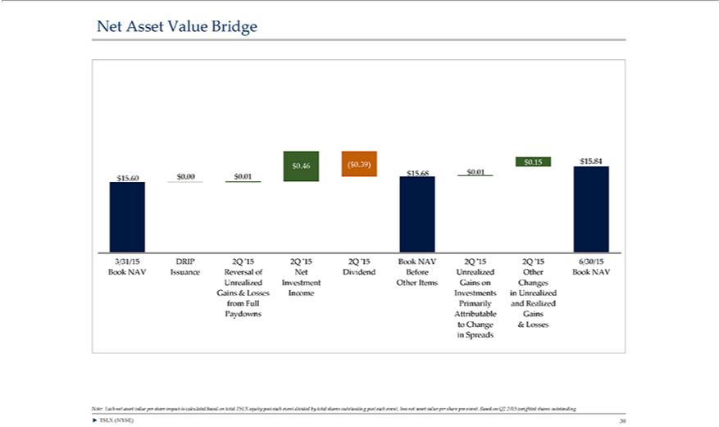

Net Asset Value Bridge ($0.39) $0.15 $15.84 $0.46 $15.68 $0.01 $15.60 $0.00 $0.01 3/31/15 DRIP 2Q ‘15 2Q ‘15 2Q ‘15 Book NAV 2Q ‘15 2Q ‘15 6/30/15 Book NAV Issuance Reversal of Net Dividend Before Unrealized Other Book NAV Unrealized Investment Other Items Gains on Changes Gains & Losses Income Investments in Unrealized from Full Primarily and Realized Paydowns Attributable Gains to Change & Lo^{Based}ses in Spreads Note: Each net asset value per share impact is calculated based on total TSLX equity post each event divided by total shares outstanding post each event, less net asset value per share pre-event.
on Q2 2015 weighted shares outstanding ? TSLX (NYSE) 38

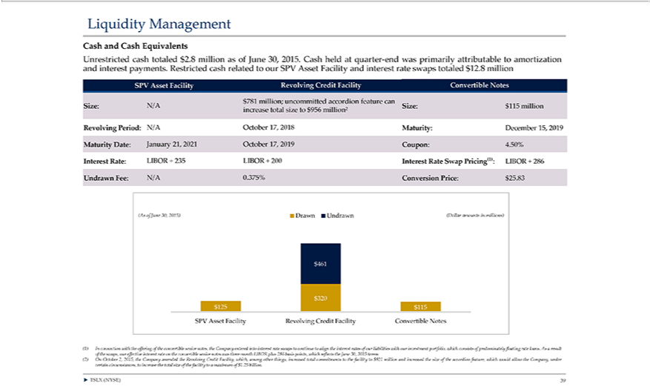

Liquidity Management Cash and Cash Equivalents Unrestricted and interest payments. cash totaled Restricted $2.8 million cash as related of June to our 30, SPV 2015. Asset Cash Facility held at and quarter-end
$interest115millionratewasincreaseswapstotalprimarilysizetototaled$956million?attributableRevolving$12.8millionPeriod:toN/AamortizationOctober17,SPV2018AssetMaturity:FacilityDecemberRevolving15,Credit2019 FacilityMaturityConvertibleDate:JanuaryNotes21,$2021781million;Octoberuncommitted17,2019Coupon:accordion4.50%featureInterestcanRate:Size:LIBORN/ASize:+235

AssetLIBORFacility+200 RevolvingInterestRate SwapFaciPricing(1):tyConvertibleLIBORNotes+286(1)UndrawnInconnectionFee:N/Awith0.375%theofferingConversionofthePrice:convertible$25.83senior(Asofnotes,June the30, Company2015)DrawnenteredUndrawnintointerest(Dollarrateamountsswapsintomillions)continue$to461align$0 the$0$interest320$125rates$115of ourSPV
Creditportfolio,
liabilities with our investme^{June} which consists of predominately floating rate loans. As a result of the swaps, our effective interest rate on the convertible senior notes was three-month LIBOR plus 286 basis
points, which reflects the 30, 3015 terms (2) On October 2, 2015, the Company amended the Revolving Credit Facility, which, among other things, increased total commitments to the facility to $821 million and increased the size of the accordion feature, which would allow the Company, under certain circumstances, to increase the total size of the facility to a maximum of $1.25 billion. ? TSLX (NYSE) 39

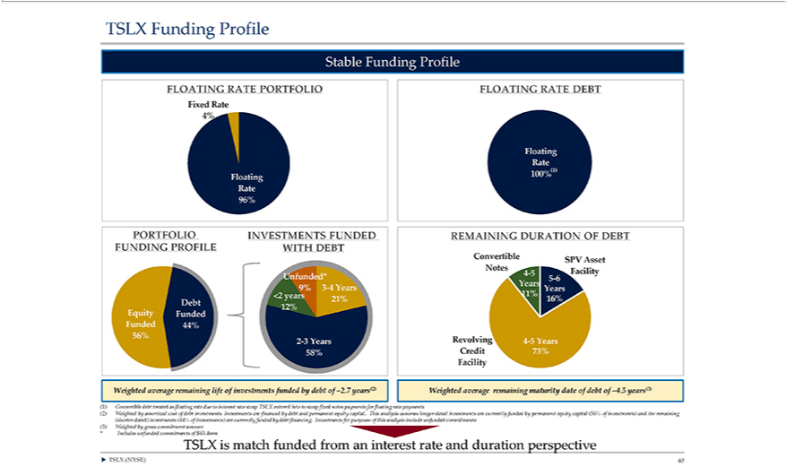

TSLX Funding Profile Stable Funding Profile FLOATING RATE PORTFOLIO Fixed Rate 4% Floating Rate 96% PORTFOLIO INVESTMENTS FUNDED FUNDING PROFILE WITH DEBT Unfunded* 9% 3-4 Years <2 years 21% Debt 12% Equity Funded Funded 44% 56% 2-3 Years 58% Weighted average remaining life of investments funded by debt of ~2.7 years(2) FLOATING RATE DEBT Floating Rate 100%(1) REMAINING DURATION OF DEBT Convertible SPV Asset Notes Facility 4-5 5-6 Years Years 11% 16% Revolving 4-5 Years Credit 73% Facility Weighted average remaining maturity date of debt of ~4.5 years(3)
(1) Convertible debt treated as floating rate due to interest rate swap TSLX entered into to swap fixed notes payments for floating rate payments (2) Weighted by amortized cost of debt investments. Investments are financed by debt and permanent equity capital. This analysis assumes longer-dated investments are currently funded by permanent equity capital (56% of investments) and the remaining (shorter-dated) investments (44% of investments) are currently funded by debt financing. Investments for purposes of this analysis include unfunded commitments (3) Weighted by gross commitment amount *Includes unfunded commitments TSLX of $60.4mm is match funded from an interest rate and duration perspective ? TSLX (NYSE) 40

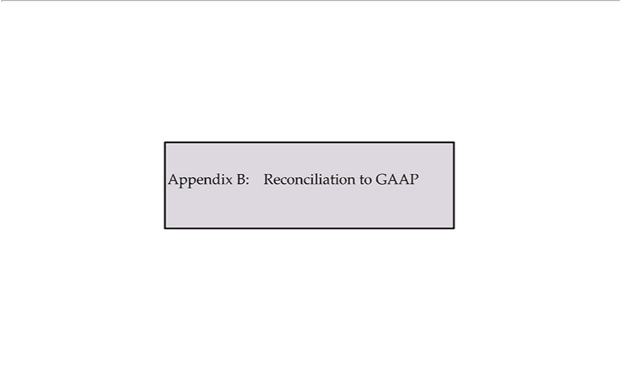

Appendix B: Reconciliation to GAAP

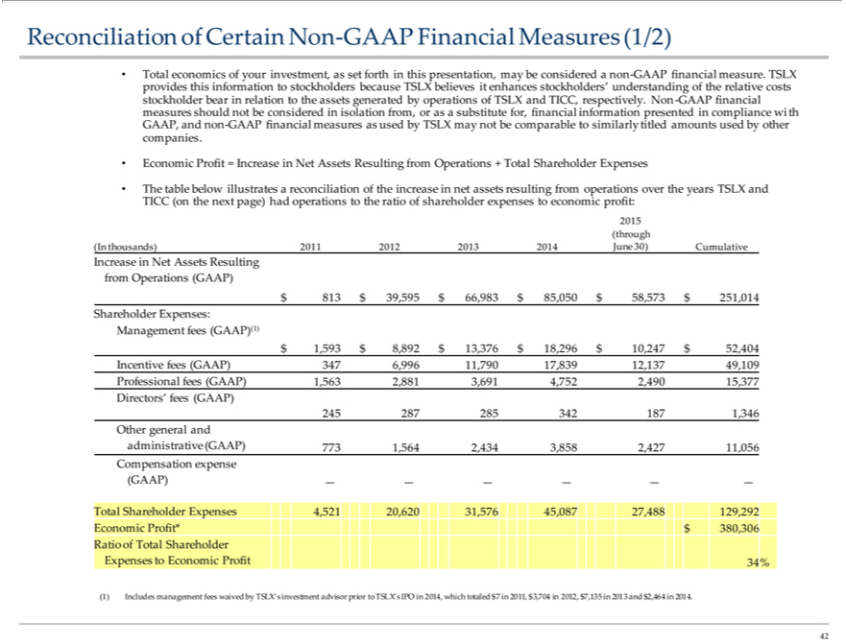

Reconciliation of Certain Non-GAAP Financial Measures (1/2) • provides Total economics this information of your investment, as set forth to stockholders because TSLX in this presentation, may believes it enhances be considered a stockholders’ non-GAAP financial measure. TSLX understanding of the relative costs measures stockholder bear in relation should not be considered in isolation to the assets generated by operations from,_{comparable}orassubstitute for, financial information of TSLX and TICC, respectively. Non-GAAP financial presented in compliance with GAAP, and companies. non-GAAP financial measures as used by TSLX may not

be to similarly titled amounts used by other • Economic Profit = Increase in Net Assets Resulting from Operations + Total Shareholder Expenses • The table below illustrates TICC (on the next page) had operations to the ratio of shareholder expenses a reconciliation of the increase in net assets resulting to economic from operations over the years profit: TSLX and 2015 (through (In thousands) 2011 2012 2013

2014 June 30) Cumulative Increase in Net Assets Resulting from Operations (GAAP) $ 813 $ 39,595 $ 66,983 $ 85,050 $ 58,573 $ 251,014 Shareholder Expenses: Management fees (GAAP)(1) $ 1,593 $ 8,892 $ 13,376 $ 18,296 $ 10,247 $ 52,404 Incentive fees (GAAP) 347 6,996 1^{1,790} 17,839 12,137 49,109 Professional fees (GAAP) 1,563 2,881 3,691 4,752 2,490 15,377 Directors’ fees (GAAP) 245 287 285 342 187 1,346 Other general and administrative (GAAP) 773 1,564 2,434 3,858 2,427 1,056 Compensation expense (GAAP) — — — — — — Total Shareholder Expenses 4,521 20,620 31,576 45,087 27,488 129,292 Economic Profit*^{$7,135}380,306 Ratio of Total Shareholder Expenses to Economic Profit 34% (1) Includes management fees waived by TSLX’s investment advisor prior to TSLX’s IPO in 2014, which totaled $7 in 2011, $3,704 in
2012, in 2013 and $2,464 in 2014. 42

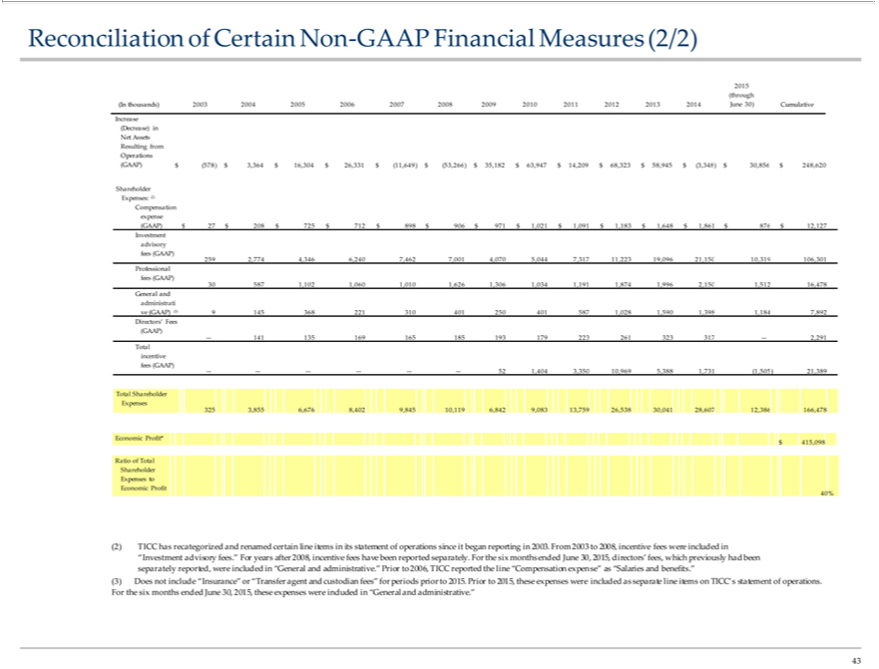

Resultingconciliation of Certain Non-GAAP Financial Measures (2/2) 2015 (through (In thousands) 2003 2004 2005 2006 2007 2008 2009 2010 2011 2012 2013 2014 June 30) Cumulative Increase (Decrease) in Net AssetsfromOperations(GAAP)$(578)$3,364$16,304$26,331$(11,649)$(53,266)$35,182$63,947$14,209$68,323$58,945$(3,348)$30,856$248,620ShareholderExpenses:(2)Compensation expense (GAAP) $ 27 $ 208 $ 725 $ 712 $ 898 $ 906 $ 971 $ 1,021 $ 1,091 $ 1,183 $ 1,648 $ 1,861 $ 876 $ 12,127 Investment advisory fees (GAAP) 259 2,774 4,346 6,240 7,462 7,001 4,070 5,044 7,317 11,223 19,0961,0281,5905010,319 106,301 Professional fees (GAAP) 30 587 1,102 1,060 1,010 1,626 1,306 1,034 1,191 1,874 1,996 2,150 1,512 16,478 General and administrati ve (GAAP) (3) 9 145 368 221 310 401 250 4015871,3981,1847,892Directors’Fees(GAAP)—141135169165185193179223261323317—2,291Totalincentive$16,26,(11,64953,266)$$$$58,(3,$fees(GAAP)——————52 1,404 3,350 10,969 5,388 1,731 (1,505) 21,389 Total Shareholder Expenses 325 3,855 6,676 8,402 9,845 10,119 6,842 9,083 13,759 26,538 30,041 28,607 12,386 166,478 Economic Profit* $ 415,098 Ratio of Total Shareholder Expenses to Economic Profit 40% (2) TICC has recategorized and renamed certain line items in its statement of operations since it began reporting in 2003. From 2003 to 2008, incentive fees were included in “GeneralInvestment advisory fees.” For years after 2008, incentive fees have been reported separately. For the six months ended June 30, 2015, directors’ fees, which previously had been separately reported, wereandadministrative.”Priorto2006,TICCreportedthelineexpense”as“Salariesandbenefits.”(3)Doesnotinclude“Insurance”or“Transferagentandcustodianfees”for periods

prior to 2015. Prior to 2015, these expenses were included as separate line items“CompensationTICC’statement of operations. For the six months ended June 30, 2015, these expenses were included in “General and administrative.” 43

