UNITED STATES

SECURITIES AND EXCHANGE COMMISSION
Washington, D.C. 20549

SCHEDULE 14A

(RULE 14a-101)

Proxy Statement Pursuant to Section 14(a) of the

Securities Exchange Act of 1934

Filed by the Registrant ☒ Filed by a Party other than the Registrant ☐

Check the appropriate box:

- Preliminary Proxy Statement

- Confidential, for Use of the Commission Only (as permitted by Rule 14a-6(e)(2))

- Definitive Proxy Statement

- Definitive Additional Materials

- Soliciting Material under §240.14a-12

Sixth Street Specialty Lending, Inc.

(Name of Registrant as Specified in Its Charter)

(Name of Person(s) Filing Proxy Statement, if other than the Registrant)

Payment of Filing Fee (Check all boxes that apply):

- No fee required.

- Fee paid previously with preliminary materials.

- Fee computed on table in exhibit required by Item 25(b) per Exchange Act Rules 14a-6(i)(1) and 0-11

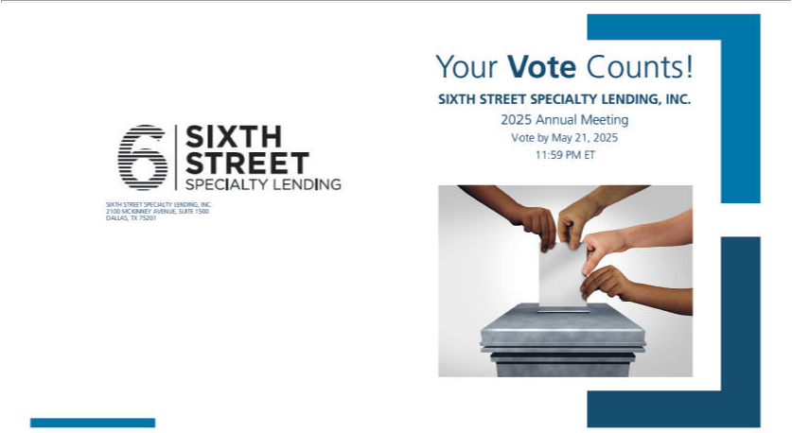

You invested in SIXTH STREET SPECIALTY LENDING, INC. and it’s time to vote!

You have the right to vote on proposals being presented at the Annual Meeting. This is an important notice regarding the availability of proxy material for the stockholder meeting to be held on May 22, 2025.

Get informed before you vote

View the Notice & Proxy Statement, Form 10-K online OR you can receive a free paper or email copy of the material(s) by requesting prior to May 08, 2025. If you would like to request a copy of the material(s) for this and/or future stockholder meetings, you may (1) visit www.ProxyVote.com, (2) call 1-800-579-1639 or (3) send an email to sendmaterial@proxyvote.com. If sending an email, please include your control number (indicated below) in the subject line. Unless requested, you will not otherwise receive a paper or email copy.
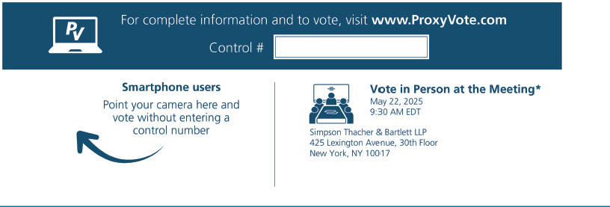

*Please check the meeting materials for any special requirements for meeting attendance. At the meeting, you will need to request a ballot to vote these shares.

- Vote at www.ProxyVote.com

- THIS IS NOT A VOTABLE BALLOT

This is an overview of the proposals being presented at the

upcoming stockholder meeting. Please follow the instructions on

the reverse side to vote these important matters.

Voting Items
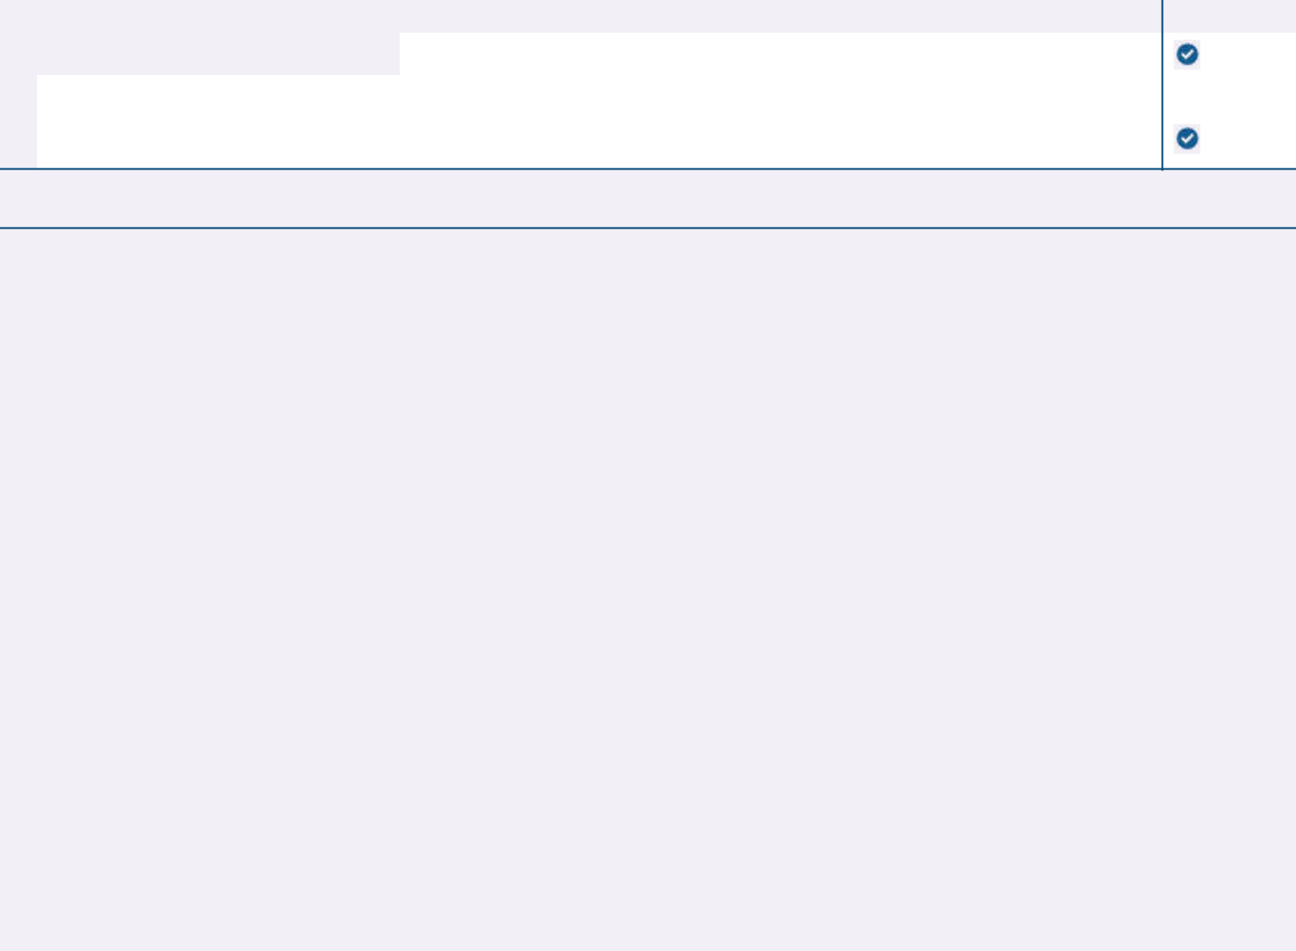

Board

Recommends

- Election of Directors

 | Nominees: |  |  | For
 | 01) P. Emery Covington | 02) Jennifer Gordon | 03) Judy Slotkin
2. | To ratify the selection of KPMG LLP as the Company’s independent registered public accounting firm for the fiscal year |  |  | For
 | ending December 31, 2025. |  |  | For

NOTE: The named proxies are also authorized to transact such other business as may properly come before the 2025 Annual Meeting of Stockholders or any postponement or adjournment thereof.

Prefer to receive an email instead? While voting on www.ProxyVote.com, be sure to click “Delivery Settings”.

