UNITED STATES

SECURITIES AND EXCHANGE COMMISSION
Washington, D.C. 20549

SCHEDULE 14A INFORMATION

PROXY STATEMENT PURSUANT TO SECTION 14(a) OF THE

SECURITIES EXCHANGE ACT OF 1934

Filed by the Registrant ☐ Filed by a Party other than the Registrant ☒

Check the appropriate box:

- Preliminary Proxy Statement

- Confidential, for Use of the Commission Only (as permitted by Rule 14a-6(e)(2))

- Definitive Proxy Statement

- Definitive Additional Materials

- Soliciting Material Pursuant to §240.14a-12

TICC CAPITAL CORP.

(Name of Registrant as Specified In Its Charter)

TPG Specialty Lending, Inc.

(Name of Person(s) Filing Proxy Statement, if other than the Registrant)

Payment of Filing Fee (Check the appropriate box):

- Fee not required.

- Fee computed on table below per Exchange Act Rules 14a-6(i)(1) and 0-11.

  - Title of each class of securities to which transaction applies:

  - Aggregate number of securities to which transaction applies:

  - Per unit price or other underlying value of transaction computed pursuant to Exchange Act Rule 0-11 (set forth the amount on which the filing fee is calculated and state how it was determined):

  - Proposed maximum aggregate value of transaction:

  - Total fee paid:

- Fee paid previously with preliminary materials.

- Check box if any part of the fee is offset as provided by Exchange Act Rule 0-11(a)(2) and identify the filing for which the offsetting fee was paid previously. Identify the previous filing by registration statement number, or the Form or Schedule and the date of its filing.

  - Amount Previously Paid:

  - Form, Schedule or Registration Statement No.:

  - Filing Party:

  - Date Filed:

TPG Specialty Lending, Inc. (“TSLX”) has filed a definitive proxy statement with the Securities and Exchange Commission (the “SEC”) and an accompanying GOLD proxy card to be used to solicit votes against TICC Capital Corp.’s (the “Company”) proposal to approve a new advisory agreement between the Company and TICC Management, LLC, to take effect upon a change of control of TICC Management, LLC, and certain related proposals, at a special meeting of stockholders of the Company scheduled to be held on October 27, 2015.

As part of the above-referenced solicitation, TSLX updated certain pages of its website, http://www.changeticcnow.com/, a website established by TSLX that contains information regarding the solicitation. This Schedule 14A filing consists of the following screenshots, which reflect the content of pages not previously filed with the SEC.

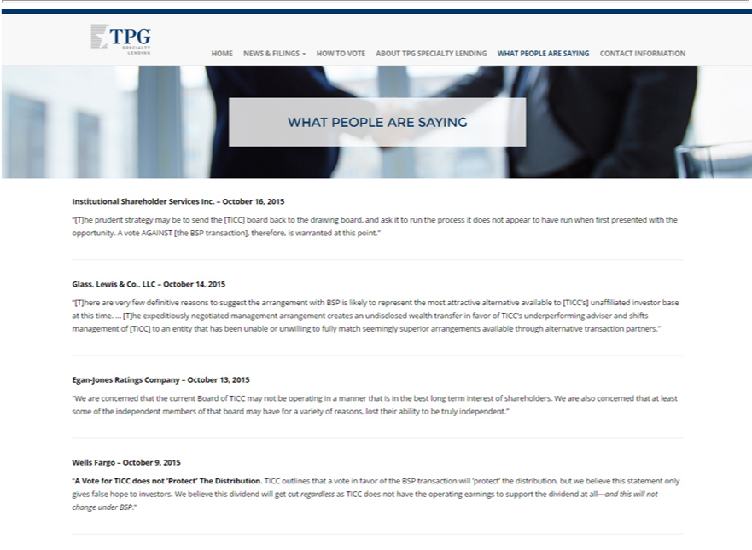

TPG
HOME NEWS & FILINGS HOW TO VOTE ABOUT TPG SPECIALTY LENDING WHAT PEOPLE ARE SAYING CONTACT INFORMATION
Institutional Shareholder Services Inc. – October 16, 2015
“[T]he prudent strategy may be to send the [TICC] board back to the drawing board, and ask it to run the process it does not appear to have run when first presented with the opportunity. A vote AGAINST [the BSP
transaction], | is warranted at this point.”
Glass, Lewis therefore,&Co.LLC – October 14, 2015 |  |  | the most attractive alternative available to [TICC’s] unaffiliated investor base at this time. … [T]he expeditiously
“[T]here are very few definitive reasons to suggest the arrangement with BSP is likely to
negotiated management arrangement creates an undisclosed wealth transfer in favor of TICC’representunderperforming adviser and shifts management of [TICC] to an entity that has been unable or unwilling to fully match
seemingly superior arrangements available through alternative transaction partners.”
Egan-Jones Ratings Company – October 13, 2015 |  | a manner that is in the best long term interest of shareholders. We are also concerned that at least some of the independent members of that
“We are concerned | the current Board of TICC may not be operating
board may have for thatvariety of reasons, lost their ability to be truly independent.”
Wells Fargo – October 9, 2015 |  | vote in favor of the BSP transaction will ’protect’ the distribution, but we believe this statement only gives false hope to investors. We believe
“A Vote for TICC does not ’Protect’ The Distribution. TICC outlines that
this dividend will get cut regardless as TICC does not have the operating earnings to support the dividend at all—and this will not change under BSP.”

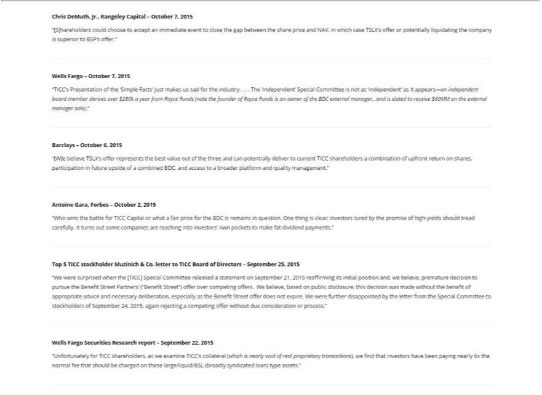

Chris DeMuth, Jr., Rangeley Capital – October 7, 2015
“[S]hareholders could choose to accept an immediate event to close the gap between the share price and NAV, in which case TSLX’s offer or potentially liquidating the company is superior to BSP’s offer.”
Wells Fargo – October 7, 2015
“TICC’s Presentation of the ‘Simple Facts’ just makes us sad for the industry. . . . The ’Independent’ Special Committee is not as ‘independent’ as it appears—an independent board member derives over $280k a year
from Royce Funds (note the founder of Royce Funds is an owner of the BDC external manager…and is slated to receive $60MM on the external manager sale).”
Barclays – October 6, 2015
“[W]e believe TSLX’s offer represents the best value out of the three and can potentially deliver to current TICC shareholders a combination of upfront return on shares, participation in future upside of a combined
BDC, and access to a broader platform and quality management.”
Antoine Gara, Forbes – October 2, 2015
“Who wins the battle for TICC Capital or what a fair price for the BDC is remains in question. One thing is clear; investors lured by the promise of high yields should tread carefully. It turns out some companies are
reaching into investors’ own pockets to make fat dividend payments.”
Top 5 TICC stockholder Muzinich & Co. letter to TICC Board of Directors – September 25, 2015
“W were surprised when the [TICC] | Committee released a statement on September 21, 2015 reaffirming its initial position and, we believe, premature decision to pursue the Benefit Street Partners’ (“Benefit
Street”) offer over competing offers. WSpecialbelieve, based on public disclosure, this decision was made without the benefit of appropriate advice and necessary deliberation, especially as the Benefit Street offer does not expire. We were further disappointed by the letter from the Special Committee to stockholders of September 24, 2015, again rejecting a competing offer without due consideration or process.”
Wells Fargo Securities Research report – September 22, 2015
“Unfortunately for TICC shareholders, as we examine TICC’^{assets}collateral (which is nearly void of real proprietary transactions), we find that investors have been paying nearly 6x the normal fee that should be charged
on these large/liquid/BSL (broadly syndicated loan) type .”

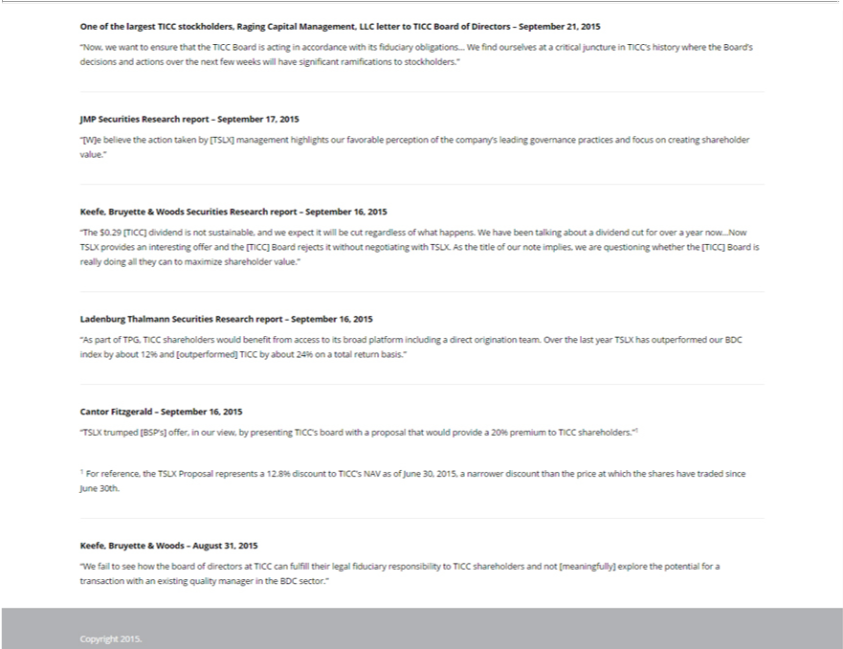

One of the largest TICC stockholders, Raging Capital Management, LLC letter to TICC Board of | – September 21, 2015
“Now, we want to ensure that the TICC Board is acting in accordance with its fiduciary obligations…DirectorsWfind ourselves at a critical juncture in TICC’s history where the Board’s decisions and actions over the next few
weeks will have significant ramifications to stockholders.”
JMP Securities Research report – September 17, 2015
“[W]e believe the action taken by [TSLX] management highlights our favorable perception of the company’s leading governance practices and focus on creating shareholder value.”
Keefe, Bruyette & Woods Securities Research report – September 16, 2015
“The $0.29 [TICC] dividend is not sustainable, and we expect it will be cut regardless of what happens. We have been talking about dividend cut for over a year now…Now TSLX provides an interesting offer and the
[TICC] Board rejects it without negotiating with TSLX. As the title of our note implies, we are questioning whether the [TICC] Board is really doing all they can to maximize shareholder value.”
Ladenburg Thalmann Securities Research report – September 16, 2015
“As part of TPG, TICC shareholders would benefit from access to its broad platform including a direct origination team. Over the last year TSLX has outperformed our BDC index by about 12% and [outperformed]
TICC by about 24% on a total return basis.”
Cantor Fitzgerald – September 16, 2015 | 20% premium to TICC shareholders.“1
“TSLX trumped [BSP’s] offer, in our view, by presenting TICC’s board with a proposal that would provide | 20% premium to TICC shareholders.“1
1 For reference, the TSLX Proposal represents a 12.8% discount to TICC’s NAV as of June 30, 2015, a narrower discount than the price at which the shares have traded since June 30th. _{Keefe,} Bruyette & Woods – August 31, 2015
“W fail to see how the board of directors at TICC can fulfill their legal fiduciary responsibility to TICC shareholders and not [meaningfully] explore the potential for a transaction with an existing quality manager in the BDC sector.”

