UNITED STATES

SECURITIES AND EXCHANGE COMMISSION
Washington, D.C. 20549

SCHEDULE 14A INFORMATION

PROXY STATEMENT PURSUANT TO SECTION 14(a) OF THE

SECURITIES EXCHANGE ACT OF 1934

Filed by the Registrant ☐ Filed by a Party other than the Registrant ☒

Check the appropriate box:

- Preliminary Proxy Statement

- Confidential, for Use of the Commission Only (as permitted by Rule 14a-6(e)(2))

- Definitive Proxy Statement

- Definitive Additional Materials

- Soliciting Material Pursuant to §240.14a-12

TICC CAPITAL CORP.

(Name of Registrant as Specified In Its Charter)

TPG Specialty Lending, Inc.

(Name of Person(s) Filing Proxy Statement, if other than the Registrant)

Payment of Filing Fee (Check the appropriate box):

- Fee not required.

- Fee computed on table below per Exchange Act Rules 14a-6(i)(1) and 0-11.

  - Title of each class of securities to which transaction applies:

  - Aggregate number of securities to which transaction applies:

  - Per unit price or other underlying value of transaction computed pursuant to Exchange Act Rule 0-11 (set forth the amount on which the filing fee is calculated and state how it was determined):

  - Proposed maximum aggregate value of transaction:

  - Total fee paid:

- Fee paid previously with preliminary materials.

- Check box if any part of the fee is offset as provided by Exchange Act Rule 0-11(a)(2) and identify the filing for which the offsetting fee was paid previously. Identify the previous filing by registration statement number, or the Form or Schedule and the date of its filing.

  - Amount Previously Paid:

  - Form, Schedule or Registration Statement No.:

  - Filing Party:

- Date Filed:

TPG Specialty Lending, Inc., together with the other participants named herein (collectively, “TSLX”), intends to file a preliminary proxy statement and an accompanying proxy card with the Securities and Exchange Commission (the “SEC”) to be used to solicit votes from the stockholders of TICC Capital Corp. (“TICC”) to: (a) elect TSLX’s director nominee at TICC’s 2016 annual meeting of stockholders and (b) approve a proposal to terminate the Investment Advisory Agreement, dated as of July 1, 2011, by and between TICC and TICC Management, LLC, as contemplated by Section 15(a) of the Investment Company Act of 1940, as amended.

As part of the above-referenced solicitation, TSLX updated certain pages of its website, http://www.changeticcnow.com/, a website established by TSLX that contains information regarding the solicitation. This Schedule 14A filing consists of the following screenshots, which reflect the content of pages not previously filed with the SEC.

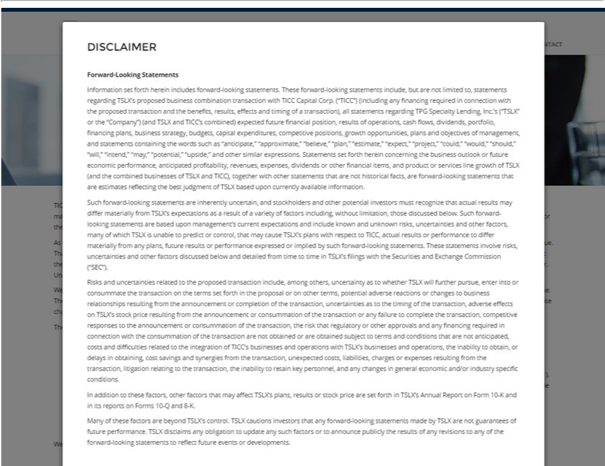

DISCLAIMER Forward-Looking Statements Information set forth herein includes forward-looking statements. These forward-looking statements include, but are not limited to, statements regarding TSLX’s
proposed business combination transaction with TICC Capital Corp. (“TICC”) (including |  |  |  |  | financing required in connection with the proposed transaction and the benefits, results, effects and timing of a
transaction), all statements regarding TPG Specialty |  |  | Inc.’s (“TSLX” or the “Company”) (and TSLX and TICC’ combined) expected future financial position, results of operations, cash flows,
dividends, portfolio, financing plans, business strategyLending,budgets, capital expenditures, competitive positions, growth opportunities, plans and objectives of management, and statements containing the words such
as “anticipate,” “approximate,” “believe,” “plan,” “esti |  |  | ate,” “expect,” “project,” “could,” |  | “should,” “will,” “intend,” “may,” “potential,” “upside,” and other similar expressions. Statements set forth
herein concerning the business outlook or future economic performance, anticipated profitability“would,”revenues, expenses, dividends or other financial items, and product or services line growth of TSLX (and the
combined businesses of TSLX and TICC), together with other statements that are not historical facts, are forward-looking statements that are es imates reflecting the best judgment of TSLX based upon currently
 | on. Such forward-looking statements are inherently uncertain, and stockholders and other potential investors must recognize that actual results may differ materially from TSLX’s expectations
asvailableresultinformatofvariety of factors including, without limitation, those discussed below. Such forward-looking statements are based upon management’ current expectations and include known and unknown risks,
uncertainties and other factors, many of which TSLX is unable to predict or control, that may cause TSLX’s plans with respect to TICC, actual results or performance to differ materially from any plans, future
results or performance expressed or implied by such forward-looking statements. These statements involve risks, uncertainties and other factors discussed below and detailed from time to time in TSLX’s filings
with the Securities and Exchange Commission (“SEC”). Risks and uncertainties related to the proposed transaction include, among others, uncertainty as to whether TSLX will further pursue, enter into or
consummate the tr nsaction on the terms set forth in the proposal or on other terms, potential adverse reactions or changes to business relationships resulting from the announcement or completion of the
transaction, uncertainties as to the timing of the transaction, adverse effects |  |  |  | TSLX’ stock price resulting from the announcement or consummation of the transaction or any failure to complete the transaction,
competitive responses to the announcement or consummation of the transaction, the risk that regulatory or other approvals and any financing required in connection with the |  |  |  |  |  |  |  | of the transaction are
not obtained or are obtained subject to terms and conditions that are not anticipated, costs and difficulties related to the integration of TICC’ businesses and operations with TSLX’consummationbusinesses and operations,
the | obtain, or delays in obtaining, cost |  | and synergies from the transaction, unexpected costs, liabilities, charges |  |  | expenses resulting from the transaction, litigation relating to the transaction,
the | to retain key | and any changes | general economic and/or industry specific conditions. In addition to these |  |  | other factors that may affect TSLX’s plans, results or stock price are set
forthinabilityTSLX’s Annual Reportpersonnel,Form 10-K andsavingsitsreports on Forms 10-Q and 8-K. Many of these factors are beyond TSLX’factors,control. TSLX cautions |  |  |  |  |  |  | that any forward-looking statements made
by TSLX are not guarantees of future performance. TSLX disclaims any obligation to update any such factors or to announce publicly the results of any revisionsinvestorsany of the forward-looking statements to reflect future events or developments.

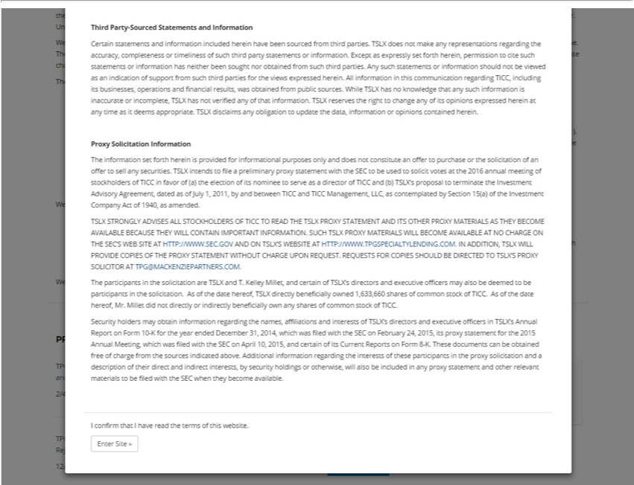

Third Party-Sourced Statements and Information
Certain statements and information included her in have been sourced from third parties. TSLX does ot make any representations regarding the accuracy, completeness or timeliness of such third party
tatements or information. Except as expressly set forth herein, permission to cite such statements or information has neither been sought nor obtained from such third parties. Any such statements or information
should not be viewed as an indication of support from such third parties for the views expressed herein. All |  |  |  | this communication regarding TICC, including its businesses, operations and financial
results, was obtained from public sources. While TSLX has no knowledge that any such information is inaccurateinformationincomplete, TSLX has not verified any of that information. TSLX reserves the right to change
any of its opinions expressed herein at any time as it deems appropriate. TSLX disclaims any obligation to update the data, information or opinions contained herein.
Proxy Solicitation Information |  | purposes only and does not constitute an offer to purchase or the solicitation of an offer to sell any securities. TSLX intends to file a preliminary
The information set forth herein is provided for
proxy statement wi h the SEC to be used to solicitinformationalvotesthe 2016 annual meeting of stockholders of TICC in favor of (a) the election of its nominee to serve as a director of TICC and (b) TSLX’s proposal to
terminate the Investment Advisory Agreement, dated as of July 1, 2011, by and between TICC and TICC Management, LLC, as contemplated by Section 15(a) of the Investment Company Act of 1940, as
amended. |  |  | O READ THE TSLX PROXY STATEMENT AND ITS |  | PROXY MATERIALS AS THEY BECOME AVAILABLE BECAUSE
SLX STRONGLY ADVISES ALL STOCKHOLDERS OF TICC
THEY WILL CONTAIN IMPORTANT INFORMATION. SUCH TSLX PROXY MATERIALS WILL BECOME AVAILABLEOTHERANO CHARGE ON THE SEC’S WEB SITE A HTTP://WWW.SEC.GOV
AND ON TSLX’S WEBSITE AT HTTP://WWW.TPGSPECIAL |  |  | .COM. IN ADDITION, | WILL PROVIDE COPIES OF THE PROXY STATEMENT WITHOUT CHARGE UPON
REQUEST. REQUESTS FOR COPIES SHOULD BE DIRECTEDTYLENDINGOTSLX’S PROXY SOLICITOR ATSLXTPG@MACKENZIEPARTNERS.COM.
The participants in the solicitation are TSLX and T. Kelley Millet, and certain of TSLX’s directors and executive officers may also be deemed to be participants in the solicitation. As of the date hereof, TSLX
directly beneficially owned 1,633,660 shares of common stock of TICC. As of the date hereof, Mr. Millet did not directly or |  |  |  |  | beneficially own any shares of common stock of TICC. | 31, 2014,
Security holders may obtain | regarding the names, affiliations and interests of TSLX’s directors and executive officersindirectlyTSLX’s Annual Report on Form 10-K for the year ended |  |  |  |  | 31, 2014,
which was filed with the SECinformationFebruary 24, 2015, its proxy statement for the 2015 Annual Meeting, which was filed with the SEC on April 10, 2015, and certain of its Current Reports on FoDecember8-K.These
documents can be obtained free of charge from |  | sources indicated above. Additional information regarding the interests of these participants in the proxy solicitation and description of their direct and
indirect interests, by security holdings or otherwise, will also be included in any proxy statement and other relevant materials to be filed with the SEC when they become available.
I confirm that I have read the terms of this website.
Enter Site »

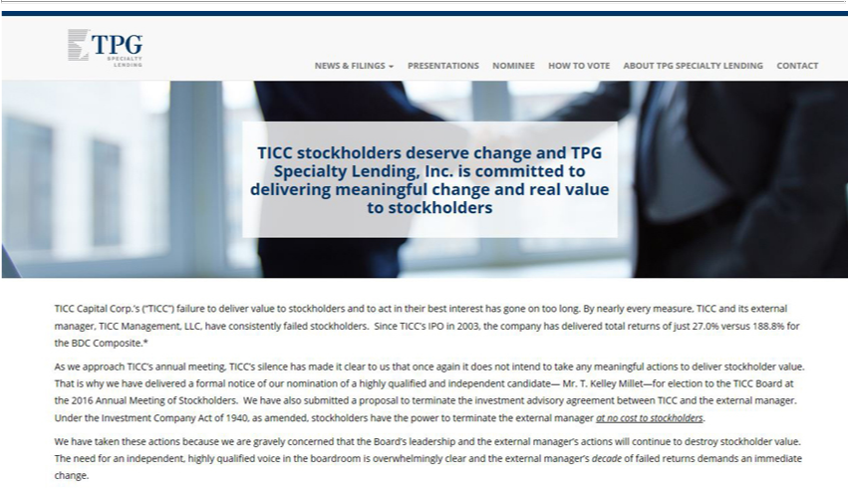

TPG Specialty Lending
News & Filings
Presentations
N minee
How to Vote
About TPG Specialty Lending
Contact |  | change and TPG Specialty Lending, Inc. is committed to delivering meaningful change and real value to stockholders
stockholders
TICC Capital Corp.’deserve(“TICC”) failure to deliver value to stockholders and to act in their best interest has gone on too long. By nearly every measure, TICC and its external manager, TICC Management, LLC,
have consistently failed stockhold rs. Since TICC’ IPO in 2003, the company has delivered total returns of just 27.0% versus 188.8% for the BDC Composite.*
As we approach TICC’s |  | nual meeting, TICC’s silence has made it clear to us that once again it does not intend to take any meaningful actions to deliver stockholder value. That is why we have delivered a
formal notice of our nomination of a highly qualifi d and independent |  |  | — Mr. T. Kelley Millet—for election to the TICC Board at the 2016 Annual Meeting of Stockholders. We have also submitted a
proposal to | the investment advisory agreement between TICCcandidatethe external manager. Under the Investment Company Act of 1940, as amended, stockholders have the power to terminate the
managerterminateno cost to stockholders. |  |  | and the external manager’ actions will continue to destroy stockholder value. The need for an independent, highly
externalWhave taken these actions because we are gravely concer ed that the Board’s
qualified voice in the boardroom is overwhelmingly clear and the external manager’leadershipdecade of failed returns demands an immediate change.

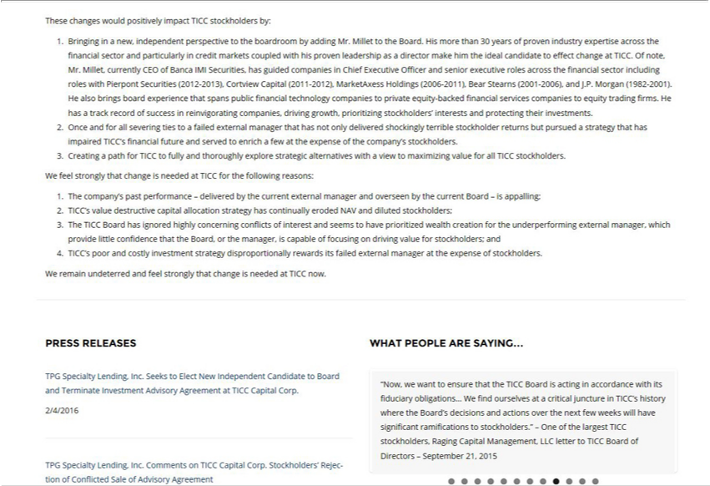

These changes would positively impact TICC stockholders by:
1.Bringing in a new, independent perspective |  |  |  | the boardroom by adding Mr. Millet to the Board. His more than 30 years of proven industry expertise across the financial sector and particularly in credit markets
coupled with his proven leadership as |  |  | director make him the ideal candidate to effect change at TICC. Of note, Mr. Millet, currently CEO of Banca IMI Securities, has guided companies in Chief Executive
Officer and senior executive roles across the financial sector including roles with Pierpont Securities (2012-2013), Cortview Capital (2011-2012), MarketAxess Holdings (2006-2011), Bear Stearns (2001-2006),
and J.P. Morgan (1982-2001). He also brings board experience that spans public financial technology companies to private equity-backed financial services companies to equity trading firms. He has a track
record of success in reinvigorating companies, driving growth, prioritizing stockholders’ interests and protecting their investments.
2.Once and for all severing ties to failed external manager that has not only delivered shockingly terrible stockholder returns but pursued a strategy that has impaired TICC’s financial future and served to
enrich |  | few the expense of the company’s stockholders.
3. |  | a path for TICC to fully and thoroughly explore strategic alternatives with a view to maximizing value for all TICC stockholders.
WCreatingfeelstrongly that change is needed at TICC for the following reasons:
1 |  | company’ past performance – delivered by the current external manager and overseen by the current Board – is appalling;
2 | ICC’s value destructive capital allocation strategy has continually eroded NAV and diluted stockholders;
3.The |  | TICC Board has ignored highly concerning conflicts of interest and seems to have prioritized wealth creation for the underperforming external manager, which provide little confidence that the Board, or
the manager, is capable of focusing on driving value for stockholders; and
4.TICC’s poor and costly investment strategy |  |  |  | rewards its failed external manager at the expense of stockholders.
We remain undeterred and feel strongly that changedisproportionallyneededat TICC now.
PRESS RELEASES
TPG Specialty Lending, Inc. Seeks to Elect New Independent Candidate to Board and Terminate Investment Advisory Agreement at TICC Capital Corp.
2/4/2016
WHAT PEOPLE ARE SAYING…
“Now, we want to ensure that the TICC Board is acting in accordance with its fiduciary obligations… W find ourselves at a critical juncture in TICC’s history where the Board’ decisions and actions over the
next few weeks will have significant |  |  |  | to stockholders.” – One of the largest TICC sto kholders, Raging Capital Management, LLC letter to TICC Board of Directors – September 21, 2015
TPG Specialty Lending, Inc. CommentsramificationsTICCCapital Corp. Stockholders’ Rejection of Conflicted Sale of Advisory Agreement

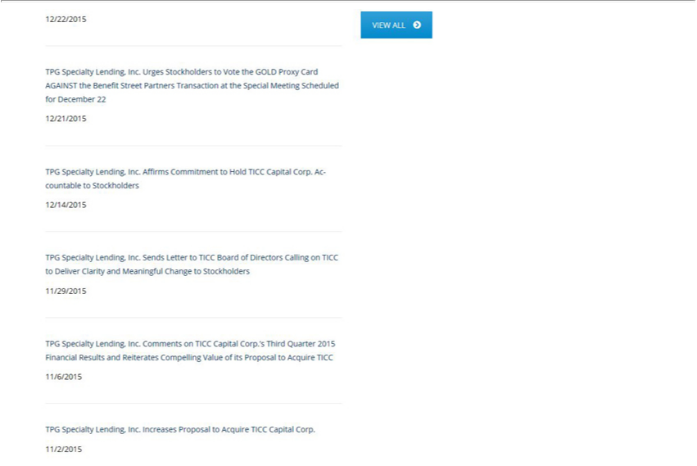

VIEW ALL
TPG Specialty Lending, Inc. Urges Stockholders to Vote the GOLD Proxy Card AGAINST the Benefit Street Partners Transaction at the Special Meeting Scheduled for December 22 12/21/2015
TPG Specialty Lending, Inc. Affirms Commitment to Hold TICC Capital Corp. Accountable to Stockholders 12/14/2015
TPG Specialty Lending, Inc. Sends Letter to TICC Board of Directors Calling on TICC to Deliver Clarity and Meaningful Change to Stockholders 11/29/2015
TPG Specialty Lending, Inc. Comments on TICC Capital Corp.’s Third Quarter 2015 Financial Results and Reiterates Compelling Value of its Proposal to Acquire TICC 11/6/2015
11/2/2015TPGSpecialty Lending, Inc. Increases Proposal to Acquire TICC Capital Corp.

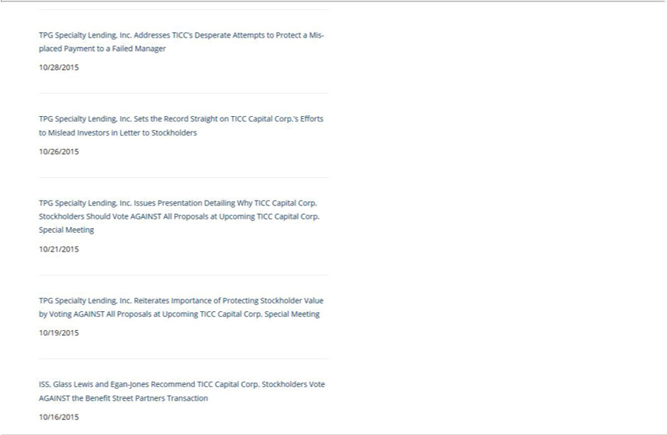

TPG Specialty Lending, Inc. Addresses TICC’s Desperate Attempts to Protect a Misplaced Payment to a Failed Manager 10/28/2015
TPG Specialty Lending, Inc. Sets the Record Straight on TICC Capital Corp.’s Efforts to Mislead Investors in Letter to Stockholders 10/26/2015
TPG Specialty Lending, Inc. Issues Presentation Detailing Why TICC Capital Corp. Stockholders Should Vote AGAINST All Proposals at Upcoming TICC Capital Corp. Special Meeting 10/21/2015
TPG Specialty Lending, Inc. Reiterates Importance of Protecting Stockholder Value by Voting AGAINST All Proposals at Upcoming TICC Capital Corp. Special Meeting 10/19/2015
ISS, Glass Lewis and Egan-Jones Recommend TICC Capital Corp. Stockholders Vote AGAINST the Benefit Street Partners Transaction 10/16/2015

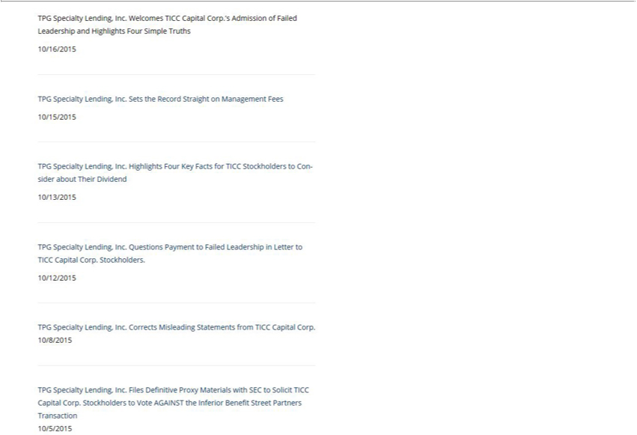

TPG Specialty Lending, Inc. Welcomes TICC Capital Corp.’s Admission of Failed Leadership and Highlights Four Simple Truths 10/16/2015
10/15/2015TPGSpecialty Lending, Inc. Sets the Record Straight on Management Fees
TPG Specialty Lending, Inc. Highlights Four Key Facts for TICC Stockholders to Consider about Their Dividend 10/13/2015
10/12/2015TPGSpecialty Lending, Inc. Questions Payment to Failed Leadership in Letter to TICC Capital Corp. Stockholders.
_{TPG Specialty Lending, Inc.} Corrects Misleading Statements from TICC Capital Corp. 10/8/2015
Files Definitive Proxy Materials with SEC to Solicit TICC Capital Corp. Stockholders to Vote AGAINST the Inferior Benefit Street Partners Transaction 10/5/2015

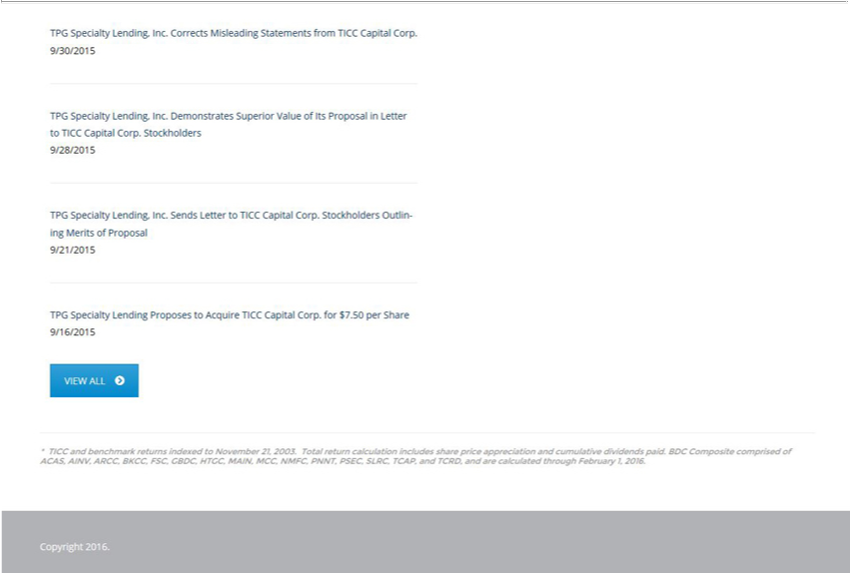

, Inc. CorrectsDemonstratesMisleadingSuperiorStatementsValueof fromItsProposalTICCCapitalinLetterCorp.toTICC9/30/2015Capital Corp. Stockholders 9/28/2015
TPGVIEWSpecialtyALL Lending ProposesSendsto LetterAcquireto TICCTICC CapitalCapital Corp.Corp. Stockholdersfor$7.50per ShareOutlining9/16/2015Merits of Proposal 9/21/2015
BKCC,*TICC FSC,andbenchmarkGBDC,HTGC,returnsMAIN,indexedMCC,toNovemberNMFC,PNNT,21,2003.PSEC,TotalSLRC,returnTCAP,calculationandTCRD,includesandshareare pricecalculatedappreciationthroughandFebruarycumulative1,2016.dividends paid. BDC Composite comprised of ACAS, AINV, ARCC,

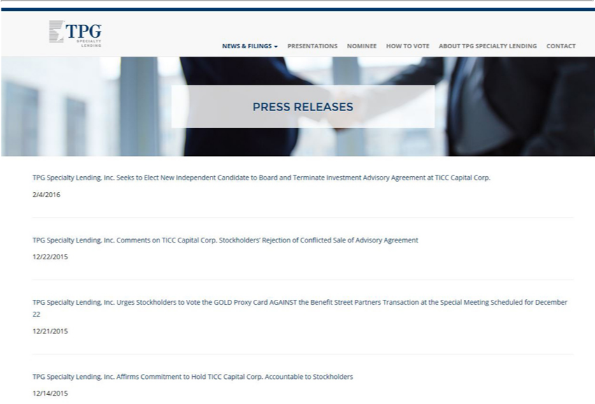

TPG Specialty Lending
News & Filings
Press Releases
SEC Filings
PresentationsIndependentvoices against TICC
N_{How}mineetoVote
ContactAboutTPG Specialty Lending
PRESS RELEASES
TPG Specialty Lending, Inc. Seeks to Elect New Independent Candidate to Board and Terminate Investment Advisory Agreement at TICC Capital Corp. 2/4/2016
TPG Specialty Lending, Inc. Comments on TICC Capital Corp. Stockholders’ Rejection of Conflicted Sale of Advisory Agreement 12/22/2015
TPG Specialty Lending, Inc. Urges Stockholders to Vote the GOLD Proxy Card AGAINST the Benefit Street Partners Transaction at the Special Meeting Scheduled for December 22 12/21/2015
TPG Specialty Lending, Inc. Affirms Commitment to Hold TICC Capital Corp. Accountable to Stockholders 12/14/2015

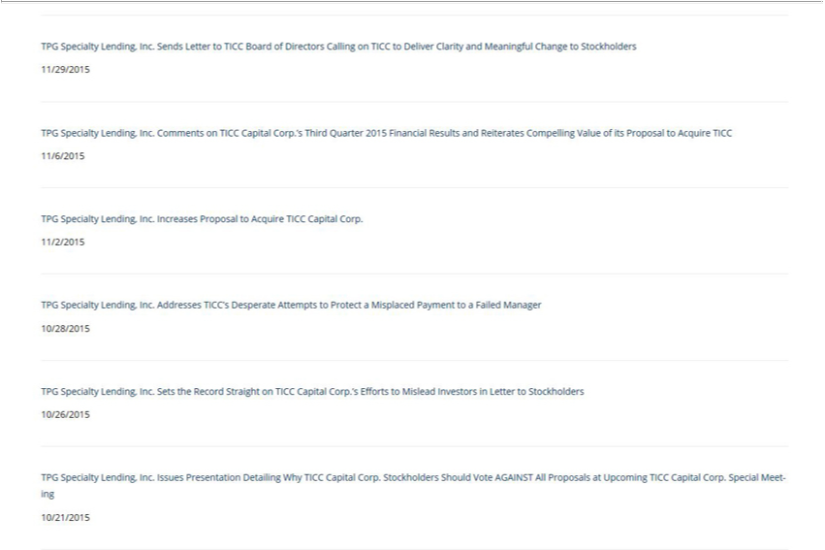

TPG Specialty Lending, Inc. Sends Letter to TICC Board of Directors Calling on TICC to Deliver Clarity and Meaningful Change to Stockholders 11/29/2015
TPG Specialty Lending, Inc. Comments on TICC Capital Corp.’s Third Quarter 2015 Financial Results and Reiterates Compelling Value of its Proposal to Acquire TICC 11/6/2015
11/2/2015TPGSpecialty Lending, Inc. Increases Proposal to Acquire TICC Capital Corp.

TPG Specialty Lending, Inc. Addresses TICC’s Desperate Attempts to Protect a Misplaced Payment to a Failed Manager 10/28/2015
TPG Specialty Lending, Inc. Sets the Record Straight on TICC Capital Corp.’s Efforts to Mislead Investors in Letter to Stockholders 10/26/2015
TPG Specialty Lending, Inc. Issues Presentation Detailing Why TICC Capital Corp. Stockholders Should Vote AGAINST All Proposals at Upcoming TICC Capital Corp. Special Meeting 10/21/2015

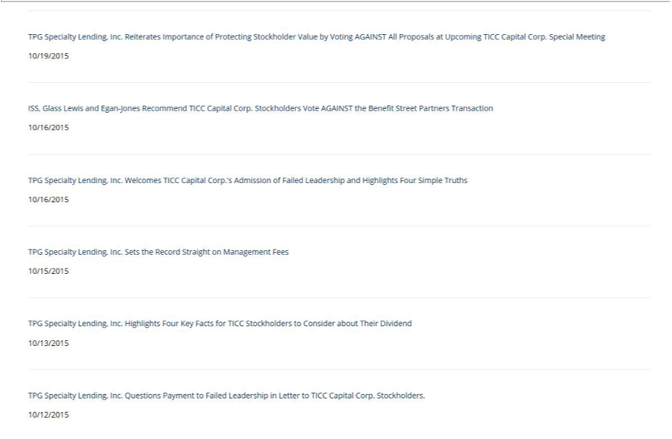

TPG Specialty Lending, Inc. Reiterates Importance of Protecting Stockholder Value by Voting AGAINST All Proposals at Upcoming TICC Capital Corp. Special Meeting 10/19/2015
ISS, Glass Lewis and Egan-Jones Recommend TICC Capital Corp. Stockholders Vote AGAINST the Benefit Street Partners Transaction 10/16/2015
TPG Specialty Lending, Inc. Welcomes TICC Capital Corp.’s Admission of Failed Leadership and Highlights Four Simple Truths 10/16/2015
10/15/2015TPGSpecialty Lending, Inc. Sets the Record Straight on Management Fees

TPG Specialty Lending, Inc. Highlights Four Key Facts for TICC Stockholders to Consider about Their Dividend 10/13/2015
10/12/2015TPGSpecialty Lending, Inc. Questions Payment to Failed Leadership in Letter to TICC Capital Corp. Stockholders.

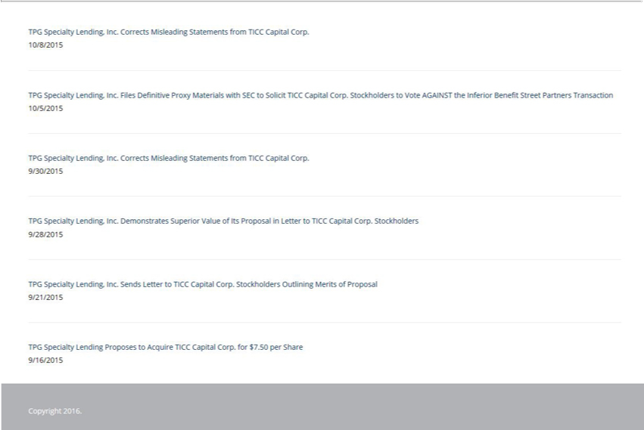

CorrectsFilesDefinitiveMisleadingProxyStatementsMaterials fromwith SECTICCtoCapitalSolicitCorp.TICC10/8/2015CapitalCorp. Stockholders to Vote AGAINST the Inferior Benefit Street Partners Transaction 10/5/2015

, Inc. DemonstratesCorrectsMisleadingSuperiorStatementsValueof fromItsProposalTICCCapitalinLetterCorp.toTICC9/30/2015Capital Corp. Stockholders 9/28/2015 TPG Specialty Lending Sends Letter to TICC Capital Corp. Stockholders Outlining Merits of Proposal 9/21/2015
Copyright 2016. Proposes to Acquire TICC Capital Corp. for $7.50 per Share 9/16/2015

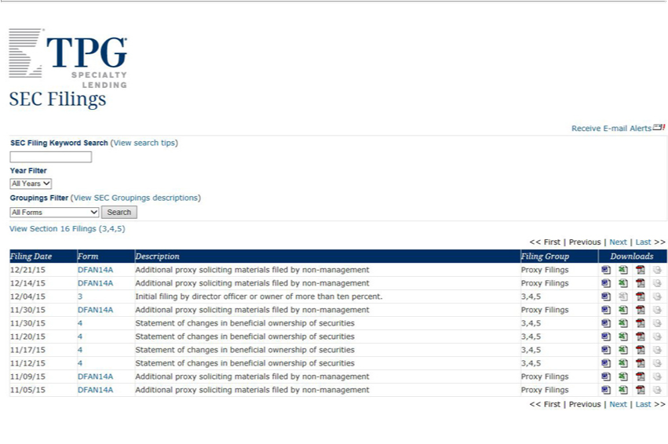

SEC Filings
TopReceiveofFormE-mail Alerts [GRAPHIC APPEARS HERE]
YearSEC FilingFilter Keyword earch (View search tips)
ViewGroupingsSectionFilter16 Filings(ViewSEC(3,4,5)Groupings descriptions)
^{Form}<<ilingFirstDate|Previous | Next | Last >>
Description
Filing Group
Downloads
DFAN14A12/21/15
ProxyAdditionalFilingsproxy soliciting materials filed by non-management
12/14/15
DFAN14A
ProxyAdditionalFilingsproxy soliciting materials filed by non-management
12/04/15
3
Initial filing by director officer or owner of more than ten percent.
11/30/153,4,5
DFAN14A
ProxyAdditionalFilingsproxy soliciting materials filed by non-management
11/30/15
4
Statement3,4,5 of changes in beneficial ownership of securities

411/20/15
Statement3,4,5 of changes in beneficial ownership of securities

411/17/15
Statement3,4,5 of changes in beneficial ownership of securities

411/12/15
Statement of changes in beneficial ownership of securities
11/09/153,4,5
DFAN14A
ProxyAdditionalFilingsproxy soliciting materials filed by non-management
11/05/15
DFAN14A
ProxyAdditionalFilingsproxy soliciting materials filed by non-management
Bottom<<First of|PreviousForm | Next | Last >>

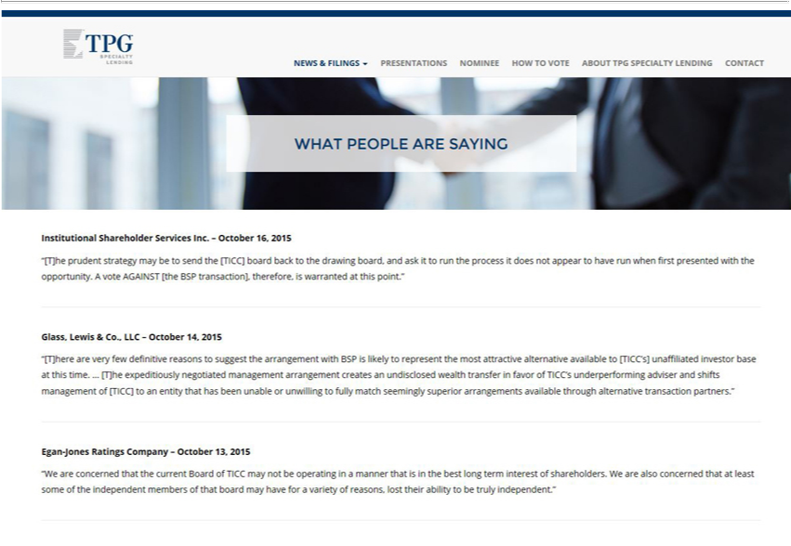

TPG Specialty Lending
News & Filings
Presentations
N minee
How to Vote
About TPG Specialty Lending
Contact
WHAT PEOPLE ARE SAYING
Institutional Shareholder Services Inc. – October 16, 2015
“[T]he prudent strategy may be to send the [TICC] board back to the drawing board, and ask it to run the process it does not appear to have run when first presented with the opportunity. A vote AGAINST [the
BSP transaction], | is warranted at this point.”
Glass, Lewis & Co.therefore,LLC– October 14, 2015 |  | with BSP is likely to represent the most attractive alternative available to [TICC’s] unaffiliated | base at this time. … [T]he
“[T]here are very few definitive reasons to suggest the |  |  | base at this time. … [T]he
expeditiously negotiated management arrangement createsarrangementundisclosed wealth transfer in favor of TICC’s underperforming adviser and shifts management of [TICC]investor an entity that has been unable or unwilling to fully match seemingly superior arrangements available through alternative transaction partners.”
Egan-Jones Ratings Company – October 13, 2015
“We are concerned that the current Board of TICC may not be operating _{independent}amanner that is in the best long term interest of shareholders. We are also concerned that at least some of the independent members of
that board may have for a variety of reasons, lost their ability to be truly .”

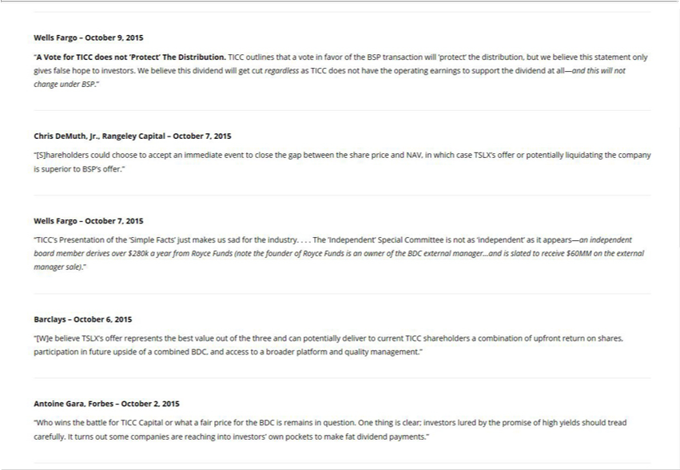

Wells“AVoteFargofor TICC–Octoberdoes 9,not2015‘Protect’ The Distribution. TICC outlines thatoperatingvotein favor of the BSP transaction will ‘protect’ thise distribution, but we believe this statement only gives false hope to investors. We
believe this dividend will get cut regardless as TICC does not have the earnings to support the dividend at all—and will not change under BSP.”
“[S]hareholdersChrisDeMuth,Jr.,couldRangeleychooseCapitaltoaccept–Octoberanimmediate7,2015event to close the gap between the share price and NAV, in which case TSLX’s offer or potentially liquidating the company is superior to BSP’s offer.”
“TICC’sWellsFargoPresentation–Octoberof7,the2015‘Simple Facts’ just makes us sad for the industry. . . . The ‘Independent’ Special Committee is not as ‘independent’ as it appears—an independent board member derives over $280k a year from Royce Funds (note the founder of Royce Funds is an owner of the BDC external manager…and is slated to receive $60MM on the external manager sale).”
“[W]eBarclaysbelieve–OctoberTSLX’6,access2015offer represents the best value out of the three and can potentially deliver to current TICC shareholders a combination of upfront return on shares, participation in future upside of a combined BDC, and a broader platform and quality management.”
Antoine Gara, Forbes – October 2, 2015
“Who wins the battle for TICC Capital or what^{make} fair price for the BDC is remains in question. One thing is clear; investors lured by the promise of high yields should tread carefully. It turns out some companies
are reaching into investors’ own pockets to fat dividend payments.”

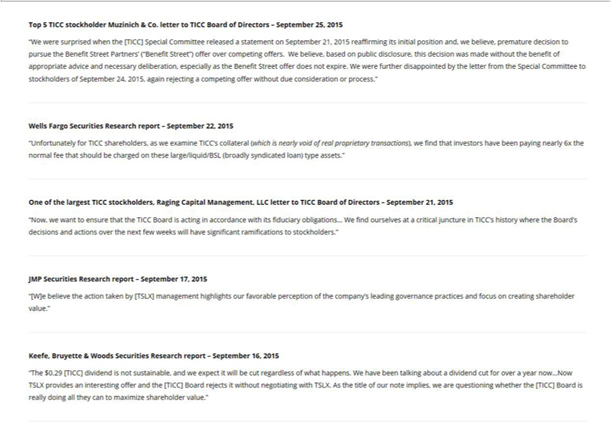

Top 5 TICC stockholder Muzinich & Co. letter to TICC Board of Directors – September 25, 2015
“W were surprised when the [TICC] Special |  | released a statement on September 21, 2015 reaffirming its initial position and, we believe, premature decision to pursue the Benefit Street Partners’
(“Benefit Street”) offer | competing offers.CommitteeWbelieve, based on public disclosure, this decision was made without the benefit of appropriate |  |  | and necessary deliberation, especially as the Benefit Street
offer does not expire. Woverwere further disappointed by the letter from the Special Committee to stockholders of September 24, 2015, again rejectingadvicecompeting offer without due consideration or process.”
Wells Fargo Securities Research report – September 22, 2015
“Unfortunately for TICC shareholders, as we examine TICC’s collateral (which is nearly void of real proprietary transactions), we find that investors have been paying nearly 6x the normal fee that should be
charged on these large/liquid/BSL (broadly syndicated loan) type assets.” |  |  | – September 21, 2015
One of the largest TICC stockholders, Raging Capital Management, LLC letter to TICC Board of |  |  | – September 21, 2015
“Now, we want to ensure that the TICC Board is acting in accordance with its fiduciary obligations…DirectorsWfind ourselves at a critical juncture in TICC’s history where the Board’s decisions and actions over the
next few weeks will have significant ramifications to stockholders.”
JMP Securities Research report – September 17, 2015
“[W]e believe the action taken by [TSLX] management highlights our favorable perception of the company’s leading governance practices and focus on creating shareholder value.”
Keefe, Bruyette & Woods Securities Research report – September 16, 2015 |  |  | have been talking about a dividend cut for over a year now…Now TSLX provides an interesting offer
“The $0.29 [TICC] dividend is not sustainable, |  | d e expect it will be cut regardless of what happens. W
and the [TICC] Board rejects it without negotiating with TSLX. As the title of our note implies, we are questioning whether the [TICC] Board is really doing all they can to maximize shareholder value.”

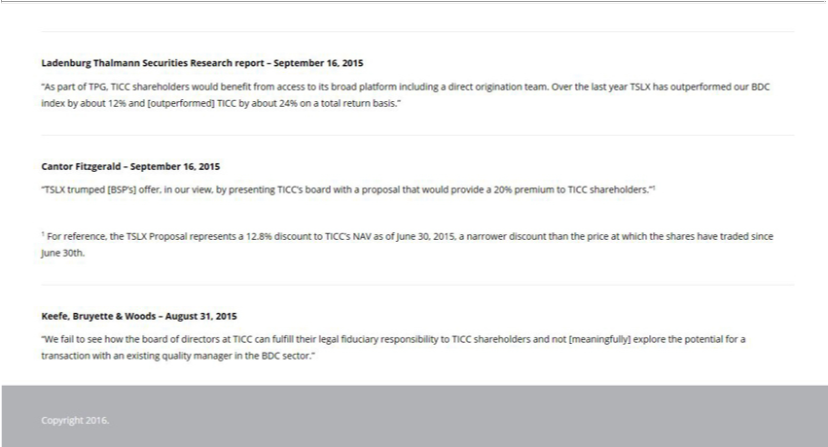

Ladenburg Thalmann Securities Research report – September 16, 2015
“As part of TPG, TICC shareholders would benefit from access to its broad platform including a direct origination team. Over the last year TSLX has outperformed our BDC index by about 12% and [outperformed] TICC by about 24% on a total return basis.”
Cantor Fitzgerald – September 16, 2015
“TSLX trumped [BSP’s] offer, in our view, by presenting TICC’s board with a proposal that would provide_{narrower}20% premium to TICC shareholders.”1
1 For reference, the TSLX Proposal represents a 12.8% discount to TICC’s NAV as of June 30, 2015, a discount than the price at which the shares have traded since June 30th. _{Keefe,} Bruyette & Woods – August 31, 2015
“W fail to see how the_{sector}board of directors at TICC can fulfill their legal fiduciary responsibility to TICC shareholders and not [meaningfully] explore the potential for a transaction with an existing quality
Copyrightmanagerin2016.theBDC .”

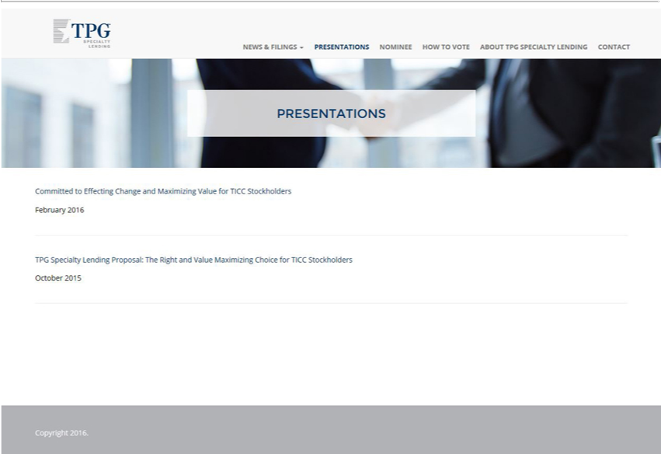

TPGNewsSpecialty&FilingsLending
N_{How}Presentationsminee
to Vote
ContactAboutTPG Specialty Lending
PRESENTATIONS
FebruaryCommitted2016toEffecting Change and Maximizing Value for TICC Stockholders

TPG Specialty Lending Proposal: The Right and Value Maximizing Choice for TICC Stockholders October 2015
Copyright 2016.

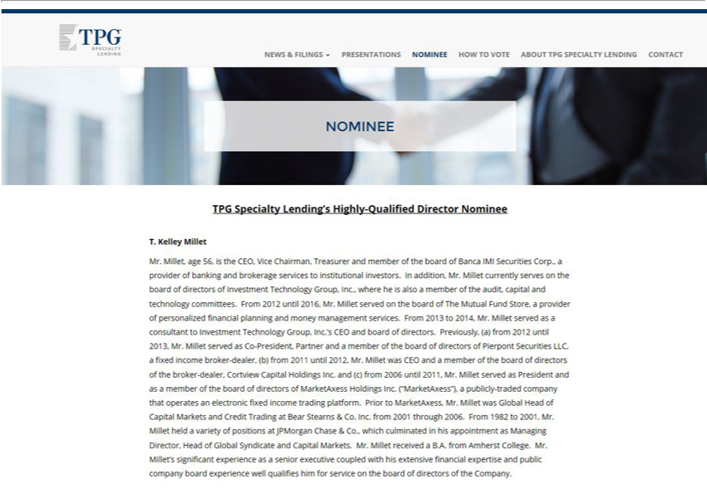

Toggle navigation TPG Specialty Lending
News & Filings
HowNPresentationsminee
to Vote
ContactAboutTPG Specialty Lending
NOMINEE
T.PGKelleySpecialtyMilletLending’s Highly-Qualified Director Nominee
currentlyMr.Millet,servesage56,on isthetheboardCEO,ofVicedirectorsChairman,ofInvestmentTreasurerTechnologyandmemberGroup,oftheInc.,boardwhereofBancaheis alsoIMI Securitiesamember Corp.,ofthe audit,providercapitalof andbankingtechnologyandbrokeragecommittees.servicesFromto 2012institutionaluntil2016,investors.Mr.MilletInaddition,served onMr.theMilletboard of The Mutual Fund Store, provider of personalized financial planning and money management services. From 2013 to 2014, Mr. Millet served as a consultant to Investment Technology Group, Inc.’s CEO and
2011boarduntilofdirectors.2012,Mr.Previously,Milletwas(a)CEOfromand2012amemberuntil2013,oftheMr.boardMilletof serveddirectorsas Coofthe-President,broker-dealer,PartnerCortviewandamemberCapitalofHoldingstheboardInc.ofdirectorsand(c)fromofPierpont2006untilSecurities2011,Mr.LLC,MilletafixedservedincomeasPresidentbroker-dealer,andGlobalas(b)memberfrom of the board of directors of MarketAxess Holdings Inc. (“MarketAxess”), a publicly-traded company that operates an electronic fixed income trading platform. Prior to Mr. Millet was Head of

Capital Markets and Credit Trading at Bear Stearns & Co. Inc. from 2001 through 2006. From 1982 to 2001, Mr. Millet held a variety of positions at JPMorgan ChaseMarketAxess,&Co.which culminated in his appointment as Managing Director, Head of Global Syndicate and Capital Markets. Mr. Millet received a B.A. from Amherst College. Mr. Millet’s significant experience as senior executive coupled with his extensive financial expertise and public company board experience well qualifies him for service on the board of directors of the Company.



TPGNewsSpecialty&FilingsLending
N_{How}Presentationsminee
to Vote
ContactAboutTPG Specialty Lending
HOW TO VOTE
Information on how to vote will be forthcoming.

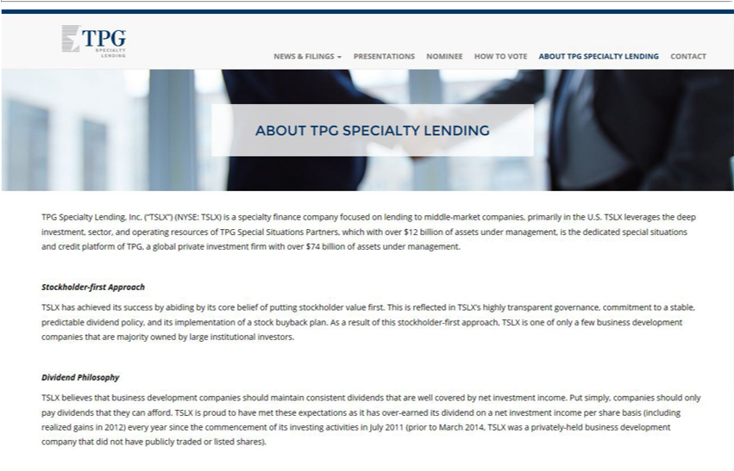

TPG
News & Filings
N_{How}Presentationsminee
to Vote
ContactAboutTPG Specialty Lending
ABOUT TPG SPECIALTY LENDING
TPG Specialty Lending, Inc. (“TSLX”) (NYSE: TSLX) is a specialty finance company focused on lending_{management,}tomiddle-market companies, primarily in the U.S. TSLX leverages the deep investment, sector, and
operating resources of TPG Special Situations Partners, which with over $12 billion of assets under is the dedicated special situations and credit platform of TPG, a global private investment firm with over $74 billion of assets under management.
Stockholder-first Approach
TSLX has achieved its suc_{stock}ess by abiding by its core belief of putting stockholder value first. This is reflected in TSLX’_{business}highly transparent governance, commitment to a stable, predictable dividend policy, and
its implementati_{Philosophy}nof a buyback plan. As a result of this stockholder-first approach, TSLX is one of only a few development companies that are majority owned by large institutional investors. Dividend
^{TSLX} believes that busin^{met}ss development companies should maintain consistent divid^{net}nds that are well covered by net investment income. Put simply, companies should only pay dividends that they can afford.
is proud to have these expectations as it has over-earned its dividend on a investment income per share basis (including realized gains in 2012) every year since the commencement of its investing activities in July 2011 (prior to March 2014, TSLX was a privately-held business development company that did not have publicly traded or listed shares).

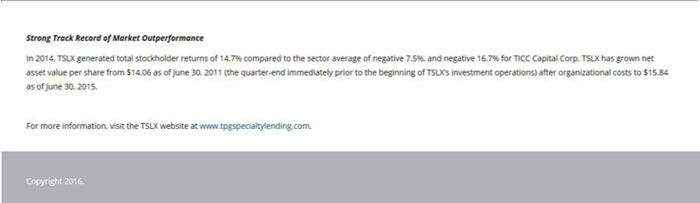

Strong Track Record of Market Outperformance |  | average of negative 7.5%, and negative 16.7% for TICC Capital Corp. TSLX has grown net asset value per share from $14.06
In 2014, TSLX generated total stockholder returns of 14.7% compared to the
as of June 30, 2011 (the quarter-end | prior to the beginning of TSLX’sectorinvestment operations) after organizational costs to $15.84 as of June 30, 2015.
For more information, visit the TSLXimmediatelywebsite www.tpgspecialtylending.com.
Copyright 2016.

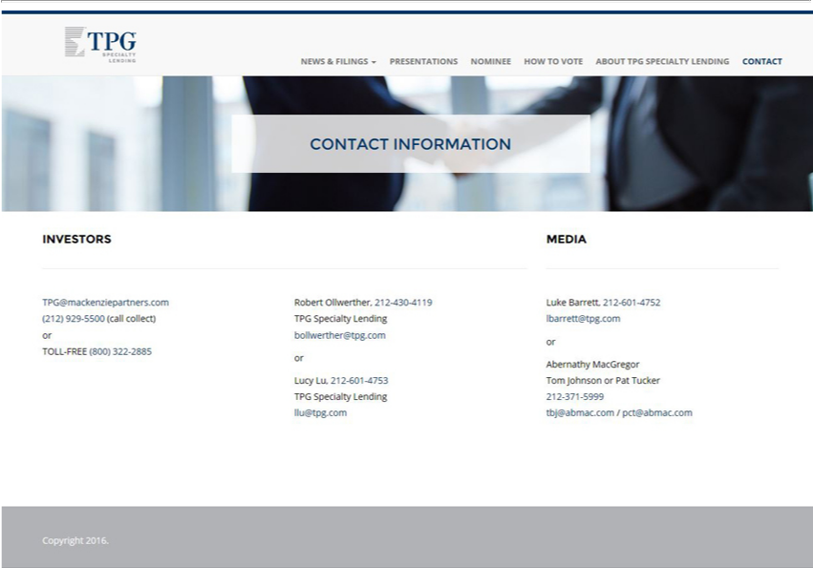

NewsToggle&navigationFilings TPG Specialty Lending
N_{How}Presentationsminee
to Vote
_{CONT}AboutontactTPG Specialty Lending
INVESTORSACTINFORMATION
MEDIA
RobertTPG@mackenziepartners.comOllwerther,212-430-4119(212)TPG929Specialty-5500(callLendingcollect)bollwerther@tpg.comorTOLL-FREE(800) 322-2885
or
^{Luke}
or cy Barrett,Lu,212-212601--6014753-4752TPGlbarrett@tpg.comSpecialtyLending llu@tpg.com
Abernathy MacGregor Tom Johnson or Pat Tucker 212-371-5999 tbj@abmac.com / pct@abmac.com

