UNITED STATES

SECURITIES AND EXCHANGE COMMISSION
Washington, D.C. 20549

SCHEDULE 14A INFORMATION

PROXY STATEMENT PURSUANT TO SECTION 14(a) OF THE

SECURITIES EXCHANGE ACT OF 1934

Filed by the Registrant ☐ Filed by a Party other than the Registrant ☒

Check the appropriate box:

- Preliminary Proxy Statement

- Confidential, for Use of the Commission Only (as permitted by Rule 14a-6(e)(2))

- Definitive Proxy Statement

- Definitive Additional Materials

- Soliciting Material Pursuant to §240.14a-12

TICC CAPITAL CORP.

(Name of Registrant as Specified In Its Charter)

TPG Specialty Lending, Inc.

(Name of Person(s) Filing Proxy Statement, if other than the Registrant)

Payment of Filing Fee (Check the appropriate box):

- Fee not required.

- Fee computed on table below per Exchange Act Rules 14a-6(i)(1) and 0-11.

  - Title of each class of securities to which transaction applies:

  - Aggregate number of securities to which transaction applies:

  - Per unit price or other underlying value of transaction computed pursuant to Exchange Act Rule 0-11 (set forth the amount on which the filing fee is calculated and state how it was determined):

  - Proposed maximum aggregate value of transaction:

  - Total fee paid:

- Fee paid previously with preliminary materials.

- Check box if any part of the fee is offset as provided by Exchange Act Rule 0-11(a)(2) and identify the filing for which the offsetting fee was paid previously. Identify the previous filing by registration statement number, or the Form or Schedule and the date of its filing.

  - Amount Previously Paid:

  - Form, Schedule or Registration Statement No.:

  - Filing Party:

  - Date Filed:

On September 16, 2015, TPG Specialty Lending, Inc. (“TSLX”) issued a press release. A copy of the press release is attached as Exhibit 1.

Also on September 16, 2015, TSLX delivered a presentation at the Global Financial Services Conference hosted by Barclays. This presentation outlined TSLX’s proposal to acquire 100% of the stock of TICC Capital Corp. (“TICC”). Under the proposal, TICC stockholders would receive a number of shares of TSLX common stock that would result in TICC stockholders receiving $7.50 in value per share as of the signing date of a definitive agreement. A copy of this presentation is attached as Exhibit 2.

Exhibit 1


News Release

TPG SPECIALTY LENDING PROPOSES TO ACQUIRE TICC CAPITAL CORP. FOR $7.50 PER SHARE

Proposal Would Deliver Immediate 20% Premium to TICC Capital Stockholders while Providing the Opportunity to Benefit from Long-Term Value Creation Within the Industry’s Leading Platform

Combination Would Be Immediately Accretive to Net Asset Value per Share

Opportunity to Drive Higher Return on Equity and Corresponding Dividends Through Rotation into Assets With More Attractive Risk-Adjusted Returns or Return Capital to Stockholders and Protect Accretion Created in the Transaction

TSLX is Fully Committed to Realizing the Value of This Transaction for All Stockholders and Urges TICC’s Special Committee to Enter into Constructive Discussions

TSLX Intends to Solicit Stockholder Proxies Against Proposed Advisory Agreement

NEW YORK—(BUSINESS WIRE)—Sep. 16, 2015 – TPG Specialty Lending, Inc. (“TSLX”; NYSE: TSLX), a specialty finance company focused on lending to middle-market companies, today announced that it has made a proposal to acquire TICC Capital Corp. (“TICC”; Nasdaq: TICC) in a stock-for-stock transaction. TSLX believes that the proposed transaction would deliver an immediate and substantial premium to TICC stockholders and significant long-term value to stockholders of both companies.

Under the terms of the non-binding proposal delivered to the Special Committee of TICC’s Board of Directors on September 10, 2015, TICC stockholders would receive a number of shares of TSLX common stock that results in TICC stockholders receiving $7.50 in value per share as of the signing date of a definitive agreement, representing approximately a 20% premium to TICC’s closing stock price on September 15, 2015. After giving effect to the proposed transaction, TICC stockholders would have the opportunity to participate in the future value creation of an industry-leading platform.

In addition to the substantial up-front premium to TICC stockholders, key aspects of the proposal include:

- ACCRETIVE TO NET ASSET VALUE - The combination would be immediately accretive to net asset value per share and is expected to drive higher return on equity over time.

- PROVEN TRACK RECORD - TSLX has a proven track record of delivering superior returns and stable dividends to stockholders. In 2014, TSLX generated total returns of 14.7% compared to the sector average of -7.5%. TSLX has grown net asset value per share from $14.06 after organizational costs to $15.84 as of June 30, 2015.

- INCREASED LIQUIDITY - TICC stockholders would benefit from increased liquidity, by owning shares in a combined company having a pro forma market capitalization potentially in excess of $1.3 billion, as compared to TICC’s current market capitalization of approximately $380 million.

- CONSISTENT AND STABLE DIVIDEND - TSLX believes business development companies should maintain consistent dividends that are well covered by net investment income. TSLX has earned per share

net investment income1 in excess of its dividend every year since its inception. It is expected that TSLX will continue its current dividend policy and, to the extent it is successful in rotating the TICC portfolio into higher yielding investments as described below, this policy would result in stockholders enjoying increased dividends.

- PROVEN ABILITY TO GENERATE RETURN ON EQUITY FOR STOCKHOLDERS - TICC stockholders would benefit from TSLX’s ability to generate industry leading return on equity for stockholders. In 2014, TSLX generated approximately a 13% return on equity based on net investment income compared to an industry return of approximately 9% given its ability to originate high risk adjusted return credit opportunities and its competitive cost structure.

TSLX leverages the deep investment, sector, and operating resources of TPG Special Situations Partners (“TSSP”), which with over $12 billion of assets under management, is the dedicated special situations and credit platform of TPG, a global private investment firm with over $74 billion of assets under management. TSSP employs 133 professionals across four offices representing the full complement of sourcing, underwriting and asset management across credit disciplines.

TSLX expects to leverage its expertise to rotate the TICC portfolio into higher value added investments focused on illiquid private credit that have a superior risk-return profile and a market-leading cost structure to drive higher return on equity over time. Where there is no opportunity to rotate assets, TSLX is committed to returning excess capital to stockholders to protect net asset value per share accretion that was created in the transaction.

TSLX made its proposal privately to the Special Committee of TICC’s Board of Directors on September 10, 2015 with the intention of entering into constructive discussions. On September 15, 2015 TSLX was advised that TICC’s Special Committee had rejected the offer without engaging TSLX or its advisors in substantive dialogue regarding the proposal. TSLX remains fully committed to pursuing this transaction for the benefit of all stockholders and urges the Special Committee to enter into constructive discussions with TSLX pursuant to its fiduciary duties.

TSLX also intends to solicit proxies of TICC stockholders against the proposals to be considered by TICC stockholders at its special meeting on October 27, 2015. TSLX expects to file with the Securities and Exchange Commission (“SEC”) a proxy statement with respect to such solicitation in the near future. TSLX owns approximately 3% of the outstanding shares of TICC and plans to vote its shares against the proposals recommended by the TICC board.

Joshua Easterly, Chairman of the Board of Directors and Co-Chief Executive Officer of TSLX commented: “As TICC considers its future, we felt the timing was right to present our own proposal for a mutually beneficial transaction that would generate significant returns for stockholders of both organizations, as opposed to rewarding external managers. We believe that a core component of the value embedded in our offer is our industry-leading governance philosophy. We are among a select group of participants in the BDC sector that puts stockholders first and, as a result, we deliver best-in-class returns. In fact, TSLX delivered total returns of 14.7% while the sector average was -7.5% in 2014.

“We are disappointed that TICC’s Special Committee rejected our proposal so quickly and has refused to engage substantively with us. However, we remain fully committed to making this combination a reality and will continue to pursue unlocking the value inherent in the proposal for both companies’ stockholders.

“We agree with NexPoint that stockholders should reject the Benefit Street Partners proposal. However, the NexPoint proposal is equally flawed as both transactions provide returns only for external managers and offer no immediate value to stockholders. This focus on fees for an external manager is in sharp contrast to the upfront 20% premium and long-term value creation potential that our proposal delivers to the long-suffering TICC stockholders.”

Goldman, Sachs & Co. is acting as financial advisor and Cleary Gottlieb Steen & Hamilton LLP is acting as legal advisor to TSLX.

- Includes realized gains in 2012.

The full text of the letter delivered to the Special Committee of TICC’s Board of Directors by TSLX on September 10, 2015 is included below.

The Special Committee of the Board of Directors

TICC Capital Corp.

8 Sound Shore Drive, Suite 255

Greenwich, CT 06830

Attention: Mr. Steven P. Novak, Chairman

Dear Steve:

Thank you for the opportunity to speak with you earlier today. As we discussed, we at TPG Specialty Lending, Inc. (“TSLX”) have watched the recent events regarding the future of TICC Capital Corp. (“TICC”) with significant interest. After a great deal of consideration and analysis, we feel strongly that a combination of our two businesses would be in our mutual interests as it will deliver an immediate and substantial premium to your stockholders while offering a clear path to long-term value creation for stockholders of both organizations.

We are therefore pleased to propose a transaction in which TICC would merge with a wholly owned subsidiary of TSLX, and each outstanding share of TICC common stock would be converted into the right to receive a number of shares of TSLX common stock that results in TICC stockholders receiving $7.50 in value per share as of the signing date of a definitive agreement, representing a 20% premium to the undisturbed trading price of TICC’s common stock as of August 3, 2015. Alternatively, we would also be open to discussing with you a transaction in which TICC stockholders receive a combination of cash and shares of TSLX common stock for their TICC stock.

We are aware of TICC’s recent decision to enter into a new investment advisory agreement with TICC Management, LLC in connection with the acquisition of TICC Management, LLC by an affiliate of Benefit Street Partners L.L.C. (“Benefit Street Partners”). We feel strongly, and believe your stockholders will as well, that our alternative offer is far superior to a proposal to replace the existing investment advisory agreement given the immediate and highly compelling value it provides to TICC stockholders.

TSLX is a specialty finance company focused on providing flexible, fully committed financing solutions to middle market companies principally located in the United States. We partner with companies across a variety of industries and excel at providing creative solutions to companies with complex business models that may have limited access to capital. Similar to TICC, we are a business development company and are externally managed by TSL Advisers, LLC, an SEC-registered investment adviser.

As detailed in the attached appendix, our business is strongly differentiated by our ability to leverage the deep investment, sector, and operating resources of TPG Special Situations Partners (“TSSP”), the dedicated special situations and credit platform of TPG, with over $12 billion of assets under management, and the broader TPG platform, a global private investment firm with over $74 billion of assets under management.

We have the expertise and experience to be an excellent steward of TICC’s portfolio. Though we intend to rotate TICC’s assets into higher value added investments focused on illiquid private credit, we have a deep understanding of liquid credit investments and CLO equity investments. TSSP manages investment vehicles that hold over $2.0 billion of similar assets and manages four active CLOs.

Further, among business development companies, TSLX has one of the largest proportions of institutional stockholders. We strive for transparency with investors and have a proven track record of returns to our stockholders. Last year, we generated total returns of 14.7% compared to the sector average of -7.5%.2 We have over-earned our dividend on a net investment income per share basis every year since our inception, while growing net asset value per share from $14.06 after organizational costs to $15.84 as of June 30, 2015. As of June 30, 2015, our portfolio had a fair value of approximately $1,398 million invested across 40 portfolio companies.

- Sector average calculated as the average 2014 total share price return of ARCC, ACAS, PSEC, AINV, MAIN, FSC, SLRC, GBDC, HTGC, PNNT, MCC, TCAP, NMFC, BKCC, and TCRD.

A combination with TSLX offers clear advantages to the existing proposals to replace TICC’s current investment advisory agreement:

- First, TICC stockholders would be able to exchange their shares at a 20% premium to the undisturbed trading price of TICC’s common stock as of August 3, 2015.

- Second, after giving effect to our proposed transaction, TICC stockholders would enjoy the benefits under TSLX’s investment advisory agreement of a highly competitive management fee of 1.5% and an adviser incentive fee of 17.5% over a 6% hurdle rate.

- Third, TSLX has a proven track record of delivering superior returns to stockholders and of stable dividends. Not only has TSLX over-earned its dividend on net investment income every year since inception, but its dividend has been stable since TSLX went public in March 2014. Our stock-for-stock proposal provides TICC stockholders with the option to participate in this demonstrated long-term growth and to invest in less accessible illiquid assets that have superior risk return, while benefiting from a market-leading cost structure that drives return on equity for stockholders.

- Fourth, as a result of our proposed transaction, TICC stockholders would benefit from increased liquidity, by owning shares in a combined company having a pro forma market capitalization potentially in excess of $1.3 billion, as compared to TICC’s current market capitalization of approximately $415 million.

In sum, any proposal focused solely on replacing TICC’s current investment advisory agreement cannot deliver the significant and tangible benefits of the substantial and immediate up-front premium we are offering, nor the increased liquidity and opportunity for long-term growth provided by our proposal.

TSLX has a keen interest in value being delivered to TICC stockholders, as we currently own approximately 3% of TICC’s outstanding common stock. These shares are eligible to vote at the special meeting of stockholders to be held on October 27, 2015 to approve the new investment advisory agreement. More generally, we are committed to fostering a culture of robust corporate governance. We seek transparency and to put stockholders first, as evidenced by, among other things, our selective capital raising efforts and continuous stock repurchase programs.

While we believe that our proposal is a full and fair one, we note that it is based solely on publicly available information and our knowledge of the industry. We would welcome the opportunity to gain a deeper understanding of TICC and the resulting benefits of a combination with TSLX by conducting confirmatory due diligence of a customary nature. In connection with our proposal, we have retained Goldman, Sachs & Co. as our financial advisor and Cleary Gottlieb Steen & Hamilton LLP as our legal advisor. We and our advisors are prepared to get started immediately on confirmatory due diligence and the negotiation of appropriate definitive agreements, and believe that, with your cooperation and assistance, we can complete the process very promptly.

Given the premium our proposal offers for TICC’s shares, we trust that the Special Committee will give it careful consideration. We look forward to hearing from you promptly, and stand ready and willing to promptly engage in discussions and address any questions or concerns you may have. We also reserve the right to publicly disclose this letter and to take other steps in furtherance of our proposal.

As we are sure you can appreciate, our proposal is also subject, among other things, to the negotiation and execution of mutually acceptable definitive agreements.

Accordingly, this letter does not constitute or create any commitment, undertaking or other binding obligation or limitation on the part of any person in any respect.

Only those obligations set forth in definitive agreements will be binding upon the parties.

We hope you will be as excited as we are about this transaction, and we look forward to discussing it with you.

Very truly yours,

Joshua Easterly

Chairman, Board of Directors

Co-Chief Executive Officer

Michael Fishman

Co-Chief Executive Officer

Appendix A

TPG Special Situations Partners (“TSSP”) is a multi-asset class credit and special situations investment platform, managing over $12 billion in assets as of June 30, 2015 across middle market direct loan origination, syndicated leveraged loan, special situations and distressed investment strategies. As of July 31, 2015, TSSP had 133 professionals operating from offices in San Francisco, New York, London, Dallas, and Fort Worth. TSSP was formed in 2009 as the dedicated credit and special situations platform of TPG Capital (“TPG”) and currently encompasses:

- TPG Specialty Lending (“TSLX”), a NYSE-listed business development company focused primarily on directly originating loans to U.S.-domiciled middle market companies;

- TPG Institutional Credit Partners (“TICP”), which is a public-side credit investment platform focused on investment opportunities in broadly syndicated leveraged loan markets;

- TPG Specialty Lending Europe, which is aimed at European middle-market loan originations;

- TPG Opportunities Partners and TPG Adjacent Opportunities Partners, which invest in special situations and distressed investments across the credit cycle; and

- Austin Credit Macro, which is focused on macro credit opportunities.

From inception in July 2011 through June 30, 2015, TSLX has originated more than $3.7 billion aggregate principal amounts of investments and currently manages a portfolio of approximately $1.4 billion at fair value as of June 30, 2015. From inception through June 30, 2015, TSLX has generated 16.4% gross unlevered returns on more than $900 million of realized investments. TICP, which began operations in October 2013, currently manages four CLOs with total CLO assets under management of over $2.0 billion as of June 30, 2015.

TPG is one of the largest alternative asset investment firms globally. Since its founding in 1992, TPG has focused on investing in alternative assets, including private equity, growth equity, venture capital, public equity and real estate and currently manages over $74 billion in assets. Collectively, TSSP and TPG have more than 814 employees operating from 17 offices across North America, South America, Europe, and Asia.

About TPG Specialty Lending

TPG Specialty Lending, Inc. (“TSLX”, or the “Company”) is a specialty finance company focused on lending to middle-market companies. The Company seeks to generate current income primarily in U.S.-domiciled middle-market companies through direct originations of senior secured loans and, to a lesser extent, originations of mezzanine loans and investments in corporate bonds and equity securities. The Company has elected to be regulated as a business development company, or a BDC, under the Investment Company Act of 1940 and the rules and regulations promulgated thereunder. TSLX is externally managed by TSL Advisers, LLC, a Securities and Exchange Commission (“SEC”) registered investment adviser. TSLX leverages the deep investment, sector, and operating resources of TPG Special Situations Partners, the dedicated special situations and credit platform of TPG, with over $12 billion of assets under management, and the broader TPG platform, a global private investment firm with over $74 billion of assets under management. For more information, visit the Company’s website at www.tpgspecialtylending.com.

Contacts:

Investors

Robert Ollwerther

TPG Specialty Lending

212-430-4119

bollwerther@tpg.com

Lucy Lu

TPG Specialty Lending

212-601-4753

llu@tpg.com

Media

Luke Barrett

212-601-4752

lbarrett@tpg.com

Tom Johnson or Pat Tucker

Abernathy MacGregor

212-371-5999

tbj@abmac.com / pct@abmac.com

Forward-Looking Statements

Information set forth herein includes forward-looking statements within the meaning of Section 27A of the Securities Act of 1933, as amended, and Section 21E of the Securities Exchange Act of 1934, as amended (the “Exchange Act”). These forward-looking statements include, but are not limited to, statements regarding TSLX’s proposed business combination transaction with TICC Capital Corp. (“TICC”) (including financing of the proposed transaction and the benefits, results, effects and timing of a transaction), all statements regarding TSLX’s (and TSLX and TICC’s combined) expected future financial position, results of operations, cash flows, dividends, financing plans, business strategy, budgets, capital expenditures, competitive positions, growth opportunities, plans and objectives of management, and statements containing the words such as “anticipate,” “approximate,” “believe,” “plan,” “estimate,” “expect,” “project,” “could,” “would,” “should,” “will,” “intend,” “may,” “potential,” “upside,” and other similar expressions. Statements set forth herein concerning the business outlook or future economic performance, anticipated profitability, revenues, expenses, dividends or other financial items, and product or services line growth of TSLX (and the combined businesses of TSLX and TICC), together with other statements that are not historical facts, are forward-looking statements that are estimates reflecting the best judgment of TSLX based upon currently available information.

Such forward-looking statements are inherently uncertain, and stockholders and other potential investors must recognize that actual results may differ materially from TSLX’s expectations as a result of a variety of factors, including, without limitation, those discussed below. Such forward-looking statements are based upon management’s current expectations and include known and unknown risks, uncertainties and other factors, many of which TSLX is unable to predict or control, that may cause TSLX’s plans with respect to TICC, actual results or performance to differ materially from any plans, future results or performance expressed or implied by such forward-looking statements. These statements involve risks, uncertainties and other factors discussed below and detailed from time to time in TSLX’s filings with the SEC.

Risks and uncertainties related to the proposed transaction include, among others, uncertainty as to whether TSLX will further pursue, enter into or consummate the transaction on the terms set forth in the proposal or on other terms, potential adverse reactions or changes to business relationships resulting from the announcement or completion of the transaction, uncertainties as to the timing of the transaction, adverse effects on TSLX’s stock price resulting from the announcement or consummation of the transaction or any failure to complete the transaction, competitive responses to the announcement or consummation of the transaction, the risk that regulatory or other approvals and financing required for the consummation of the transaction are not obtained or are obtained

subject to terms and conditions that are not anticipated, costs and difficulties related to the integration of TICC’s businesses and operations with TSLX’s businesses and operations, the inability to obtain, or delays in obtaining, cost savings and synergies from the transaction, unexpected costs, liabilities, charges or expenses resulting from the transaction, litigation relating to the transaction, the inability to retain key personnel, and any changes in general economic and/or industry specific conditions.

In addition to these factors, other factors that may affect TSLX’s plans, results or stock price are set forth in TSLX’s Annual Report on Form 10-K and in its reports on Forms 10-Q and 8-K.

Many of these factors are beyond TSLX’s control. TSLX cautions investors that any forward-looking statements made by TSLX are not guarantees of future performance. TSLX disclaims any obligation to update any such factors or to announce publicly the results of any revisions to any of the forward-looking statements to reflect future events or developments.

Additional Information

The information set forth herein is provided for informational purposes only and does not constitute an offer to purchase or the solicitation of an offer to sell any securities. TSLX intends to make a preliminary filing with the SEC of a preliminary proxy statement and accompanying proxy card to be used to solicit votes against (a) approval of the new advisory agreement between TICC and TICC Management, LLC (the “Adviser”), to take effect upon a change of control of the Adviser in connection with the entrance of the Adviser into a purchase agreement with an affiliate of Benefit Street Partners L.L.C. (“Benefit Street Partners”), pursuant to which BSP will acquire control of the Adviser, and (b) the election of six directors nominated by TICC’s board of directors at a special meeting of stockholders of TICC scheduled to be held on October 27, 2015 (the “Special Meeting”).

TSLX STRONGLY ADVISES ALL STOCKHOLDERS OF THE COMPANY TO READ THE TSLX PROXY STATEMENT AND ITS OTHER PROXY MATERIALS AS THEY BECOME AVAILABLE BECAUSE THEY WILL CONTAIN IMPORTANT INFORMATION. SUCH TSLX PROXY MATERIALS WILL BE AVAILABLE AT NO CHARGE ON THE SEC’S WEB SITE AT HTTP://WWW.SEC.GOV AND AT TSLX’S WEBSITE AT HTTP://WWW.TPGSPECIALTYLENDING.COM. IN ADDITION, TSLX WILL PROVIDE COPIES OF THE PROXY STATEMENT WITHOUT CHARGE, WHEN AVAILABLE, UPON REQUEST. REQUESTS FOR COPIES SHOULD BE DIRECTED TO TSLX’S PROXY SOLICITOR AT PROXY@MACKENZIEPARTNERS.COM.

Participants in a Solicitation

TSLX and certain of its respective directors and executive officers may be deemed to be participants in any solicitation with respect to the proposed transaction under the rules of the SEC. Security holders may obtain information regarding the names, affiliations and interests of TSLX’s directors and executive officers in TSLX’s Annual Report on Form 10-K for the year ended December 31, 2014, which was filed with the SEC on February 24, 2015, its proxy statement for the 2015 Annual Meeting, which was filed with the SEC on April 10, 2015 and certain of its Current Reports on Form 8-K. These documents can be obtained free of charge from the sources indicated above. Additional information regarding the interests of these participants in the proxy solicitation and a description of their direct and indirect interests, by security holdings or otherwise, will also be included in any proxy statement and other relevant materials to be filed with the SEC when they become available.

As of the date hereof, TSLX directly beneficially owned 1,633,660 shares of Common Stock of TICC.

Source: TPG Specialty Lending, Inc.

Exhibit 2
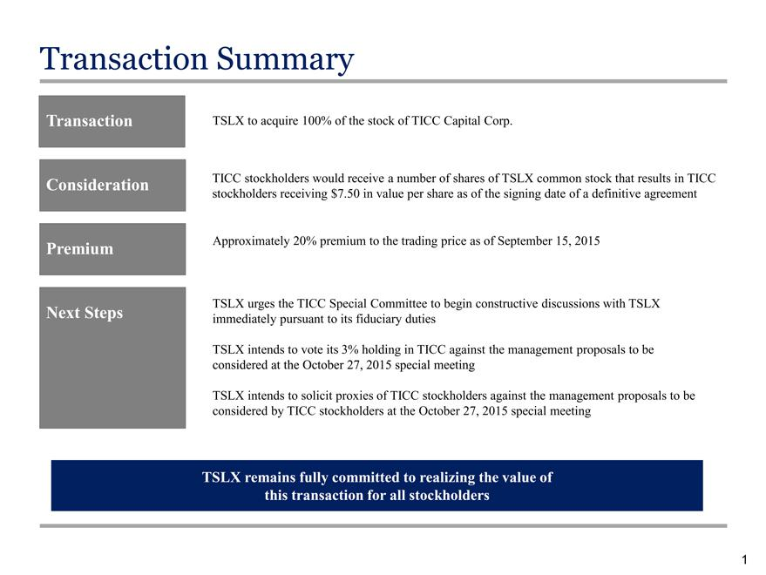

Transaction ^{Summary}
TSLX to acquire 100% of the stock of TICC Capital Corp.
_{stockholders}Cnsideration TICC stockholders would receive a number of shares of TSLX common stock that results in TICC receiving $7.50 in value per share as of the signing date of a definitive agreement
Premium Approximately 20% premium to the trading price as of September 15, 2015
TSLX urges the TICC Special Committee to begin constructive discussions with TSLX
Next Steps immediately pursuant to its fiduciary duties
consideredTSLXintendsattheto voteOctoberits3%27,holding2015specialinTICCmeetingagainst the management proposals to be
consideredTSLXintendsby TICCtosolicitstockholdersproxiesof atTICCtheOctoberstockholders27,2015againstspecialthe managementmeeting proposals to be
1TSLX remains fully committed to realizing the value of this transaction for all stockholders

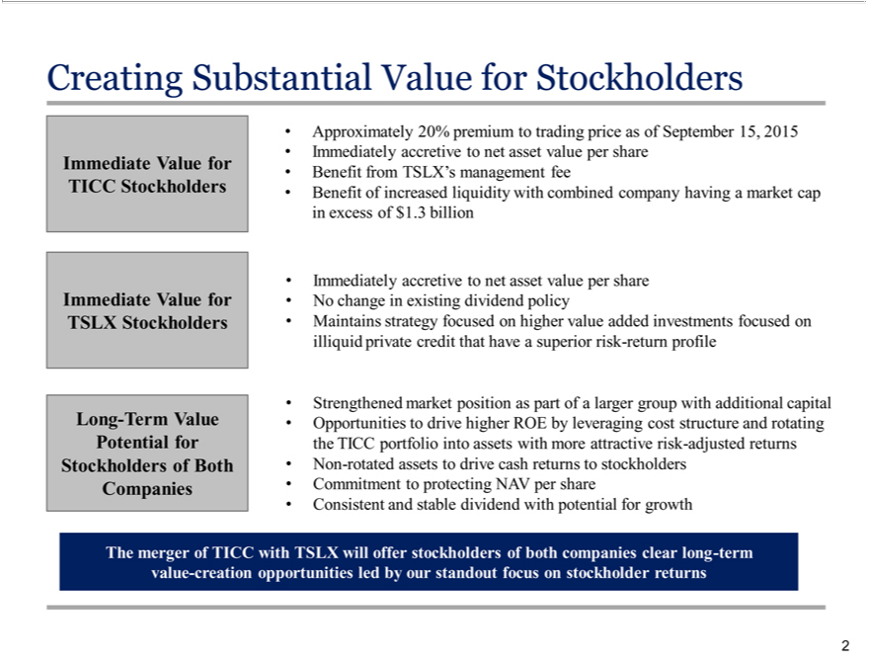

Creating Substantial Value for Stockholders
ICC Stockholders
LongImmediate-TermValueValue forPotentialTSLX forStockholdersStockholders of Both Companies
BenefitApproximatelyfromTSLX’s20%premiummanagementtotradingfee price as of September 15, 2015 Immediately accretive to net asset value per share of increased liquidity with combined company having a market cap in excess of $1.3 billion

ImmedMaitainsatelystrategyaccretivefocusedtonetonassethighervalue peraddedshare investmentsNochangeinfocusedexistingondividendilliquid policyprivate credit that have a superior risk-return profile
Strengthened market position as part ofvaluelarger group with additional capital Opportunities to drive higher ROE by leveraging cost structure and rotating the TICC portfolio into assets with more attractive risk-adjusted returns Non-rotated assets to drive cash returns_{stockholders}stockholders Commitment to protecting NAV per share Consistent and stable dividend with potential for growth

The merger of TICC with TSLX will offer of both companies clear long-term value-creation opportunities led by our standout focus on stockholder returns 2

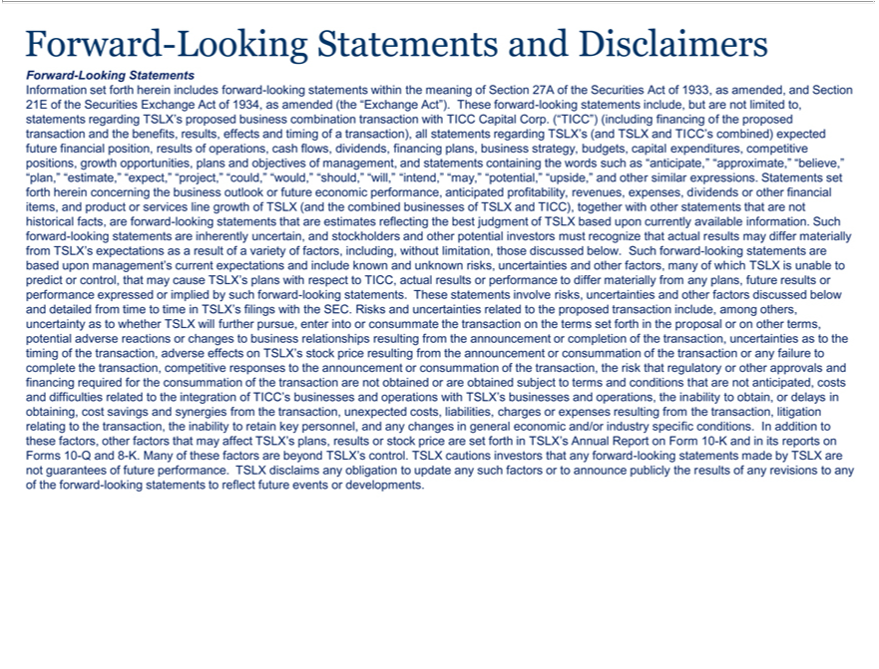

Forward-Looking Stateme ts ^{and Disclaimers}
Information set forth herein includes forward-looking statements within the meaning of Section 27A of the Securities Act of 1933, as amended, and Section |  |  |  |  |  |  |  | combination
21E of the Securities Exchange Act of 1934, as amended (the “Exchange Act”). These forward-looking statements include, but are not limited to, statements regarding TSLX’s proposed |  |  |  |  |  |  |  | combination
transaction with TICC Capital Corp. (“TICC”) (including financing of the proposed transaction and the benefits, results, effects and timing of a transaction), all statements regarding TSLX’business(and TSLX and TICC’s
combined) expected future financial position, results of operations, |  |  | flows, dividends, financing plans, business strategy budgets, capital expenditures, competitive positions, growth opportunities, plans and
objectives of management, and statements containing the words suchcash “anticipate,” “approximate,” “believe,” “plan,” “estimate,” |  |  |  |  | “expect,” “project,” | “would,” “should,” “will,” “intend,” “may,” “potential,”
“upside,” and other similar expressions. Statements set forth herein concerning the business outlook or future economic performance, anticipated profitability“could,”revenues, expenses, dividends or other financial items, and
product or services line growth of TSLX (and the combined businesses of TSLX and TICC), together with other statements that are not historical facts, are forward-looking statements that are estimates reflecting the
best judgment of TSLX based upon currently |  |  | . Such forward-looking statements are inherently uncertain, and stockholders and other potential investors must recognize that actual results may
differ materially from TSLX’s expectations asavailableresultofinformationvarietyof factors, including, without limitation, those discussed below. Such forward-looking statements are based upon management’s current expectations
and include known and unknown risks, uncertainties and other |  |  | many of which TSLX is unable to predict or control, that may cause TSLX’s plans with respect to TICC, actual results or performance to differ
materially from any plans, future results or performance expressedfactors,implied by such forward-looking statements. These statements involve risks, uncertainties and other factors discussed below and detailed from time
to time in TSLX’s | with the SEC. Risks and uncertainties related to the proposed transaction include, among others, uncertainty as to whether TSLX will further pursue, enter into or consummate the transaction
on the terms set forthfilingsthe proposal or on other terms, potential adverse reactions or changes to business relationships resulting from the announcement or completion of the transaction, uncertainties as to the timing of
the transaction, adverse effects on TSLX’s stock price resulting from the announcement or consummation of the transaction or any failure to complete the transaction, competitive responses to the announcement or
consummation of the transaction, the risk that regulatory or other |  |  | and financing required for the | of the transaction are not obtained or are |  |  | subject to terms and conditions that are not
anticipated, costs and difficulties related to the integration of TICC’approvalsbusinesses and operations with TSLX’consummationbusinssesand operations, the inability to obtain, or delaysobtainedobtaining, cost savings and synergies from the
transaction, unexpected costs, liabilities, charges |  | expenses resulting from the transaction, litigation relating to the transaction, the |  |  | to retain key |  | and any changes in general | mic and/or
industry specific conditions. In addition to |  | factors, other factors that may affect TSLX’s plans, results or stock price are set forthinabilityTSLX’ Annual Reportpersonnel,Form 10-K and in its reports econForms 10-Q and 8-
K. Many of the e | are beyond TSLX’thesecontrol. TSLX cautions investors that any forward-looking statements made by TSLX are not guarantees of future performance. TSLX disclaims any obligation to update
any such factors orfactorsannounce publicly the results of any revisions to any of the forward-looking statements to reflect future events or developments.

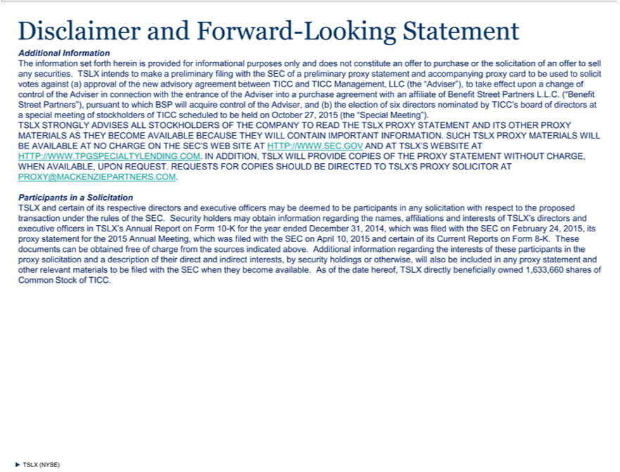

Disclaimer and Forward-Looking Statement
Additional Information
The information set forth herein is provided for informational purposes only and does not constitute an offer to purchase or the solicitation of an offer to sell any securities. TSLX intends to make a preliminary filing
with the SEC of a |  |  | proxy statement and | proxy card to be used to solicit votes |  | (a) approval of the new advisory agreement between TICC and TICC Management, LLC (the “Adviser”),
to take effect uponpreliminarychangeof control of the Adviseraccompanyingconnection with the entrance of the Adviser intoagainstpurchase agreement with an affiliate of Benefit Street Partners L.L.C. (“Benefit Street Partners”), pursuant to
which BSP will acquire control of the Adviser, and (b) the election of six directors nominated by TICC’s board of directors at a special meeting of stockholders of TICC scheduled to be held on October 27, 2015 (the
“Special Meeting”). |  |  |  |  | PROXY STATEMENT AND ITS OTHER PROXY
TSLX STRONGLY ADVISES ALL STOCKHOLDERS OF THE COMPANY O READ THE
MA | AS |  | BECOME AVAILABLE BECAUSE | WILL CONTAIN IMPORTSLXANT INFORMATION. SUCH TSLX PROXY MATERIALS WILL
BE TERIALSVAILABLE |  | THEYNO CHARGE ON THE SEC’S WEB SITETHEY HTTP://WWW.SEC.GOV AND AT TSLX’S WEBSITE A
HTTP://WWW.TPGSPECIALTYLENDING.COM. IN ADDITION, TSLX WILL PROVIDE |  |  |  |  | OF THE PROXY STATEMENT WITHOUT CHARGE,
WHEN VAILABLE, UPON REQUEST. REQUESTS FOR COPIES SHOULD BE DIRECTEDCOPIESTTSLX’S PROXY SOLICITOR AT
ROXY@MACKENZIEPARTNERS.COM.
Participants | a Solicitation |  |  |  |  | with respect to the proposed transaction under the rules of the SEC. Security holders may obtain
TSLX and certain of its respective directors and executive officers may be deemed to be participants in any
information regarding the names, affiliations and interests of TSLX’s directors and executive officers in TSLX’solicitationAnnual Report on Form 10-K for the year ended December 31, 2014, which was filed with the SEC on
February 24, 2015, its proxy statement for the 2015 Annual Meeting, which was filed with the SEC on April 10, 2015 and certain of its Current Reports on Form 8-K. These documents can be obtained free of charge
from the sources |  |  | above. Additional information regarding the interests of these participants in |  |  | proxy solicitation and a description their direct and indirect interests, by security holdings or otherwise,
will also be includedindicatedany proxy statement and other relevant materials to be filed with the SEC when they become available. As of the date hereof, TSLX directly beneficially owned 1,633,660 shares of Common Stock of TICC.
TSLX (NYSE)

