UNITED STATES

SECURITIES AND EXCHANGE COMMISSION
Washington, D.C. 20549

FORM 8-K

CURRENT REPORT

Pursuant to Section 13 or 15(d)
of the Securities Exchange Act of 1934

Date of Report (Date of earliest event reported): July 23, 2020

Sixth Street Specialty Lending, Inc.

(Exact name of registrant as specified in charter)

Delaware | 001-36364 | 27-3380000
(State or Other Jurisdiction | (Commission | (I.R.S. Employer
of Incorporation) | File Number) | Identification No.)
2100 McKinney Avenue, Suite 1500
 | Dallas, TX | 75201
(Address of Principal Executive Offices) |  | (zip code)

Registrant’s telephone number, including area code: (469) 621-3001

Check the appropriate box below if the Form 8-K filing is intended to simultaneously satisfy the filing obligation of the registrant under any of the following provisions:

- Written communications pursuant to Rule 425 under the Securities Act (17 CFR 230.425)

- Soliciting material pursuant to Rule 14a-12 under the Exchange Act (17 CFR 240.14a-12)

- Pre-commencement communications pursuant to Rule 14d-2(b) under the Exchange Act (17 CFR 240.14d-2(b))

- Pre-commencement communications pursuant to Rule 13e-4(c) under the Exchange Act (17 CFR 240.13e-4(c))

Securities registered pursuant to Section 12(b) of the Act:

Title of each class | Trading Symbol(s) | Name of each exchange on which registered
Common Stock, par value $0.01 per share | TSLX | The New York Stock Exchange

Indicate by check mark whether the registrant is an emerging growth company as defined in Rule 405 of the Securities Act of 1933 (§230.405 of this chapter) or Rule 12b-2 of the Securities Exchange Act of 1934 (§240.12b-2 of this chapter).

Emerging growth company ☐

If an emerging growth company, indicate by check mark if the registrant has elected not to use the extended transition period for complying with any new or revised financial accounting standards provided pursuant to Section 13(a) of the Exchange Act. ☐

Item 2.02 – Results of Operations and Financial Condition

On July 23, 2020, the registrant issued a shareholder letter on a press release that provides preliminary updates on the registrant’s business and financial performance for the quarter ended June 30, 2020. A copy of the shareholder letter is furnished as Exhibit 99.1 to this report.

The information disclosed under this Item 2.02, including Exhibit 99.1 hereto, is being furnished and shall not be deemed “filed” for purposes of Section 18 of the Securities Exchange Act of 1934 and shall not be deemed incorporated by reference into any filing made under the Securities Act of 1933, except as expressly set forth by specific reference in such filing.

Item 9.01 – Financial Statements and Exhibits

- Exhibits:

Exhibit | Description
Number | Description

99.1 Press release, dated July 23, 2020

SIGNATURES

Pursuant to the requirements of the Securities Exchange Act of 1934, as amended, the Registrant has duly caused this report to be signed on its behalf by the undersigned hereunto duly authorized.

SIXTH STREET SPECIALTY LENDING, INC.

(Registrant)

Date: July 23, 2020 By: /s/ Ian Simmonds

Ian Simmonds

Chief Financial Officer

Exhibit 99.1


Sixth Street Specialty Lending, Inc. Provides a Business Update and Preliminary Q2 2020 Financial Results

NEW YORK—(BUSINESS WIRE)—July 23, 2020— Sixth Street Specialty Lending, Inc. (NYSE: TSLX, or the “Company”) today sent the following letter to its stakeholders to provide a business update and preliminary Q2 2020 financial results.

July 23, 2020

Dear Stakeholder,

We hope that this letter finds you well, and we and everyone across the Sixth Street platform continue to send our best regards to you and your loved ones. As part of our commitment to providing our stakeholders with relevant and timely information on our business and financial results, we have prepared the following summarized preliminary financial results for the quarter ended June 30, 2020. We have also included updates on our portfolio; observations from our Q2 quarterly portfolio valuation process; a preliminary Q2 NAV bridge; thoughts on our sector’s (and our own) business model and its inherent constraints; our liquidity, funding and capital profile; and our post-quarter end activity.

We believe that transparency is the foundation for our relationship with our stakeholders and strengthens our position to best serve all of our clients, including issuers and financial sponsors. We hope the format is a welcome break from another Zoom conference call. However, don’t fret – we will continue to host our live quarterly earnings calls.

Summary Preliminary Financial Results for Quarter Ended June 30, 2020

The following information is preliminary, based upon information available to us as of today and is subject to change as a result of the completion of our financial closing procedures, including any final adjustments or other developments:

- Estimated net asset value per share at June 30, 2020 was $16.08, an increase of 3.2% from our reported net asset value per share of $15.57 at March 31, 2020 (which is prior to the impact of the $0.50 aggregate special dividends per share that were paid in Q2). Using our pro forma net asset value per share from March 31, 2020 of $15.07 (that is, reflecting the impact of the $0.50 aggregate special dividends in Q2), net asset value per share increased by an estimated 6.7% to June 30, 2020.

- Estimated net investment income per share was approximately $0.59, compared to our Q2 base dividend per share of $0.41. This was driven by strong prepayment (most notably prepayment fees related to our fully realized investment in Ferrellgas) and other fee activity during the quarter.

- Estimated net income per share was approximately $1.43, primarily driven by the overearning of our base dividend and unrealized gains related to the impact of market spread tightening on the valuation of our portfolio. Unrealized gains related to market spreads this quarter approximated 60% of the Q1 spread-related unrealized losses.

- Estimated debt-to-equity at quarter-end was approximately 0.81x, well below the regulatory threshold of 2.0x. We continue to have substantial investment capacity and flexibility during these uncertain times, which we believe will allow us to create value for our stakeholders and

1

serve our companies, management teams and sponsor partners with creative financing solutions.

- Debt funding at quarter end was comprised of approximately 73% unsecured / 27% secured debt, and we had over $1.0 billion of available liquidity through the undrawn capacity under our revolving credit facility.

- Non-accruals increased slightly from approximately 0.1% to 0.4% of the portfolio by fair value at quarter end. This was driven by certain tranches of debt investments in two portfolio companies: the $1.0 million principal amount of Neiman Marcus 1st lien term loan and the residual non-DIP roll up portions of our J.C. Penney 1st lien term loan and secured notes totaling $19.4 million principal amount. It is worth noting that while we received the regularly scheduled cash interest payments on these investments during the quarter, given the high probability of a less-than-par recovery, we have applied these payments towards the amortized cost of the loans, instead of recognizing them as income during the period.

Portfolio Update

As of June 30, 2020, the overall performance of our portfolio continues to be solid with approximately 98% of our portfolio rated 1 or 2 (on a performance rating scale of 1 to 5, with 1 being the strongest) and minimal non-accruals at approximately 0.4% of the portfolio on a fair value basis, representing three investments. We believe the main drivers of our portfolio’s performance to-date are: (i) our long-term focus on a defensive portfolio construction (including sector, business model, and management team selection), and (ii) and the quick actions undertaken by our portfolio companies at the onset of COVID to lower cost structures and protect liquidity positions. We would like to think that our frequent and proactive engagement with C-suite executives provided a common language and approach during this uncertain time (but it was probably just the result of our high quality and dynamic management teams and sponsors).

At quarter end, our retail ABL exposure remained stable from the prior quarter at approximately 9.4% of the portfolio at fair value. 99 Cents, Save-a-Lot and Staples, businesses that were generally deemed “essential” during the COVID shutdown, continued to benefit from tailwinds in the current environment and together represent 44.5% of our retail ABL exposure at quarter end. Our largest retail ABL exposure is our FILO term loan in Neiman Marcus which was estimated to be approximately 3.6% of the portfolio at fair value at quarter end. Our current expectation based on the company’s plan of reorganization and case milestones is that we will be refinanced upon Neiman’s exit from bankruptcy, which is expected to occur in the fall of 2020.

Our energy exposure at quarter end was estimated to be limited to approximately 3.9% of the portfolio by fair value, consistent with the prior quarter. As a result of the challenging commodity price environment, Energy Alloys, our second largest energy exposure at quarter end, is pursuing an out-of-court wind-down of the business through a liquidation of its assets. Post quarter end, we received a paydown on half of our principal position on Energy Alloys and expect to be fully repaid by Q4. Given this and the partial paydowns we have received on Verdad Resources post quarter-end, our energy exposure at quarter end, pro forma for post-quarter end activity, would have been approximately 2.8% at quarter end and our largest energy position would continue to be our reserve-based loan in Verdad (representing approximately 54.0% of our total energy exposure and 1.5% of our portfolio at fair value, in each case on a pro forma basis). We continue to believe our Verdad loan has strong structural protections given the company’s significantly hedged production volume through 2023.

2

We believe that our portfolio continues to be defensively positioned with approximately 96% of the portfolio on a fair value basis comprised of first lien loans at quarter end. We continue to have limited cyclical exposure of approximately 3.2% of the portfolio on a fair value basis. Note that we classify the cyclicality of our portfolio companies by end-market, and that this excludes our asset-based loans in retail and reserve- and asset-based loans in energy.

The Sector’s Business Model and Constraints, Our Business Model, and the Role of Fragility / Antifragility

Allow us now to digress a little and provide a backdrop for how we think about the BDC sector, its business model and our business model at Sixth Street Specialty Lending. Please excuse the philosophical off-ramp, we’ve tried to make it short.

Pure credit assets (i.e., spread assets vs. other credit asset classes that have an interest rate component such as fixed-rate investment grade or high yield) are by nature fragile. While there are a number of reasons for this, it is primarily a function of two factors: (i) pure credit (i.e., loans) assets are callable (the “gardening the weeds paradox,” where one’s good investments are called away, and you are left with your bad investments, the weeds), and (ii) they are short volatility and uncertainty (i.e., during periods of uncertainty, credit spreads tend to widen and lower the value of these assets). For my partners and me, who are all long-term stakeholders in Sixth Street Specialty Lending, and as a manager whose business model is levered to retaining the management contract, this fragility seems outright undesirable. Complicating this further is the typical BDC model where managers have to be long-only investors and fully invested to meet a dividend that the market expects, and where “alpha” generating middle market loan assets are not able to be infinitely originated (especially when you consider where the typical BDC sits on the cost curve, i.e., its fees and expenses). This is even further complicated by the promises and perils of financial leverage, a mark-to-market valuation framework, and regulatory requirements (both on retaining capital and incurrence of debt), to name a few. If you are Texas hold’em player (which I am not), this is clearly not starting a hand with an Ace-Ace, King-King or Ace-King suited.

So how do we try to solve this? Unfortunately, there is no magic bullet. But we do have a pretty good idea of the “first step”: recognizing the inherent constraints and risks of one’s business model and developing principles to mitigate their undesired outcomes. Hindsight is always 20/20, but let me be clear, we have gotten things wrong in the past, and we will inevitably get things wrong in the future, but we are learning along the way and continuing to evolve (our thinking and our processes). The fundamental constraint as we see it is: on the left-hand side of the balance sheet, we are short volatility and uncertainty, and therefore, we are long fragile assets. This is coupled with both leverage and strict regulatory requirements. Our stated goal is not only to survive volatility and uncertainty, but to grow and create value (following Nassim Nicholas Taleb’s concept of anti-fragility1).

- “Antifragility is beyond resilience or robustness. The resilient resists shocks and stays the same; the antifragile gets better.” Antifragile: Things That Gain From Disorder, Nassim Nicholas Taleb (2012)

3

How do you bring anti-fragile elements into your model (or at minimum, elements of robustness)? We wanted to share our thoughts with you on this subject and provide insight into how we think our business model is differentiated:

- Mitigating the “inherent fragility” on the left-hand side of the balance sheet: we have talked about this extensively in the past, but among

the general tools we use to endeavor to mitigate this fragility in our investments are: high-quality sector, financial sponsor and management team selection, reducing reinvestment risk (the fight against the “gardening the weeds” paradox), covenants, interest rate floors, understanding where we are in the earnings and business cycles, and focus on secondary source of repayment (where that secondary source isn’t correlated to the enterprise value of your issuer).

- Building anti-fragility (or at least robustness) on the right-hand side of the balance sheet:

  - Swapping our fixed-rate liabilities into floating-rate – this has created a source of liquidity and capital for us during these uncertain times. At quarter end, we had approximately $34 million of unrealized mark-to-market gains on our interest rate swaps (only approximately $15 million of this was embedded in our NAV since our interest rate swaps on our 2024 Unsecured Notes was accounted for using hedge accounting and therefore does not show up in our current NAV). This represented approximately 3% of our paid-in-capital at the end of Q2.

  - Paying for the “option” on liquidity during periods of low volatility – although an uncomfortable concept, this is paying for and holding liquidity (which can be less than optimal from an ROE standpoint). As discussed further in this letter, we have over $1 billion of liquidity on a balance sheet that is only approximately $2 billion in size. We cover our unfunded commitments by approximately 15 times versus the sector median of 5 times (as of March 31, 2020).2

  - Paying for “insurance” related to tenor / roll risk – we have a policy of extending the maturity of our five-year revolving credit facility every 12-15 months. As a result of this and through opportunistically issuing notes in the unsecured market during periods of low market volatility, we have an estimated weighted average remaining life of investments funded with debt at quarter end of approximately 2.1 years, compared to a weighted average remaining maturity on our debt of approximately 4.2 years.3

- Building anti-fragility into our financial policy regarding financial leverage: our stated financial policy of 0.9x to 1.25x debt-to-equity ratio is well below the regulatory limits (and any constraints in our financing arrangements). This was designed to preserve our “reinvestment option” during times of high uncertainty when risk-reward is more obvious.

- Finding the right business model/balance of scale to create anti-fragility: we have long said that scale is the enemy of outsized returns (there are not limitless “alpha” direct middle market lending opportunities especially in context of a BDC’s total cost structure). Scale is most definitely beneficial – at times (but not all of the time), one can bring the scale of the platform and its capital

- Based on rated BDC Peers, which includes 13 publicly traded BDCs that are rated by Moody, S&P, Fitch, and/or Kroll. Metric is calculated as (total undrawn commitments under revolving credit facility + unrestricted cash) / unfunded commitments. Since unfunded commitments may be
subject to limitations on borrowings set forth in the agreements between the Company and the applicable portfolio company, when data is available, we use the lessor of i) eligible unfunded commitment to be drawn as of 3/31/20 and ii) total unfunded commitments.

- Weighted by amortized cost of debt investments. Investments are financed by debt and permanent equity capital. This analysis assumes longer-dated investments are currently funded by permanent equity capital (54% of investments) and the remaining (shorter-dated) investments (46% of investments) are currently funded by debt financing. Permanent equity capital is defined as 6/30/20.

4

to solve an issuer’s problem and create substantial value for stakeholders. In addition, scale allows you to have additional resources available (e.g., deep sector knowledge, sourcing capabilities) to benefit your clients (i.e., financial sponsors and issuers) and stakeholders. Given that the inherent constraints of the BDC model (i.e., having to be long only, fully invested, finite “alpha” direct middle market lending assets across economic and business cycles, limitations in size and access points in the funding markets (i.e., bank revolver and unsecured notes)), we have kept our BDC vehicle small (relative to the growth observed in many of our BDC peers) as a strategy. That said, we have provided the benefits of scale through the Sixth Street platform which now manages approximately $34 billion of credit and credit-related assets.4

Our belief is that we are still early in the impact of COVID-19 on the real economy. We are proud (again, albeit in the early innings) that we have not only avoided the cost of fragility (i.e., permanently dilutive rights offerings or being a forced issuer into a wider spread BDC investment grade market) but have had small wins of playing offense to create value for our shareholders and of being a solutions provider for our clients. These small wins include our strong earnings this quarter (on an net investment income basis), the impact of our LIBOR floors on our net interest margin, some promising new investments (that closed after June 30, 2020), and some small accretive investments in our own capital structure (versus being a forced issuer into a wide spread market). Again, hindsight is always 20/20, but we will continue to think about building a business model to try to take advantage of volatility and uncertainty versus being the victim of it.

Why is having an enduring business model important? Besides the obvious of being able to create consistent value for our stakeholders, we have a deep desire to continue to serve and provide capital to support our issuers, management teams and financial sponsors so they in turn can create value for their own stakeholders.

Valuation of Portfolio Investments

In arriving at this quarter’s portfolio marks, we followed the valuation framework (which has been the same since TSLX’s inception in 2010) as described in detail in our March 26 and April 16 stakeholder letters. In summary, we incorporated “market spreads” into the valuation of our investments, adjusting for the existence of LIBOR floors, expected weighted average life, and other factors specific to each investment (including issuer-specific credit marks related to idiosyncratic issues, such as outperformance / underperformance). While we have designed our quarterly valuation process to be highly methodical and detail-oriented, we are mindful to not lose sight of the forest for the trees. Ultimately, the goal of our valuation process is to use tools that allows us to determine “the price that would be received to sell an asset or paid to transfer a liability in an orderly transaction between market participants at the measurement date.”5 Therefore, assessing whether our mark outputs reflect what we believe are appropriate prices that market participants would transact at (as of the measurement date) is critical to the credibility of our valuation process.

- AUM presented as of 3/31/20

- FASB ASC Topic 820

5

Our weighted average portfolio marks increased from 94.1% at March 31, 2020 to an estimated 96.5% as of June 30, 2020. On a dollar price basis, this correlates with movements in broadly syndicated loan prices, albeit at a lesser magnitude given our lower beta portfolio. As discussed in previous communications, the lower beta is a function of: (i) our portfolio’s shorter contractual tenor and shorter weighted average effective life as a result of the voting control positions and indebtedness/restricted payment limitations that we underwrite into our loan agreements, and (ii) the existence of LIBOR floors across our portfolio (average of 1.2% as of June 30, 2020, compared to approximately 35 basis points for the broadly syndicated market according to LCD), which provide embedded yield protection in low interest rate environments. In short, our portfolio is credit-spread sensitive, just less so than a broadly syndicated leveraged loan portfolio given the shorter weighted average life (e.g., actual shorter tenure, covenants) and the offset of widening credit spreads by embedded, above-market LIBOR floors.

Preliminary NAV Bridge

Based on the preliminary results described above, our net asset value per share increased by approximately 6.7% in Q2 from $15.07 (which includes the impact of the Q2 special dividends) to an estimated $16.08. The chart below depicts the preliminary NAV bridge, which illustrates that the largest driver of this quarter’s NAV increase was $0.72 per share of unrealized gains from the impact of credit spread tightening on the valuation of our portfolio.

Other factors that impacted NAV this quarter were: (i) a contribution of $0.59 per share from net investment income against a Q2 base dividend of $0.41 per share, (ii) a reduction of $0.15 per share as we reversed net unrealized gains on the balance sheet related to investment realizations (and recognized the gains into income), and (iii) a positive $0.25 per share impact from “Other Changes” in net realized and unrealized gains primarily driven by unrealized gains in our equity positions.

6

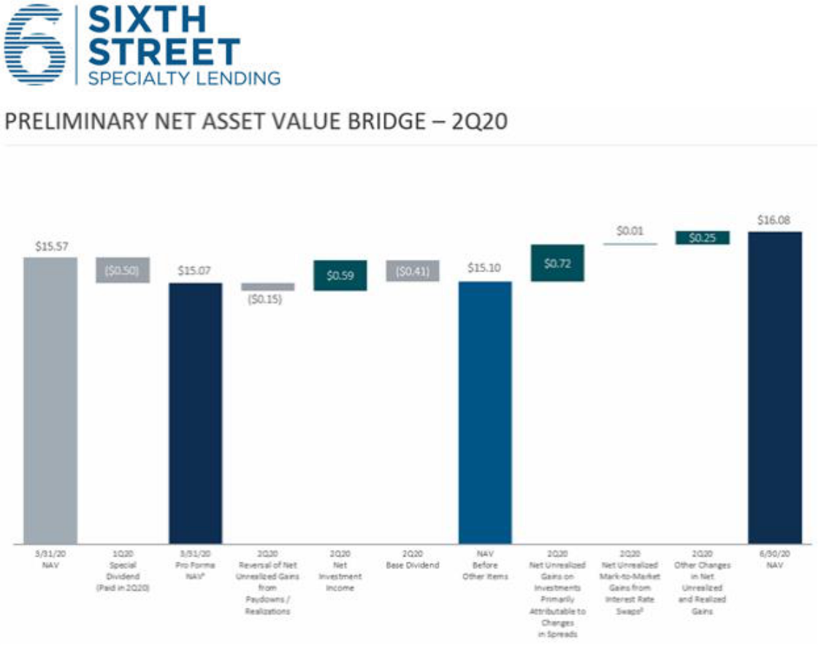

- Reflects Q1 2020 NAV per share pro forma for the declared special dividends per share of $0.50, declared in Q1 2020 and payable in Q2 2020

- Excludes the impact from changes in the fair value of the interest rate swap related to the 2024 notes given the application of Hedge Accounting on this instrument

Note: Per share data was derived using the Q2 2020 weighted average shares outstanding except for DRIP, dividend and share repurchase amounts. Numbers may not sum due to rounding

Liquidity, Funding Profile and Capital

As of June 30, 2020, we continued to be well positioned from a liquidity, funding profile and capital standpoint. Our liquidity as a percentage of total assets was approximately 54%, with over $1.0 billion of undrawn capacity on our revolving credit facility. We had approximately $73 million of unfunded commitments available to be drawn by our borrowers based on contractual requirements in the underlying loan agreements, which means we had nearly 15 times coverage on these unfunded commitments from our revolver. We continue to have meaningful cushions on all applicable financial covenant thresholds under our revolving credit facility, and as a result, expect to continue to be able to access our full revolver capacity. The table below summarizes our liquidity at June 30, 2020 (estimated) compared to March 31, 2020, including changes to unfunded commitments.

7

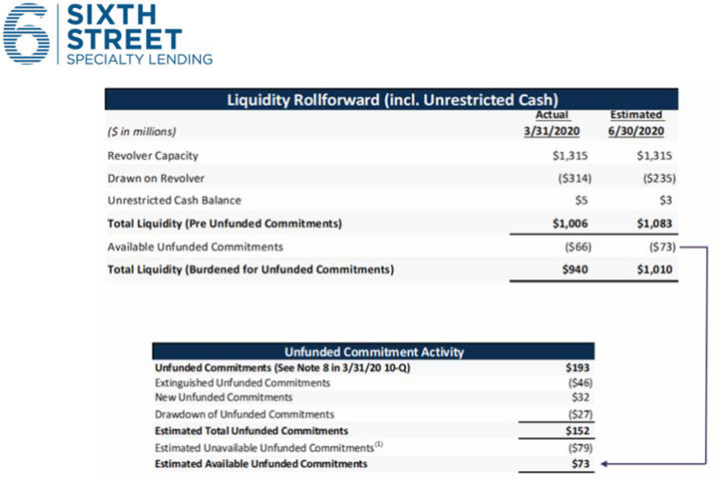

Note: Numbers may not sum due to rounding

- Commitments may be subject to limitations on borrowings set forth in the agreements between the Company and the applicable portfolio company, As a result, portfolio companies may not be eligible to borrow the full commitment on such date

As alluded to earlier in this letter, during Q2, we opportunistically repurchased $29.7 million principal amount of our 2022 Convertible Notes and $2.5 million principal amount of our 2024 Unsecured Notes at prices below par using the available liquidity under our revolver. By “permanentizing” the unrealized mark-to-market gains on the interest rate swaps corresponding to the notes we repurchased (through effectively cancelling portions of our swaps by issuing offsetting swaps), our weighted average purchase price on the combined $32.2 million of notes was approximately 94. These opportunistic investments in our capital structure were accretive to both our ROE (due to the decrease in our blended cost of debt) and our overall capital position, with no material impact to our overall liquidity.

As of June 30, 2020, our earliest maturity is still over two years away in August 2022 with approximately $143 million of principal outstanding. The estimated weighted average remaining life of investments funded with debt at quarter end was approximately 2.1 years, compared to a weighted average remaining maturity on our debt of approximately 4.2 years.

8

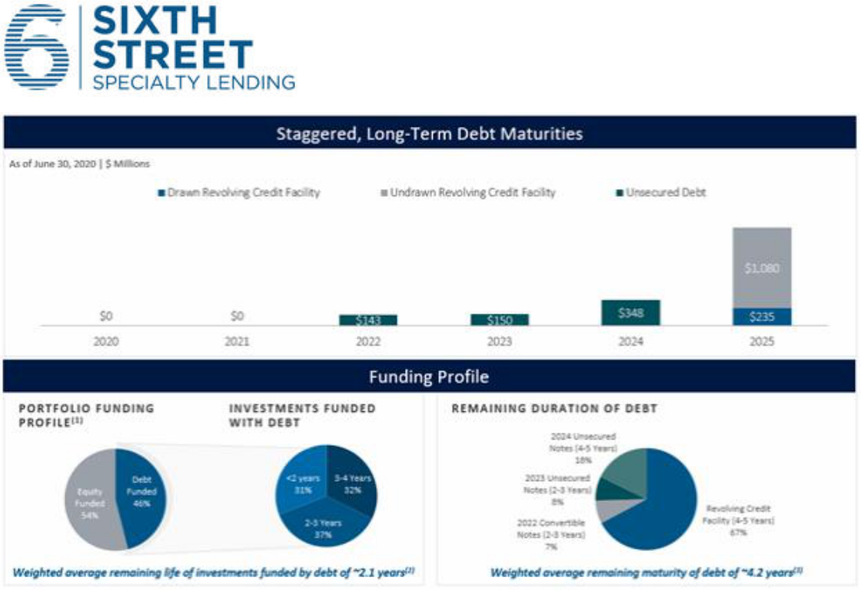

Numbers may not sum to 100% due to rounding

- Net of Deferred Financial Costs and Interest Rate Fair Value Hedging

- Weighted by amortized cost of debt investments. Investments are financed by debt and permanent equity capital. This analysis assumes longer-dated investments are currently funded by permanent equity capital (54% of investments) and the remaining (shorter-dated) investments (46% of investments) are currently funded by debt financing. Permanent equity capital is defined as 6/30/2020
- Weighted by gross commitment amount

We believe we continue to have substantial capital in this environment. On a preliminary basis, our debt-to-equity at June 30, 2020 was approximately 0.81x, compared to 0.96x at March 31, 2020. This decrease reflects net repayment activity in our portfolio during the second quarter, as well as the impact of improving valuation marks across our portfolio. Given the strength of the pipeline we generated during Q2, we have experienced net funding activity post quarter to-date, bringing our estimated leverage today back in our targeted range of 0.9x to 1.25x.

Post Quarter Activity

During Q2, we remained steadfast in our belief that it’s important to remain patient and prudent in this environment in order to have the capital to deploy at the appropriate time to create long-term stakeholder value and be a differentiated solutions provider for our clients. During the quarter, central bank intervention resulted in significant investor demand for risk assets, pushing up asset prices and creating abundant liquidity for investment grade and high yield issuers (albeit not for debt of BDC issuers). As our immediate opportunity set for secondary market purchases and rescue financings became less actionable, we continued to work hard at building a pipeline of opportunities where we could create value through our core competencies of deep sector expertise, the ability to underwrite complexity, and the scale and certainty of capital / execution we bring to our clients. These efforts have already resulted in two new investments (amongst other activity) post quarter end, resulting in total capital deployment of approximately $117 million and an increase in portfolio leverage from an estimated 0.81x at the end of Q2 to an estimated 0.91x today.

9

One of our new investments was the recapitalization of a securitization facility with a pricing of L+1050 bps (1.0% LIBOR floor), along with additional other fees. Our other investment was a senior secured credit facility with a pricing of L+850 bps (1.25% LIBOR floor), meaningful call protection (non-call-2/102/101) and upside in the form of warrants. Our current pipeline of attractive risk-adjusted return opportunities remains robust, and we are optimistic about the value we can create for our stakeholders and our clients (to fulfill their own strategic plans) given our strong liquidity and capital position.

During these uncertain times, we believe we have a real opportunity to continue to build new and strengthen existing relationships with participants in our ecosystem, specifically those along our sector themes. Our objective is to continue to be a source of creative financing solutions to companies, management teams and sponsor partners. Given the Sixth Street platform’s long-term oriented, highly flexible, and scaled capital base, we believe we can be a value-add partner to businesses requiring capital through this volatile period.

This quarter, no supplemental dividends will be declared relating to our earnings in excess of our base dividend as a result of the NAV limiter on our dividend formula. However, based on our outlook as of today and assuming no material declines to our net asset value per share as a result of exogenous events (like the market volatility we observed in March), we would expect to be able to declare 50% of the over-earning of our base dividend in Q3 provided that our reported NAV per share at quarter end September 30, 2020 is above $14.92.6

We look forward to discussing our Q2 results and latest business updates in more detail when we speak to you on August 5th.

Sincerely,


Joshua Easterly

Chief Executive Officer and Chairman of the Board

Partner, Sixth Street

- Based on our NAV limiter of no more than a $0.15 per share decline in reported NAV (inclusive of the impact of any supplemental dividends) over the current and preceding quarter. For Q3 2020, the NAV limiter threshold is calculated as $15.07 (Q1 2020 NAV per share after the impact of special dividends) minus $0.15 (maximum NAV decline) = $14.92.

10

About Sixth Street Specialty Lending

Sixth Street Specialty Lending is a specialty finance company focused on lending to middle-market companies. The Company seeks to generate current income primarily in U.S.-domiciled middle-market companies through direct originations of senior secured loans and, to a lesser extent, originations of mezzanine loans and investments in corporate bonds and equity securities. The Company has elected to be regulated as a business development company, or a BDC, under the Investment Company Act of 1940 and the rules and regulations promulgated thereunder. The Company is externally managed by Sixth Street Specialty Lending Advisers, LLC, an affiliate of Sixth Street and a Securities and Exchange Commission (“SEC”) registered investment adviser. The Company leverages the deep investment, sector, and operating resources of Sixth Street, a global investment firm with approximately $34 billion of assets under management as of March 31, 2020. For more information, visit the Company’s website at www.sixthstreetspecialtylending.com.

About Sixth Street

Sixth Street is a global investment firm with approximately $34 billion in assets under management and committed capital as of March 31, 2020. Sixth Street operates eight diversified, collaborative investment platforms across our growth investing, adjacencies, direct lending, fundamental public strategies, infrastructure, special situations, agriculture and par liquid credit businesses. Our long-term oriented, highly flexible capital base and “One Team” cultural philosophy allow us to invest thematically across sectors, geographies and asset classes. Founded in 2009, Sixth Street has more than 275 team members including over 140 investment professionals operating from nine locations around the world. For more information, visit www.sixthstreet.com.

Forward-Looking Statements

Statements included herein may constitute “forward-looking statements,” which relate to future events or the Company’s future performance or financial condition, including the Company’s future operating results and liquidity position, expectations regarding the timing and outcome of bankruptcy, reorganization and liquidation proceedings of its portfolio companies and the impact on the Company, expectations with respect to future dividends, the impact of COVID-19 and related changes in base interest rates and market volatility on the Company’s business, the Company’s portfolio companies, the Company’s industry and the global economy. These statements are not guarantees of future performance, conditions or results and involve a number of risks and uncertainties. Actual results may differ materially from those in the forward-looking statements as a result of a number of factors, including those described from time to time in the Company’s filings with the Securities and Exchange Commission. The Company assumes no obligation to update any such forward-looking statements.

The Company’s closing procedures for the three months ended June 30, 2020 are not yet complete and, as a result, these preliminary estimates of the financial information above reflect the Company’s preliminary estimate with respect to such results based on information currently available to management, and may vary from the Company’s actual financial results as of and for the quarter ended June 30, 2020. For example, estimated net asset value per share is based on the value of the Company’s total assets, including the Company’s investments (some of which are not publicly traded or whose market prices are not readily available, the fair value of which is determined by the Company’s board of directors in good faith). The fair value of the Company’s investments have not yet been determined by the Company’s board of directors or

11

reviewed by its audit committee and the actual fair value of such investments, when determined by the Company’s board of directors, may be materially different than the estimates reported herein. Further, these estimates are not a comprehensive statement of the Company’s financial results as of and for the quarter ended June 30, 2020. Accordingly, you should not place undue reliance on this preliminary information. These estimates, which are the responsibility of the Company’s management, were prepared by the Company’s management in connection with the preparation of its financial statements and are based upon a number of assumptions. Additional items that may require adjustments to the preliminary operating results may be identified as a result of the completion of our financial closing procedures, final adjustments and other developments arising between now and the time that our financial results, for the three months ended June 30, 2020 are released, and could result in material changes to the Company’s estimated preliminary operating results. Estimates of operating results are inherently uncertain and we undertake no obligation to update this information. See “Special Note Regarding Forward-Looking Statements,” “Risk Factors” and “Management’s Discussion and Analysis of Financial Condition and Results of Operations” included or incorporated by reference herein for factors that could impact the Company’s actual results of operations. KPMG LLP has not audited, reviewed, compiled or performed any procedures with respect to this preliminary financial information. Accordingly, KPMG LLP does not express an opinion or provide any form of assurance with respect thereto.

Investors:

Lucy Lu, 212-601-4753

Sixth Street Specialty Lending

IRTSL@tssp.com

Media:

Patrick Clifford, 617-793-2004

Sixth Street

PClifford@tssp.com

12

