UNITED STATES
SECURITIES AND EXCHANGE COMMISSION
Washington, D.C. 20549

SCHEDULE 14A
(RULE 14a-101)

Proxy Statement Pursuant to Section 14(a) of the
Securities Exchange Act of 1934
Filed by the Registrant ☒ Filed by a Party other than the Registrant ☐
Check the appropriate box:

☐ |  | Preliminary Proxy Statement
☐ |  | Confidential, for Use of the Commission Only (as permitted by Rule 14a-6(e)(2))
☐ |  | Definitive Proxy Statement
☒ |  | Definitive Additional Materials
☐ |  | Soliciting Material Pursuant to §240.14a-12
Sixth Street Specialty Lending, Inc.
(Name of Registrant as Specified in Its Charter)
(Name of Person(s) Filing Proxy Statement, if other than the Registrant)
Payment of Filing Fee (Check the appropriate box):

☒ |  | No fee required.
☐ |  | Fee paid previously with preliminary materials.
☐ |  | Fee computed on table in exhibit required by Item 25(b) per Exchange Act Rules 14a-6(i)(1) and 0-11


EXPANDING TOOLS FOR VALUE CREATION AND FINANCIAL FLEXIBILITY April 2024 S I X T H S T R E E T S P E C I A L T Y L E N D I N G

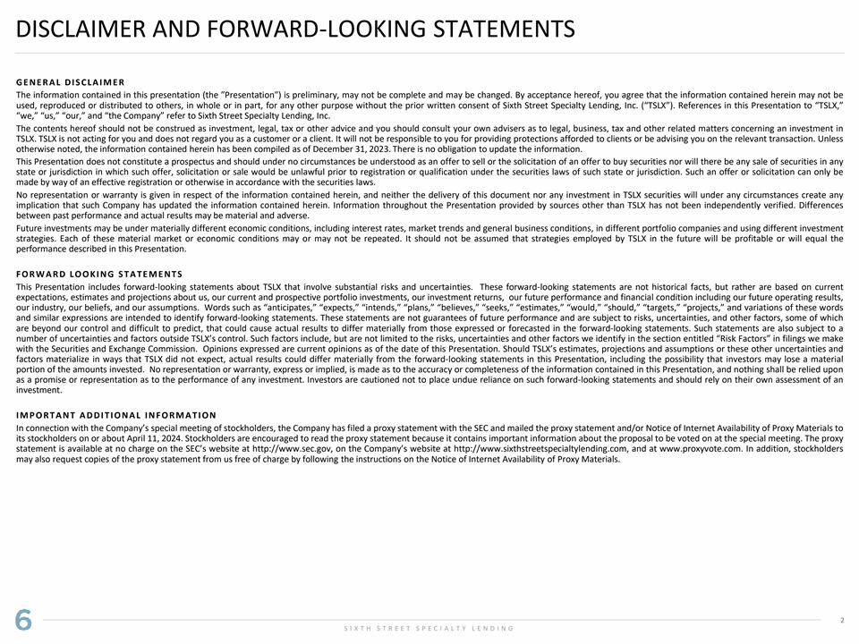
DISCLAIMER AND FORWARD-LOOKING STATEMENTS G E N E R A L D I S CL A I M E R The information contained in this presentation (the ʺPresentationʺ) is preliminary, may not be complete and may be changed. By acceptance hereof, you agree that the information contained herein may not be used, reproduced or distributed to others, in whole or in part, for any other purpose without the prior written consent of Sixth Street Specialty Lending, Inc. (“TSLX”). References in this Presentation to “TSLX,” “we,” “us,” “our,” and “the Company” refer to Sixth Street Specialty Lending, Inc. The contents hereof should not be construed as investment, legal, tax or other advice and you should consult your own advisers as to legal, business, tax and other related matters concerning an investment in TSLX. TSLX is not acting for you and does not regard you as a customer or a client. It will not be responsible to you for providing protections afforded to clients or be advising you on the relevant transaction. Unless otherwise noted, the information contained herein has been compiled as of December 31, 2023. There is no obligation to update the information. This Presentation does not constitute a prospectus and should under no circumstances be understood as an offer to sell or the solicitation of an offer to buy securities nor will there be any sale of securities in any state or jurisdiction in which such offer, solicitation or sale would be unlawful prior to registration or qualification under the securities laws of such state or jurisdiction. Such an offer or solicitation can only be made by way of an effective registration or otherwise in accordance with the securities laws. No representation or warranty is given in respect of the information contained herein, and neither the delivery of this document nor any investment in TSLX securities will under any circumstances create any implication that such Company has updated the information contained herein. Information throughout the Presentation provided by sources other than TSLX has not been independently verified. Differences between past performance and actual results may be material and adverse. Future investments may be under materially different economic conditions, including interest rates, market trends and general business conditions, in different portfolio companies and using different investment strategies. Each of these material market or economic conditions may or may not be repeated. It should not be assumed that strategies employed by TSLX in the future will be profitable or will equal the performance described in this Presentation. F O R W A R D LO O K I N G S T A T E M E N T S This Presentation includes forward‐looking statements about TSLX that involve substantial risks and uncertainties. These forward-looking statements are not historical facts, but rather are based on current expectations, estimates and projections about us, our current and prospective portfolio investments, our investment returns, our future performance and financial condition including our future operating results, our industry, our beliefs, and our assumptions. Words such as “anticipates,” “expects,” “intends,” “plans,” “believes,” “seeks,” “estimates,” “would,” “should,” “targets,” “projects,” and variations of these words and similar expressions are intended to identify forward-looking statements. These statements are not guarantees of future performance and are subject to risks, uncertainties, and other factors, some of which are beyond our control and difficult to predict, that could cause actual results to differ materially from those expressed or forecasted in the forward-looking statements. Such statements are also subject to a number of uncertainties and factors outside TSLX’s control. Such factors include, but are not limited to the risks, uncertainties and other factors we identify in the section entitled “Risk Factors” in filings we make with the Securities and Exchange Commission. Opinions expressed are current opinions as of the date of this Presentation. Should TSLX’s estimates, projections and assumptions or these other uncertainties and factors materialize in ways that TSLX did not expect, actual results could differ materially from the forward‐looking statements in this Presentation, including the possibility that investors may lose a material portion of the amounts invested. No representation or warranty, express or implied, is made as to the accuracy or completeness of the information contained in this Presentation, and nothing shall be relied upon as a promise or representation as to the performance of any investment. Investors are cautioned not to place undue reliance on such forward‐looking statements and should rely on their own assessment of an investment. I M P O R T A N T A D D I T I O N A L I N F O R M A T I O N In connection with the Company’s special meeting of stockholders, the Company has filed a proxy statement with the SEC and mailed the proxy statement and/or Notice of Internet Availability of Proxy Materials to its stockholders on or about April 11, 2024. Stockholders are encouraged to read the proxy statement because it contains important information about the proposal to be voted on at the special meeting. The proxy statement is available at no charge on the SEC’s website at http://www.sec.gov, on the Company’s website at http://www.sixthstreetspecialtylending.com, and at www.proxyvote.com. In addition, stockholders may also request copies of the proxy statement from us free of charge by following the instructions on the Notice of Internet Availability of Proxy Materials. 2 S I X T H S T R E E T S P E C I A L T Y L E N D I N G

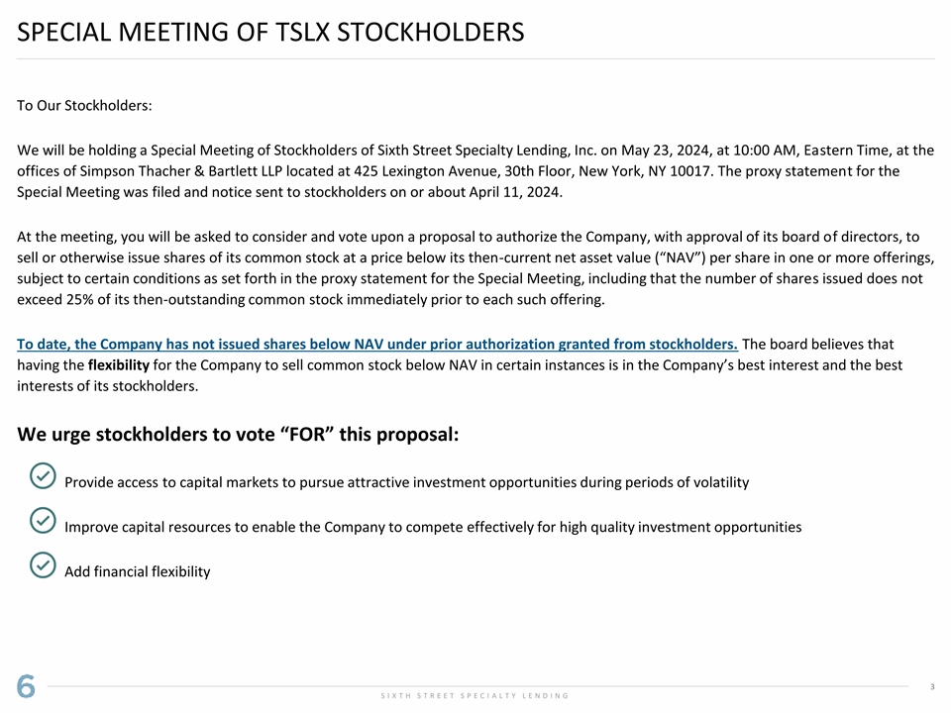
SPECIAL MEETING OF TSLX STOCKHOLDERS To Our Stockholders: We will be holding a Special Meeting of Stockholders of Sixth Street Specialty Lending, Inc. on May 23, 2024, at 10:00 AM, Eastern Time, at the offices of Simpson Thacher & Bartlett LLP located at 425 Lexington Avenue, 30th Floor, New York, NY 10017. The proxy statement for the Special Meeting was filed and notice sent to stockholders on or about April 11, 2024. At the meeting, you will be asked to consider and vote upon a proposal to authorize the Company, with approval of its board of directors, to sell or otherwise issue shares of its common stock at a price below its then-current net asset value (“NAV”) per share in one or more offerings, subject to certain conditions as set forth in the proxy statement for the Special Meeting, including that the number of shares issued does not exceed 25% of its then-outstanding common stock immediately prior to each such offering. To date, the Company has not issued shares below NAV under prior authorization granted from stockholders. The board believes that having the flexibility for the Company to sell common stock below NAV in certain instances is in the Company’s best interest and the best interests of its stockholders. We urge stockholders to vote “FOR” this proposal: Provide access to capital markets to pursue attractive investment opportunities during periods of volatility Improve capital resources to enable the Company to compete effectively for high quality investment opportunities Add financial flexibility 3 S I X T H S T R E E T S P E C I A L T Y L E N D I N G

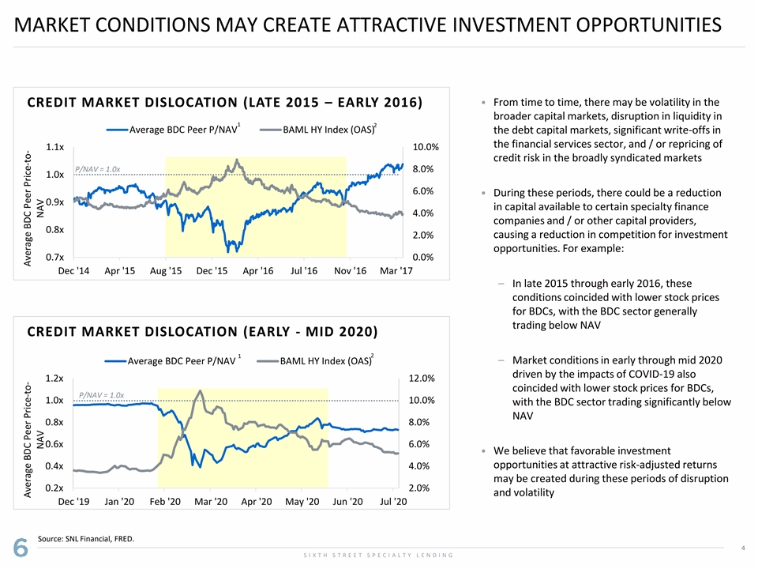
MARKET CONDITIONS MAY CREATE ATTRACTIVE INVESTMENT OPPORTUNITIES • From time to time, there may be volatility in the CREDIT MARKET DISLOCATION (LATE 2015 – EARLY 2016) broader capital markets, disruption in liquidity in 1 2 Average BDC Peer P/NAV BAML HY Index (OAS) the debt capital markets, significant write-offs in the financial services sector, and / or repricing of 1.1x 10.0% credit risk in the broadly syndicated markets P/NAV = 1.0x 8.0% 1.0x 6.0% • During these periods, there could be a reduction 0.9x in capital available to certain specialty finance 4.0% companies and / or other capital providers, 0.8x 2.0% causing a reduction in competition for investment opportunities. For example: 0.7x 0.0% Dec '14 Apr '15 Aug '15 Dec '15 Apr '16 Jul '16 Nov '16 Mar '17 – In late 2015 through early 2016, these conditions coincided with lower stock prices for BDCs, with the BDC sector generally trading below NAV CREDIT MARKET DISLOCATION (EARLY - MID 2020) 2 1 – Market conditions in early through mid 2020 Average BDC Peer P/NAV BAML HY Index (OAS) driven by the impacts of COVID-19 also 1.2x 12.0% coincided with lower stock prices for BDCs, P/NAV = 1.0x 1.0x 10.0% with the BDC sector trading significantly below NAV 0.8x 8.0% 0.6x 6.0% • We believe that favorable investment opportunities at attractive risk-adjusted returns 0.4x 4.0% may be created during these periods of disruption 0.2x 2.0% and volatility Dec '19 Jan '20 Feb '20 Mar '20 Apr '20 May '20 Jun '20 Jul '20 Source: SNL Financial, FRED. 4 S I X T H S T R E E T S P E C I A L T Y L E N D I N G Average BDC Peer Price-to- Average BDC Peer Price-to- NAV NAV

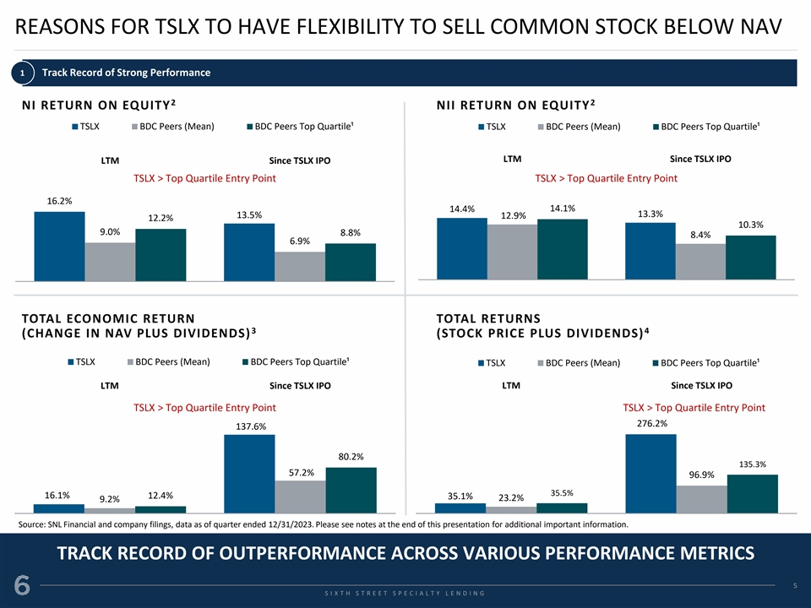
REASONS FOR TSLX TO HAVE FLEXIBILITY TO SELL COMMON STOCK BELOW NAV 1 Track Record of Strong Performance 2 2 NI RETURN ON EQUITY NII RETURN ON EQUITY TSLX BDC Peers (Mean) BDC Peers Top Quartile¹ TSLX BDC Peers (Mean) BDC Peers Top Quartile¹ LTM Since TSLX IPO LTM Since TSLX IPO TSLX > Top Quartile Entry Point TSLX > Top Quartile Entry Point 16.2% 14.1% 14.4% 13.3% 13.5% 12.9% 12.2% 10.3% 9.0% 8.8% 8.4% 6.9% TOTAL ECONOMIC RETURN TOTAL RETURNS 3 4 (CHANGE IN NAV PLUS DIVIDENDS) (STOCK PRICE PLUS DIVIDENDS) TSLX BDC Peers (Mean) BDC Peers Top Quartile¹ TSLX BDC Peers (Mean) BDC Peers Top Quartile¹ LTM Since TSLX IPO LTM Since TSLX IPO TSLX > Top Quartile Entry Point TSLX > Top Quartile Entry Point 276.2% 137.6% 80.2% 135.3% 57.2% 96.9% 35.5% 16.1% 12.4% 35.1% 23.2% 9.2% Source: SNL Financial and company filings, data as of quarter ended 12/31/2023. Please see notes at the end of this presentation for additional important information. TRACK RECORD OF OUTPERFORMANCE ACROSS VARIOUS PERFORMANCE METRICS 5 S S I I X X T T H H S S T T R R E E E E T T S S P P E E C C I I A A L L T T Y Y L L E E N N D D I I N N G G

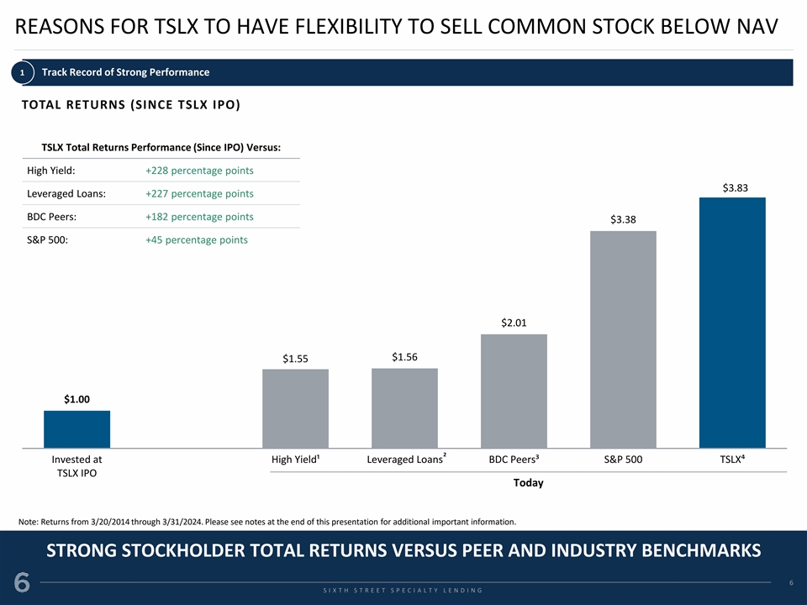
REASONS FOR TSLX TO HAVE FLEXIBILITY TO SELL COMMON STOCK BELOW NAV 1 Track Record of Strong Performance TOTAL RETURNS (SINCE TSLX IPO) TSLX Total Returns Performance (Since IPO) Versus: High Yield: +228 percentage points $3.83 Leveraged Loans: +227 percentage points BDC Peers: +182 percentage points $3.38 S&P 500: +45 percentage points $2.01 $1.56 $1.55 $1.00 2 Invested at High Yield¹ Leveraged Loans BDC Peers³ S&P 500 TSLX⁴ TSLX IPO Today Note: Returns from 3/20/2014 through 3/31/2024. Please see notes at the end of this presentation for additional important information. STRONG STOCKHOLDER TOTAL RETURNS VERSUS PEER AND INDUSTRY BENCHMARKS 6 S S I I X X T T H H S S T T R R E E E E T T S S P P E E C C I I A A L L T T Y Y L L E E N N D D I I N N G G

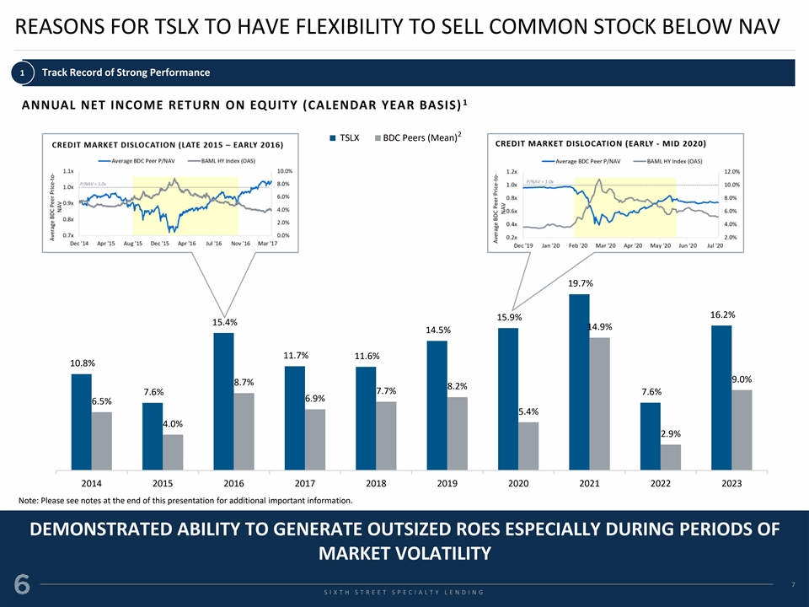
REASONS FOR TSLX TO HAVE FLEXIBILITY TO SELL COMMON STOCK BELOW NAV 1 Track Record of Strong Performance 1 ANNUAL NET INCOME RETURN ON EQUITY (CALENDAR YEAR BASIS) 2 TSLX BDC Peers (Mean) 19.7% 16.2% 15.9% 15.4% 14.9% 14.5% 11.7% 11.6% 10.8% 9.0% 8.7% 8.2% 7.7% 7.6% 7.6% 6.9% 6.5% 5.4% 4.0% 2.9% 2014 2015 2016 2017 2018 2019 2020 2021 2022 2023 Note: Please see notes at the end of this presentation for additional important information. DEMONSTRATED ABILITY TO GENERATE OUTSIZED ROES ESPECIALLY DURING PERIODS OF MARKET VOLATILITY 7 S S I I X X T T H H S S T T R R E E E E T T S S P P E E C C I I A A L L T T Y Y L L E E N N D D I I N N G G

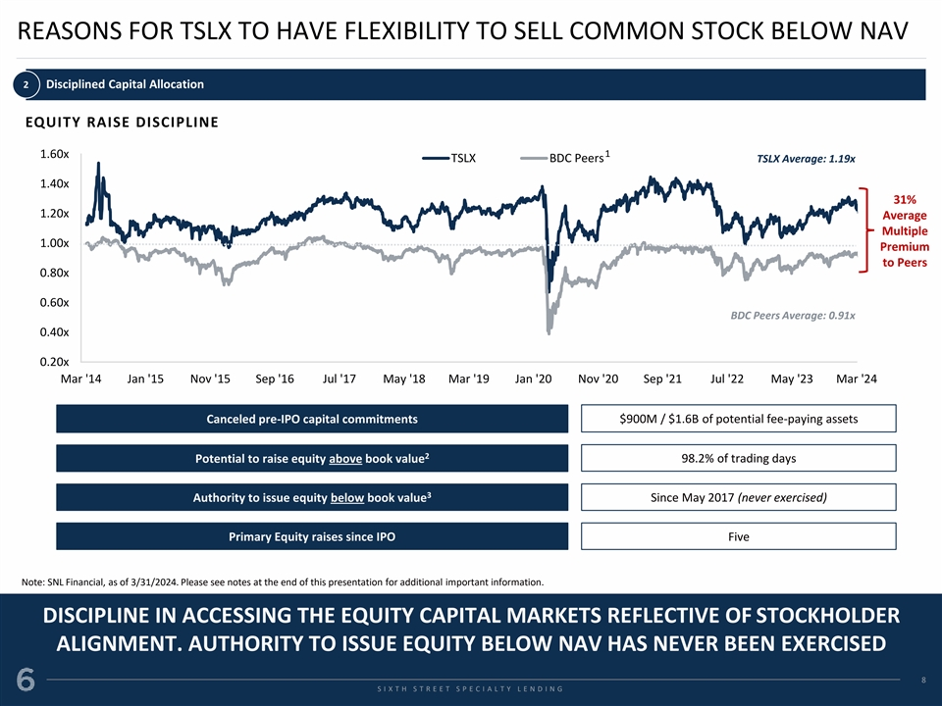
REASONS FOR TSLX TO HAVE FLEXIBILITY TO SELL COMMON STOCK BELOW NAV 2 Disciplined Capital Allocation EQUITY RAISE DISCIPLINE 1 1.60x TSLX BDC Peers TSLX Average: 1.19x 1.40x 31% 1.20x Average Multiple 1.00x Premium to Peers 0.80x 0.60x BDC Peers Average: 0.91x 0.40x 0.20x Mar '14 Jan '15 Nov '15 Sep '16 Jul '17 May '18 Mar '19 Jan '20 Nov '20 Sep '21 Jul '22 May '23 Mar '24 Canceled pre-IPO capital commitments $900M / $1.6B of potential fee-paying assets 2 Potential to raise equity above book value 98.2% of trading days 3 Authority to issue equity below book value Since May 2017 (never exercised) Primary Equity raises since IPO Five Note: SNL Financial, as of 3/31/2024. Please see notes at the end of this presentation for additional important information. DISCIPLINE IN ACCESSING THE EQUITY CAPITAL MARKETS REFLECTIVE OF STOCKHOLDER ALIGNMENT. AUTHORITY TO ISSUE EQUITY BELOW NAV HAS NEVER BEEN EXERCISED 8 S S I I X X T T H H S S T T R R E E E E T T S S P P E E C C I I A A L L T T Y Y L L E E N N D D I I N N G G

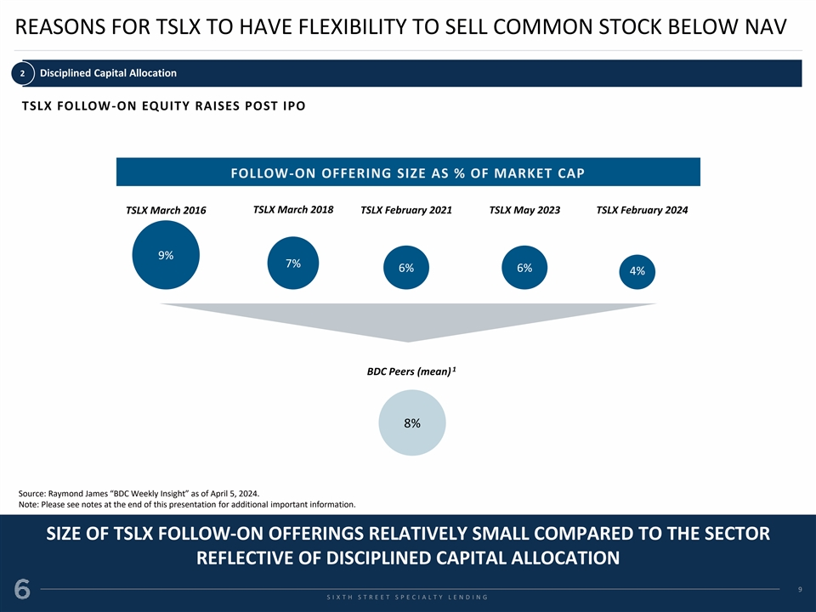
REASONS FOR TSLX TO HAVE FLEXIBILITY TO SELL COMMON STOCK BELOW NAV 2 Disciplined Capital Allocation TSLX FOLLOW-ON EQUITY RAISES POST IPO FOLLOW-ON OFFERING SIZE AS % OF MARKET CAP TSLX March 2018 TSLX March 2016 TSLX February 2021 TSLX May 2023 TSLX February 2024 9% 7% 6% 6% 4% 1 BDC Peers (mean) 8% Source: Raymond James “BDC Weekly Insight” as of April 5, 2024. Note: Please see notes at the end of this presentation for additional important information. SIZE OF TSLX FOLLOW-ON OFFERINGS RELATIVELY SMALL COMPARED TO THE SECTOR REFLECTIVE OF DISCIPLINED CAPITAL ALLOCATION 9 S S I I X X T T H H S S T T R R E E E E T T S S P P E E C C I I A A L L T T Y Y L L E E N N D D I I N N G G

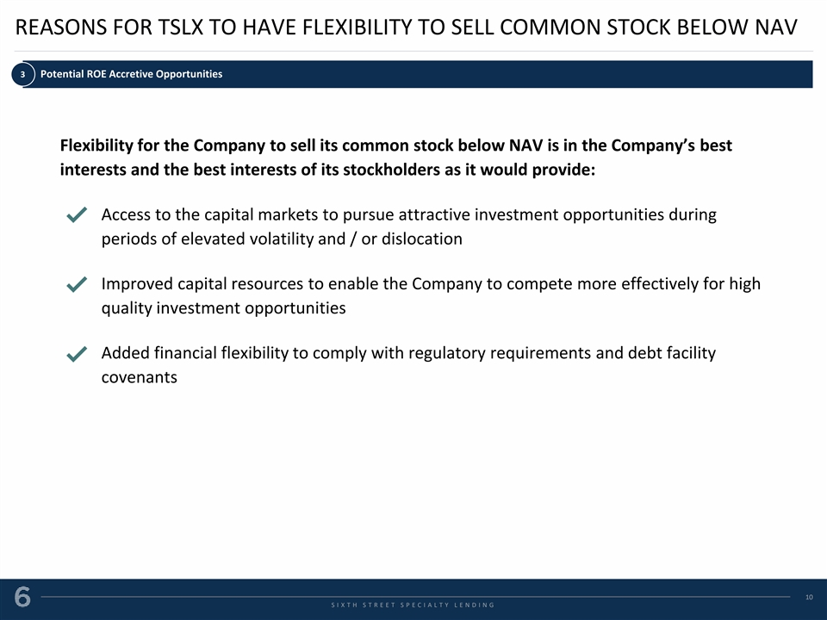
REASONS FOR TSLX TO HAVE FLEXIBILITY TO SELL COMMON STOCK BELOW NAV 3 Potential ROE Accretive Opportunities Flexibility for the Company to sell its common stock below NAV is in the Company’s best interests and the best interests of its stockholders as it would provide: Access to the capital markets to pursue attractive investment opportunities during periods of elevated volatility and / or dislocation Improved capital resources to enable the Company to compete more effectively for high quality investment opportunities Added financial flexibility to comply with regulatory requirements and debt facility covenants 10 S S I I X X T T H H S S T T R R E E E E T T S S P P E E C C I I A A L L T T Y Y L L E E N N D D I I N N G G

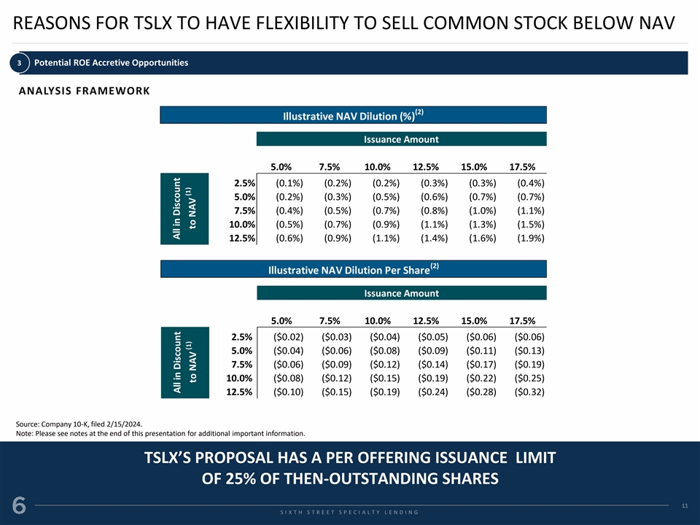
REASONS FOR TSLX TO HAVE FLEXIBILITY TO SELL COMMON STOCK BELOW NAV 3 Potential ROE Accretive Opportunities ANALYSIS FRAMEWORK (2) Illustrative NAV Dilution (%) Issuance Amount (0.0) 5.0% 7.5% 10.0% 12.5% 15.0% 17.5% 2.5% (0.1%) (0.2%) (0.2%) (0.3%) (0.3%) (0.4%) 5.0% (0.2%) (0.3%) (0.5%) (0.6%) (0.7%) (0.7%) 7.5% (0.4%) (0.5%) (0.7%) (0.8%) (1.0%) (1.1%) 10.0% (0.5%) (0.7%) (0.9%) (1.1%) (1.3%) (1.5%) 12.5% (0.6%) (0.9%) (1.1%) (1.4%) (1.6%) (1.9%) (2) Illustrative NAV Dilution Per Share Issuance Amount Issuance Amount (0.1) 5.0% 7.5% 10.0% 12.5% 15.0% 17.5% 2.5% ($0.02) ($0.03) ($0.04) ($0.05) ($0.06) ($0.06) 5.0% ($0.04) ($0.06) ($0.08) ($0.09) ($0.11) ($0.13) 7.5% ($0.06) ($0.09) ($0.12) ($0.14) ($0.17) ($0.19) 10.0% ($0.08) ($0.12) ($0.15) ($0.19) ($0.22) ($0.25) 12.5% ($0.10) ($0.15) ($0.19) ($0.24) ($0.28) ($0.32) Source: Company 10-K, filed 2/15/2024. Note: Please see notes at the end of this presentation for additional important information. TSLX’S PROPOSAL HAS A PER OFFERING ISSUANCE LIMIT OF 25% OF THEN-OUTSTANDING SHARES 11 S S I I X X T T H H S S T T R R E E E E T T S S P P E E C C I I A A L L T T Y Y L L E E N N D D I I N N G G All in Discount All in Discount (1) (1) to NAV to NAV

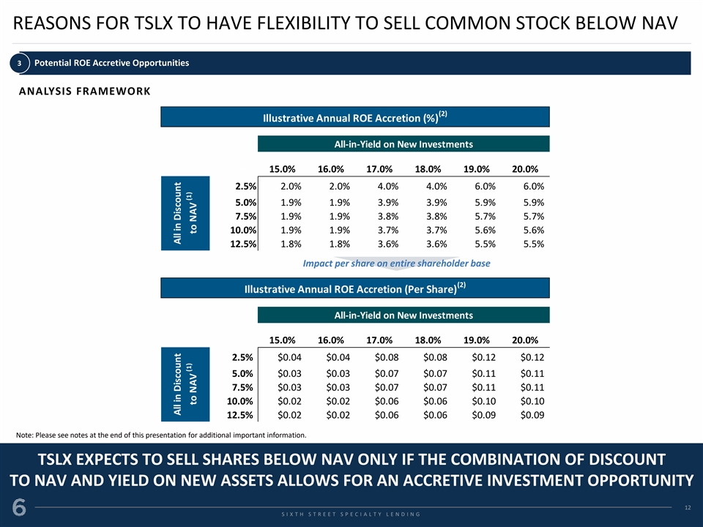
REASONS FOR TSLX TO HAVE FLEXIBILITY TO SELL COMMON STOCK BELOW NAV 3 Potential ROE Accretive Opportunities ANALYSIS FRAMEWORK (2) Illustrative Annual ROE Accretion (%) All-in-Yield on New Investments 0.0 15.0% 16.0% 17.0% 18.0% 19.0% 20.0% 2.5% 2.0% 2.0% 4.0% 4.0% 6.0% 6.0% 5.0% 1.9% 1.9% 3.9% 3.9% 5.9% 5.9% 7.5% 1.9% 1.9% 3.8% 3.8% 5.7% 5.7% 10.0% 1.9% 1.9% 3.7% 3.7% 5.6% 5.6% 12.5% 1.8% 1.8% 3.6% 3.6% 5.5% 5.5% Impact per share on entire shareholder base (2) (2) Illustrative Annual ROE Accretion (Per Share) Illustrative Annual ROE Accretion (%) All-in-Yield on New Investments All-in-Yield on New Investments 0.0 15.0% 16.0% 17.0% 18.0% 19.0% 20.0% 2.5% $0.04 $0.04 $0.08 $0.08 $0.12 $0.12 5.0% $0.03 $0.03 $0.07 $0.07 $0.11 $0.11 7.5% $0.03 $0.03 $0.07 $0.07 $0.11 $0.11 10.0% $0.02 $0.02 $0.06 $0.06 $0.10 $0.10 12.5% $0.02 $0.02 $0.06 $0.06 $0.09 $0.09 Note: Please see notes at the end of this presentation for additional important information. TSLX EXPECTS TO SELL SHARES BELOW NAV ONLY IF THE COMBINATION OF DISCOUNT TO NAV AND YIELD ON NEW ASSETS ALLOWS FOR AN ACCRETIVE INVESTMENT OPPORTUNITY 12 S S I I X X T T H H S S T T R R E E E E T T S S P P E E C C I I A A L L T T Y Y L L E E N N D D I I N N G G All in Discount All in Discount (1) (1) to NAV to NAV

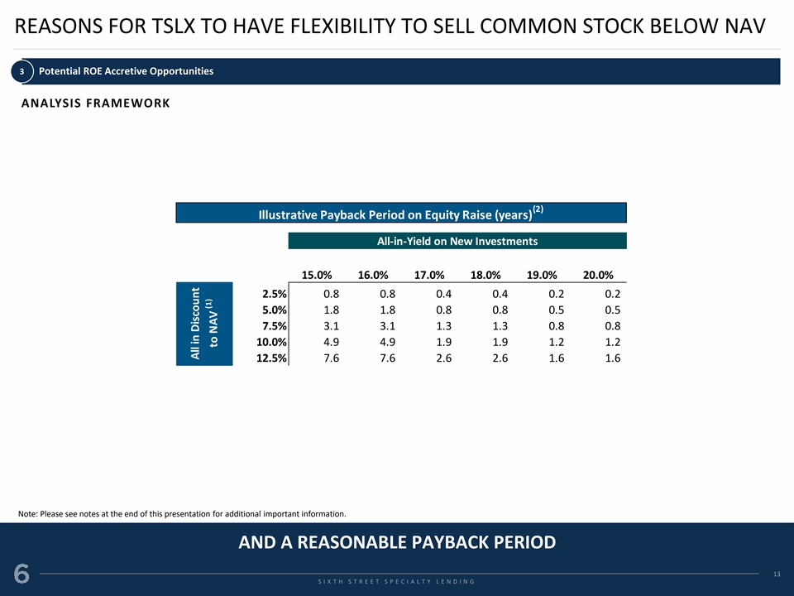
REASONS FOR TSLX TO HAVE FLEXIBILITY TO SELL COMMON STOCK BELOW NAV 3 Potential ROE Accretive Opportunities ANALYSIS FRAMEWORK (2) Illustrative Payback Period on Equity Raise (years) All-in-Yield on New Investments 3.9 15.0% 16.0% 17.0% 18.0% 19.0% 20.0% 2.5% 0.8 0.8 0.4 0.4 0.2 0.2 5.0% 1.8 1.8 0.8 0.8 0.5 0.5 7.5% 3.1 3.1 1.3 1.3 0.8 0.8 10.0% 4.9 4.9 1.9 1.9 1.2 1.2 12.5% 7.6 7.6 2.6 2.6 1.6 1.6 Note: Please see notes at the end of this presentation for additional important information. AND A REASONABLE PAYBACK PERIOD 13 S S I I X X T T H H S S T T R R E E E E T T S S P P E E C C I I A A L L T T Y Y L L E E N N D D I I N N G G All in Discount (1) to NAV

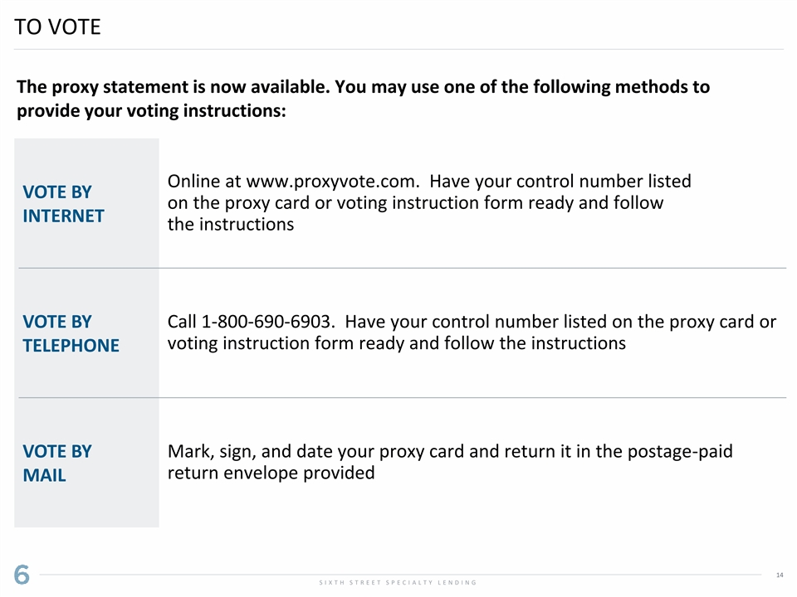
TO VOTE The proxy statement is now available. You may use one of the following methods to provide your voting instructions: Online at www.proxyvote.com. Have your control number listed VOTE BY on the proxy card or voting instruction form ready and follow INTERNET the instructions VOTE BY Call 1-800-690-6903. Have your control number listed on the proxy card or voting instruction form ready and follow the instructions TELEPHONE VOTE BY Mark, sign, and date your proxy card and return it in the postage-paid return envelope provided MAIL 14 S I X T H S T R E E T S P E C I A L T Y L E N D I N G

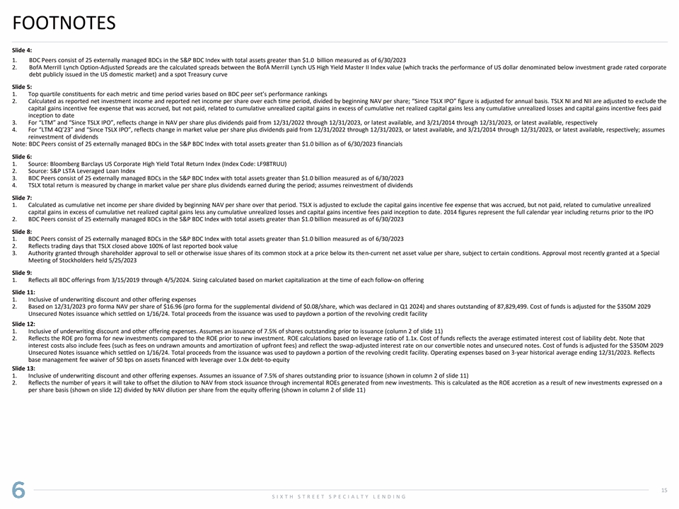
FOOTNOTES Slide 4: 1. BDC Peers consist of 25 externally managed BDCs in the S&P BDC Index with total assets greater than $1.0 billion measured as of 6/30/2023 2. BofA Merrill Lynch Option-Adjusted Spreads are the calculated spreads between the BofA Merrill Lynch US High Yield Master II Index value (which tracks the performance of US dollar denominated below investment grade rated corporate debt publicly issued in the US domestic market) and a spot Treasury curve Slide 5: 1. Top quartile constituents for each metric and time period varies based on BDC peer set’s performance rankings 2. Calculated as reported net investment income and reported net income per share over each time period, divided by beginning NAV per share; “Since TSLX IPO” figure is adjusted for annual basis. TSLX NI and NII are adjusted to exclude the capital gains incentive fee expense that was accrued, but not paid, related to cumulative unrealized capital gains in excess of cumulative net realized capital gains less any cumulative unrealized losses and capital gains incentive fees paid inception to date 3. For “LTM” and “Since TSLX IPO”, reflects change in NAV per share plus dividends paid from 12/31/2022 through 12/31/2023, or latest available, and 3/21/2014 through 12/31/2023, or latest available, respectively 4. For “LTM 4Q’23” and “Since TSLX IPO”, reflects change in market value per share plus dividends paid from 12/31/2022 through 12/31/2023, or latest available, and 3/21/2014 through 12/31/2023, or latest available, respectively; assumes reinvestment of dividends Note: BDC Peers consist of 25 externally managed BDCs in the S&P BDC Index with total assets greater than $1.0 billion as of 6/30/2023 financials Slide 6: 1. Source: Bloomberg Barclays US Corporate High Yield Total Return Index (Index Code: LF98TRUU) 2. Source: S&P LSTA Leveraged Loan Index 3. BDC Peers consist of 25 externally managed BDCs in the S&P BDC Index with total assets greater than $1.0 billion measured as of 6/30/2023 4. TSLX total return is measured by change in market value per share plus dividends earned during the period; assumes reinvestment of dividends Slide 7: 1. Calculated as cumulative net income per share divided by beginning NAV per share over that period. TSLX is adjusted to exclude the capital gains incentive fee expense that was accrued, but not paid, related to cumulative unrealized capital gains in excess of cumulative net realized capital gains less any cumulative unrealized losses and capital gains incentive fees paid inception to date. 2014 figures represent the full calendar year including returns prior to the IPO 2. BDC Peers consist of 25 externally managed BDCs in the S&P BDC Index with total assets greater than $1.0 billion measured as of 6/30/2023 Slide 8: 1. BDC Peers consist of 25 externally managed BDCs in the S&P BDC Index with total assets greater than $1.0 billion measured as of 6/30/2023 2. Reflects trading days that TSLX closed above 100% of last reported book value 3. Authority granted through shareholder approval to sell or otherwise issue shares of its common stock at a price below its then-current net asset value per share, subject to certain conditions. Approval most recently granted at a Special Meeting of Stockholders held 5/25/2023 Slide 9: 1. Reflects all BDC offerings from 3/15/2019 through 4/5/2024. Sizing calculated based on market capitalization at the time of each follow-on offering Slide 11: 1. Inclusive of underwriting discount and other offering expenses 2. Based on 12/31/2023 pro forma NAV per share of $16.96 (pro forma for the supplemental dividend of $0.08/share, which was declared in Q1 2024) and shares outstanding of 87,829,499. Cost of funds is adjusted for the $350M 2029 Unsecured Notes issuance which settled on 1/16/24. Total proceeds from the issuance was used to paydown a portion of the revolving credit facility Slide 12: 1. Inclusive of underwriting discount and other offering expenses. Assumes an issuance of 7.5% of shares outstanding prior to issuance (column 2 of slide 11) 2. Reflects the ROE pro forma for new investments compared to the ROE prior to new investment. ROE calculations based on leverage ratio of 1.1x. Cost of funds reflects the average estimated interest cost of liability debt. Note that interest costs also include fees (such as fees on undrawn amounts and amortization of upfront fees) and reflect the swap-adjusted interest rate on our convertible notes and unsecured notes. Cost of funds is adjusted for the $350M 2029 Unsecured Notes issuance which settled on 1/16/24. Total proceeds from the issuance was used to paydown a portion of the revolving credit facility. Operating expenses based on 3-year historical average ending 12/31/2023. Reflects base management fee waiver of 50 bps on assets financed with leverage over 1.0x debt-to-equity Slide 13: 1. Inclusive of underwriting discount and other offering expenses. Assumes an issuance of 7.5% of shares outstanding prior to issuance (shown in column 2 of slide 11) 2. Reflects the number of years it will take to offset the dilution to NAV from stock issuance through incremental ROEs generated from new investments. This is calculated as the ROE accretion as a result of new investments expressed on a per share basis (shown on slide 12) divided by NAV dilution per share from the equity offering (shown in column 2 of slide 11) 15 S I X T H S T R E E T S P E C I A L T Y L E N D I N G

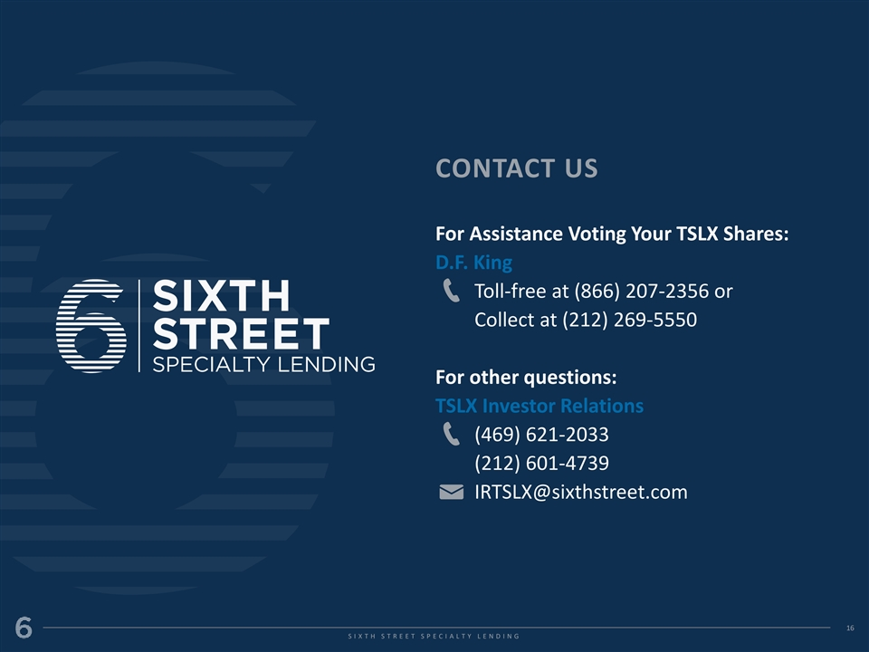
CONTACT US For Assistance Voting Your TSLX Shares: D.F. King Toll-free at (866) 207-2356 or Collect at (212) 269-5550 For other questions: TSLX Investor Relations (469) 621-2033 (212) 601-4739 IRTSLX@sixthstreet.com 16 16 S I X T H S T R E E T S P E C I A L T Y L E N D I N G

