UNITED STATES
SECURITIES AND EXCHANGE COMMISSION
Washington, D.C. 20549

SCHEDULE 14A
(RULE 14a-101)

Proxy Statement Pursuant to Section 14(a) of the
Securities Exchange Act of 1934
Filed by the Registrant ☒ Filed by a Party other than the Registrant ☐
Check the appropriate box:

☐ |  | Preliminary Proxy Statement
☐ |  | Confidential, for Use of the Commission Only (as permitted by Rule 14a-6(e)(2))
☐ |  | Definitive Proxy Statement
☒ |  | Definitive Additional Materials
☐ |  | Soliciting Material Pursuant to §240.14a-12
Sixth Street Specialty Lending, Inc.
(Name of Registrant as Specified in Its Charter)
(Name of Person(s) Filing Proxy Statement, if other than the Registrant)
Payment of Filing Fee (Check the appropriate box):

☒ |  | No fee required.
☐ |  | Fee paid previously with preliminary materials.
☐ |  | Fee computed on table in exhibit required by Item 25(b) per Exchange Act Rules 14a-6(i)(1) and 0-11

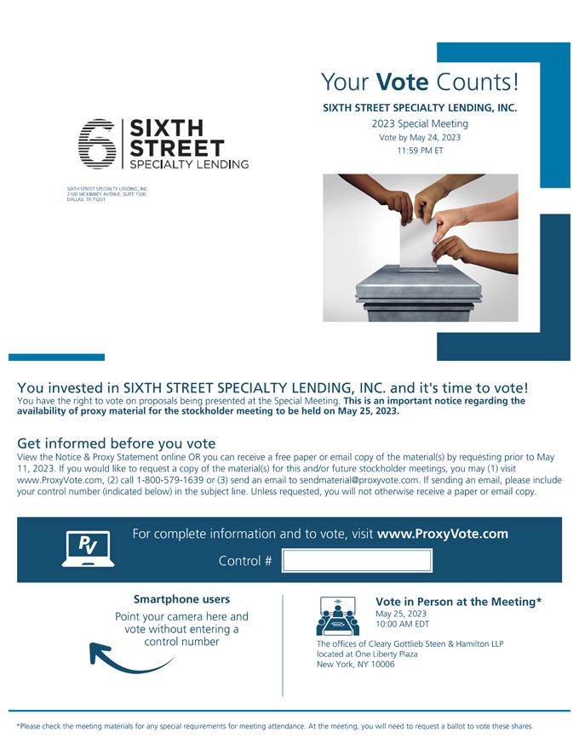
Your Vote Counts! SIXTH STREET SPECIALTY LENDING, INC. - SIXITIH 2023 Special Meeting ---· Vote by May 24, 2023 ·- - - STREET 11 :59 PM ET -- SPECIA.LTY LEND,ING SIXTH STREET SPECIALTY LENDING, INC. 2100 MCKINNEY AVENUE, SUITE 1500 DALLAS, TX 75201 You invested in SIXTH STREET SPECIALTY LENDING, INC. and its time to vote! You have the right to vote on proposals being presented at the Special Meeting. This is an important notice regarding the availability of proxy material for the stockholder meeting to be held on May 25, 2023. Get informed before you vote View the Notice & Proxy Statement online OR you can receive a free paper or email copy of the material(s) by requesting prior to May 11, 2023. If you would like to request a copy of the material(s) for this and/or future stockholder meetings, you may (1) visit www.ProxyVote.com, (2) call 1-800-579-1639 or (3) send an email to sendmaterial@proxyvote.com. If sending an email, please include your control number (indicated below) in the subject line. Unless requested, you will not otherwise receive a paper or email copy. Smartphone users Vote in Person at the Meeting* Point your camera here and May 25, 2023 10:00 AM EDT vote without entering a ~Inumber The offices of Cleary Gottlieb Steen & Hamilton LLP located at One Liberty Plaza New York, NY 10006 *Please check the meeting materials for any special requirements for meeting attendance. At the meeting, you will need to request a ballot to vote these shares.

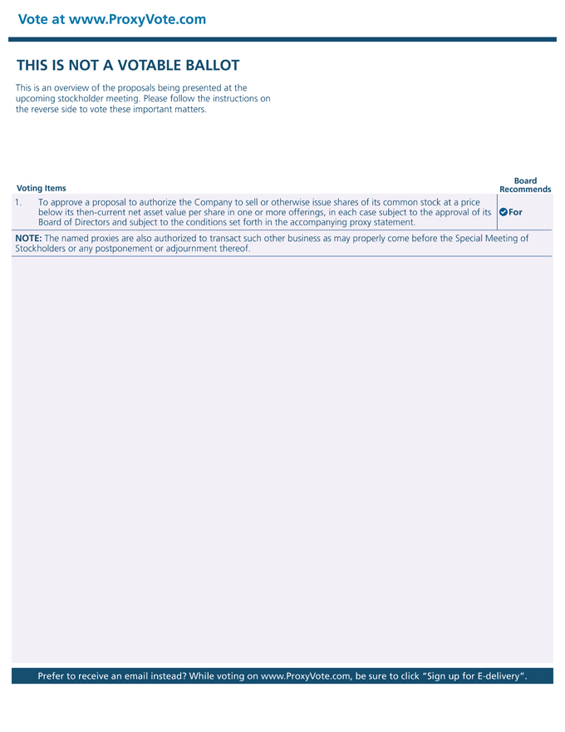
Vote at www.ProxyVote.com THIS IS NOT A VOTABLE BALLOT This is an overview of the proposals being presented at the upcoming stockholder meeting. Please follow the instructions on the reverse side to vote these important matters. Board Voting Items Recommends 1. To approve a proposal to authorize the Company to sell or otherwise issue shares of its common stock at a price below its then-current net asset value per share in one or more offerings, in each case subject to the approval of its ~For Board of Directors and subject to the conditions set forth in the accompanying proxy statement. NOTE: The named proxies are also authorized to transact such other business as may properly come before the Special Meeting of Stockholders or any postponement or adjournment thereof. Prefer to receive an email instead? While voting on www.ProxyVote.com, be sure to click Sign up forE-delivery.

