UNITED STATES

SECURITIES AND EXCHANGE COMMISSION
Washington, D.C. 20549

SCHEDULE 14A INFORMATION

PROXY STATEMENT PURSUANT TO SECTION 14(a) OF THE

SECURITIES EXCHANGE ACT OF 1934

Filed by the Registrant ☐ Filed by a Party other than the Registrant ☒

Check the appropriate box:

- Preliminary Proxy Statement

- Confidential, for Use of the Commission Only (as permitted by Rule 14a-6(e)(2))

- Definitive Proxy Statement

- Definitive Additional Materials

- Soliciting Material Pursuant to §240.14a-12

TICC CAPITAL CORP.

(Name of Registrant as Specified In Its Charter)

TPG Specialty Lending, Inc.

(Name of Person(s) Filing Proxy Statement, if other than the Registrant)

Payment of Filing Fee (Check the appropriate box):

- Fee not required.

- Fee computed on table below per Exchange Act Rules 14a-6(i)(1) and 0-11.

  - Title of each class of securities to which transaction applies:

  - Aggregate number of securities to which transaction applies:

  - Per unit price or other underlying value of transaction computed pursuant to Exchange Act Rule 0-11 (set forth the amount on which the filing fee is calculated and state how it was determined):

  - Proposed maximum aggregate value of transaction:

  - Total fee paid:

- Fee paid previously with preliminary materials.

- Check box if any part of the fee is offset as provided by Exchange Act Rule 0-11(a)(2) and identify the filing for which the offsetting fee was paid previously. Identify the previous filing by registration statement number, or the Form or Schedule and the date of its filing.

  - Amount Previously Paid:

  - Form, Schedule or Registration Statement No.:

  - Filing Party:

- Date Filed:

TPG Specialty Lending, Inc., together with the other participants named herein (collectively, “TSLX”), filed a definitive proxy statement and an accompanying GOLD proxy card with the Securities and Exchange Commission (the “SEC”) to be used to solicit votes from the stockholders of TICC Capital Corp. (“TICC”) to: (a) elect TSLX’s director nominee at TICC’s 2016 annual meeting of stockholders and (b) approve a proposal to terminate the Investment Advisory Agreement, dated as of July 1, 2011, by and between TICC and TICC Management, LLC, as contemplated by Section 15(a) of the Investment Company Act of 1940, as amended.

As part of the above-referenced solicitation, TSLX updated certain pages of its website, http://www.changeticcnow.com/, a website established by TSLX that contains information regarding the solicitation. This Schedule 14A filing consists of the following screenshots, which reflect the content of pages not previously filed with the SEC.

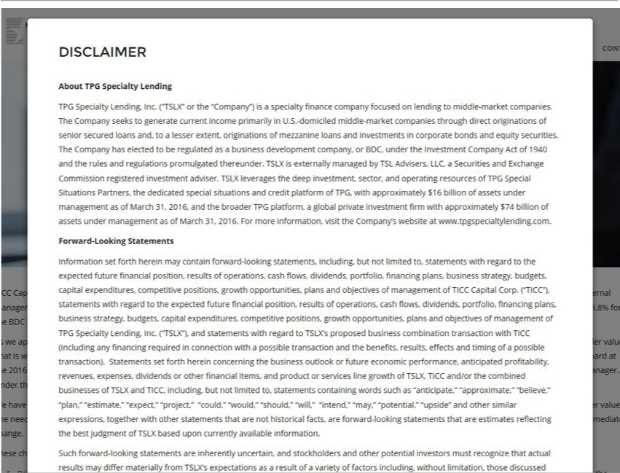

DISCLAIMER About TPG Specialty Lending TPG Specialty Lending, Inc. (“TSLX” or the “Company”) is a specialty finance company focused on lending to middle-market companies. The Company seeks to
generate current income primarily in U.S.-domiciled middle-market companies through direct originations of senior secured loans and, to a lesser extent, originations of mezzanine loans and investments in
corporate bonds and equity securities. The Company has elected to be |  | as a business development company, or BDC, under the Investment Company Act of 1940 and the rules and regulations
promulgated thereunder. TSLX is externally managed by TSL Advisers,regulatedLLC, Securities and Exchange Commission registered investment adviser. TSLX leverages the deep investment, sector, and operating
resources of TPG Special Situations Partners, the dedicated special situations and credit platform of TPG, with approximately $16 billion of assets under management |  |  |  | of March 31, 2016, and the broader TPG
platform, a global private investment firm with approximately $74 billion of assets under management as of March 31, 2016. For more information, visit the Company’as website at www.tpgspecialtylending.com.
Forward-Looking Statements Information set forth herein may contain forward-looking statements, including, but not limited to, statements with regard to the expected future financial position, results of
operations, cash flows, dividends, portfolio, financing plans, business strategy budgets, capital expenditures, competitive positions, growth opportunities, plans and objectives of management of TICC Capital
Corp. (“TICC”), statements with regard to the expected future financial position, results of operations, cash flows, dividends, portfolio, financing plans, business |  |  |  | , budgets, capital expenditures,
competitive positions, growth opportunities, plans and objectives of management of TPG Specialty Lending, Inc. (“TSLX”), and |  |  | with regard to TSLX’strategyproposed business combination transaction
wi h TICC (including any financing required in connection with a possible transaction and the benefits, results, effects and timingstatementsofpossible transaction). Statements set forth herein concerning the business
outlook or future economic performance, anticipated profitability, revenues, expenses, dividends or other financial items, and product or services line growth of TSLX, TICC and/or the combined businesses of
TSLX and TICC, including, but not limited to, statements containing words such as “anticipate,” “approximate,” “believe,” “plan,” “estimate,” “expect,” “project,” “could,” “would,” “should,” “will,” “intend,”
“may,” “potential,” “upside” and other similar expressions, together with other statements that are not historical facts, are forward-looking statements that are estimates reflecting the best judgment of TSLX
based upon currently | . Such ward-looking statements | re inherently uncertain, and stockholders and other potential investors must recognize that actual results may differ materially from
TSLX’s expectations availableasresultinformationofvariety of factors including, without limitation, those discussed

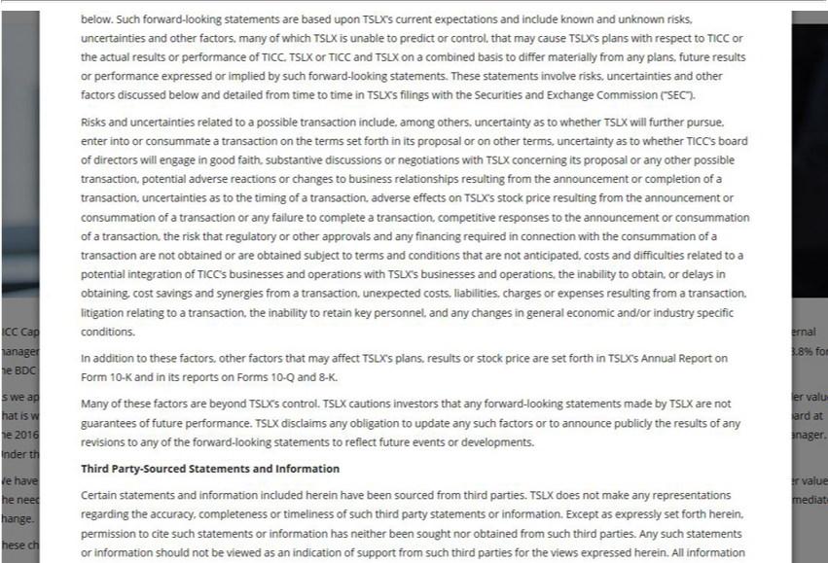

below. Such forward-looking statements are based upon TSLX’s current expectations and include known and unknown risks, |  |  |  |  |  |  |  | and other factors, many of which TSLX is unable to predict control,
that may cause TSLX’s plans with respect to TICC or the actual results or performance of TICC, TSLX or TICC and TSLX onuncertaintiescombined basis to differ materially from any |  |  |  |  |  |  |  |  |  | future results or performance
expressed or implied by such forward-looking statements. These |  |  |  |  | involve risks, uncertainties and other factors discussed below and detailed from time to time in TSLX’plans,filings with the Securities and
Exchange Commission (“SEC”). Risks and uncertainties related tostatementspossible |  |  |  |  |  | include, among others, uncertainty as to whether TSLX will further pursue, enter into or consummate a transaction on the
terms set forth in its proposal or on other terms, uncertainty as to whether TICC’transactionboardof directors will engage in good faith, substantive discussions or negotiations with TSLX concerning its proposal or any
other possible |  | potential adverse reactions or changes to business |  |  |  | resulting from the announcement or completion of a transaction, uncertainties as to the timing of transaction,
effects | TSLX’transaction,stockprice resulting from the announcement or consummationrelationshipsoftransaction or any failure to complete |  |  |  |  |  |  | transaction, competitive responses to the announcement or consummation ofadverse
transaction, the risk that regulatory or other |  |  |  | and any financing required |  | connection with the consummation of a transaction are not obtained or are obtained subject to terms and conditions that are
not anticipated, costs and difficulties relatedapprovalstopotential integration of TICC’ businesses |  |  |  |  |  |  | operations with TSLX’s businesses and operations, the inability to obtain, or delays in obtaining, cost savings and
synergies from |  | transaction, unexpected costs, liabilities, charges |  |  | expenses resulting fromand transaction, litigation relating to a transaction, the |  |  |  | to retain key personnel, and any changes in general
 | and/or industry specific conditions. In addition to these |  |  |  | other factors that may affect TSLX’s plans, results or stock price are setinabilityforth |  |  |  | TSLX’s Annual Report on Form 10-K and in its reports
economicForms 10-Q and 8-K. Many of these factors are beyond TSLX’factors,control. TSLX cautions investors that any forward-looking statements made by TSLX are not guarantees of future performance. TSLX
disclaims any obligation to update any such factors |  |  |  | to announce publicly the results of any revisions to any of the forward-looking statements to reflect future events or developments. Third Party-Sourced
Statements and Information |  |  | statements and information included herein have been sourced from third parties. TSLX does not make any representations regarding the accuracy, completeness or timeliness
Certain permission
of such third party_{information}stements or _{not}formation. Except as expressly set forth herein, to cite such statements or information has neither been sought nor obtained from such third parties. Any such
statements or should be viewed as an indication of support from such third parties for the views expressed herein. All information

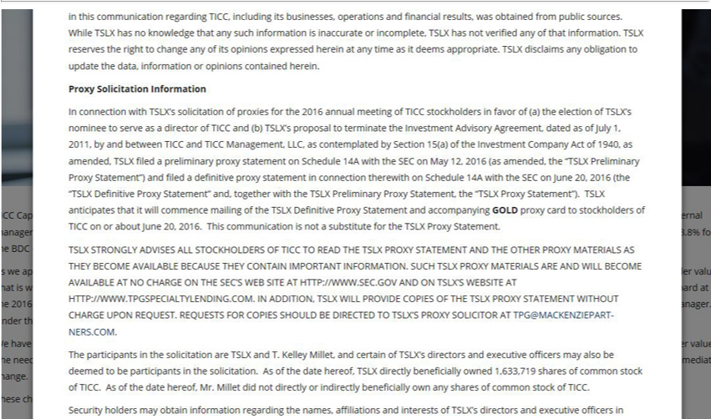

this communication regarding TICC, including its businesses, operations and financial results, was obtained from public sources. While TSLX has no knowledge that any such information is inaccurate or
incomplete, TSLX has not verified any of that information. TSLX reserves the right to change any of its |  |  |  | expressed herein at any time as it deems appropriate. TSLX disclaims any obligation to update
the data, information or opinions contained herein. Proxy Solicitation Information In connection with TSLX’opinionssolicitation of proxies for the 2016 annual meeting of TICC stockholders in favor of (a) the election
of TSLX’s nominee to serve as a director of TICC and (b) TSLX’s proposal to terminate the Investment Advisory Agreement, dated as of July 1, 2011, by and between TICC and TICC Management, LLC, as
contemplated by Section 15(a) of the Investment Company Act of 1940, as amended, TSLX filed a preliminary proxy statement on Schedule 14A with the SEC on May 12, 2016 (as amended, “TSLX
Preliminary Proxy Statement”) and filed a definitive proxy statement in connection |  |  | on Schedule 14A with the SEC on June 20, 2016 (the “TSLX Definitive Proxy Statement” and, together with the
TSLX Preliminary Proxy Statement, the “TSLX Proxy Statement”). TSLX |  |  | therewiththatwill commence mailing of the TSLX Definitive Proxy Statement and accompanying GOLD proxy card to
stockholders of TICC on or about June 20, 2016. This communication is notanticipatessubstitute for the TSLX Proxy Statement. TSLX STRONGLY ADVISES ALL STOCKHOLDERS OF TICC TO READ THE
TSLX PROXY STATEMENT AND THE OTHER PROXY MATERIALS AS THEY BECOME AV |  |  |  | BECAUSE THEY CONTAIN IMPOR ANT INFORMA | . SUCH TSLX PROXY
MATERIALS ARE AND WILL BECOME AVAILABLE |  | T NO CHARGE ON THE SEC’S WEB AILABLESITEHTTP://WWW.SEC.GOV AND ON TSLX’S WEBSITE ATION
HTTP://WWW.TPGSPECIAL | .COM. IN ADDITION, TSLX WILL PROVIDE COPIES OF THE TSLX PROXY STATEMENT WITHOUT CHARGE UPON REQUEST. REQUESTS FOR
COPIES SHOULD BE DIRECTEDTYLENDINGOTSLX’S PROXY SOLICITOR AT TPG@MACKENZIEPARTNERS.COM. The participants in the solicitation are TSLX and T. Kelley Millet, and certain of TSLX’s
directors and executive officers may also be deemed to |  | participants in the solicitation. As of the date hereof, TSLX directly beneficially owned 1,633,719 shares of common stock of TICC. As of the date
hereof, Mr. Millet did not directly or indirectly beneficially own any shares of common stock of TICC.

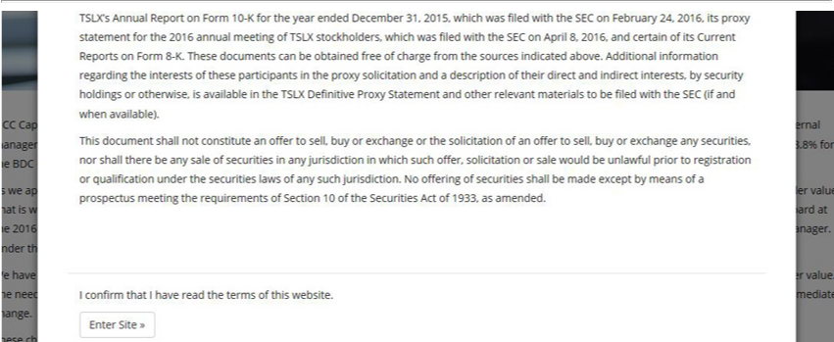

TSLX’s Annual Report on Form 10-K for the year ended December 31, 2015, which was filed with the SEC on February 24, 2016, its proxy statement for the 2016 annual meeting of TSLX stockholders, which was filed with the SEC on April 8, 2016, and certain of its Current Reports on Form 8-K. These documinterests,nts can be obtained free of charge from the sources indicated above. Additional information regarding theintrestsoftheseparticipantsintheproxysolicitationanddescriptionoftheirdirectandindirectbysecurityholdingsorisavailableintheTSLXDefinitiveProxyStatementandother
relevant ava otherwise,
materials to be filed with the SEC (if and when _{which}lable). This document shall not constitute an offer to sell, buy or exchange or solicitation of an offer to sell, buy or exchange any securities, nor
shall there be any sale of securities in any jurisdiction in such offer, solicitation or sale would be unlawful prior to registration or qualification under the securities laws of any such jurisdiction. No offering of securities shall be made except by means of a prospectus meeting the requirements of Section 10 of the Securities Act of 1933, as amended.

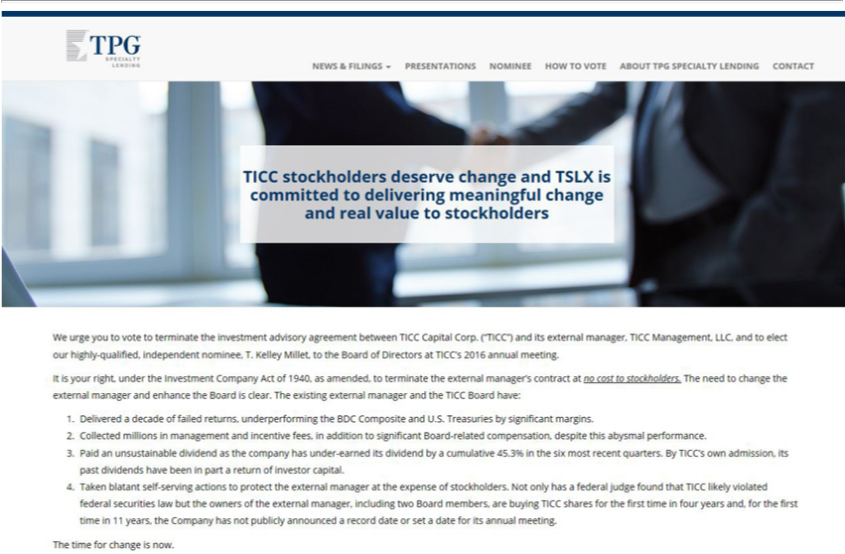

Presentations Nominee How to Vote About TPG Specialty Lending Contact
Wnominee,TICCurgestockholdersyouvotedeservetoterminatechangetheandinvestmentTSLXis advisorycommittedagreementtodeliveringbetweenmeaningfulTICCCapitalchangeCorp.andreal(“TICC”)value toandstockholdersitsexternal manager, TICC Management, LLC, and to elect our highly-qualified, independent
It is your right,T.KelleyunderMillet,theInvestmenttotheBoardCompanyofDirectorsActofat 1940,TICC’as 2016amended,annualto meeting.terminate the external manager’s contract at no cost to stockholders. The need to change the external manager and enhance the Board is clear. The existing external manager and the TICC Board have:

DeCollectedivered millionsadecade ofmanagementfailedreturns,andunderperformingincentivefees, intheadditionBDCCompositetosignificantand U.S. Treasuries-relatedcompensation,bysignificantdespitemargins.this abysmal performance.
Paid an unsustainable dividend as the company has under-earned its dividend byBoardcumulative 45.3% in the six most recent quarters. By TICC’s own admission, its past dividends have been in part a return of investor capital.
Taken blatant self-serving actions to protect the external manager at the expense of stockholders. Not only has a federal judge found that TICC likely violated federal securities law but the owners of the external manager, including two Board members, are buying TICC shares for the first time in four years and, for the first time in 11 years, the Company has not publicly announced a record date or set a date for its annual meeting.
The time for change is now.

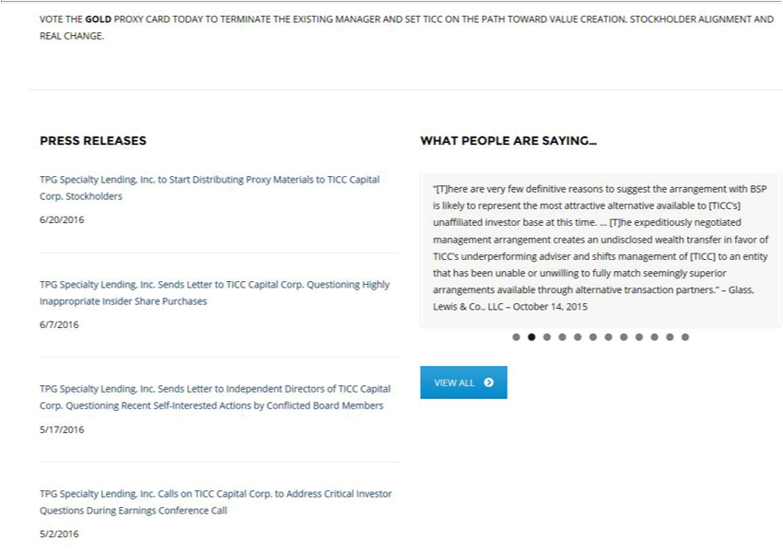

VOTE THE GOLD PROXY CARD TODAY TO TERMINATE THE EXISTING MANAGER AND SET TICC ON THE PATH TOWARD VALUE CREATION, STOCKHOLDER ALIGNMENT AND REAL CHANGE.
PRESS RELEASES
6/20/2016TPGSpecialty Lending, Inc. to Start Distributing Proxy Materials to TICC Capital Corp. Stockholders

TPG Specialty Lending, Inc. Sends Letter to TICC Capital Corp. Questioning Highly Inappropriate Insider Share Purchases 6/7/2016
TPG Specialty Lending, Inc. Sends Letter to Independent Directors of TICC Capital Corp. Questioning Recent Self-Interested Actions by Conflicted Board Members 5/17/2016
TPG Specialty Lending, Inc. Calls on TICC Capital Corp. to Address Critical Investor Questions During Earnings Conference Call 5/2/2016
WHAT PEOPLE ARE SAYING…
“The $0.29 [TICC] dividend is not sustainable,_{negotiating}d _{with}eexpect it will be cut regardless of what happens._{questioning}Whavebeen talking about a dividend cut for over a year now…Now TSLX provides an interesting offer
and the [TICC] Board rejects it without_{September} TSLX. As the title of our note implies, we are whether the [TICC] Board is really doing all they can to maximize shareholder value.” –
Keefe, Bruyette & Woods report – 16, 2015

VIEW ALL

TPG Specialty Lending, Inc. Sends Letter to TICC Board of Directors Calling Recent Actions Wholly Unacceptable and Affirming Commitment to Deliver Value to TICC Stockholders 3/17/2016
TPG Specialty Lending, Inc. Seeks to Elect New Independent Candidate to Board and Terminate Investment Advisory Agreement at TICC Capital Corp. 2/4/2016
TPG Specialty Lending, Inc. Comments on TICC Capital Corp. Stockholders’ Rejection of Conflicted Sale of Advisory Agreement 12/22/2015
TPG Specialty Lending, Inc. Urges Stockholders to Vote the GOLD Proxy Card AGAINST the Benefit Street Partners Transaction at the Special Meeting Scheduled for December 22 12/21/2015
TPG Specialty Lending, Inc. Affirms Commitment to Hold TICC Capital Corp. Accountable to Stockholders 12/14/2015

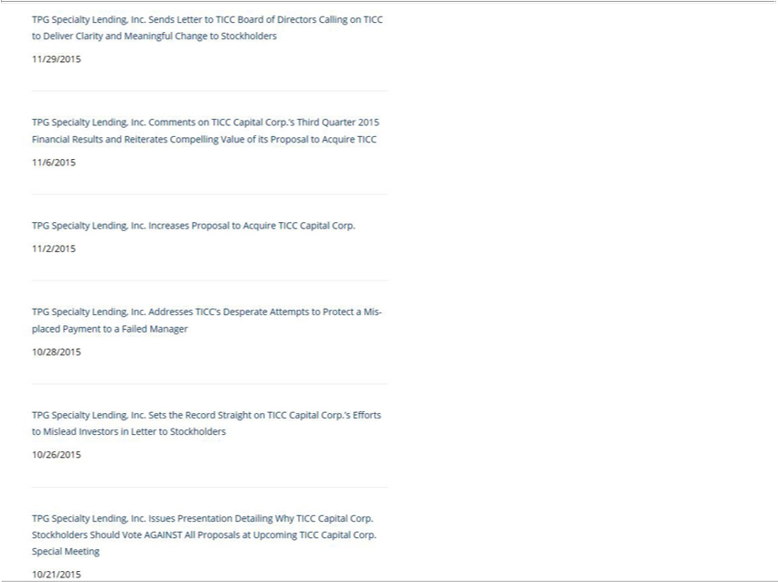

TPG Specialty Lending, Inc. Sends Letter to TICC Board of Directors Calling on TICC to Deliver Clarity and Meaningful Change to Stockholders 11/29/2015
TPG Specialty Lending, Inc. Comments on TICC Capital Corp.’s Third Quarter 2015 Financial Results and Reiterates Compelling Value of its Proposal to Acquire TICC 11/6/2015
11/2/2015TPGSpecialty Lending, Inc. Increases Proposal to Acquire TICC Capital Corp.

TPG Specialty Lending, Inc. Addresses TICC’s Desperate Attempts to Protect a Misplaced Payment to a Failed Manager 10/28/2015
TPG Specialty Lending, Inc. Sets the Record Straight on TICC Capital Corp.’s Efforts to Mislead Investors in Letter to Stockholders 10/26/2015
TPG Specialty Lending, Inc. Issues Presentation Detailing Why TICC Capital Corp. Stockholders Should Vote AGAINST All Proposals at Upcoming TICC Capital Corp. Special Meeting 10/21/2015

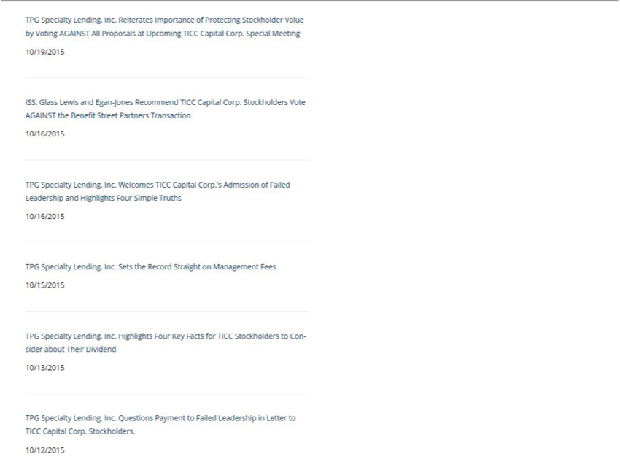

TPG Specialty Lending, Inc. Reiterates Importance of Protecting Stockholder Value by Voting AGAINST All Proposals at Upcoming TICC Capital Corp. Special Meeting 10/19/2015
ISS, Glass Lewis and Egan-Jones Recommend TICC Capital Corp. Stockholders Vote AGAINST the Benefit Street Partners Transaction 10/16/2015
TPG Specialty Lending, Inc. Welcomes TICC Capital Corp.’s Admission of Failed Leadership and Highlights Four Simple Truths 10/16/2015
10/15/2015TPGSpecialty Lending, Inc. Sets the Record Straight on Management Fees

TPG Specialty Lending, Inc. Highlights Four Key Facts for TICC Stockholders to Consider about Their Dividend 10/13/2015
10/12/2015TPGSpecialty Lending, Inc. Questions Payment to Failed Leadership in Letter to TICC Capital Corp. Stockholders.

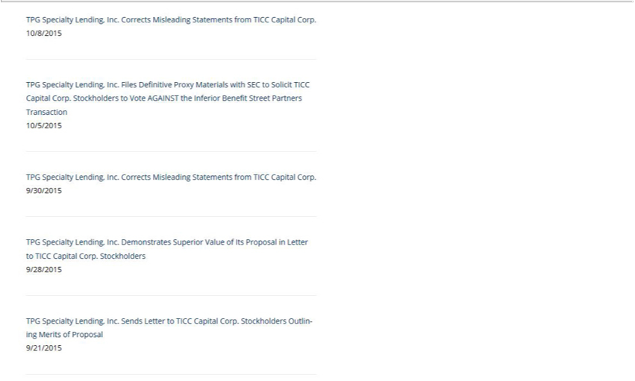

10/8/2015TPGSpecialty Lending, Inc. Corrects Misleading Statements from TICC Capital Corp.
TPG Specialty Lending, Inc. Files Definitive Proxy Materials with SEC to Solicit TICC Capital Corp. Stockholders to Vote AGAINST the Inferior Benefit Street Partners Transaction 10/5/2015
9/30/2015TPGSpecialty Lending, Inc. Corrects Misleading Statements from TICC Capital Corp.

TPG Specialty Lending, Inc. Demonstrates Superior Value of Its Proposal in Letter to TICC Capital Corp. Stockholders 9/28/2015
TPG Specialty Lending, Inc. Sends Letter to TICC Capital Corp. Stockholders Outlining Merits of Proposal 9/21/2015

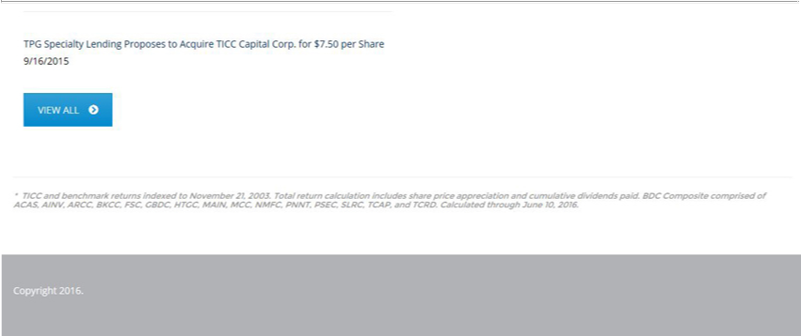

9/16/2015TPGSpecialty Lending Proposes to Acquire TICC Capital Corp. for $7.50 per Share
VIEW ALL

About TPG Specialty Lending

TPG Specialty Lending, Inc. (“TSLX” or the “Company”) is a specialty finance company focused on lending to middle-market companies. The Company seeks to generate current income primarily in U.S.-domiciled middle-market companies through direct originations of senior secured loans and, to a lesser extent, originations of mezzanine loans and investments in corporate bonds and equity securities. The Company has elected to be regulated as a business development company, or BDC, under the Investment Company Act of 1940 and the rules and regulations promulgated thereunder. TSLX is externally managed by TSL Advisers, LLC, a Securities and Exchange Commission registered investment adviser. TSLX leverages the deep investment, sector, and operating resources of TPG Special Situations Partners, the dedicated special situations and credit platform of TPG, with approximately $16 billion of assets under management as of March 31, 2016, and the broader TPG platform, a global private investment firm with approximately $74 billion of assets under management as of March 31, 2016. For more information, visit the Company’s website at www.tpgspecialtylending.com.

Forward-Looking Statements

Information set forth herein may contain forward-looking statements, including, but not limited to, statements with regard to the expected future financial position, results of operations, cash flows, dividends, portfolio, financing plans, business strategy, budgets, capital expenditures, competitive positions, growth opportunities, plans and objectives of management of TICC Capital Corp. (“TICC”), statements with regard to the expected future financial position, results of operations, cash flows, dividends, portfolio, financing plans, business strategy, budgets, capital expenditures, competitive positions, growth opportunities, plans and objectives of management of TPG Specialty Lending, Inc. (“TSLX”), and statements with regard to TSLX’s proposed business combination transaction with TICC (including any financing required in connection with a possible transaction and the benefits, results, effects and timing of a possible transaction). Statements set forth herein concerning the business outlook or future economic performance, anticipated profitability, revenues, expenses, dividends or other financial items, and product or services line growth of TSLX, TICC and/or the combined businesses of TSLX and TICC, including, but not limited to, statements containing words such as “anticipate,” “approximate,” “believe,” “plan,” “estimate,” “expect,” “project,” “could,” “would,” “should,” “will,” “intend,” “may,” “potential,” “upside” and other similar expressions, together with other statements that are not historical facts, are forward-looking statements that are estimates reflecting the best judgment of TSLX based upon currently available information.

Such forward-looking statements are inherently uncertain, and stockholders and other potential investors must recognize that actual results may differ materially from TSLX’s expectations as a result of a variety of factors including, without limitation, those discussed below. Such forward-looking statements are based upon TSLX’s current expectations and include known and unknown risks, uncertainties and other factors, many of which TSLX is unable to predict or control, that may cause TSLX’s plans with respect to TICC or the actual results or performance of TICC, TSLX or TICC and TSLX on a combined basis to differ materially from any plans, future results or performance expressed or implied by such forward-looking statements. These statements involve risks, uncertainties and other factors discussed below and detailed from time to time in TSLX’s filings with the Securities and Exchange Commission (“SEC”).

Risks and uncertainties related to a possible transaction include, among others, uncertainty as to whether TSLX will further pursue, enter into or consummate a transaction on the terms set forth in its proposal or on other terms, uncertainty as to whether TICC’s board of directors will engage in good faith, substantive discussions or negotiations with TSLX concerning its proposal or any other possible transaction, potential adverse reactions or changes to business relationships resulting from the announcement or completion of a transaction, uncertainties as to the timing of a transaction, adverse effects on TSLX’s stock price resulting from the announcement or consummation of a transaction or any failure to complete a transaction, competitive responses to the announcement or consummation of a transaction, the risk that regulatory or other approvals and any financing required in connection with the consummation of a transaction are not obtained or are obtained subject to terms and conditions that are not anticipated, costs and difficulties related to a potential integration of TICC’s businesses and operations with TSLX’s businesses and operations, the inability to obtain, or delays in obtaining, cost savings and synergies from a transaction, unexpected costs, liabilities, charges or expenses resulting from a transaction, litigation relating to a transaction, the inability to retain key personnel, and any changes in general economic and/or industry specific conditions.

In addition to these factors, other factors that may affect TSLX’s plans, results or stock price are set forth in TSLX’s Annual Report on Form 10-K and in its reports on Forms 10-Q and 8-K.

Many of these factors are beyond TSLX’s control. TSLX cautions investors that any forward-looking statements made by TSLX are not guarantees of future performance. TSLX disclaims any obligation to update any such factors or to announce publicly the results of any revisions to any of the forward-looking statements to reflect future events or developments.

Third Party-Sourced Statements and Information

Certain statements and information included herein have been sourced from third parties. TSLX does not make any representations regarding the accuracy, completeness or timeliness of such third party statements or information. Except as expressly set forth herein, permission to cite such statements or information has neither been sought nor obtained from such third parties. Any such statements or information should not be viewed as an indication of support from such third parties for the views expressed herein. All information in this communication regarding TICC, including its businesses, operations and financial results, was obtained from public sources. While TSLX has no knowledge that any such information is inaccurate or incomplete, TSLX has not verified any of that information. TSLX reserves the right to change any of its opinions expressed herein at any time as it deems appropriate. TSLX disclaims any obligation to update the data, information or opinions contained herein.

Proxy Solicitation Information

In connection with TSLX’s solicitation of proxies for the 2016 annual meeting of TICC stockholders in favor of (a) the election of TSLX’s nominee to serve as a director of TICC and (b) TSLX’s proposal to terminate the Investment Advisory Agreement, dated as of July 1, 2011, by and between TICC and TICC Management, LLC, as contemplated by Section 15(a) of the Investment Company Act of 1940, as amended, TSLX filed a preliminary proxy statement on Schedule 14A with the SEC on May 12, 2016 (as amended, the “TSLX Preliminary Proxy Statement”) and filed a definitive proxy statement in connection therewith on Schedule 14A with the SEC on June 20, 2016 (the “TSLX Definitive Proxy Statement” and, together with the TSLX Preliminary Proxy Statement, the “TSLX Proxy Statement”). TSLX anticipates that it will commence mailing of the TSLX Definitive Proxy Statement and accompanying GOLD proxy card to stockholders of TICC on or about June 20, 2016. This communication is not a substitute for the TSLX Proxy Statement.

TSLX STRONGLY ADVISES ALL STOCKHOLDERS OF TICC TO READ THE TSLX PROXY STATEMENT AND THE OTHER PROXY MATERIALS AS THEY BECOME AVAILABLE BECAUSE THEY CONTAIN IMPORTANT INFORMATION. SUCH TSLX PROXY MATERIALS ARE AND WILL BECOME AVAILABLE AT NO CHARGE ON THE SEC’S WEB SITE AT HTTP://WWW.SEC.GOV AND ON TSLX’S WEBSITE AT HTTP://WWW.TPGSPECIALTYLENDING.COM. IN ADDITION, TSLX WILL PROVIDE COPIES OF THE TSLX PROXY STATEMENT WITHOUT CHARGE UPON REQUEST. REQUESTS FOR COPIES SHOULD BE DIRECTED TO TSLX’S PROXY SOLICITOR AT TPG@MACKENZIEPARTNERS.COM.

The participants in the solicitation are TSLX and T. Kelley Millet, and certain of TSLX’s directors and executive officers may also be deemed to be participants in the solicitation. As of the date hereof, TSLX directly beneficially owned 1,633,719 shares of common stock of TICC. As of the date hereof, Mr. Millet did not directly or indirectly beneficially own any shares of common stock of TICC.

Security holders may obtain information regarding the names, affiliations and interests of TSLX’s directors and executive officers in TSLX’s Annual Report on Form 10-K for the year ended December 31, 2015, which was filed with the SEC on February 24, 2016, its proxy statement for the 2016 annual meeting of TSLX stockholders, which was filed with the SEC on April 8, 2016, and certain of its Current Reports on Form 8-K. These documents can be obtained free of charge from the sources indicated above. Additional information regarding the interests of these participants in the proxy solicitation and a description of their direct and indirect interests, by security holdings or otherwise, is available in the TSLX Definitive Proxy Statement and other relevant materials to be filed with the SEC (if and when available).

This document shall not constitute an offer to sell, buy or exchange or the solicitation of an offer to sell, buy or exchange any securities, nor shall there be any sale of securities in any jurisdiction in which such offer, solicitation or sale would be unlawful prior to registration or qualification under the securities laws of any such jurisdiction. No offering of securities shall be made except by means of a prospectus meeting the requirements of Section 10 of the Securities Act of 1933, as amended.

